SVCR GOVT DEGREE COLLEGE
PALAMANER
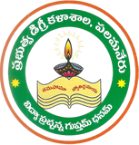
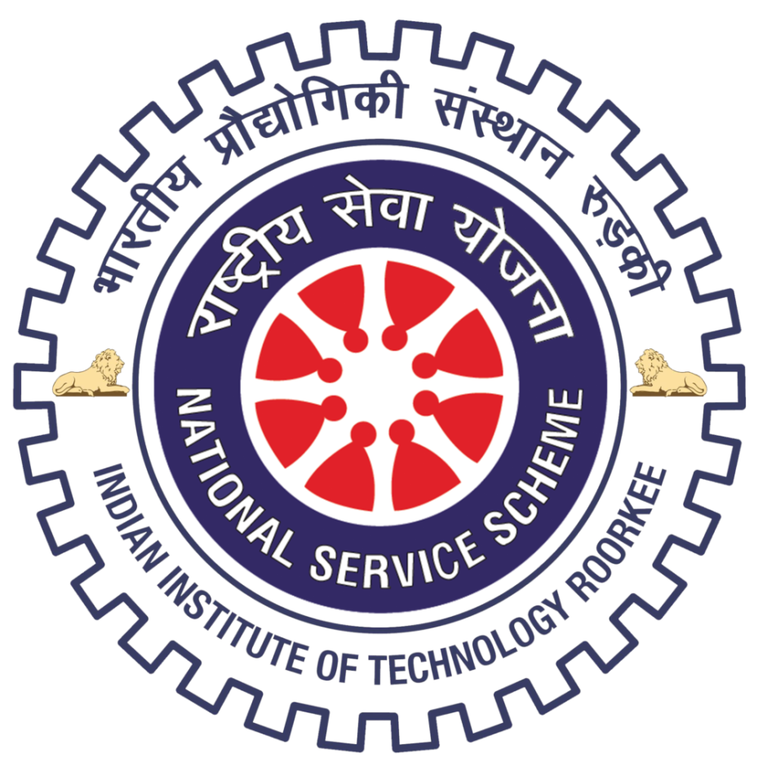
PROGRAM NAME: NSS SPECIAL CAMP
PROGRAM DATE: 29.09.2016
TIME: 09.00 AM
VENUE: AT P.VADDURU AND MARIMAKULA PALLI
RESOURCE PERSON:

SIGNATURE OF THE STUDENTS:
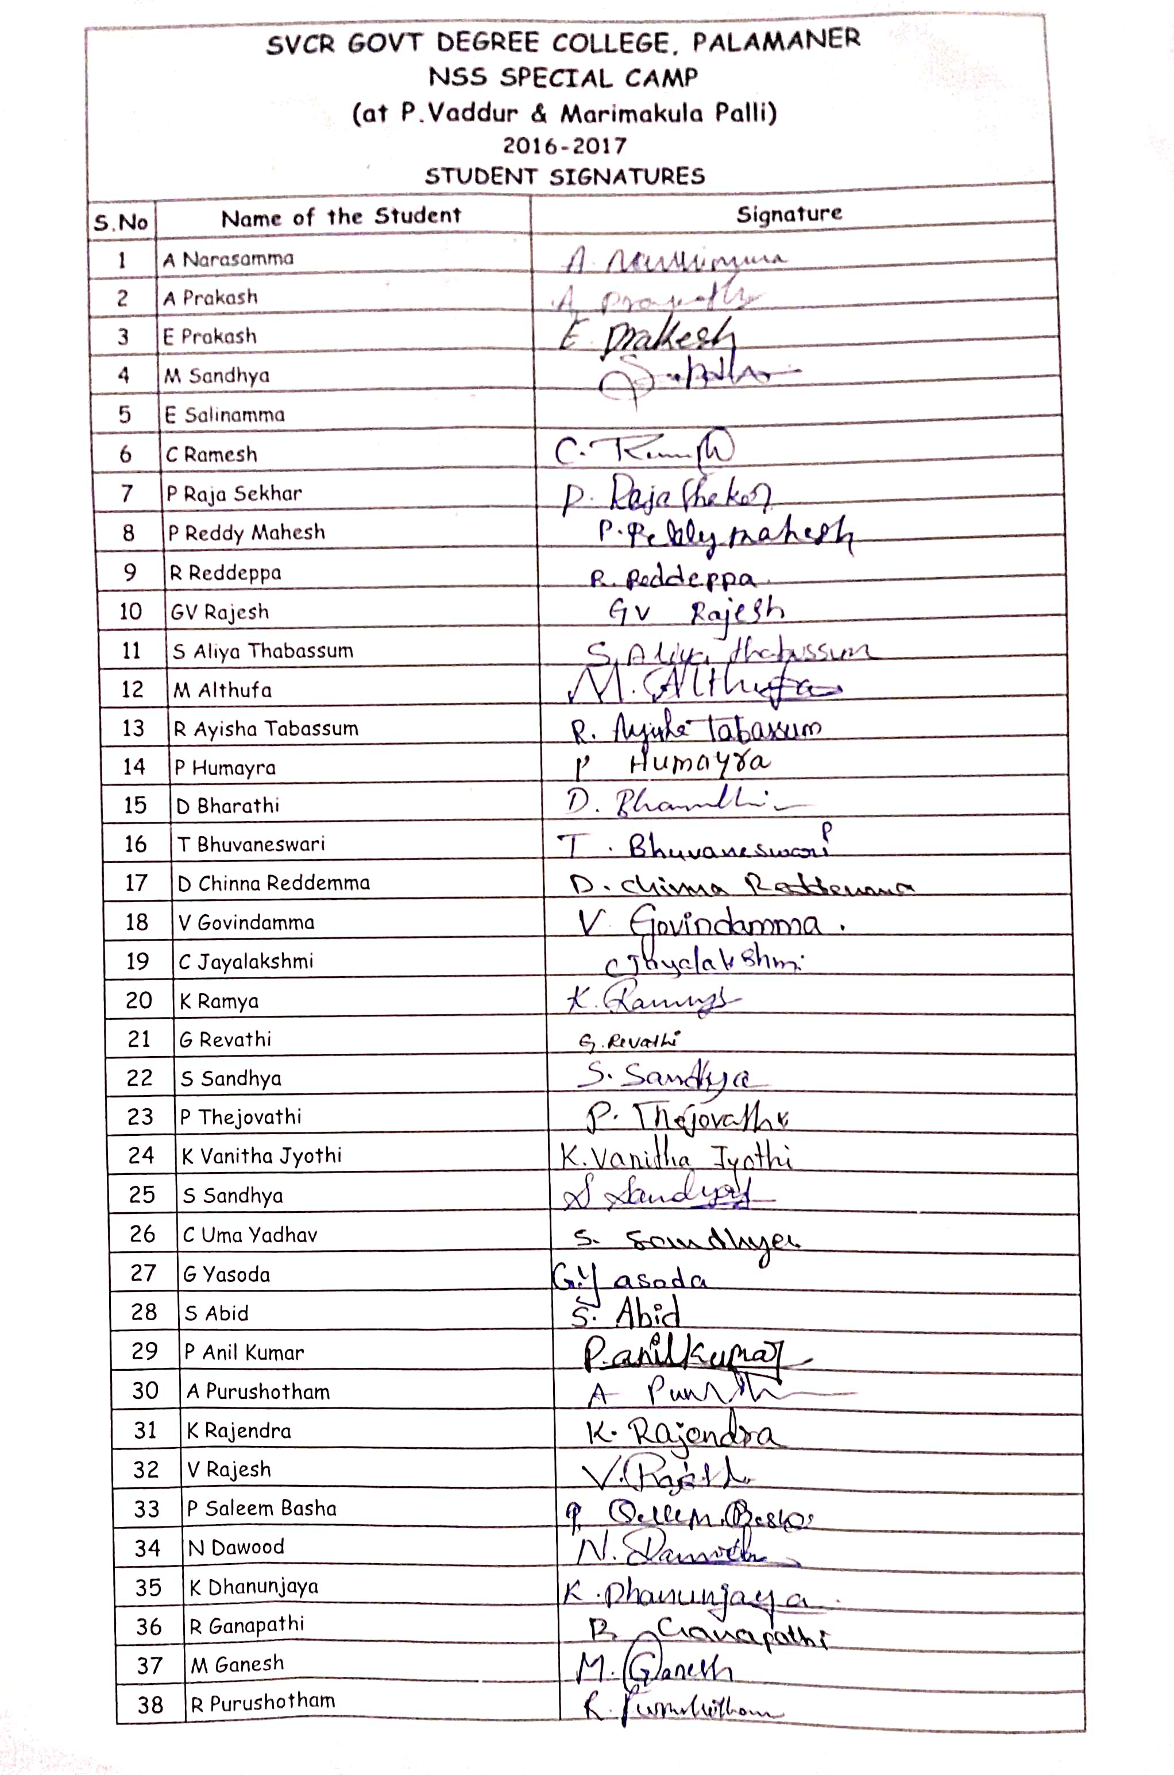

FEED BACK:
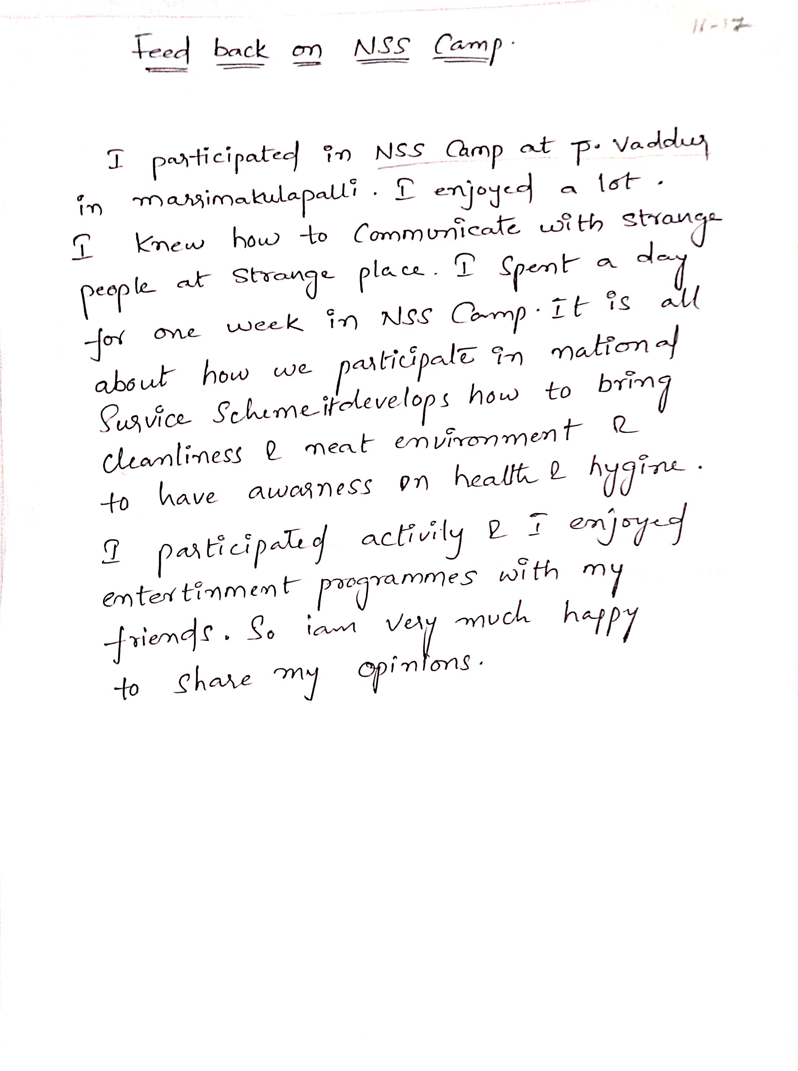
Pepper clips
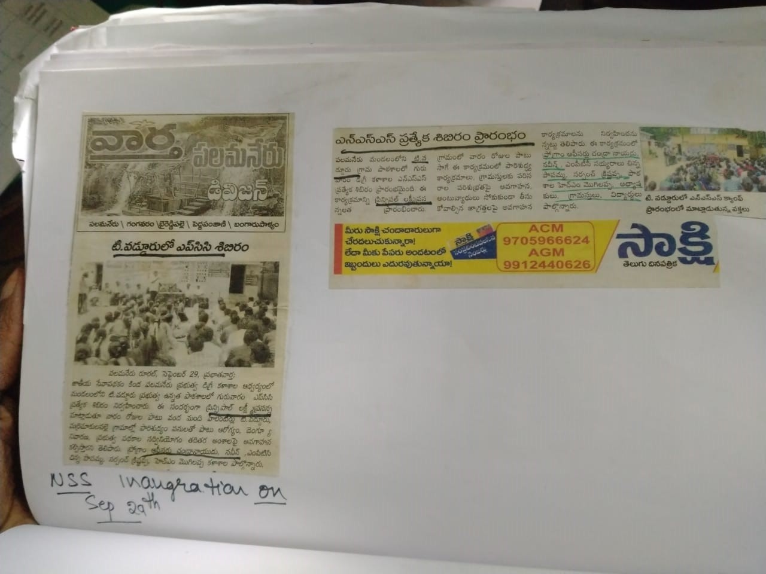
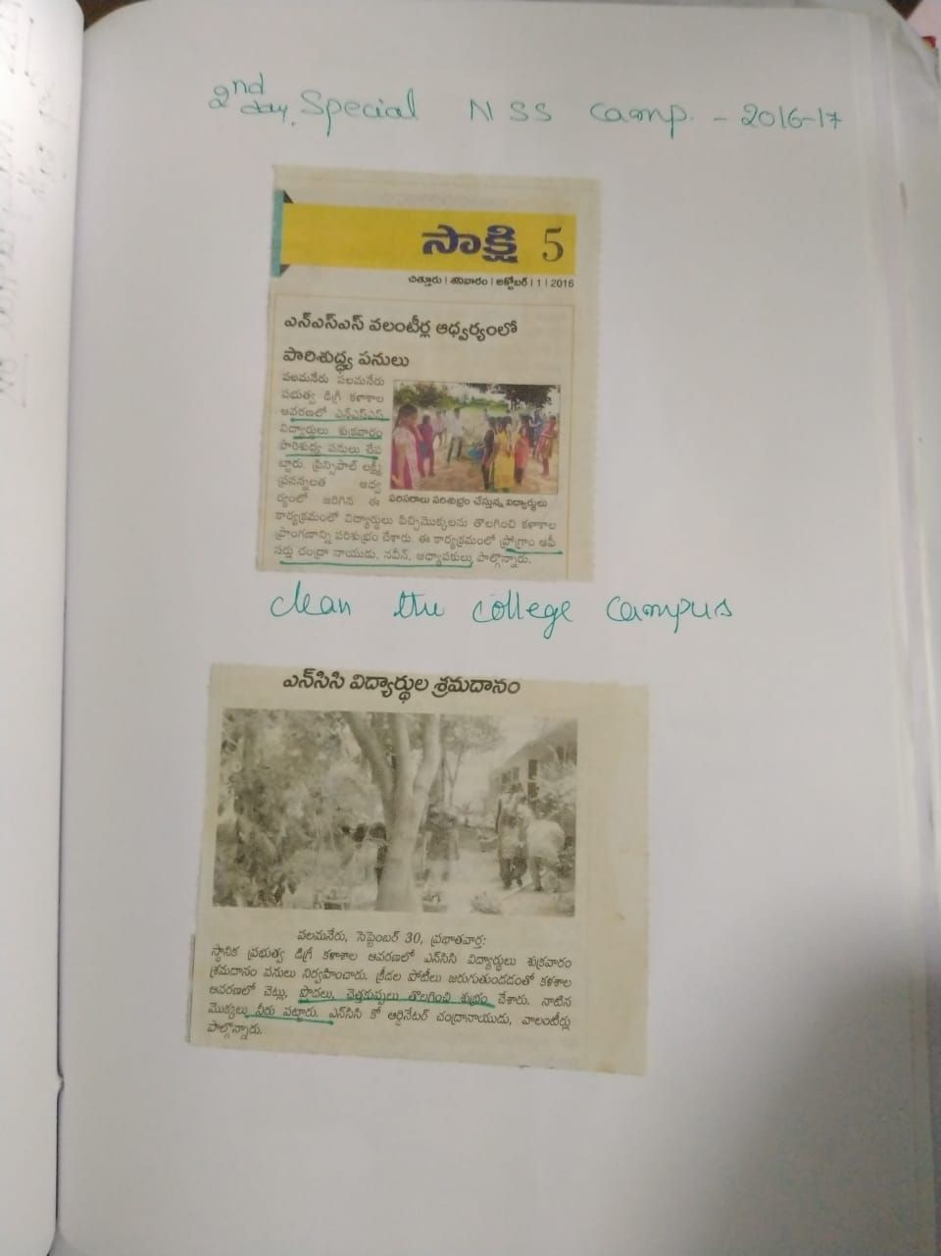

PHOTOS:
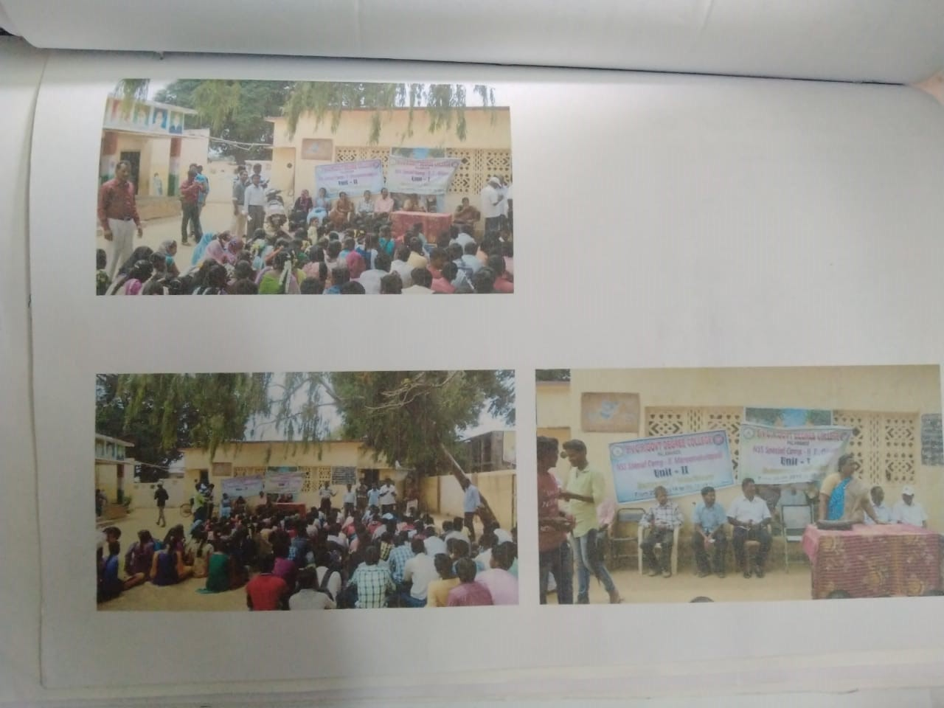

SVCR GOVT DEGREE COLLEGE
PALAMANER
PROGRAM NAME: AWARENESS ON CASHLESS TRANSACTIONS
PROGRAM DATE: 14.12.2016
TIME: 09.00 AM
VENUE: SEMINAR HALL
RESOURCE PERSON: COLLEGE

FEED BACK:
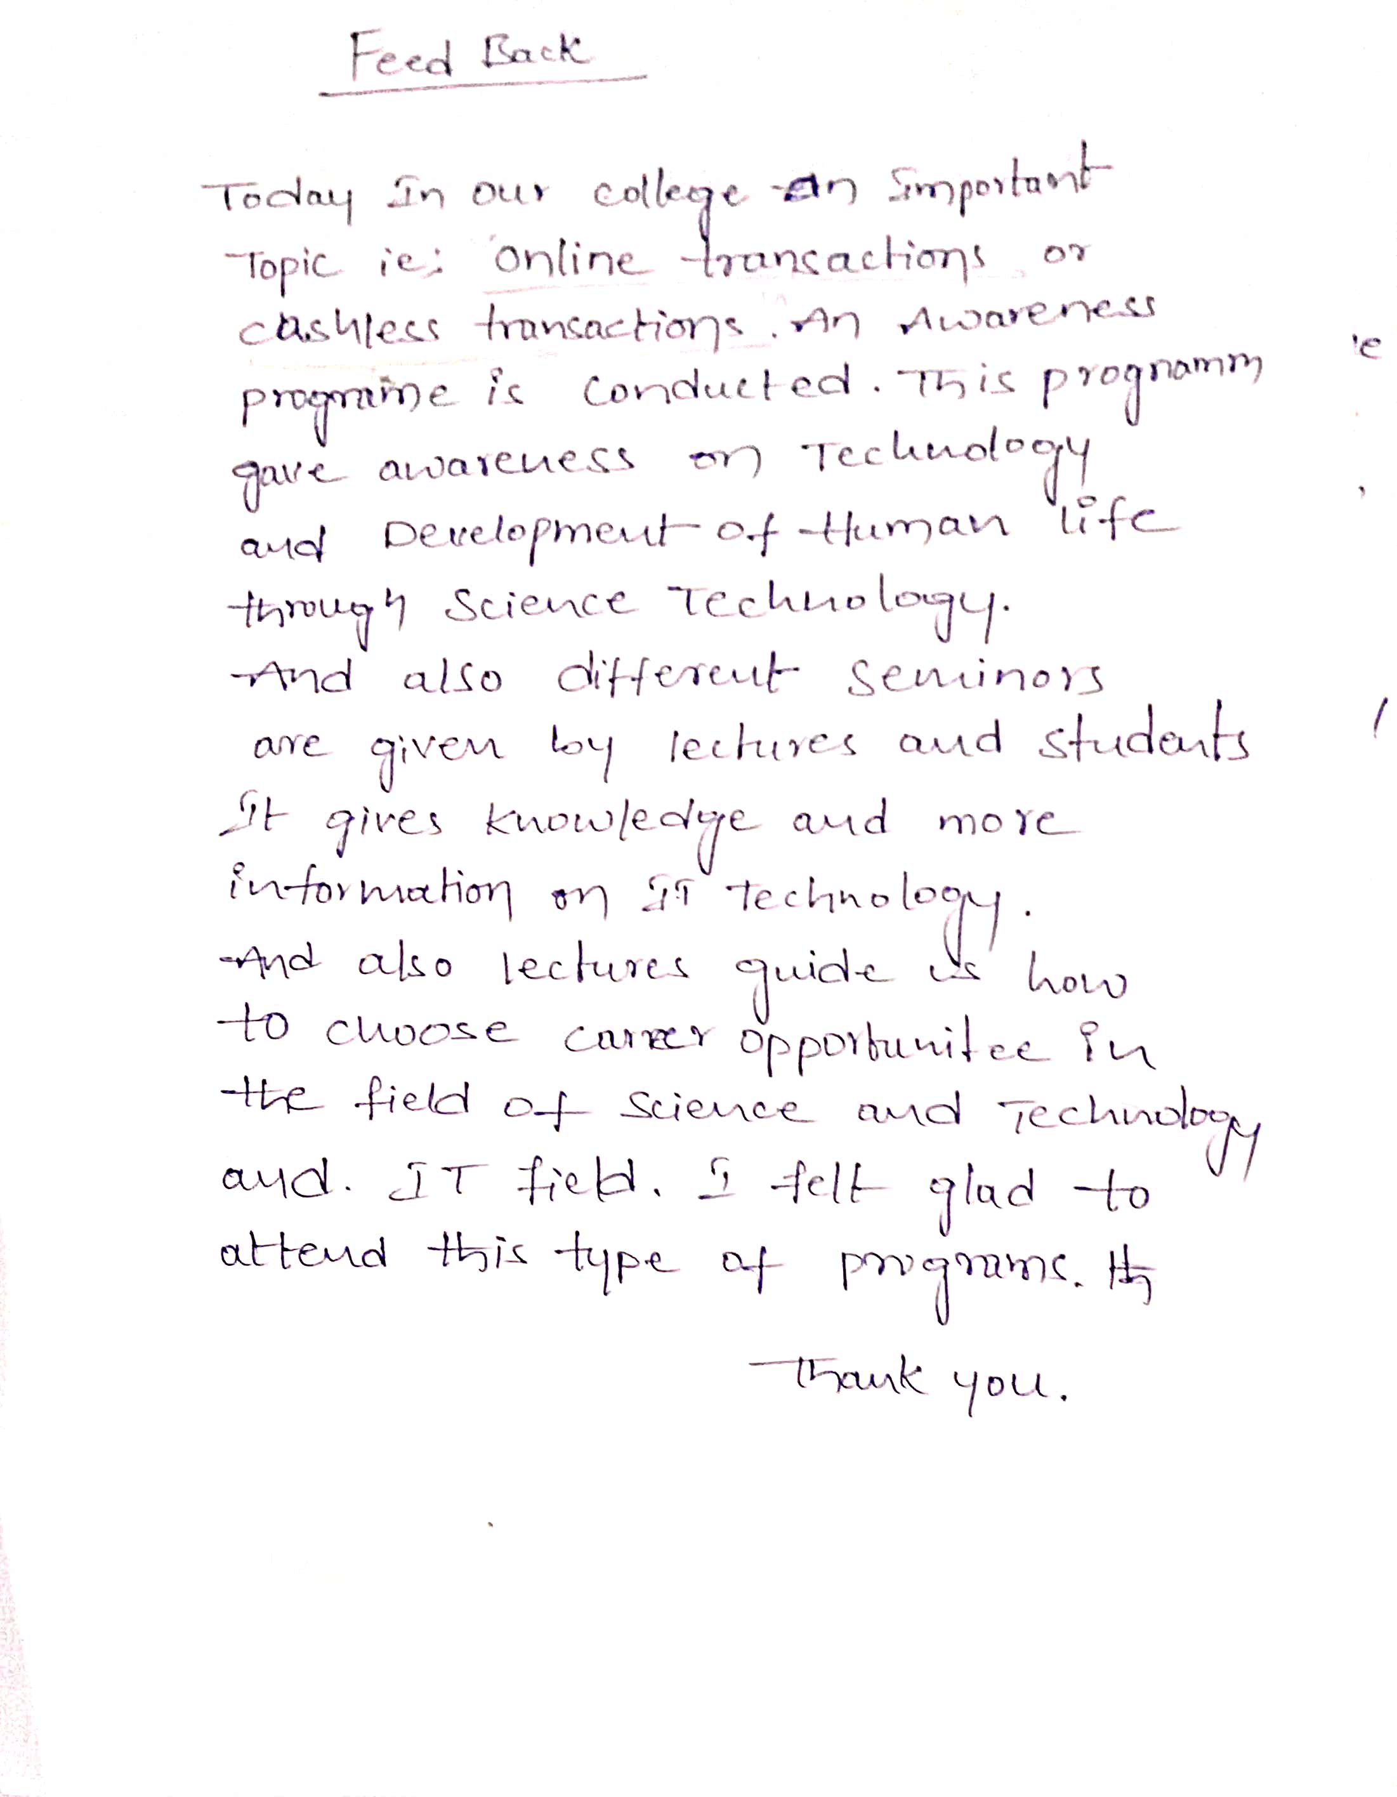

SIGNATURE OF THE STUDENTS:
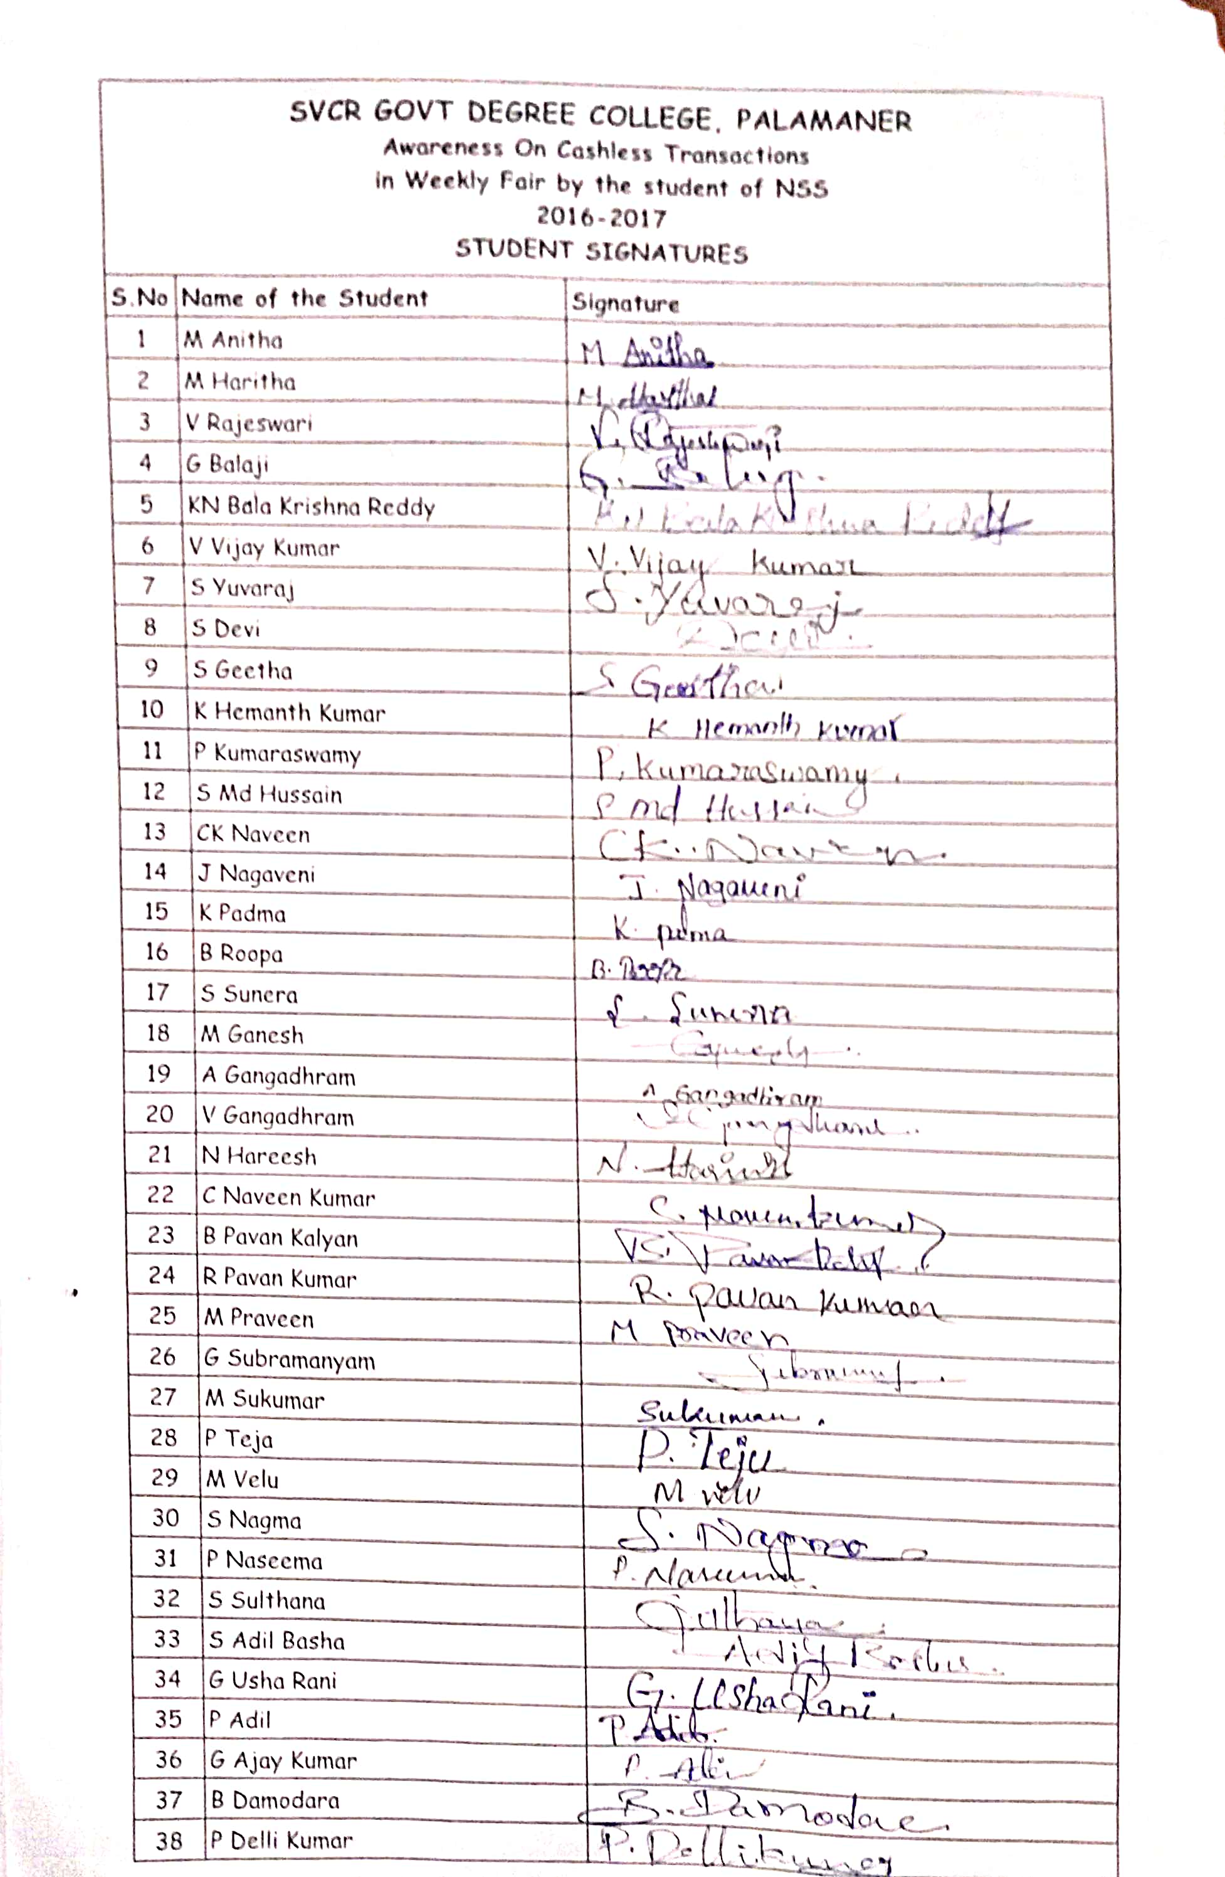
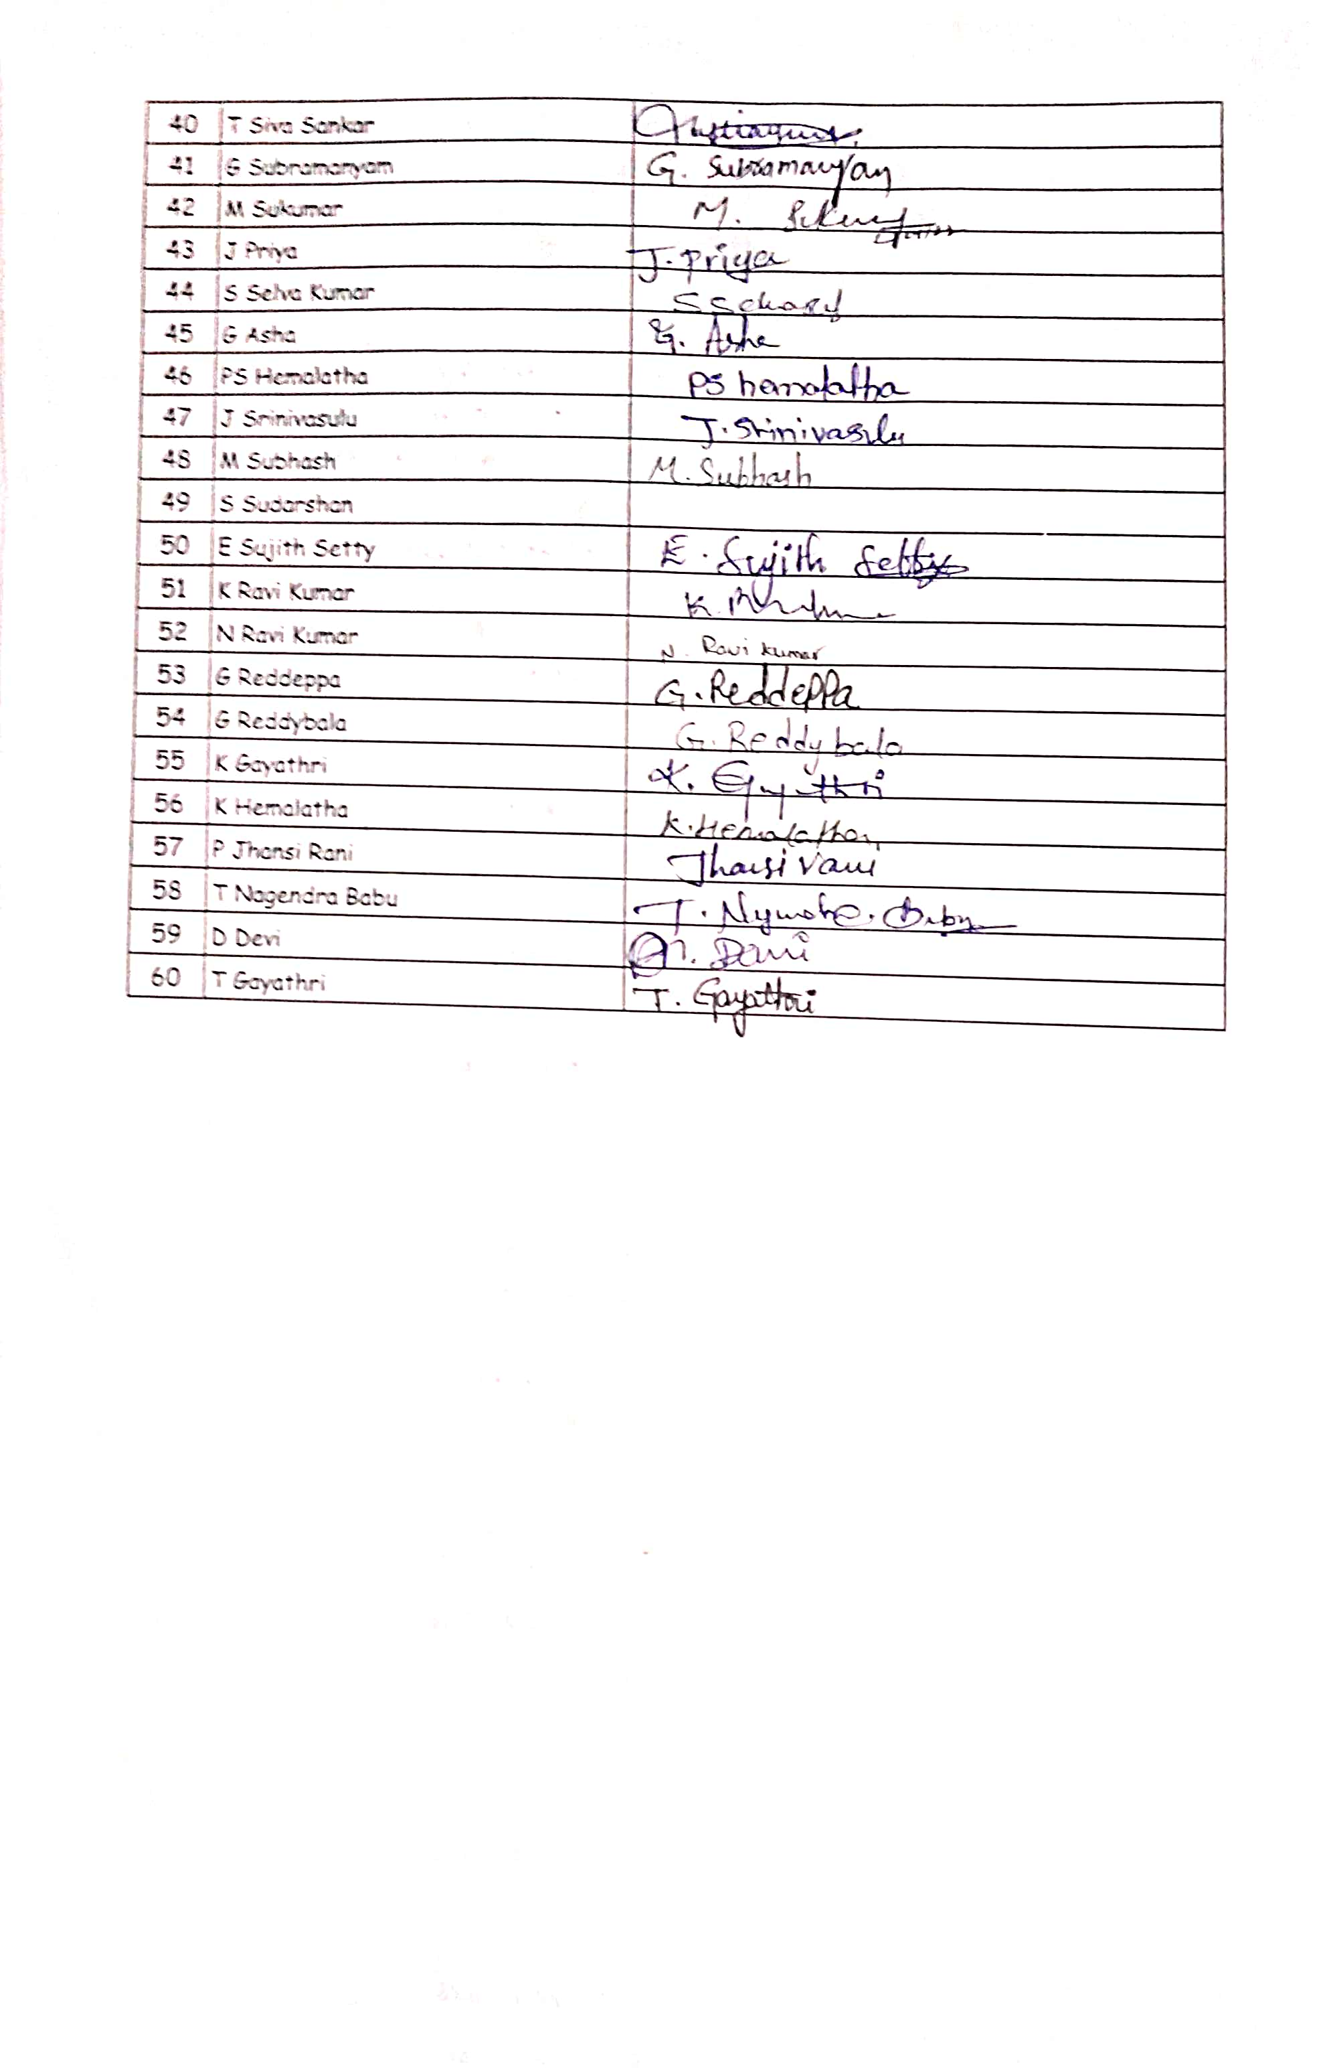
Pepper clips
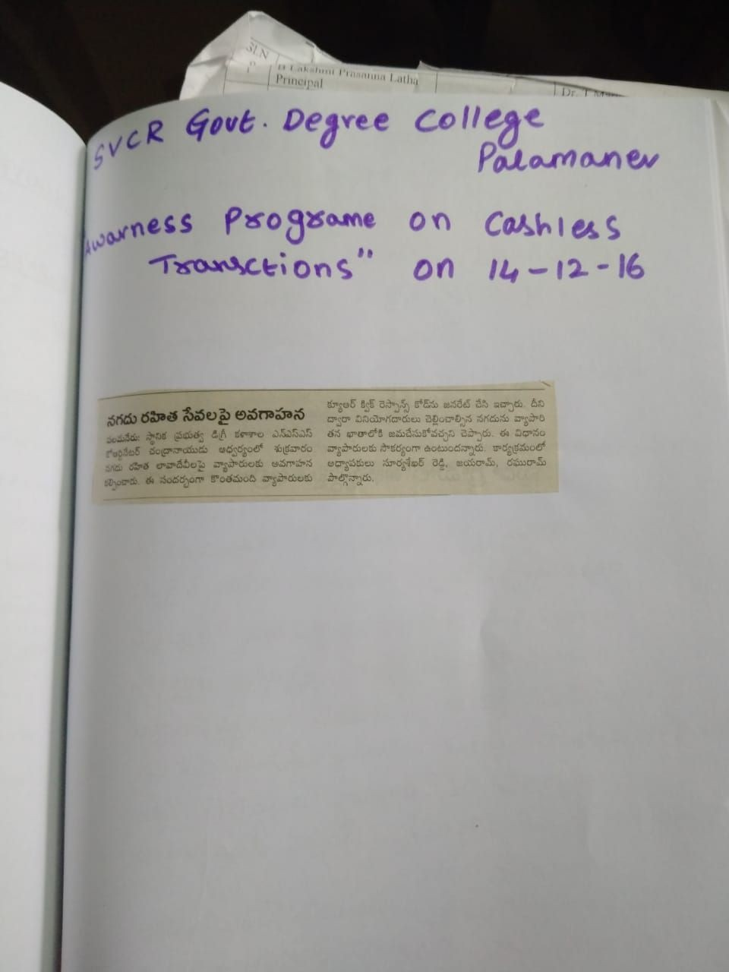
SVCR GOVT DEGREE COLLEGE
PALAMANER
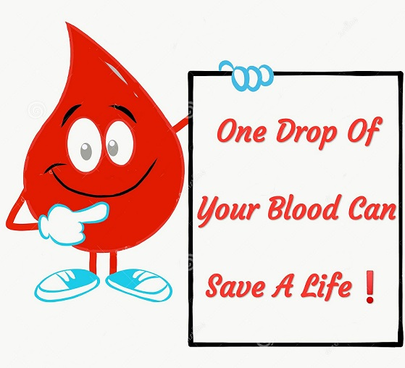
PROGRAM NAME: BLOOD DONATION CAMP
PROGRAM DATE: 28.12.2016
TIME: 09.00 AM
VENUE: SVCR GOVT.DEGREE COLLEGE, PALAMANER

SIGNATURE OF THE STUDENTS:
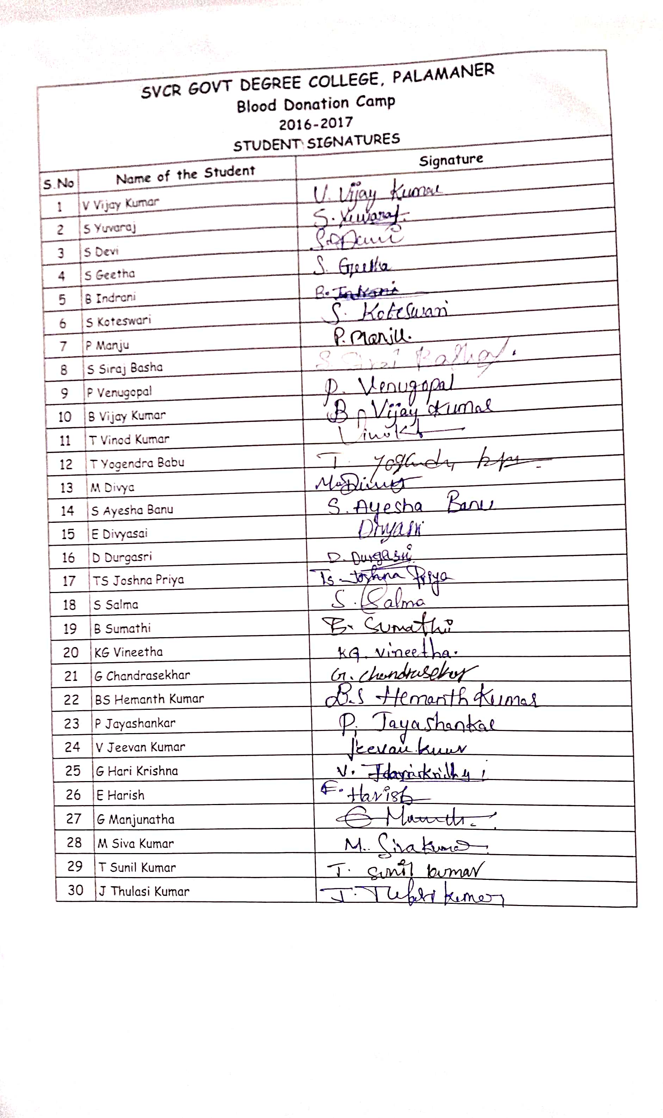

FEED BACK:
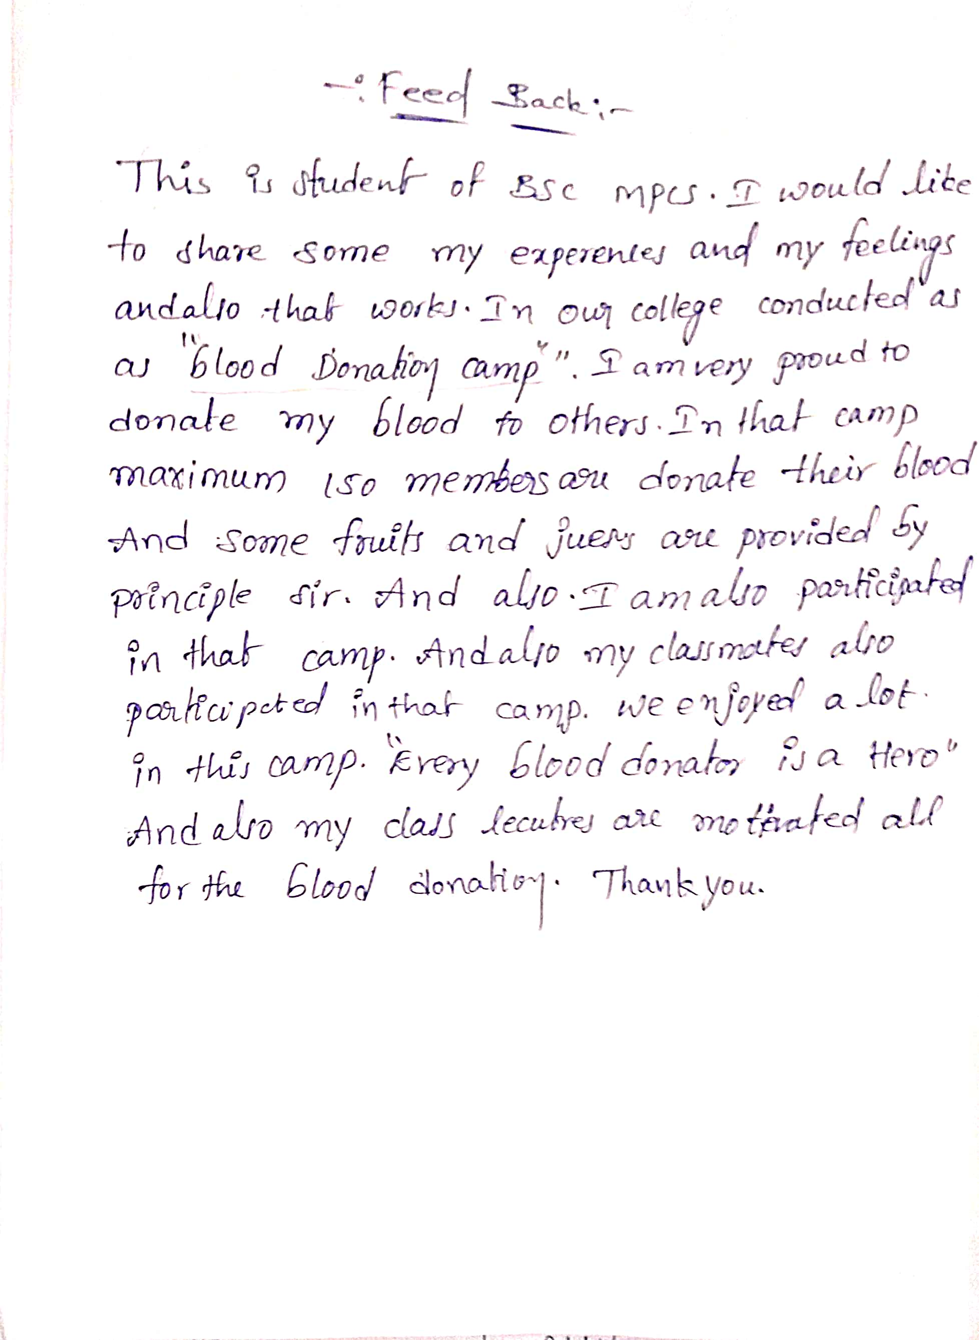

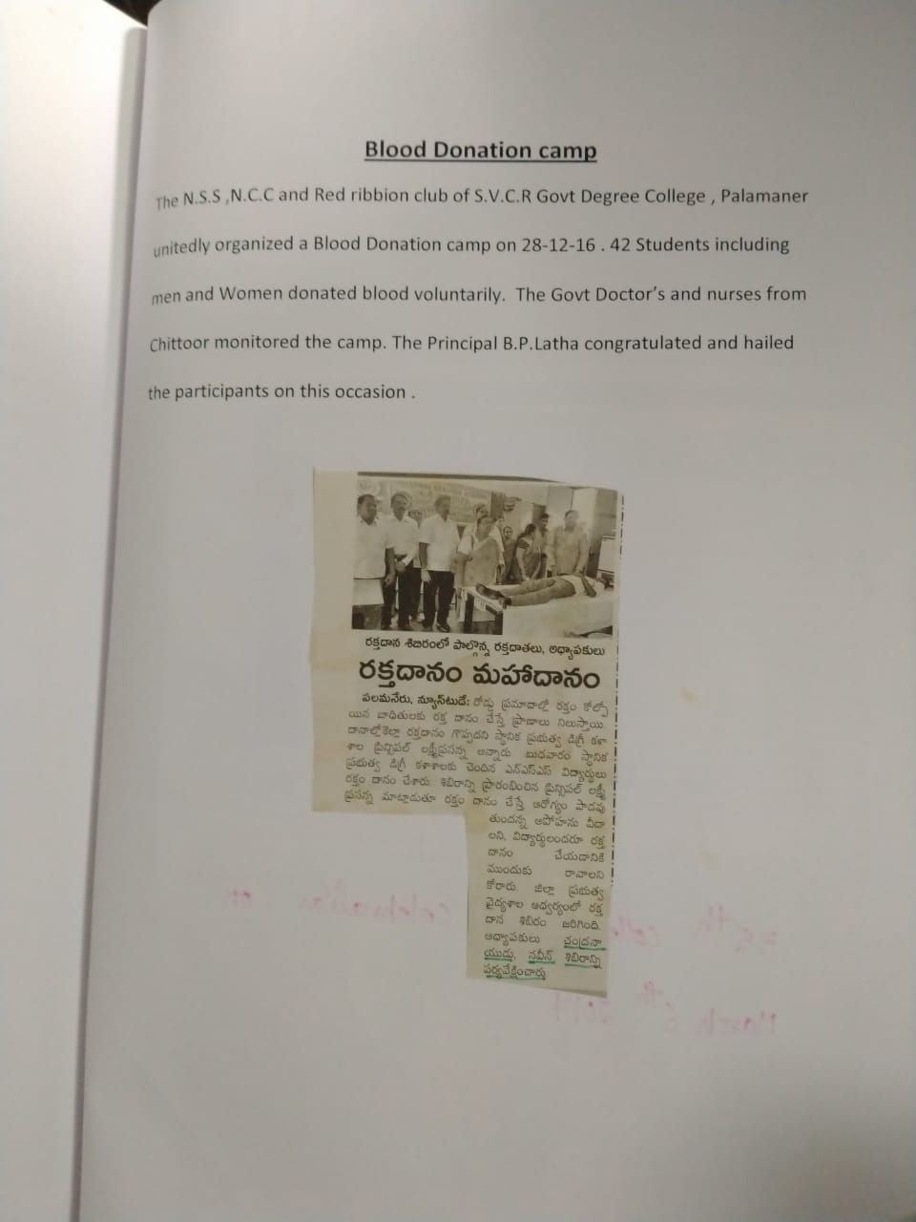
Pepper clips

PHOTOS:
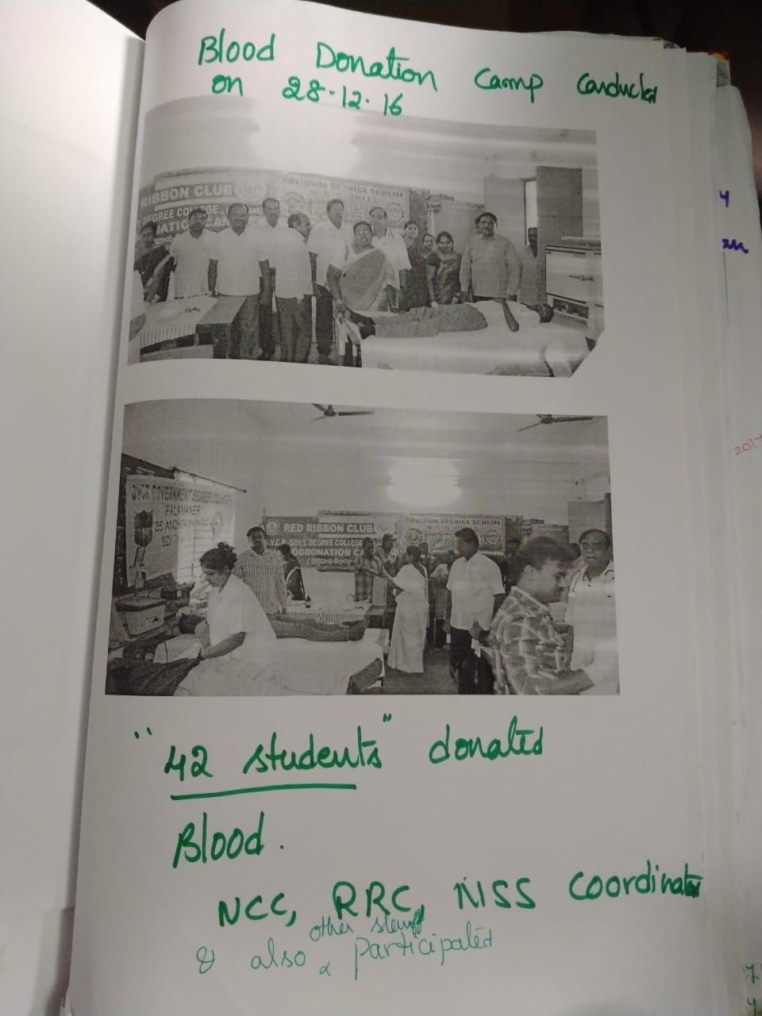

SVCR GOVT DEGREE COLLEGE
PALAMANER
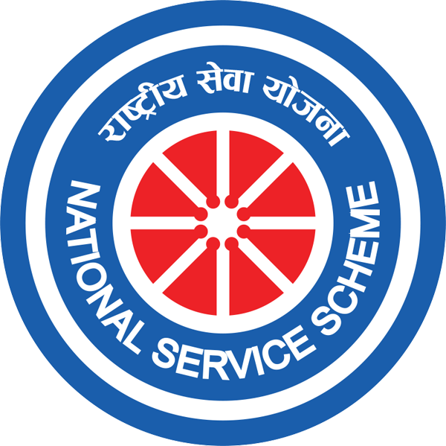

PROGRAM NAME: NSS ORIENTATION PROGRAMME
PROGRAM DATE: 04.08.2017
TIME: 09.00 AM
VENUE: VIRTUAL CLASS ROOM
RESOURCE PERSON: NSS UNIT

CIRCULAR
The NSS unit is going to organize an awareness program and enrolment on 04.08.2017 at 9.00 AM in Virtual class room. The first year students have to attend the meeting.
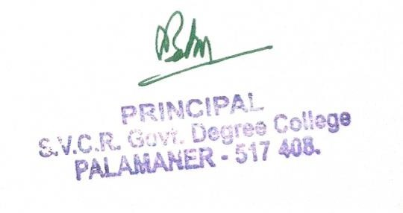

OBJECTIVE OF THE PROGRAMME:
- To enroll students into NSS.
- To explain them about the activities and the need for joining NSS.
REPORT OF THE PROGRAMME:
Enrollment drive was conducted in the month of July and enrolled 100 volunteers forthe year 2017-18. Asensitization campaign is conducted bySri. P. Bhanuprakash, NSSProgramOfficer,SVCRGovtDegreeCollege,Palamaner,tobringawarenessonNSSactivities among the newly joined students. They were invited to join NSS programme. TheNSS Programme Officer gave an idea about the motto and the symbol of NSS. They wereexplainedabouttheirdutiesinNSS,theirworkinghoursandaboutthevoluntaryinvolvementto do service to the society. Dr. P.Babu,Principalspoke about the regularactivities to be undertaken by the NSS Volunteers. The students were taken outto thefield, explained the importance of trees and motivated them to plant more trees to save thenature.Heexpressedthateveryoneshouldbethelightgiverforthedarkness.Hemotivated the Volunteers to love our country and to attend the NSS Special Camp and makeawarenessamongthevillagepeople.

OUT COME:
- The students get motivated to join the NSS.
- They get sensitized about the service in NSS activities.

SIGNATURE OF THE STUDENTS:
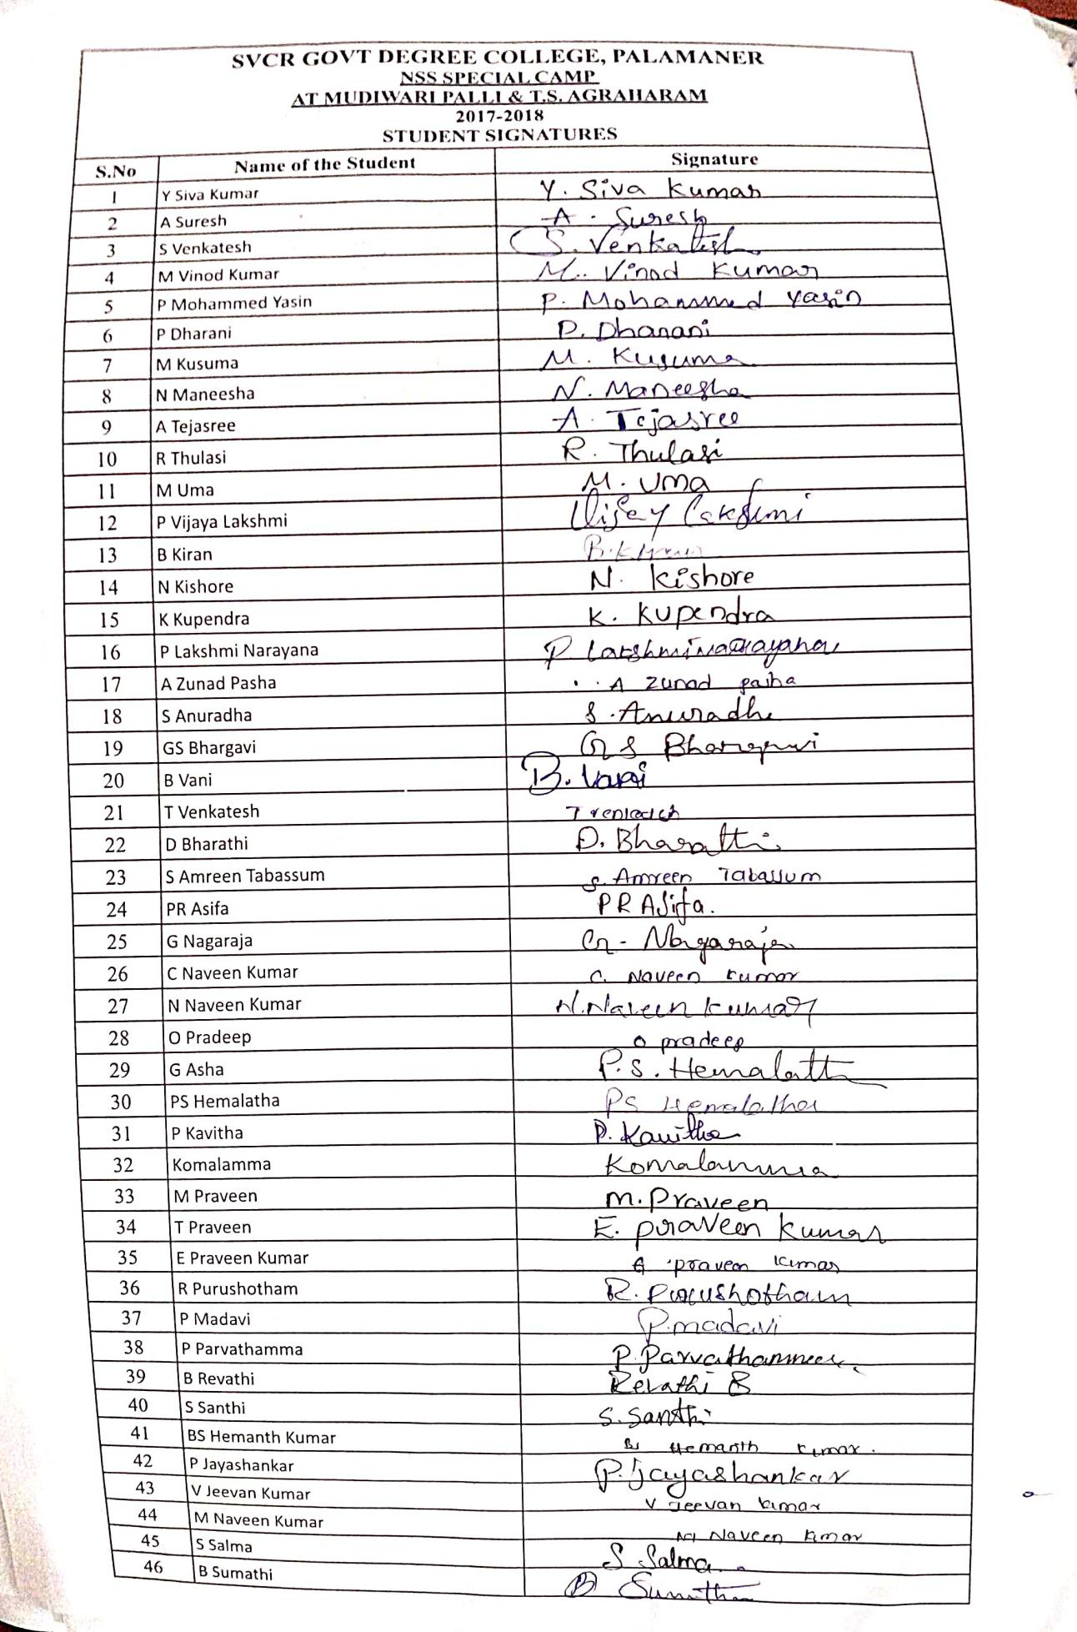
FEED BACK:
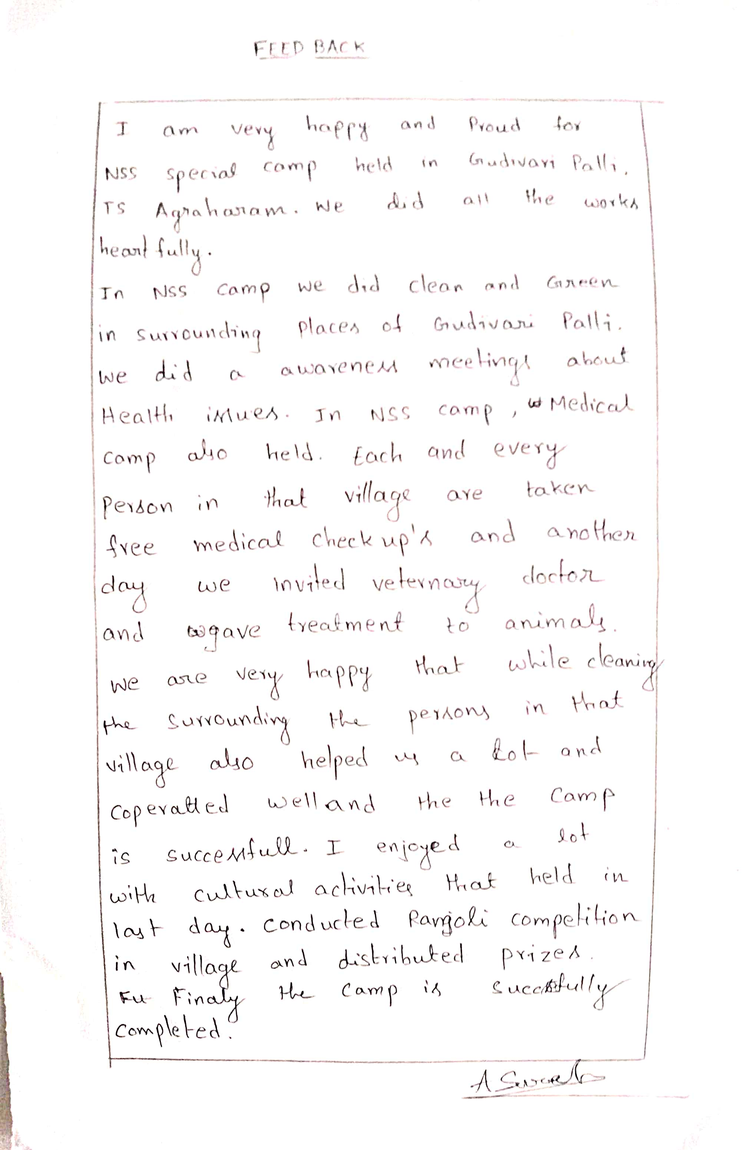
PHOTOS:
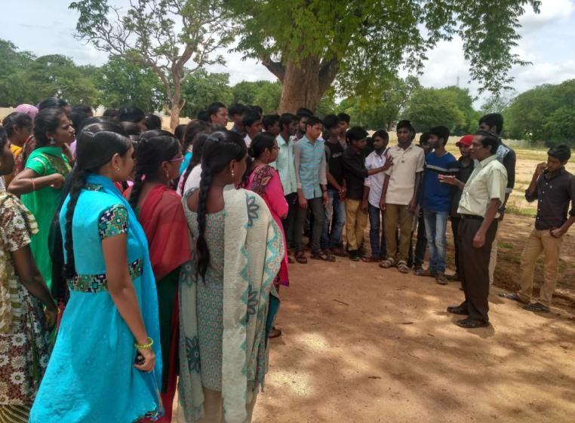
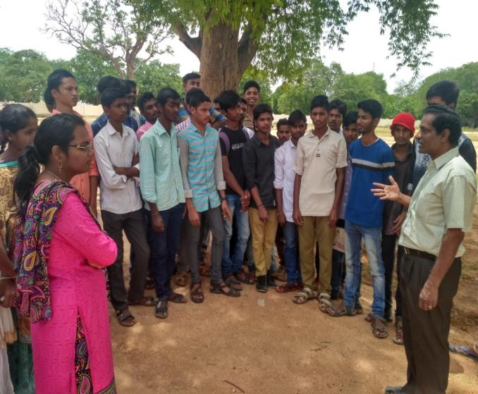
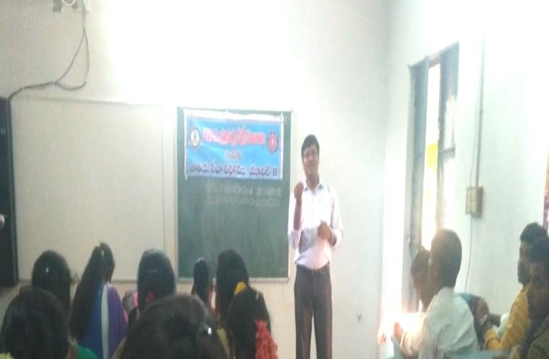
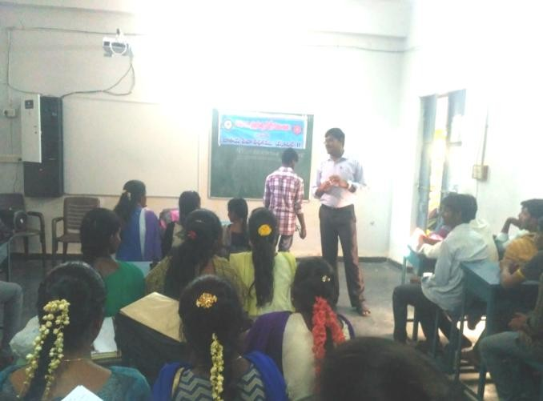

SVCR GOVT DEGREE COLLEGE
PALAMANER

PROGRAM NAME: VanamManamandCampusCleaning
PROGRAM DATE: 05.08.2017
TIME: 09.00 AM
VENUE: COLLEGE GROUND
RESOURCE PERSON: NSS UNIT

CIRCULAR
This is to inform all the students and the staff tomorrow (05.08.2017) our college is going to conduct VanamManam-SaplingPlantationProgramme. All the staff have to attend along with their students. The program is conducted as per the orders of the Government of Andhra Pradesh.

OBJECTIVE OF THE PROGRAMME:
To make the campus clean and green.
REPORT OF THE PROGRAMME:
NSSUnitofthecollegeorganizedVanamManam-TreePlantationprogrammeon5thAugust2017. ThePrincipal,NSSProgrammeOfficer,Teaching,Non-teachingstaff,NSS volunteers and students have actively participated inthe plantation programme. We have planted various types ofsaplingslikeGulmohar,Teak,Badam,Neem,Pongamia,Gangireni etc. A total number of 69 saplings were planted inthecollegecampus.

OUT COME:
The saplings are planted and taken care of.

SIGNATURE OF THE STUDENTS:
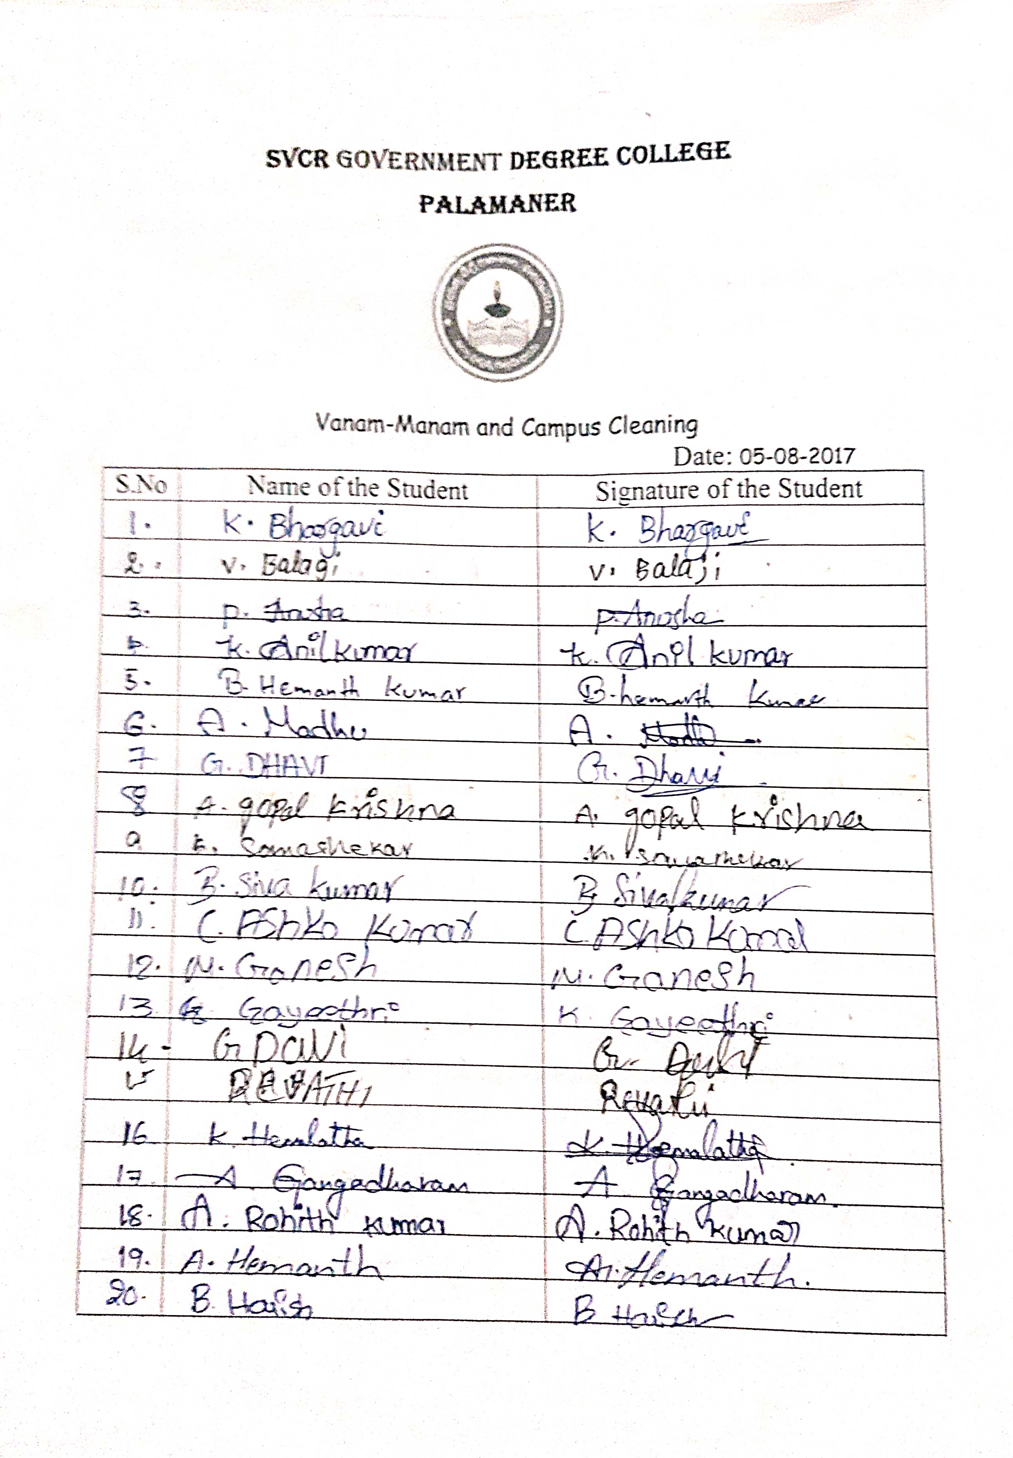

FEED BACK:
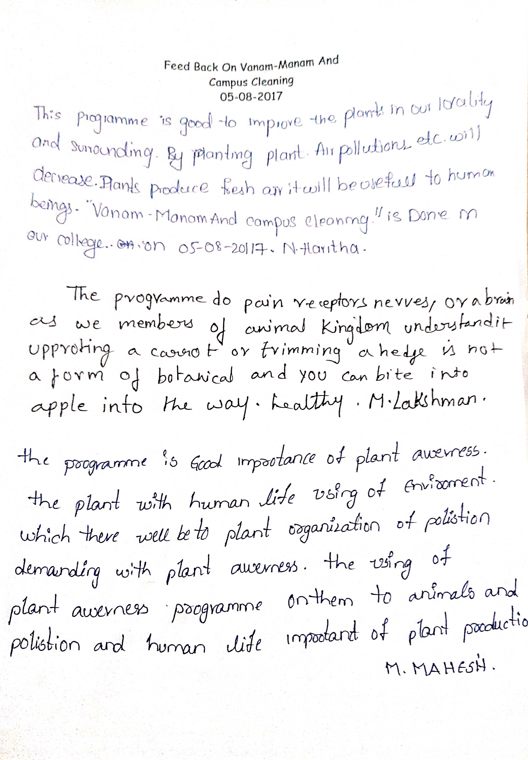
PHOTOS:
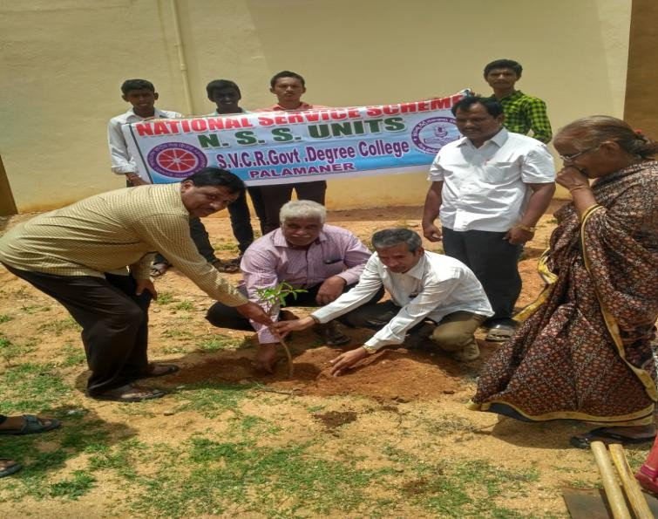
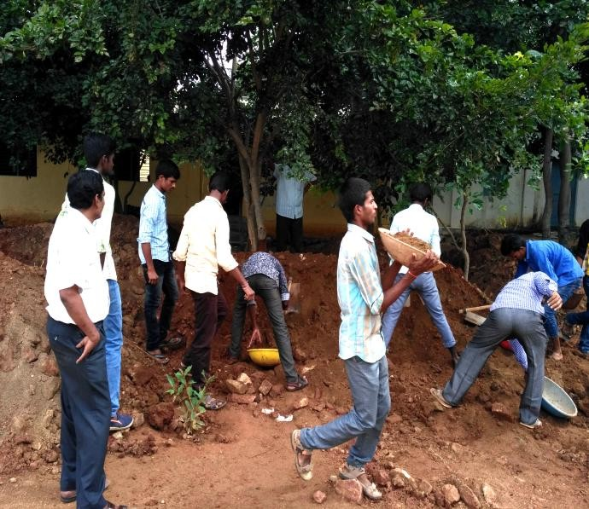
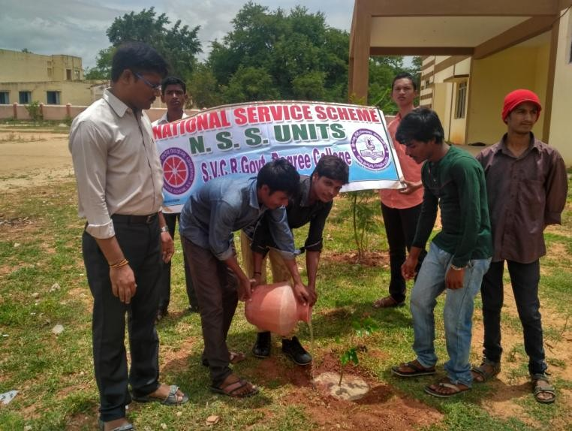
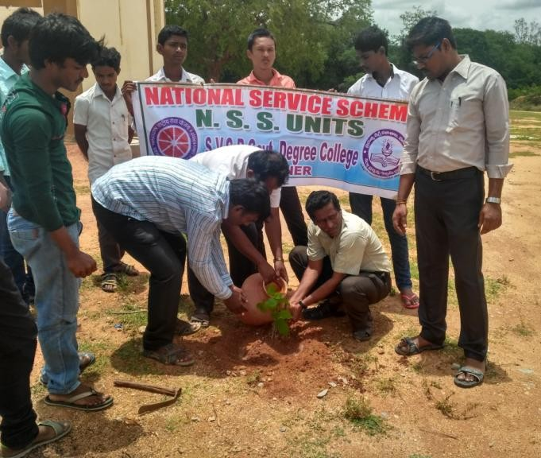

SVCR GOVT DEGREE COLLEGE
PALAMANER

PROGRAM NAME: AWARENESS PROGRAMME ON ROAD SAFETY MEASURES
PROGRAM DATE: 07.08.2017
TIME: 09.00 AM
VENUE: VERANDA
RESOURCE PERSON: DEPARTMENT OF POLICE PALAMANER

CIRCULAR
This is to inform all the students and the staff that an awareness program on Road Safety Measures is going to be conducted by the Department of Police, Palamaner in the college on 07.08.2017. The classes in charges have to bring their students to the verandah of the ground floor for the meeting.

OBJECTIVE OF THE PROGRAMME:
The main objective of the program is to reduce accidents and to promote safety culture in the students.
REPORT OF THE PROGRAMME:
AsapartofNSSRegularactivities,NSSUnitofthecollegeorganizedAwarenessProgramme on Road Safety Measures on 7th August 2017 in the college. The Chief Guest ofthe programme was Sri. Surendra Reddy, Circle Inspector, Palamaner. He created awarenessamong the students and NSS Volunteers about road safety and the measures that are to betaken to avoid roadaccidents. Sri.Rambhoopal,Sub-Inspector of Police,Palamaner askedthe students to come up with new ideas to stop road accidents. We conducted Debate andEssay writing competition on “Road safety measures” to aware the students of the collegeregarding various safety measures that should be adopted while driving the vehicles on theroad.Prizesweregivenforthewinnersofthecompetition.

OUT COME:
- The students get awareness on the safety driving measures.
- They learnt the punishments for rash and reckless driving.

SIGNATURE OF THE STUDENTS:
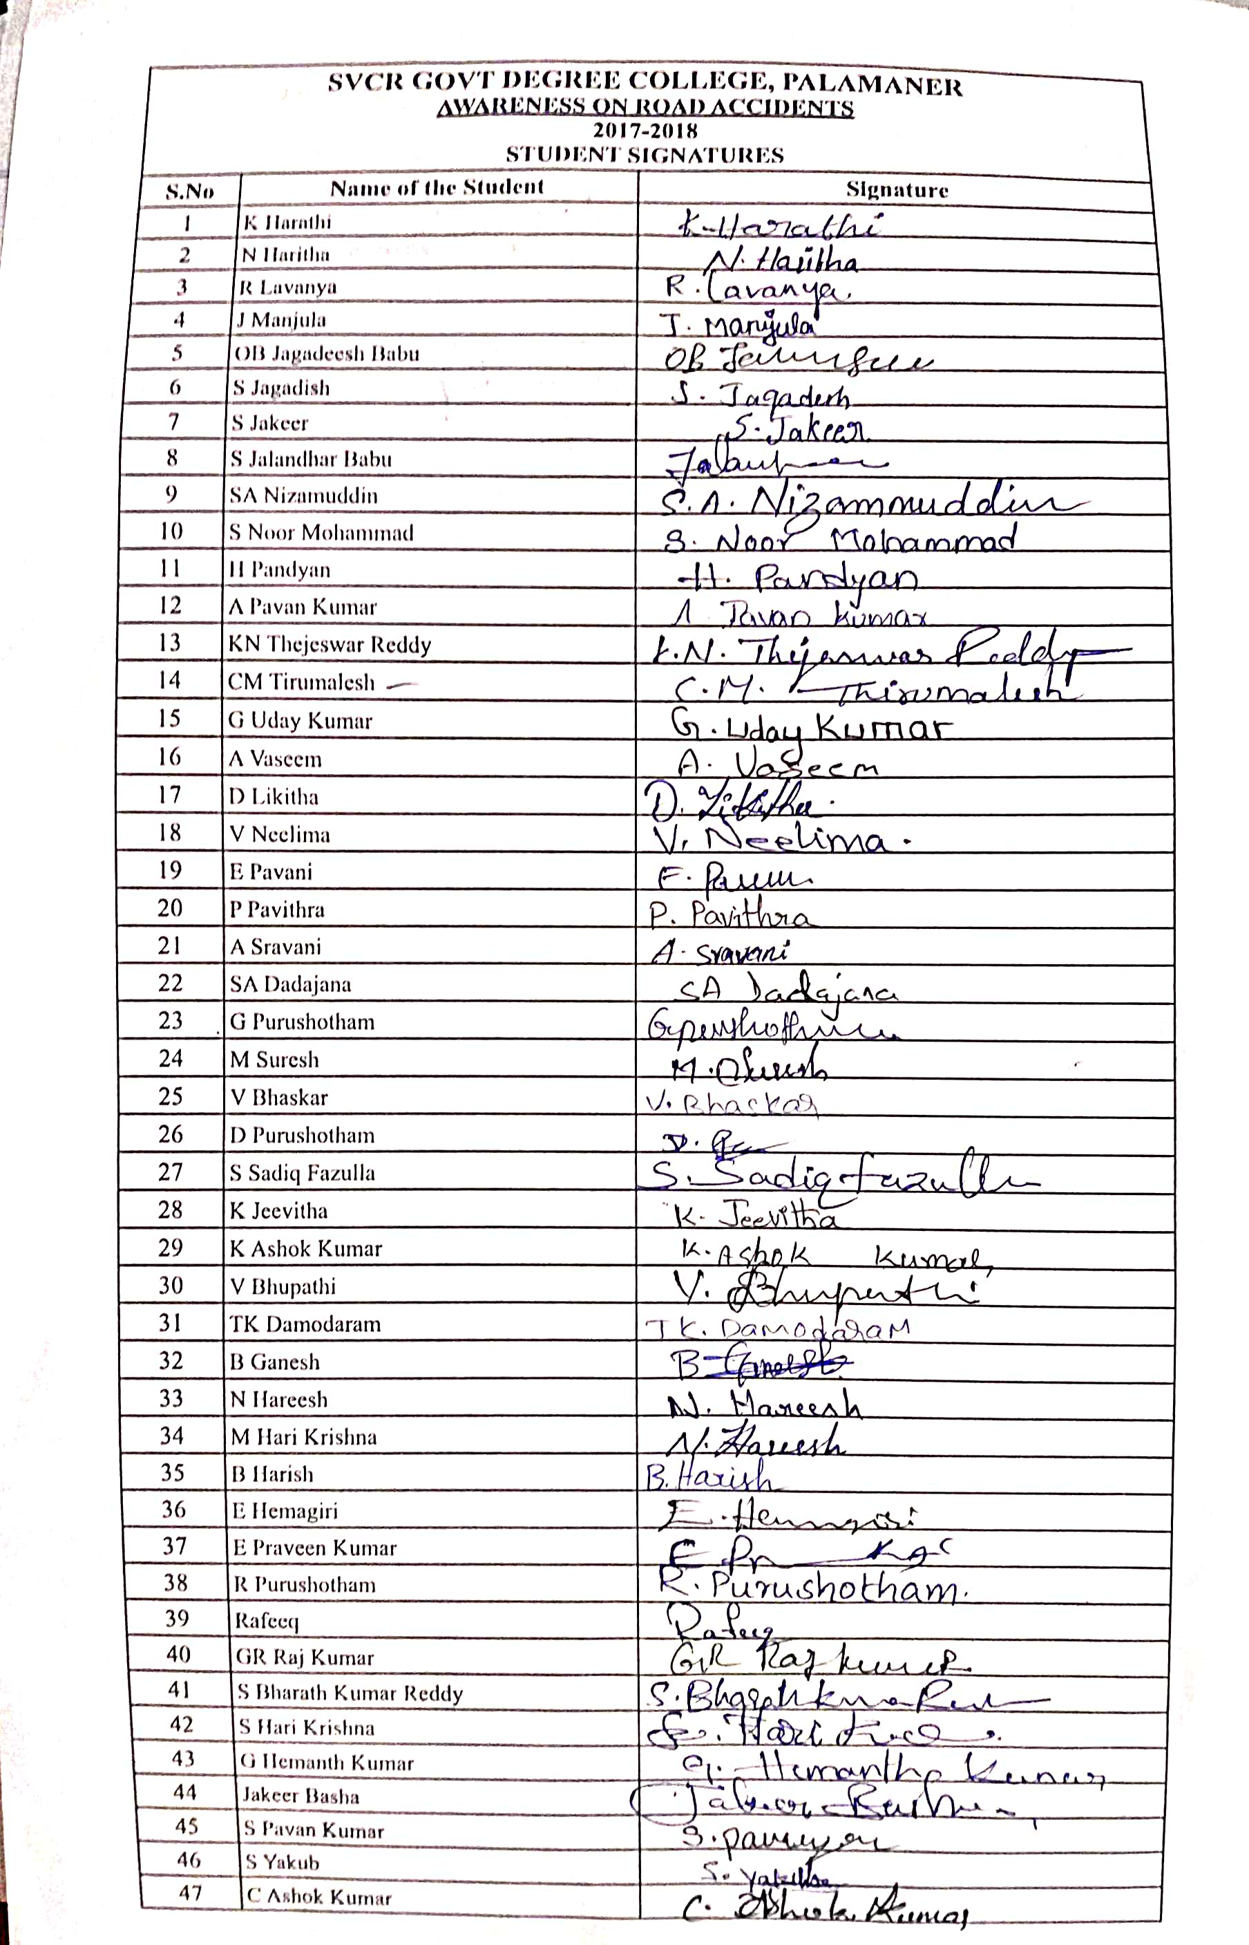

FEED BACK:
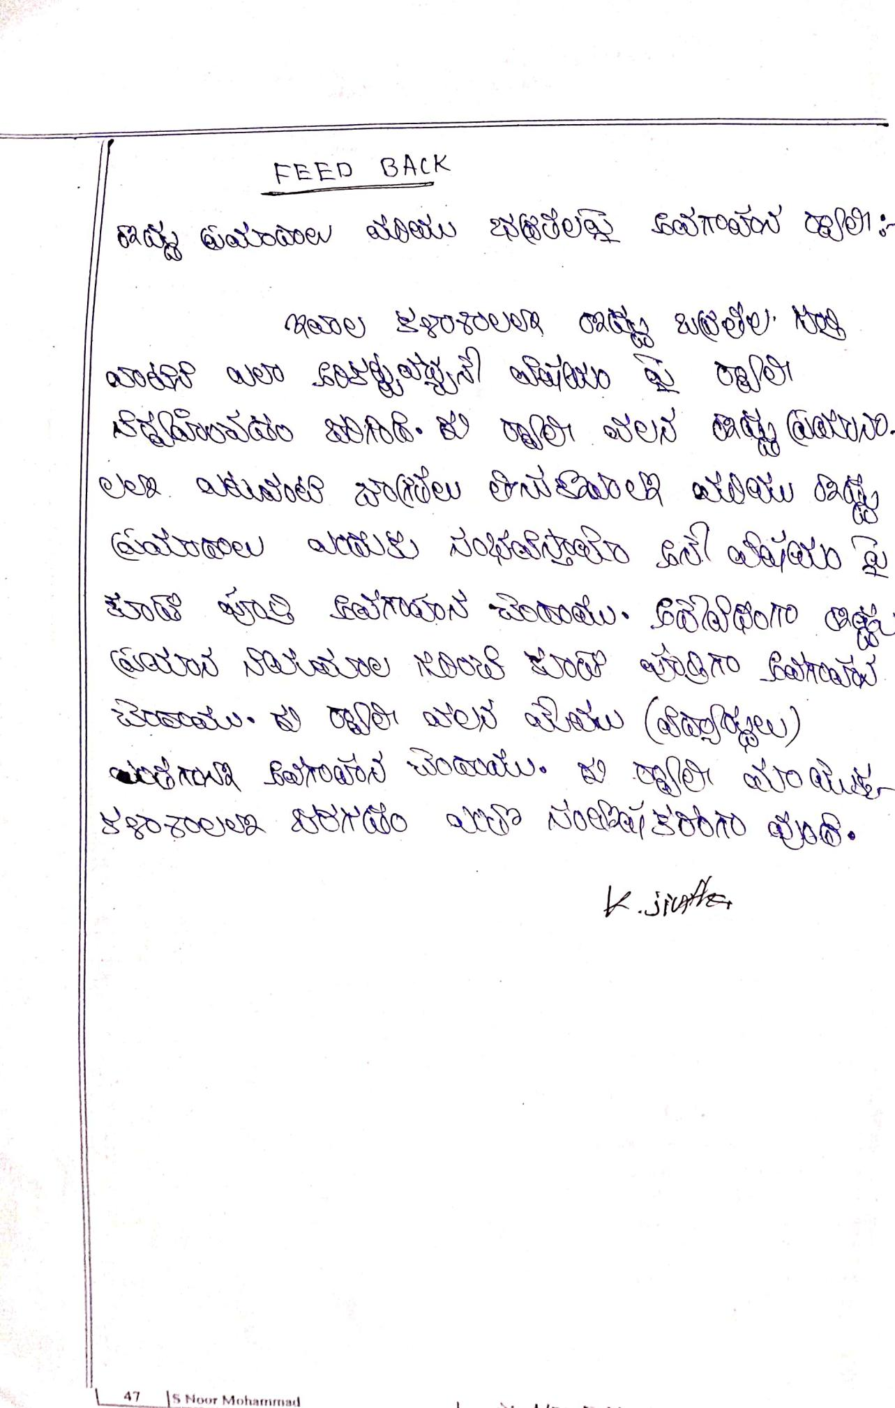
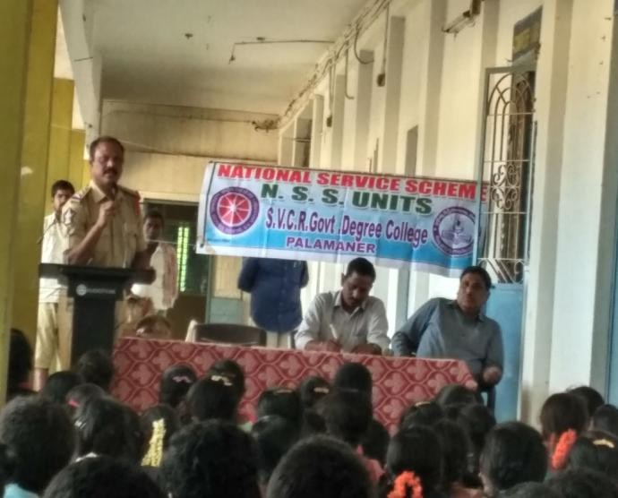
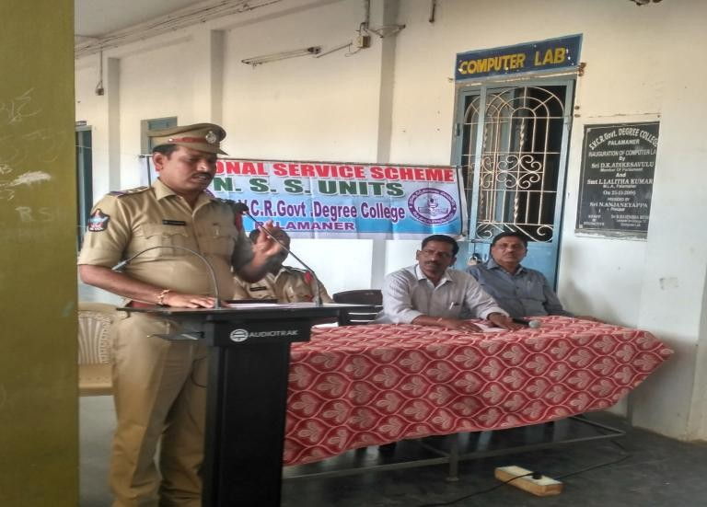
PHOTOS:
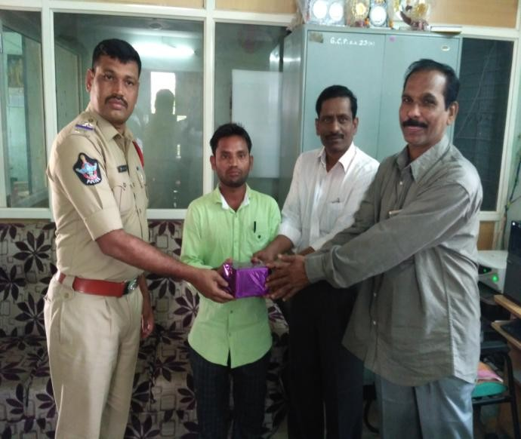
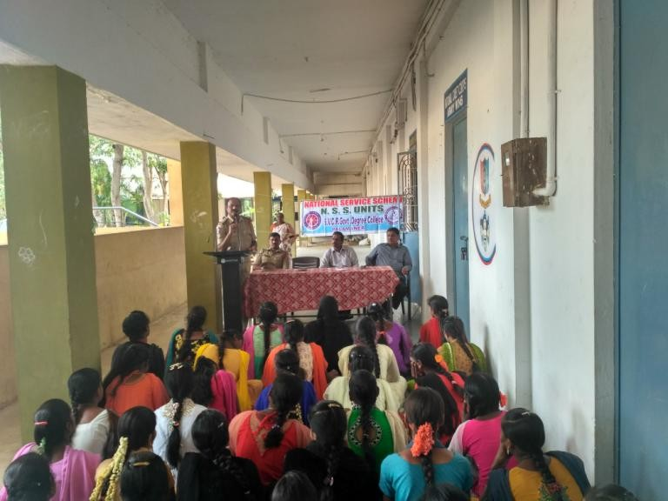

SVCR GOVT DEGREE COLLEGE
PALAMANER

PROGRAM NAME: VanamManam-SaplingPlantationProgramme
PROGRAM DATE: 11.08.2017
TIME: 09.00 AM
VENUE: COLLEGE GROUND
RESOURCE PERSON: NSS UNIT

CIRCULAR
This is to inform all the students and the staff tomorrow (11.08.2017) our college is going to conduct VanamManam-SaplingPlantationProgramme. All the staff have to attend along with their students. The program is conducted as per the orders of the Government of Andhra Pradesh.

OBJECTIVE OF THE PROGRAMME:
To make the campus clean and green.
REPORT OF THE PROGRAMME:
NSS Unit of the college organized Vanam Manam-Sapling PlantationProgramme on 11th August 2017. NSS Programme Officer, TeachingStaff and NSS volunteers were in the plantation programme. WehaveplantedvarietyofsaplingslikeGulmohar,Teak,Neem,Pongamia,Pippala,Badam,Gangirenietc.Atotalnumberof59saplings were planted in the college campus. We have watered all theplantedsaplings.

OUT COME:
The saplings are planted and are taken care of.

SIGNATURE OF THE STUDENTS
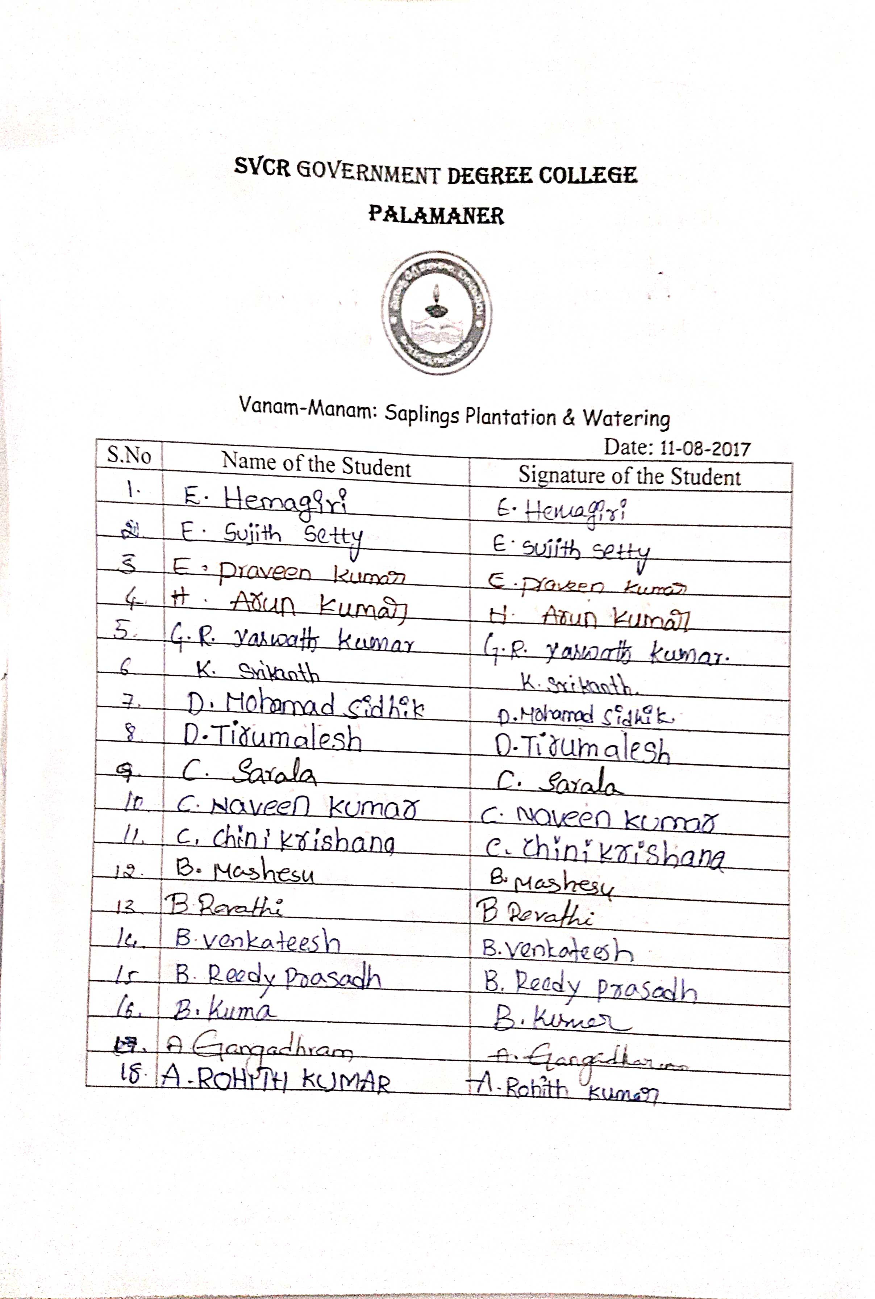
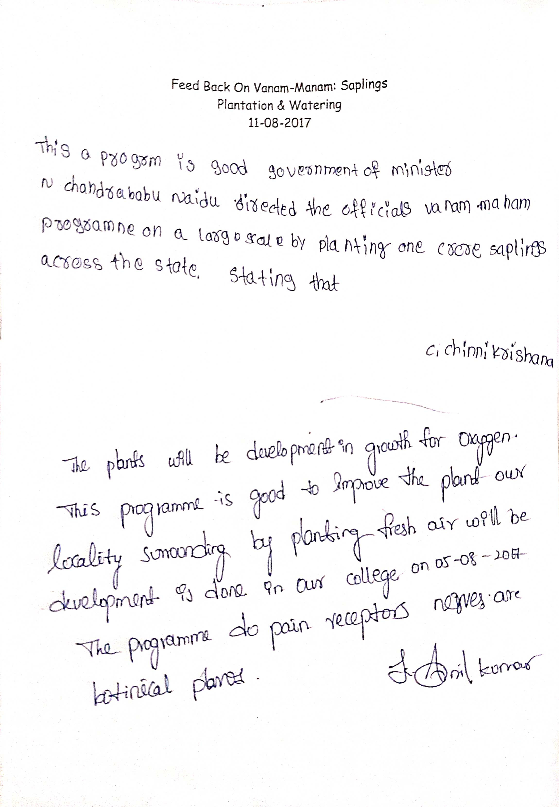
FEED BACK:

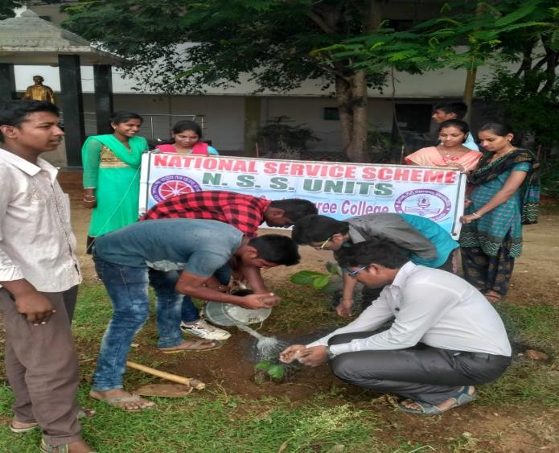
PHOTOS:
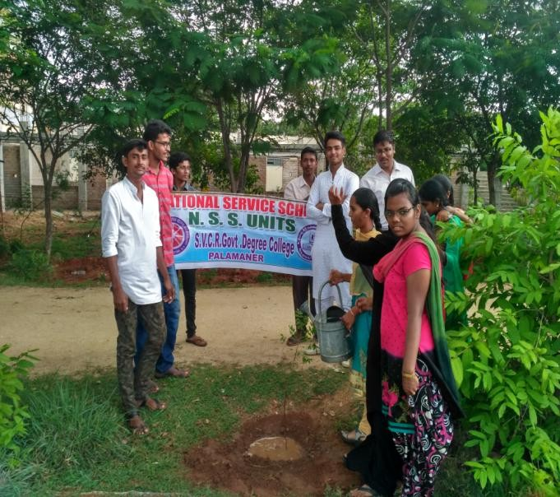
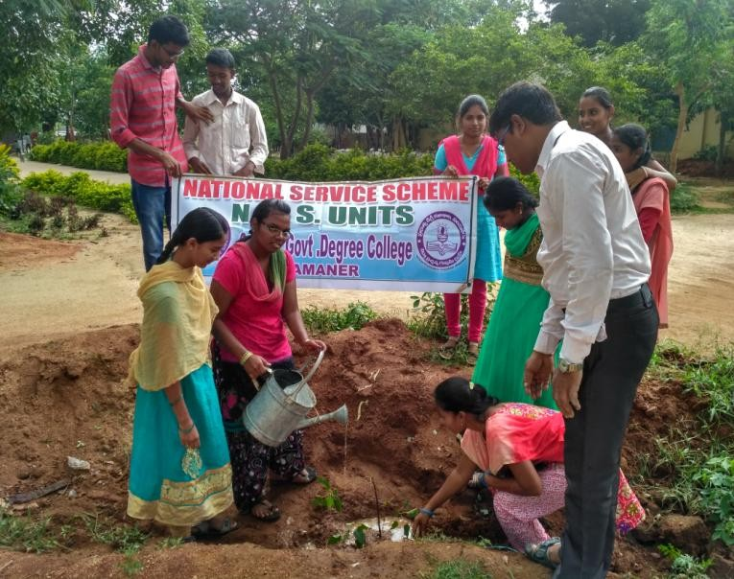
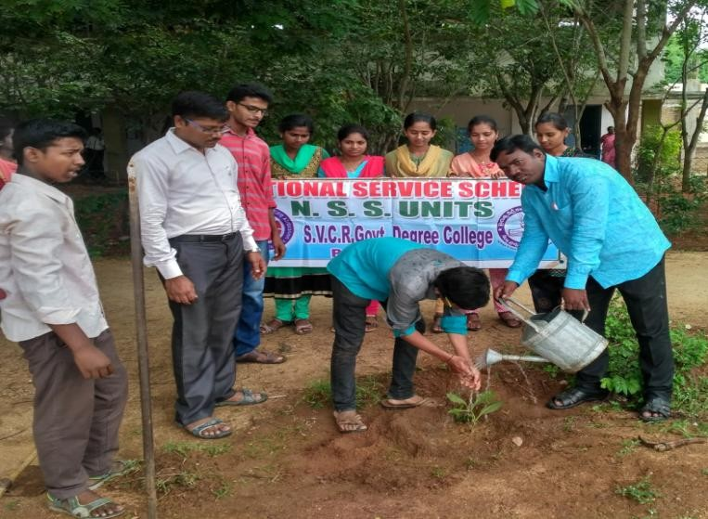

SVCR GOVT DEGREE COLLEGE
PALAMANER

PROGRAM NAME:AWARENESSRALLYON“IMPORTANCEOFTREEPLANTATION
PROGRAM DATE: 19.08.2017
TIME: 10.00 AM
VENUE: COLLEGE GROUND
RESOURCE PERSON: FOREST DEPARTMENT

CIRCULAR
The Department of Forests is going to conducted sapling plantation under the title Vanam – Manam in the college on 19.08.2017. The NCC and NSS volunteers and the staff have to participate in the work without disturbing the class work.

OBJECTIVE OF THE PROGRAMME:
- To make college a green campus.
REPORT OF THE PROGRAMME:
NSS Unit of the college in association with Forest Department, Palamaner organized VanamManam-Sapling PlantationProgrammeon 19th August 2017.TheNSSvolunteers,Collegestaff and Staff of Forest Department together planted fruit bearing saplings like Badam,Allaneredu, Jack fruit, Guava, Pomegranate at different places inside the campus. We havewatered all the planted saplings. Later, the NSS Unit took out a rally creating awarenessamong the public about the Importance of Tree Plantation. This rally was inaugurated by Sri.Madhan MohanReddy,ForestRangeOfficerandSri.Krishnamandhadi,ForestSectionOfficer, Palamaner. NSS Volunteeers rallied out from campus to Gudiyatham Cross road bygiving slogansrelatedtoimportanceoftreesplantation toprotectenvironment.

OUT COME:
- A huge number of saplings have been planted.
SIGNATURE OF THE STUDENTS:
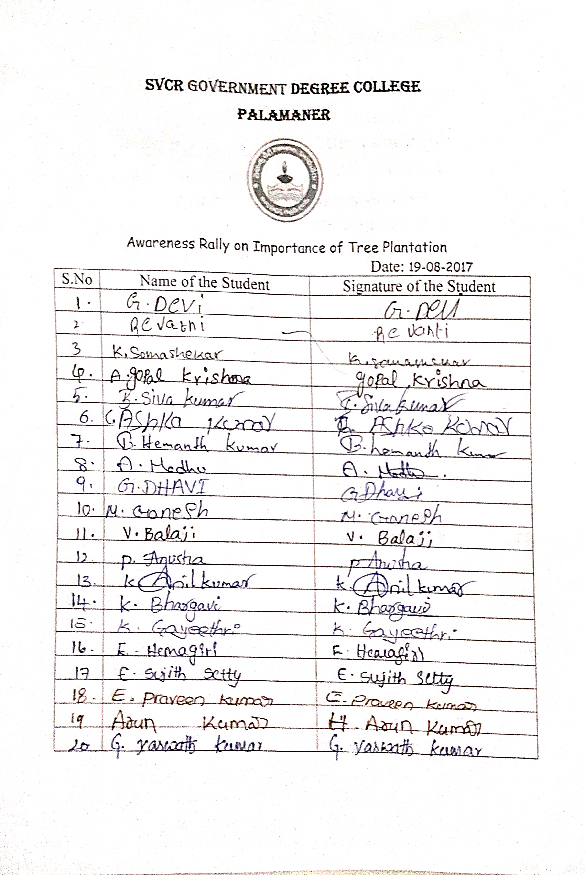

FEED BACK:
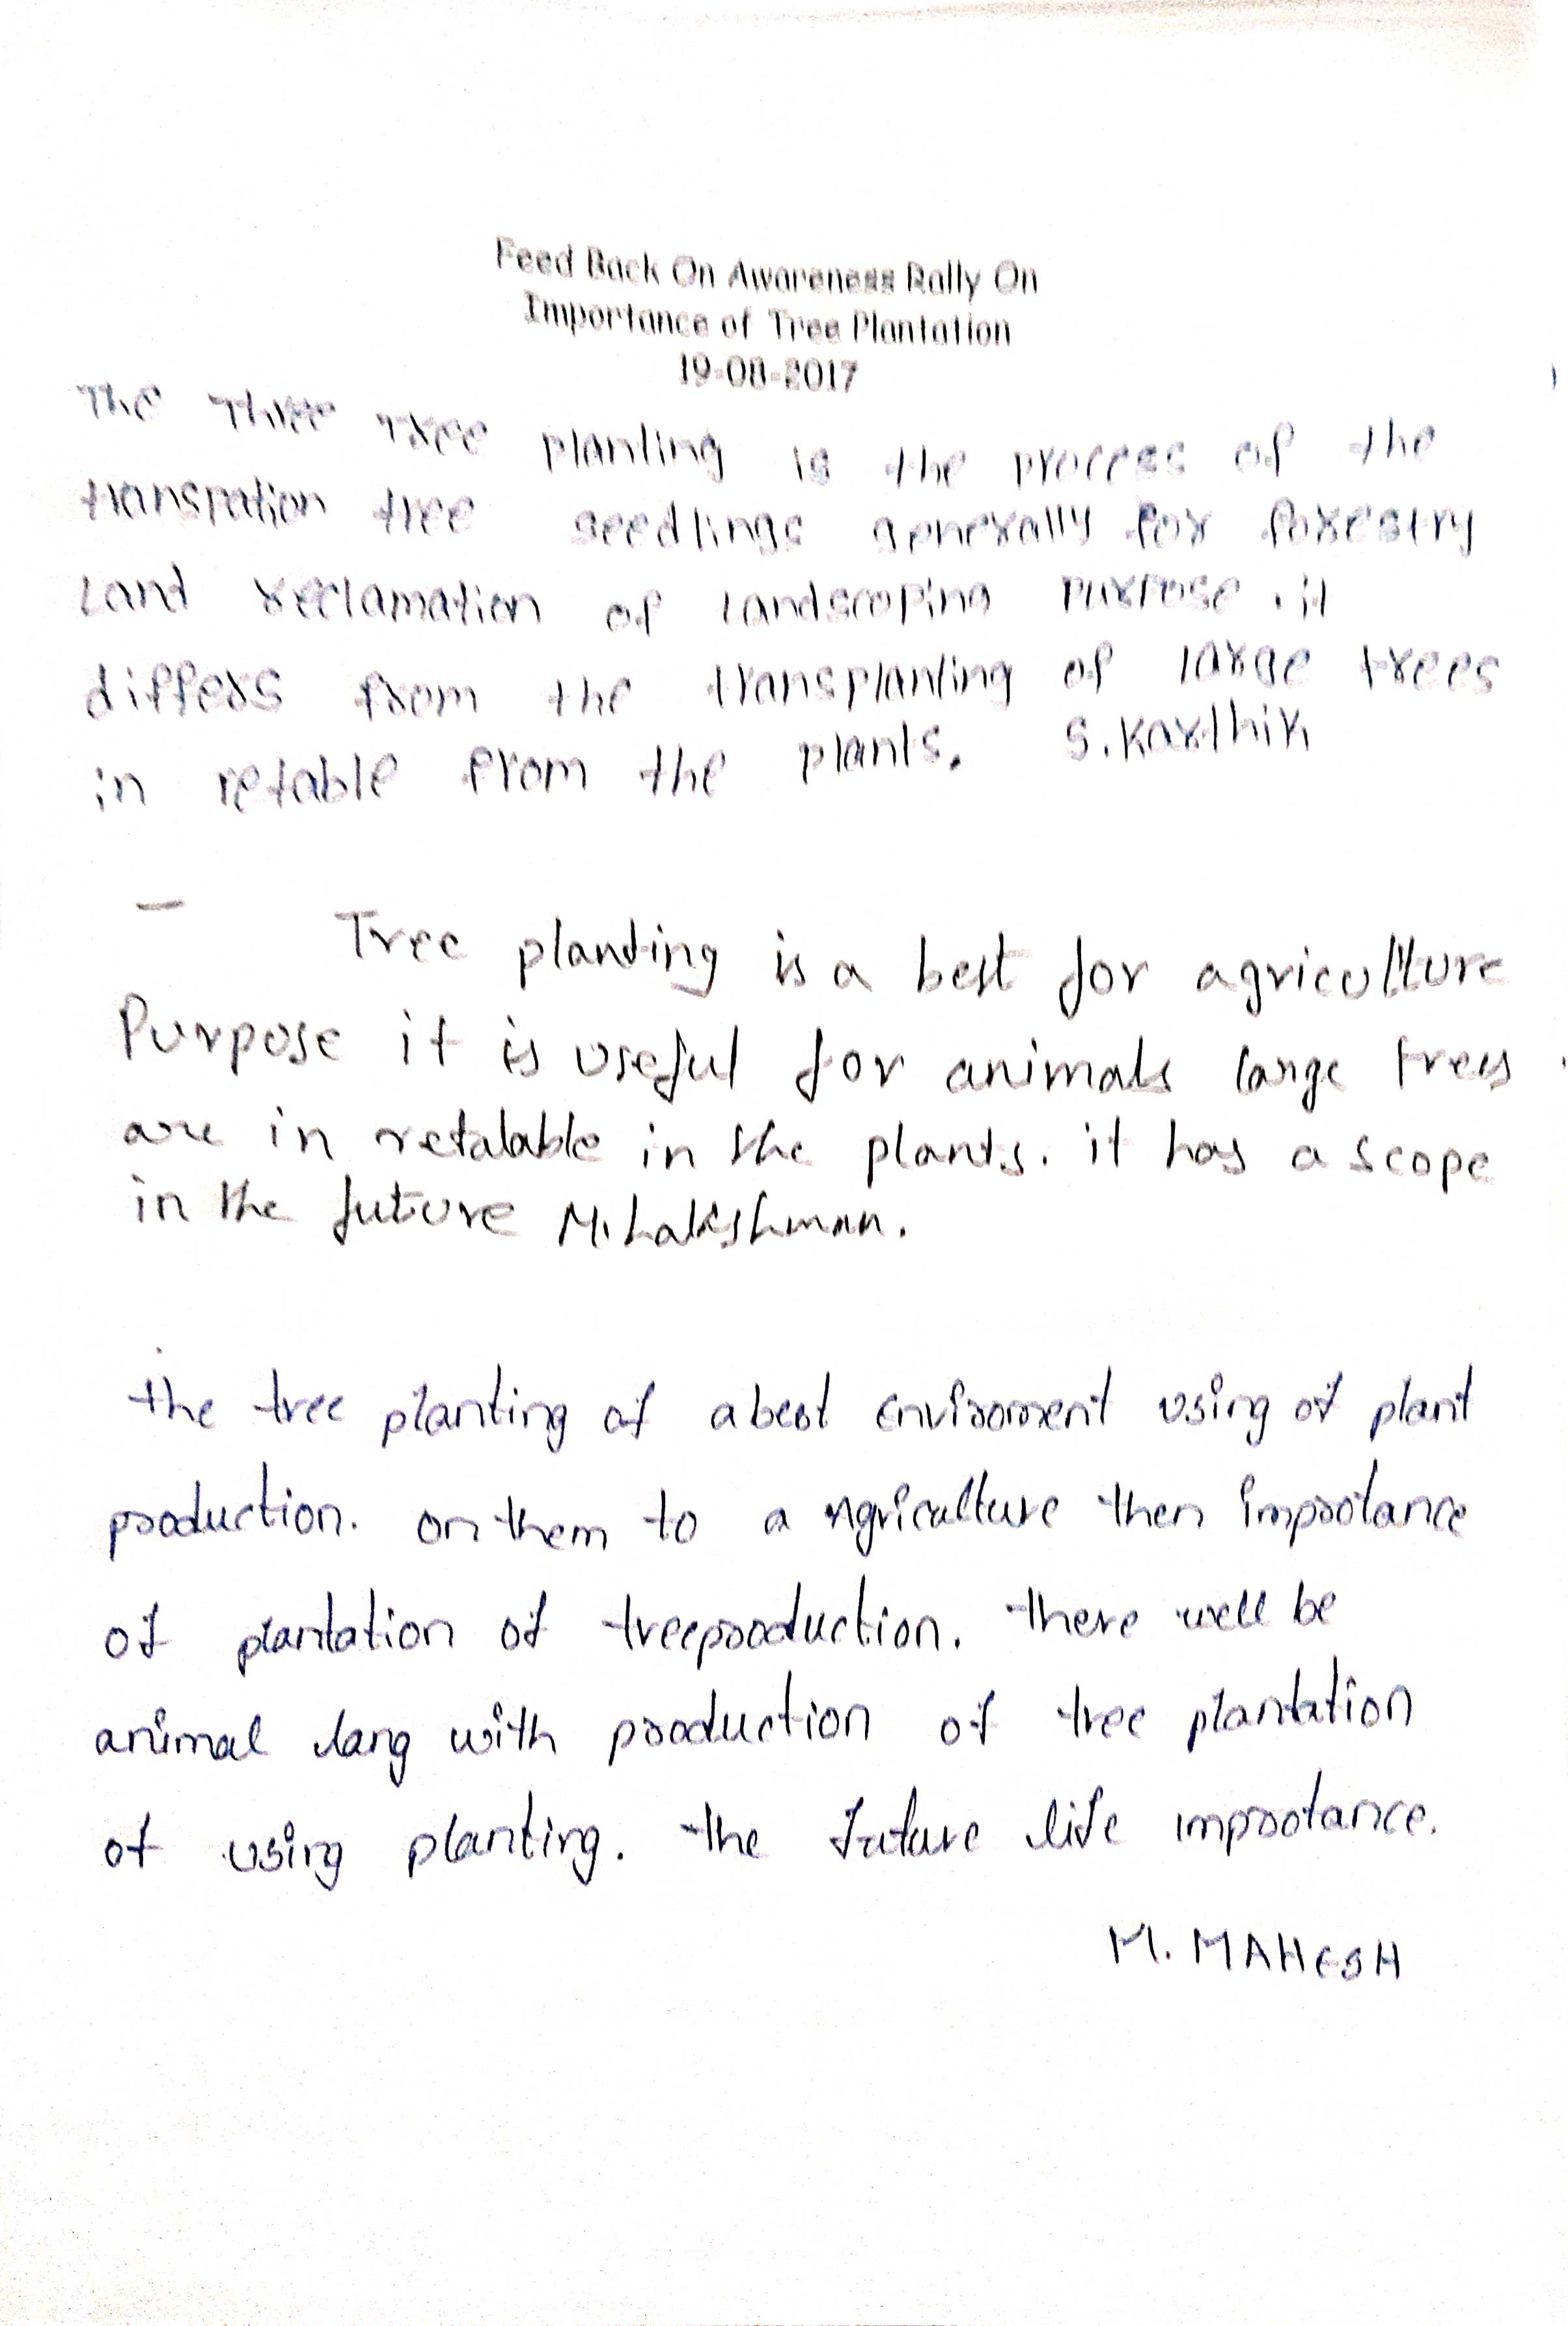
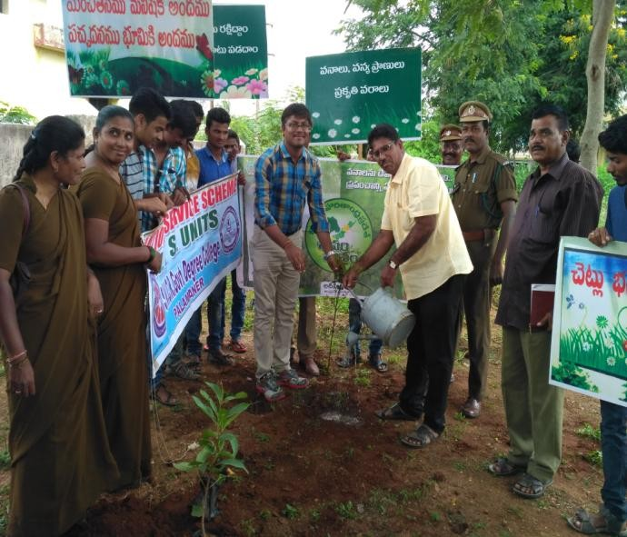
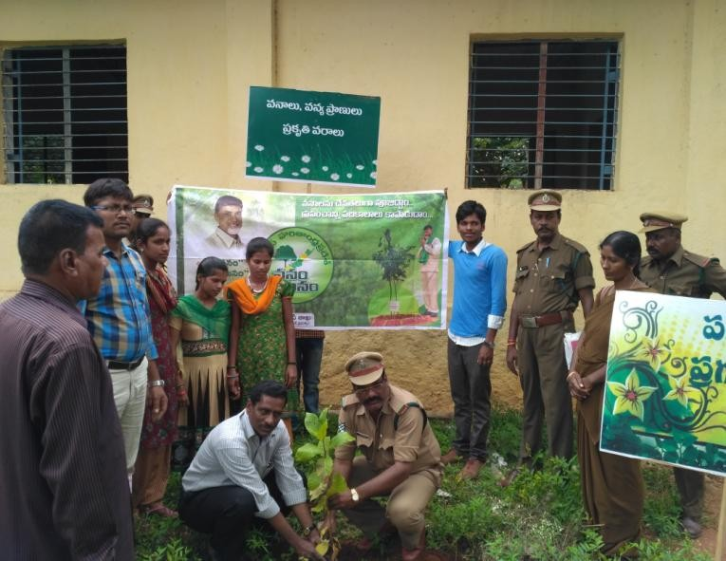
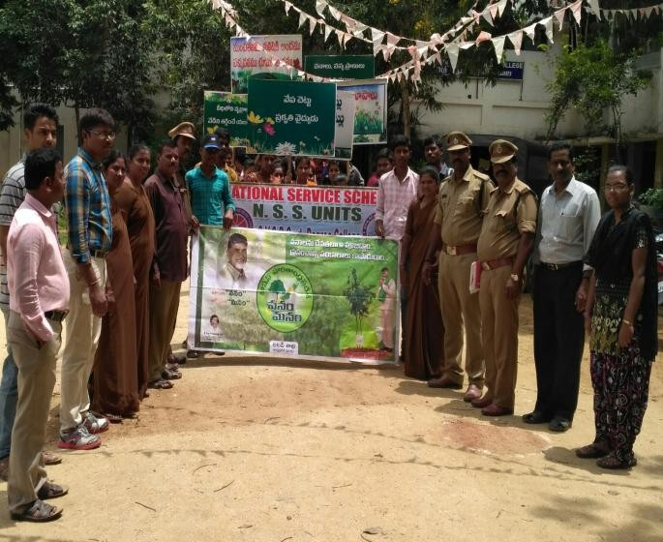
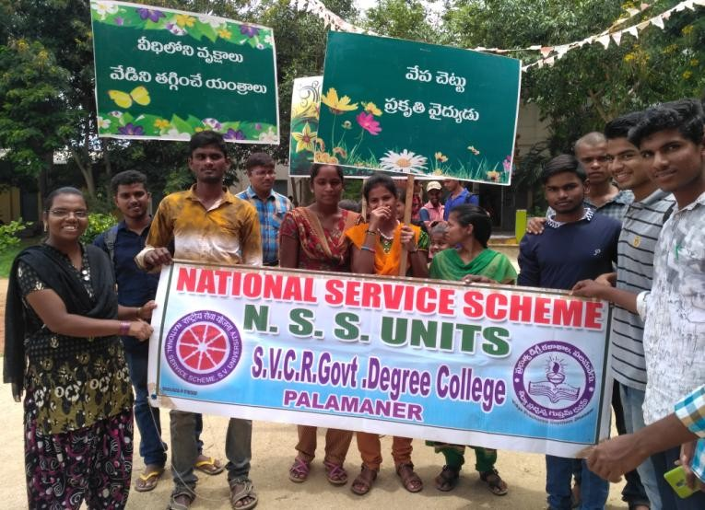
PHOTOS:

SVCR GOVT DEGREE COLLEGE
PALAMANER

PROGRAM NAME: GoGreen GaneshaRally
PROGRAM DATE: 24.08.2017
TIME: 09.00 AM
VENUE: ON ROAD
RESOURCE PERSON: COLLEGE STAFF

OBJECTIVE OF THE PROGRAMME:
The objective of the program is to stop pollution in the water resources and to promote eco friendly festivals.
REPORT OF THE PROGRAMME:
NSSUnitofourCollegeorganizedarallywiththename“GoGreenGanesha(GGG)”on 24th August i.e., before the day of Ganesha festival to create awareness in the public to useonly unpainted clay idols or natural dyes painted idols for pooja instead of Plaster of Paris(P0P) idols in order to protect our environment. This rally was inaugurated by Dr. P.Babu,Principal, SVCR GDC, Palamaner. NSS volunteers rallied with displaying Green Ganesha idol.They rallied by giveing slogans to go for Green Ganesha along with placards showing theharmfuleffectsofPlasterofParisidolsontheenvironment.Thisrallyhadinitiatedenvironmental concern among NSS volunteers and public in Gudiyatham road, Police stationroad and Venugopala Swamy street areas of Palamner town. The Principal, NSS ProgrammeOfficer,Teaching,Non-teachingstaff,NSSvolunteersandstudentshaveactivelyparticipatedintherallytoshowtheirconcerntowardsenvironment

OUT COME:
- The slogans of the students made the public to think about clay Ganesha idols for making the water resources pollution free.
- The students carries this message to their respective villages.
SIGNATURE OF THE STUDENTS:
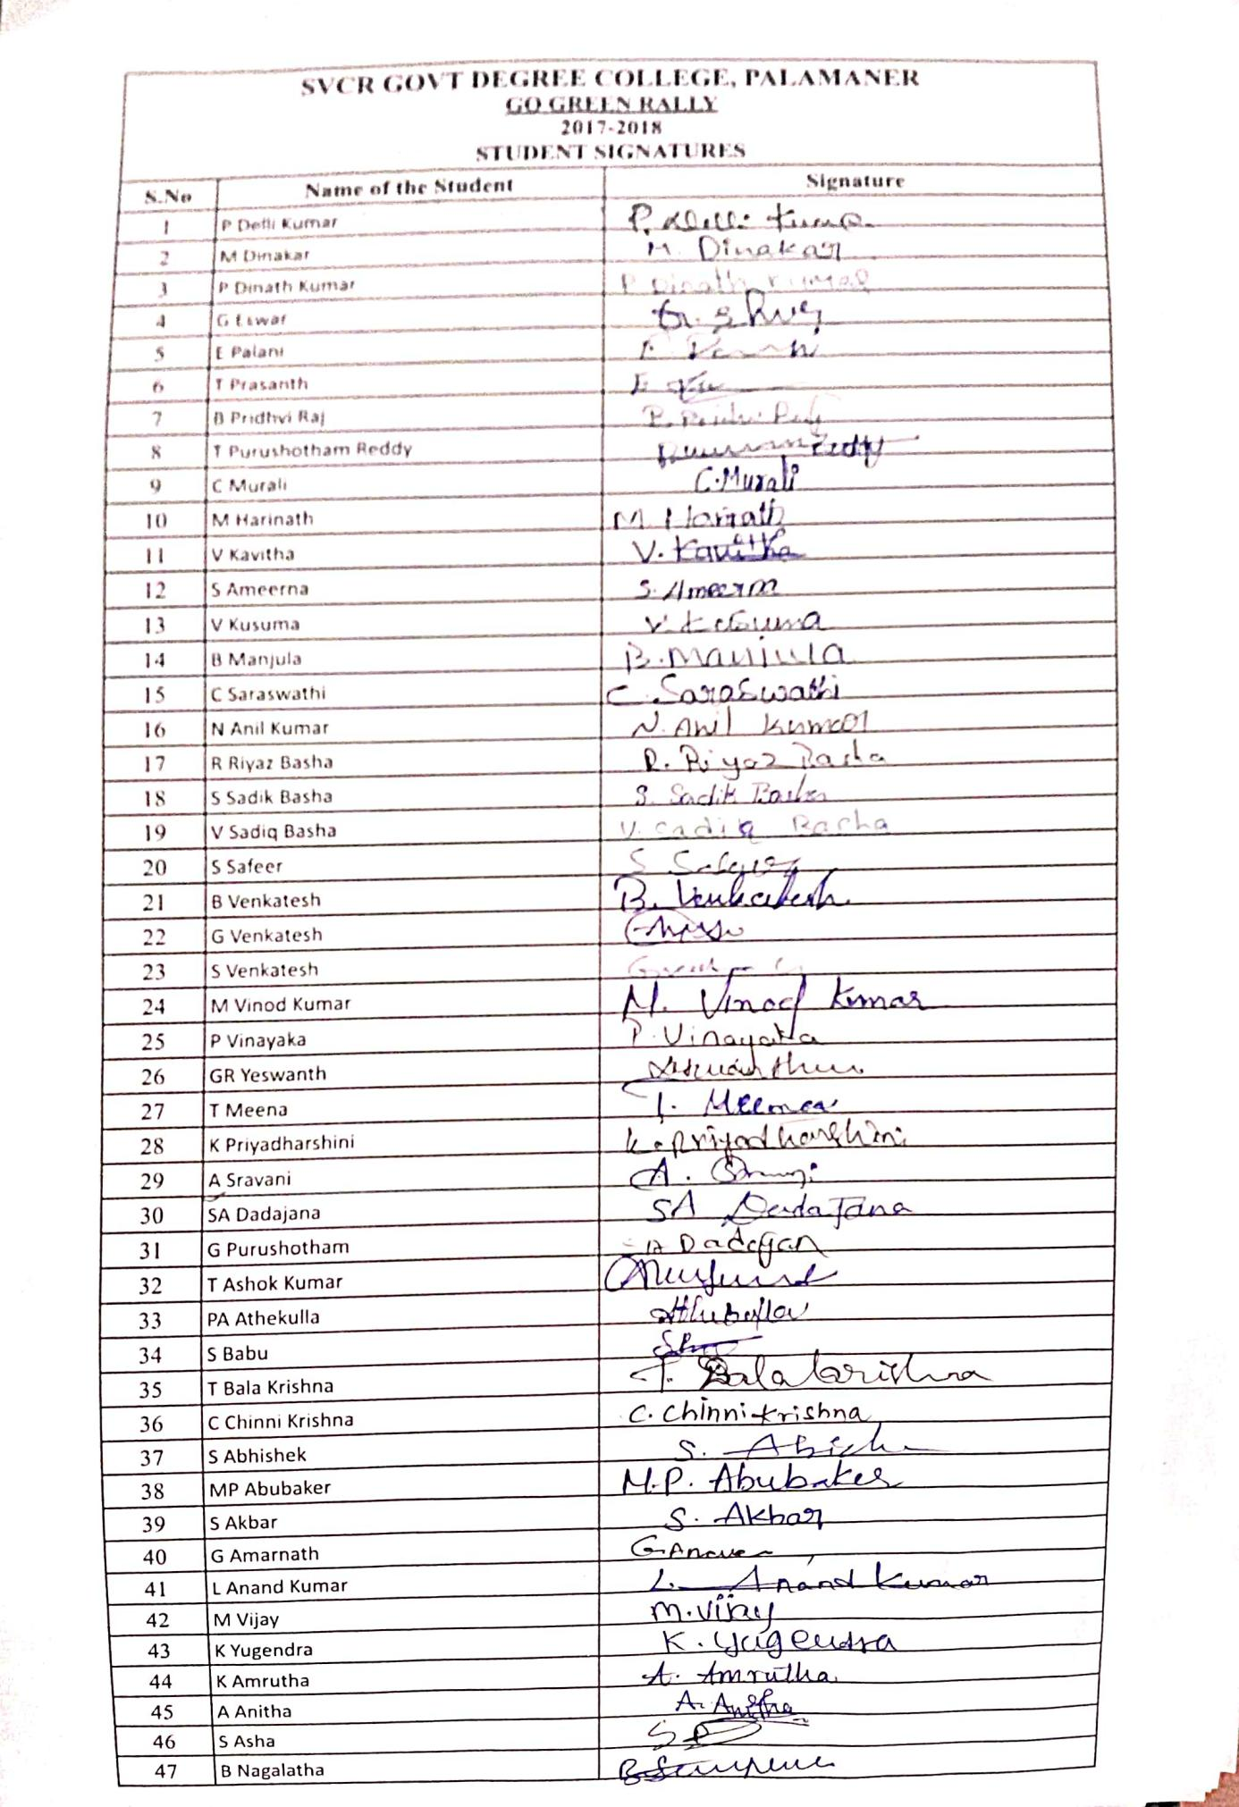

FEED BACK:
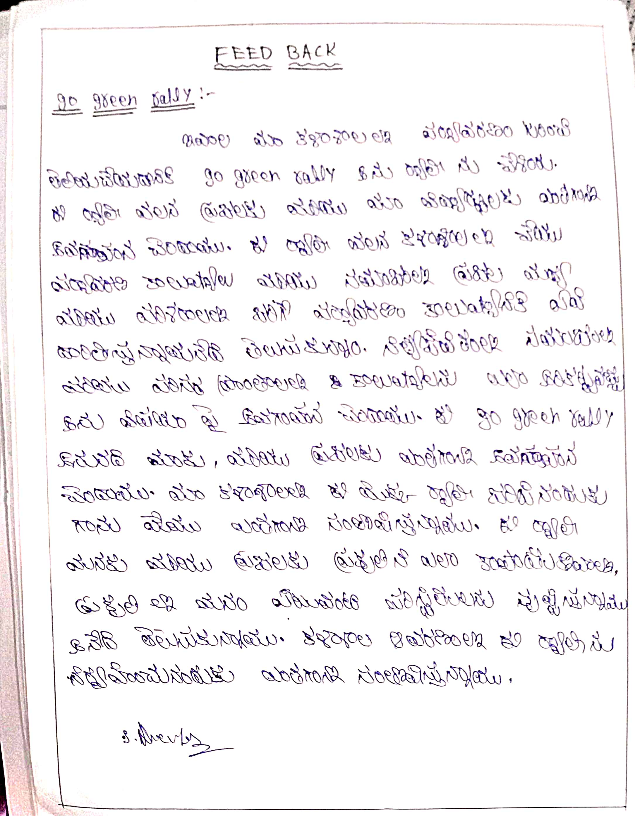
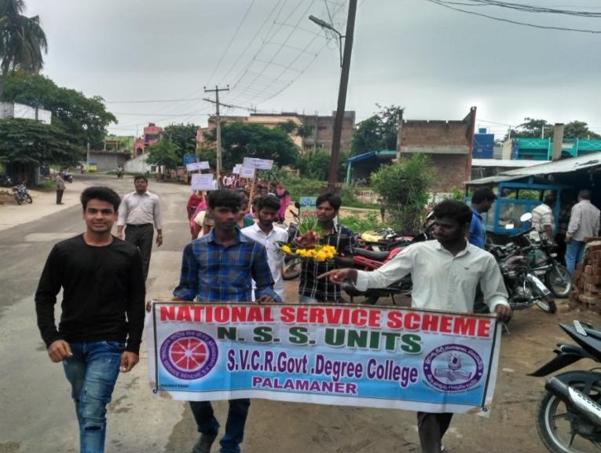
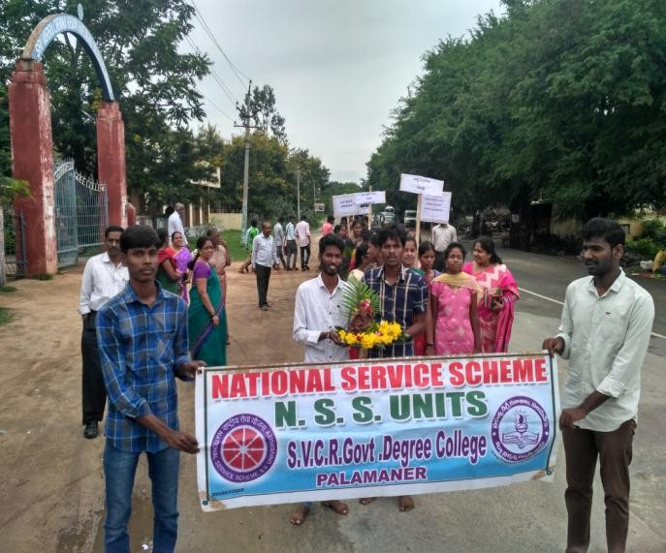
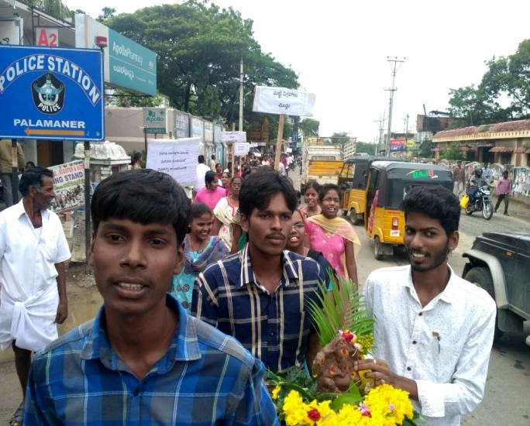
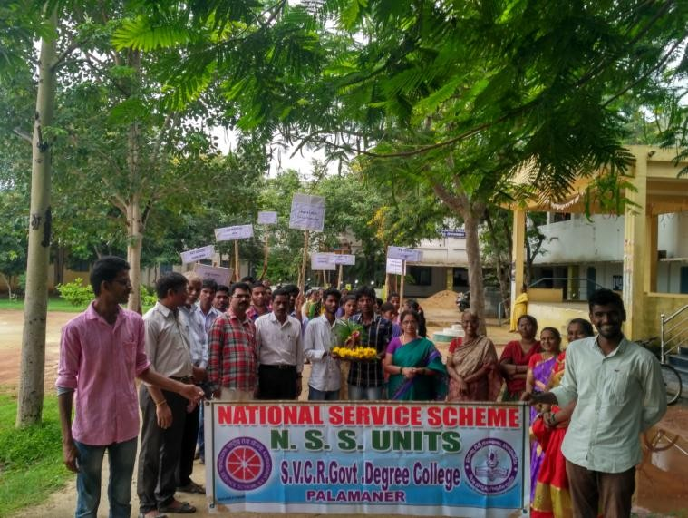
PHOTOS:

SVCR GOVT DEGREE COLLEGE
PALAMANER
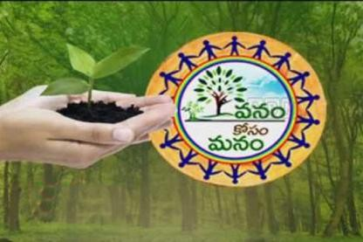

PROGRAM NAME: Vanam-ManamSaplingsPlantationProgramme
PROGRAM DATE: 01.09.2017
TIME: 09.00 AM
VENUE: COLLEGE GROUND
RESOURCE PERSON: NSS UNIT

CIRCULAR
This is to inform all the students and the staff tomorrow (01.09.2017) our college is going to conduct VanamManam-SaplingPlantationProgramme. All the staff have to attend along with their students. The program is conducted as per the orders of the Government of Andhra Pradesh.

OBJECTIVE OF THE PROGRAMME:
To make the campus green.
REPORT OF THE PROGRAMME:
NSSUnitofthecollegeorganizedVanamManam-SaplingsPlantationProgrammeon01stSeptember2017.Dr.P.Babu,Principal; P. Bhanuprakash, NSS Programme Officer; Non-teachingstaff; NSS volunteers and students have actively involved in thesapling plantation programme. We have planted various types ofsaplings like Allaneredu, Guava, Gulmohar, Neem, Pongamia, Badametc.Atotalof39saplingswereplantedinthecollegecampus.

OUT COME:
The saplings are planted and are taken care of.

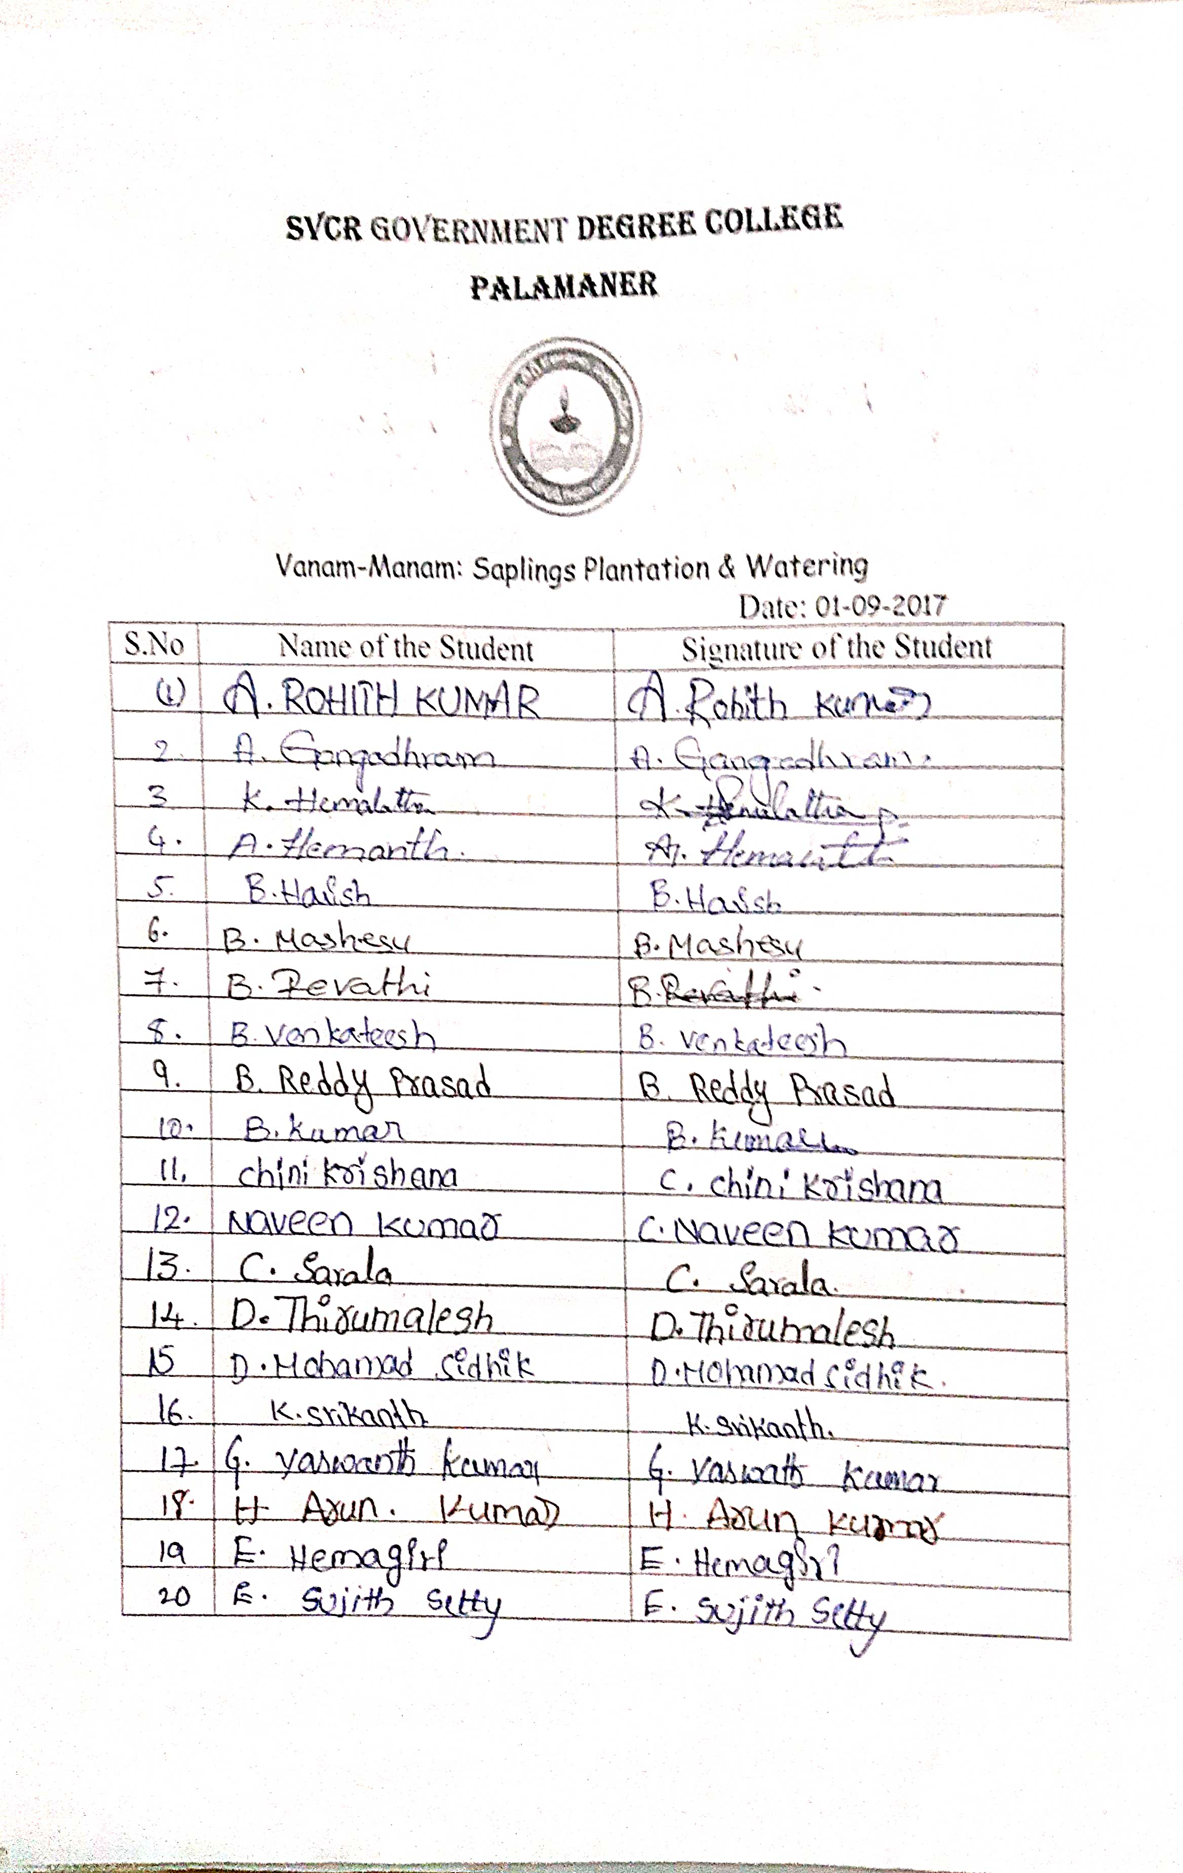
FEED BACK:
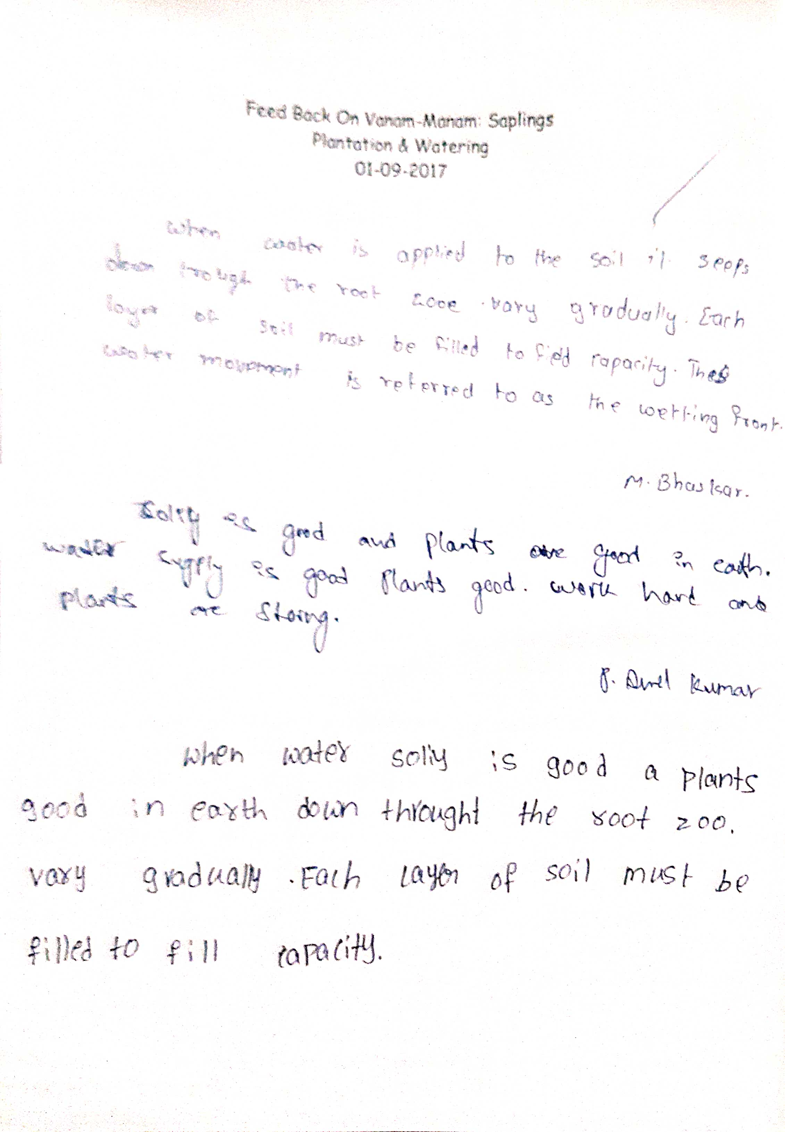

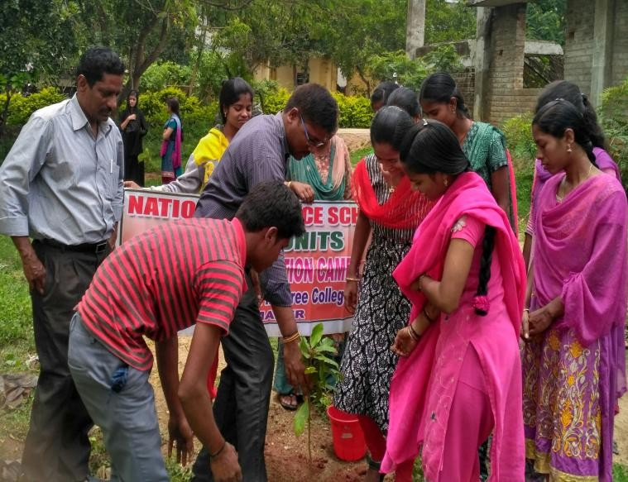
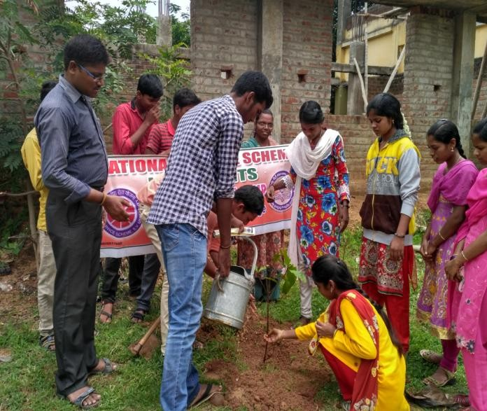
PHOTOS:
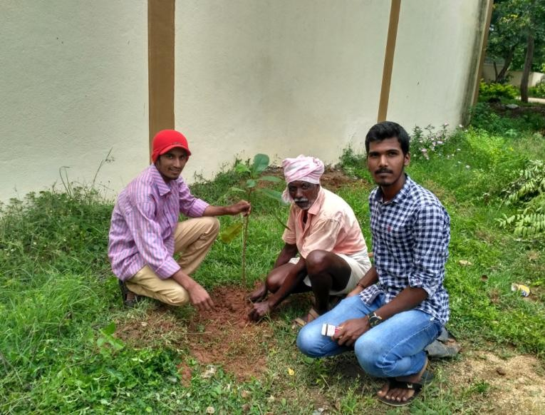
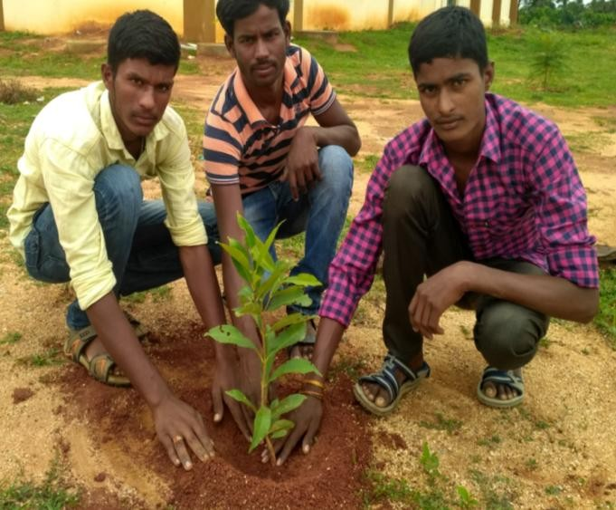

. SVCR GOVT DEGREE COLLEGE
PALAMANER

PROGRAM NAME: RoadSafetyCampaign
PROGRAM DATE: 08.09.2017
TIME: 10.00 AM
VENUE: ON ROAD
RESOURCE PERSON: POLICE DEPARTMENT OF PALAMANER

OBJECTIVE OF THE PROGRAMME:
- To make students ambassadors of the concept road safety.
- To sensitise public on road safety measures through students.
REPORT OF THE PROGRAMME:
NSSUnitofthecollegeparticipatedintheRoadSafetyCampaignorganizedbythePalamaner Urban Police to create awareness among the public on following the traffic rulesand usage of helmet.The Campaign was started by Sri. Shankar, DSP, Palamaner. NSSVolunteersservedas RoadSafetyAmbassadors.

OUT COME:
The students sensitized the public on the disasters occurred through reckless driving and they explained the measures to take for road safety driving.

SIGNATURE OF THE STUDE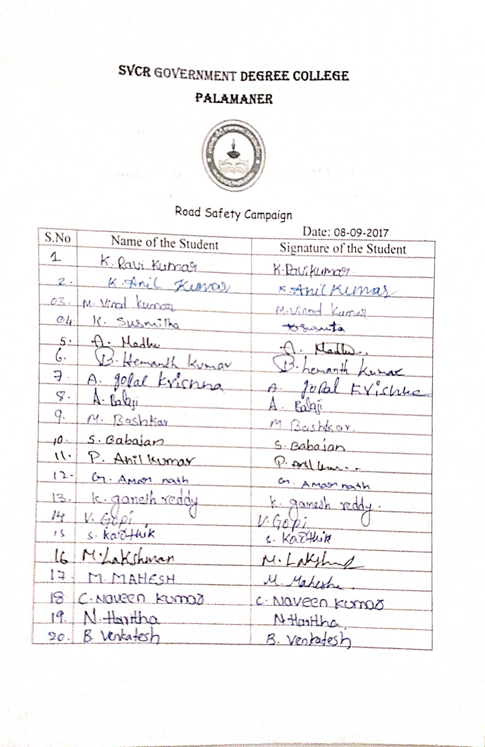NTS:

FEED BACK:
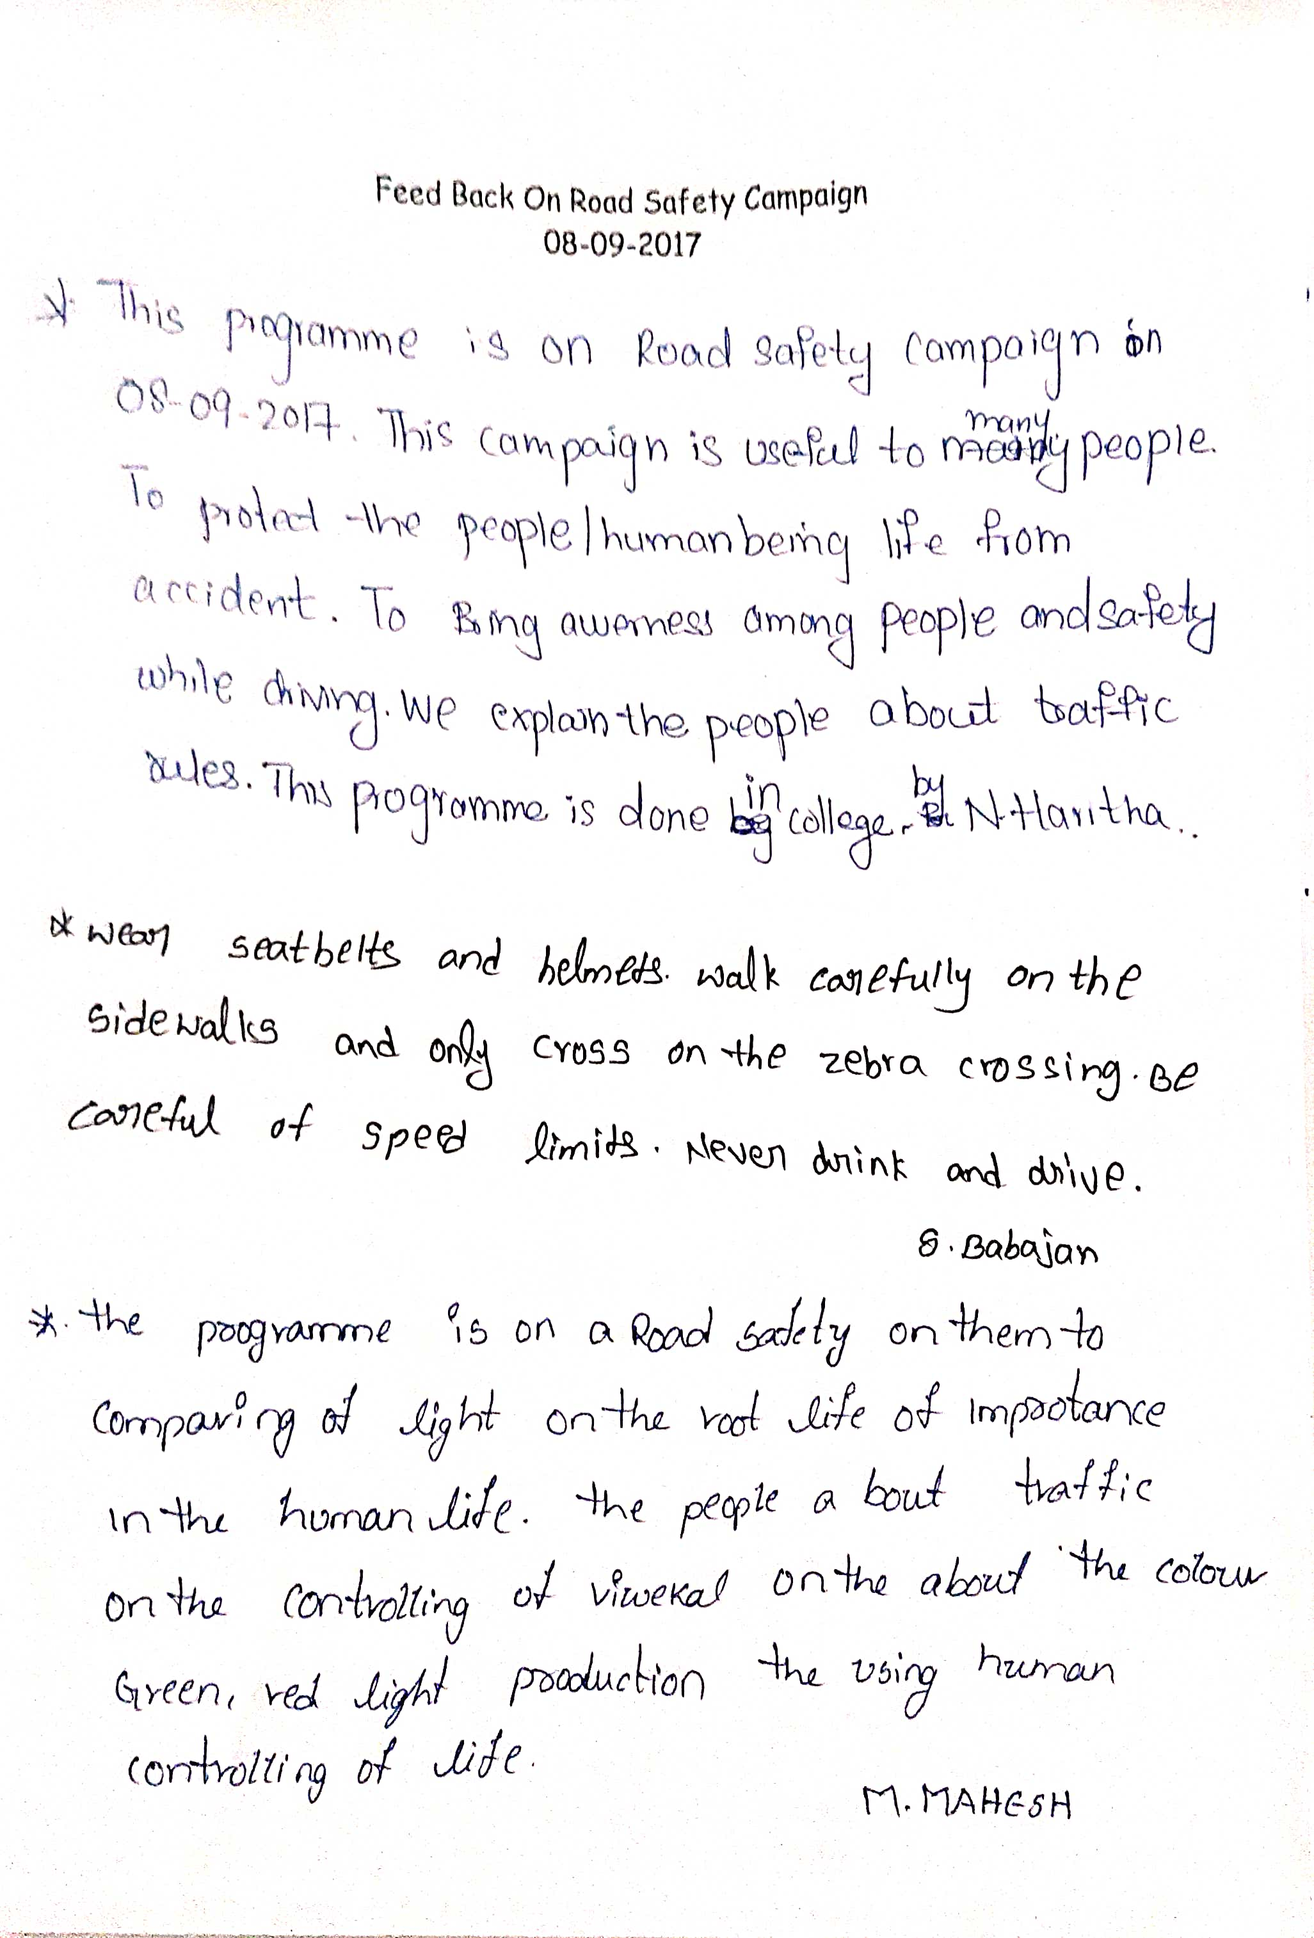

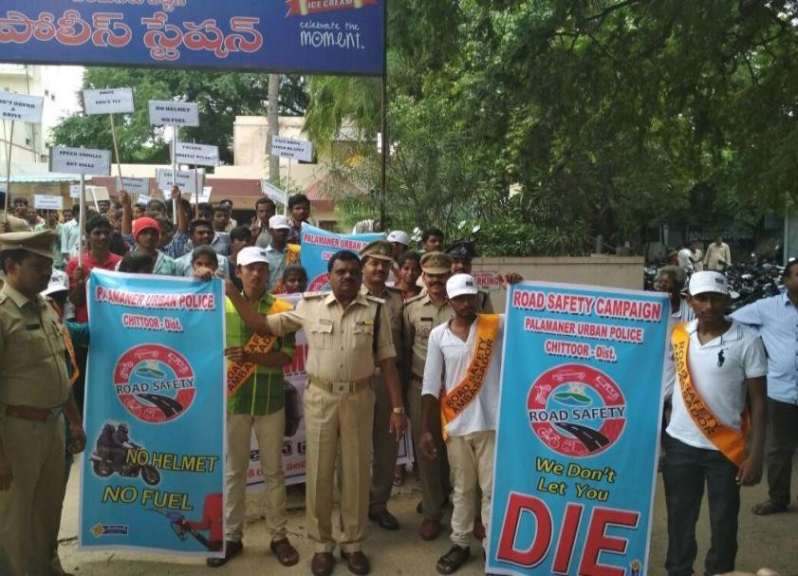
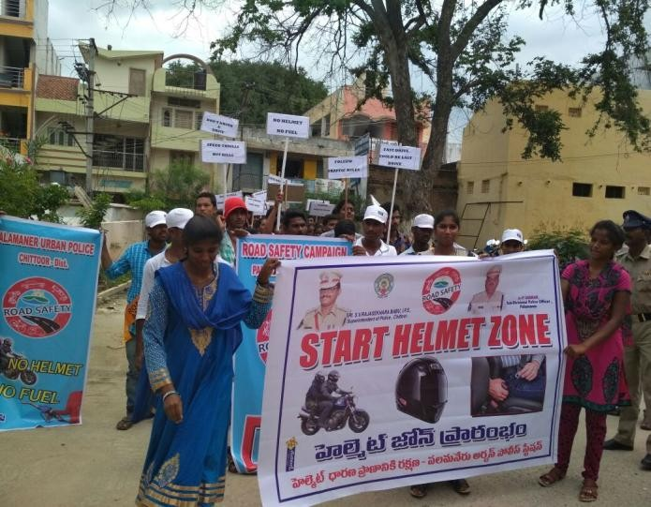
PHOTOS:

. SVCR GOVT DEGREE COLLEGE
PALAMANER
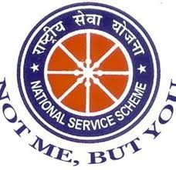

PROGRAM NAME: NSS DAY CELEBRATIONS
PROGRAM DATE: 24.09.2017
TIME: 09.00 AM
VENUE: SEMINAR HALL
RESOURCE PERSON: NSS UNIT

CIRCULAR
The NSS units of the college are going to conduct NSS Day Celebrations in the Seminar hall on 24.09.2017. All the students and the staff can attend the program and make it a grand success.

OBJECTIVE OF THE PROGRAMME:
- To sensitize the students on the motto “not me, but you”.
- To motivate the students on the NSS activities.

REPORT OF THE PROGRAMME:
NSS was formally launched on 24th September 1969, the birth centenary year of the Fatherof the Nation. 24th September is observed every year as NSS Day to sensitize youth of thenation about nation building competencies. NSS Day was celebrated in the college and Dr. P.Babu,Principalofthecollegepresidedoverthefunction.Smt.C.Sarada,Municipalchairperson, Palamaner Municipality acted as the Chief Guest. Sri K. Shyam Sundar Raj, 11thWard counseller, Palamaner as the guest of honour for the function. They appreciated thevolunteers for taking up social service activities and encouraged to take up more activities inthe furture. The Dignitaries and NSS Volunteers involved in plantation activity. They plantedsaplings of different varieties in the college campus and watered them. On this occasion, theNSS Unit of the College has started Special Camping Programme from 24th September 2017 to30th September, 2017 at Mandal Parishad Primary School, T.S. Agraharam, Palamaner with the maintheme“Health,PublicSanitationandPersonalHygiene”

OUT COME:
A special camp is conducted by the selected volunteers of NSS units.

SIGNATURE OF THE STUDENTS:
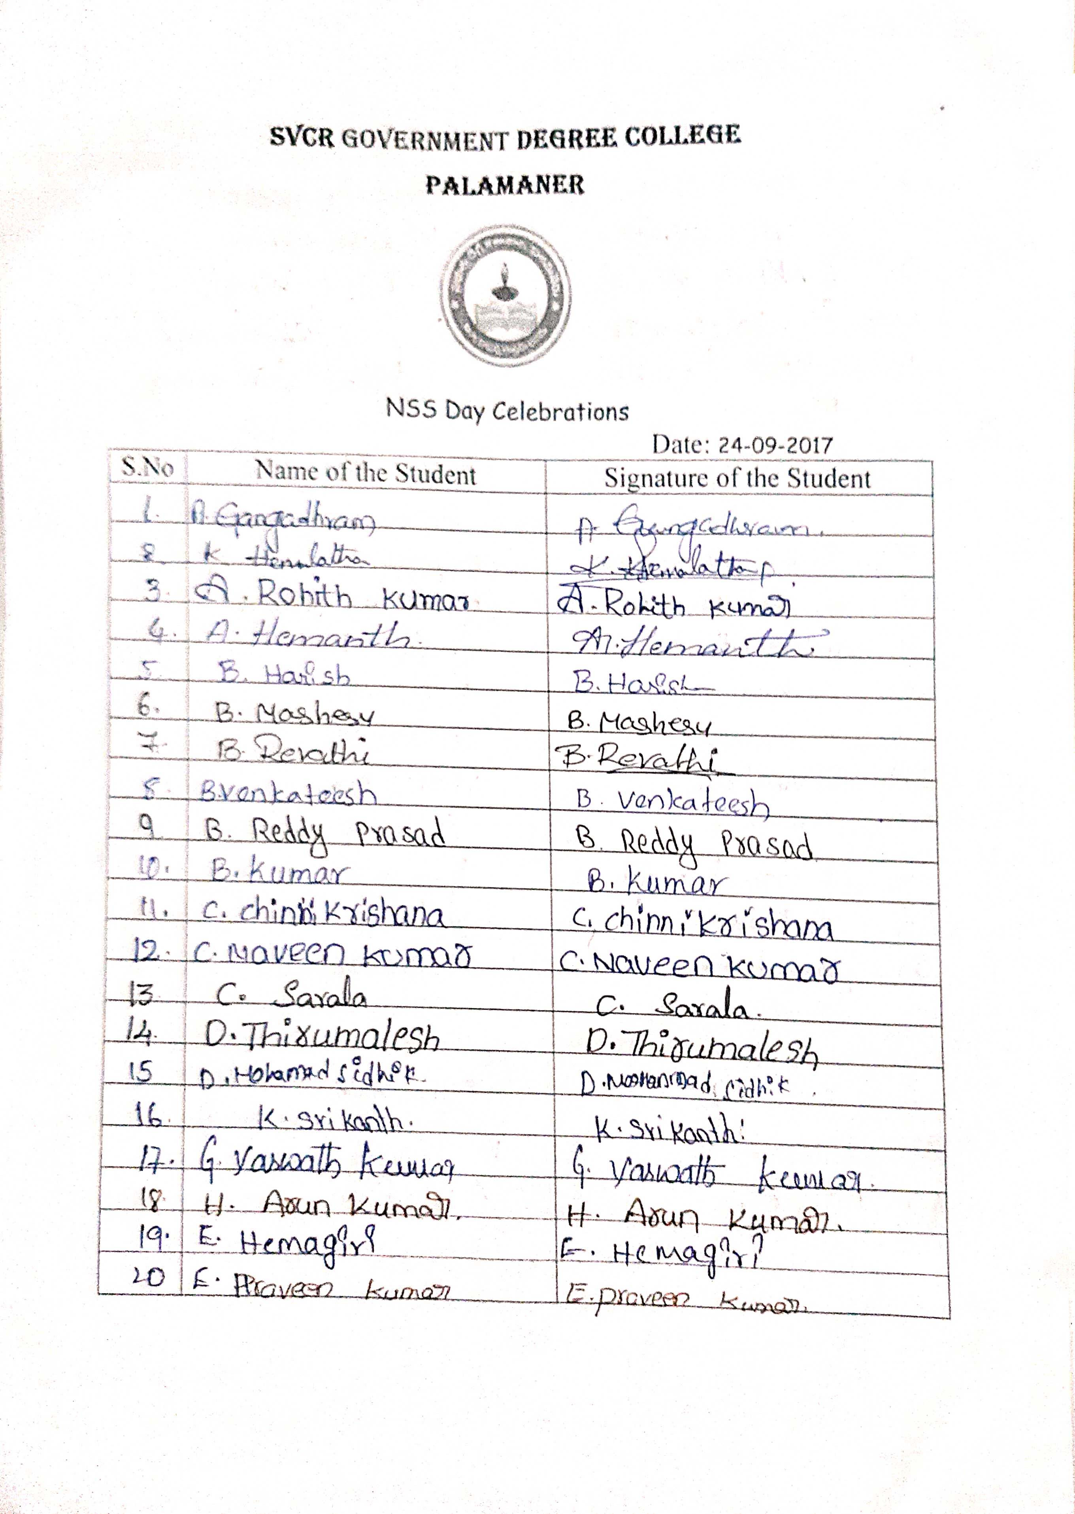

FEED BACK:
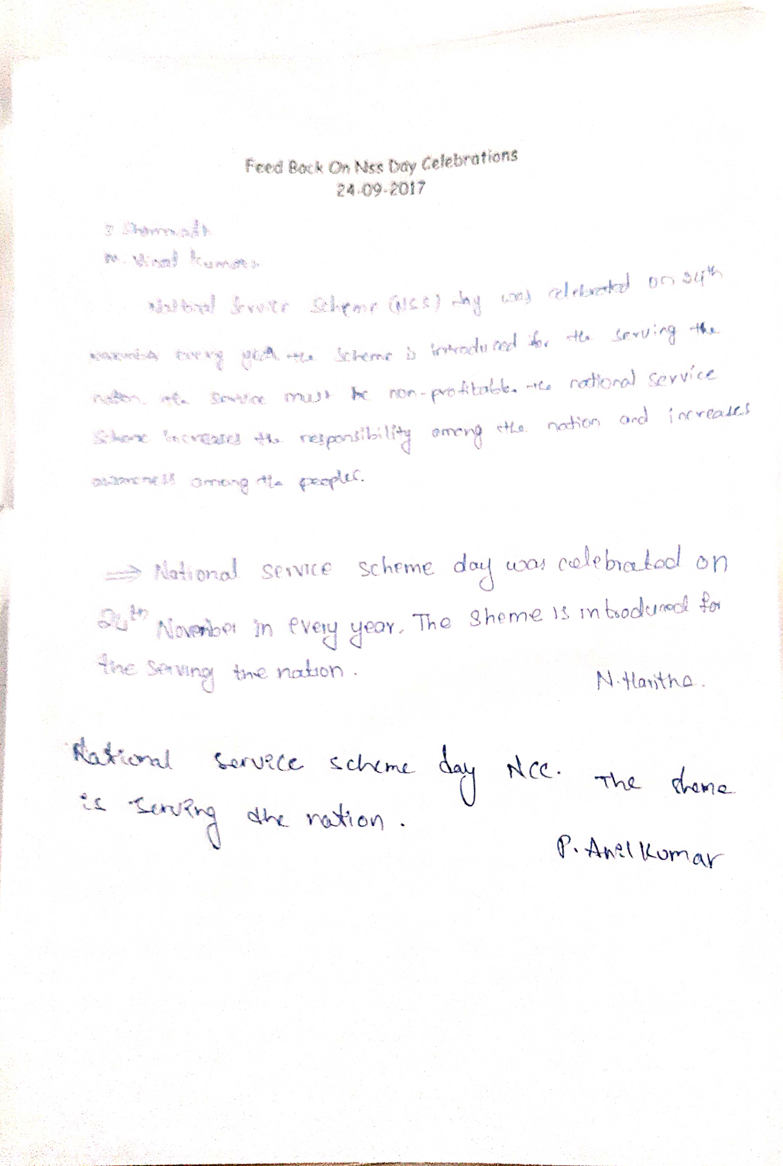
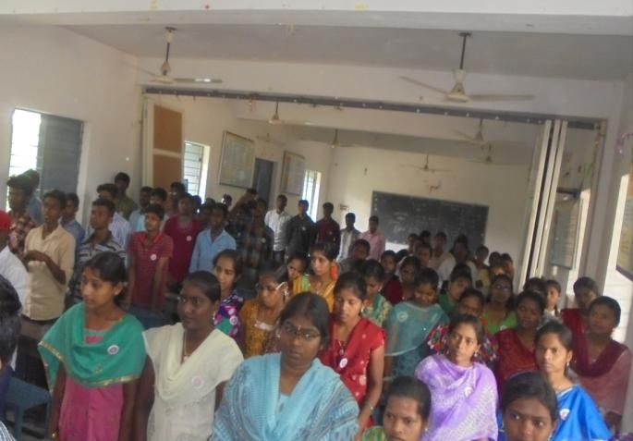
PHOTOS:
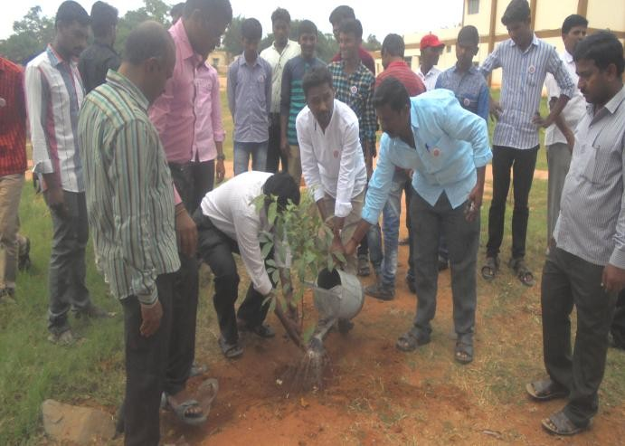
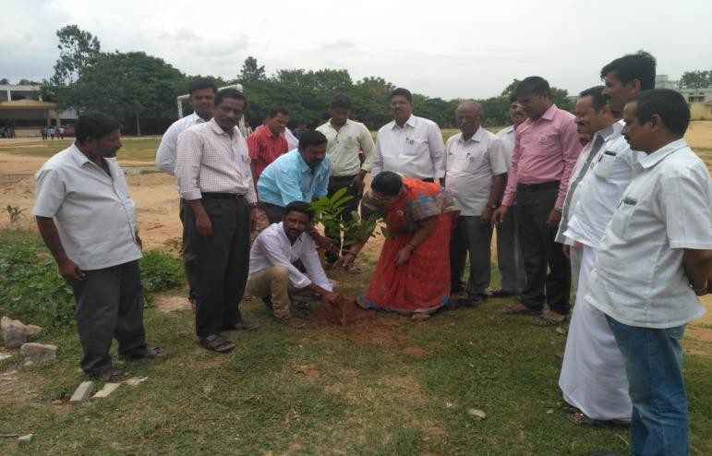
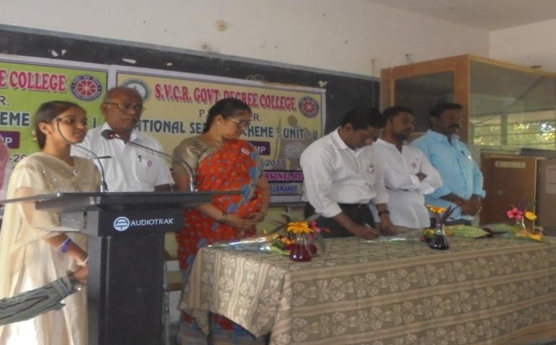

. SVCR GOVT DEGREE COLLEGE
PALAMANER
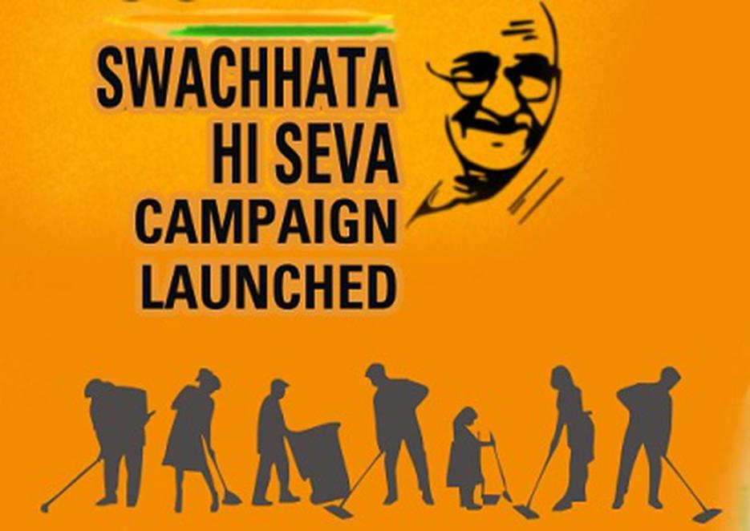

PROGRAM NAME: SwachhataHiSeva
PROGRAM DATE: 02.10.2017
TIME: 09.00 AM
VENUE: ON ROAD
RESOURCE PERSON: NCC UNIT

CIRCULAR
The students are hereby informed that the college will conduct a rally on Swatchacha Tha Hi Seva on 02.10.2017. The students and the staff have to assemble at the college at 8.30 AM for making the rally in the town.
OBJECTIVE OF THE PROGRAMME:
- To promote the culture of cleanliness among the public.
- To motivate the public on the need for being clean.
REPORT OF THE PROGRAMME:
The Principal, the staff and the students participated in a rally against pollutions. They carry the banners of Swatchatha Hi Seva activity and explained the need for being clean among the residents of the town. They explained the need to clean the sewage canals infront of the houses of the inhabitants. Thus the activity was a productive one.
OUT COME:
The students learnt to have social responsibility.
They learnt to need for being clean while they are explaining to others.

SIGNATURE OF THE STUDENTS:
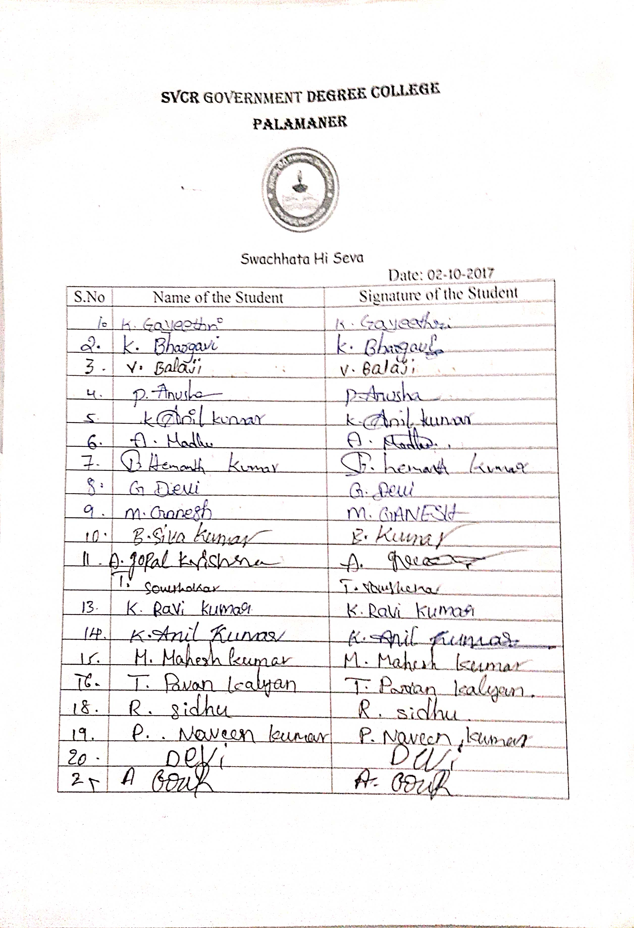
FEED BACK:
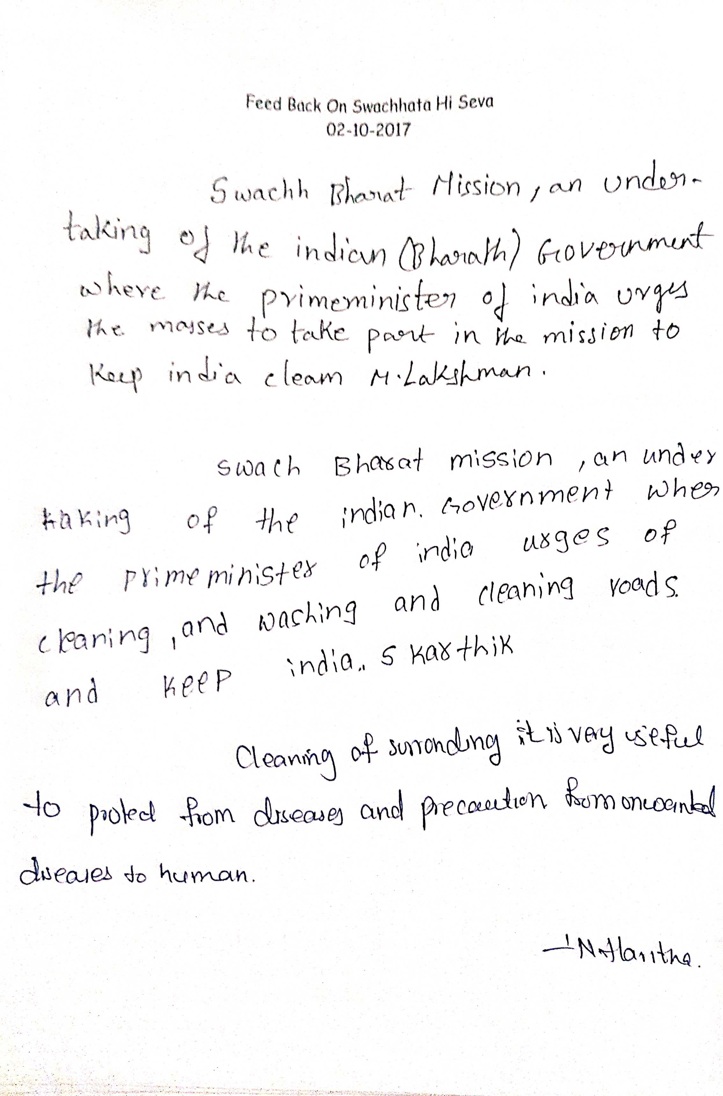
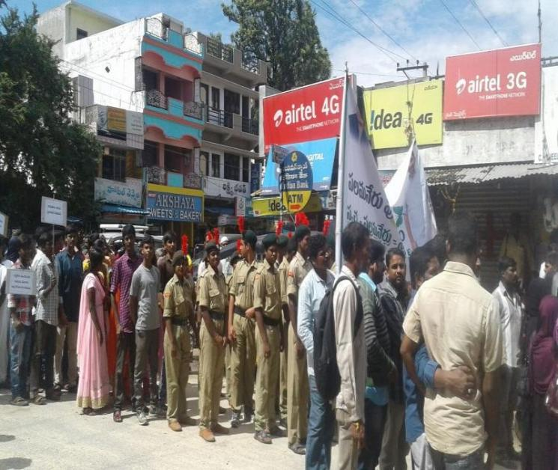
PHOTOS:
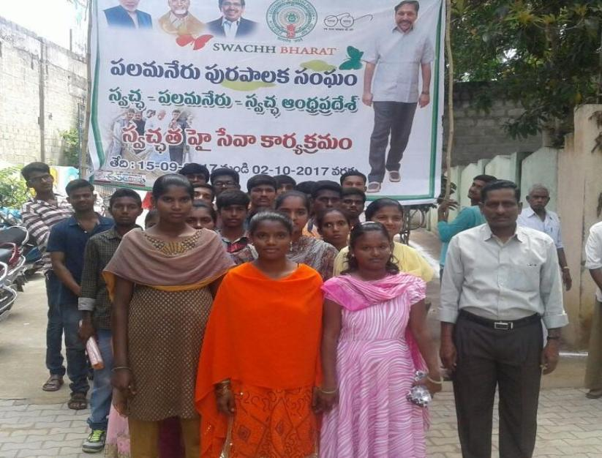

SVCR GOVT DEGREE COLLEGE
PALAMANER
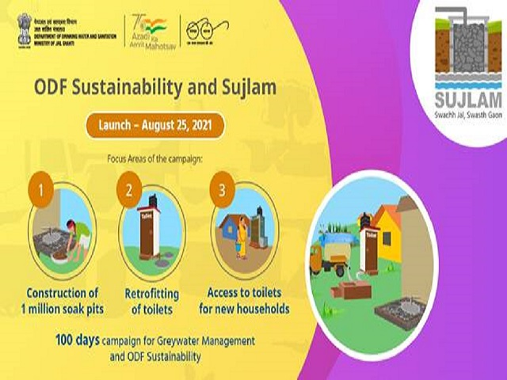

PROGRAM NAME: AWARENESSPROGRAMMEONOPEN DEFECATION FREE
PROGRAM DATE: 13.10.2017
TIME: 09.00 AM
VENUE: PENGARGUNTA VILLAGE PALAMANER
RESOURCE PERSON: NSS UNIT

CIRCULAR
The Government of India instructed the young students and the NSS Volunteers to spread the message on Open Defecation Free society among the villagers. Hence, an awareness program is going to be conducted by the students and the volunteers of the NSS units in the village Pengaragunta, Palamaner Mandal.

OBJECTIVE OF THE PROGRAMME:
The objective of the program is to sensitize the villagers to have toilets and to put an end to open defecation.
REPORT OF THE PROGRAMME:
NSS Unit organized awareness Programme on “Open Defecation Free” (ODF) at Pengargunta Village on 13th October 2017. The NSS PO explained the school children about effects of Open Defecation and need for ODF village. Awareness rally on “Open Defecation Free” was conducted in the village along with school children. Later, the volunteers involved in door to door campaign and explained them to use IHHL scheme by Govt of A.P to make the village ODF. The volunteers also briefed the villagers about contaminations from open defecation which not only leads to pollution of the ground water but also contaminates agricultural produce, spreads diseases like diarrhea and cholera.

OUT COME:
The students did their best in sensitizing the villagers. Sri E. Chandra Naidu, lecturer in Commerce received praise from the District Collector, Chittoor for his endless effort in the activity. He made nearly 400 villagers to construct toilet in their home premises.
url of the activity: The students clapped for motivating the villagers of Pengaragunta.
https://youtu.be/oi6tZsY8zaw

SIGNATURE OF THE STUDENTS:
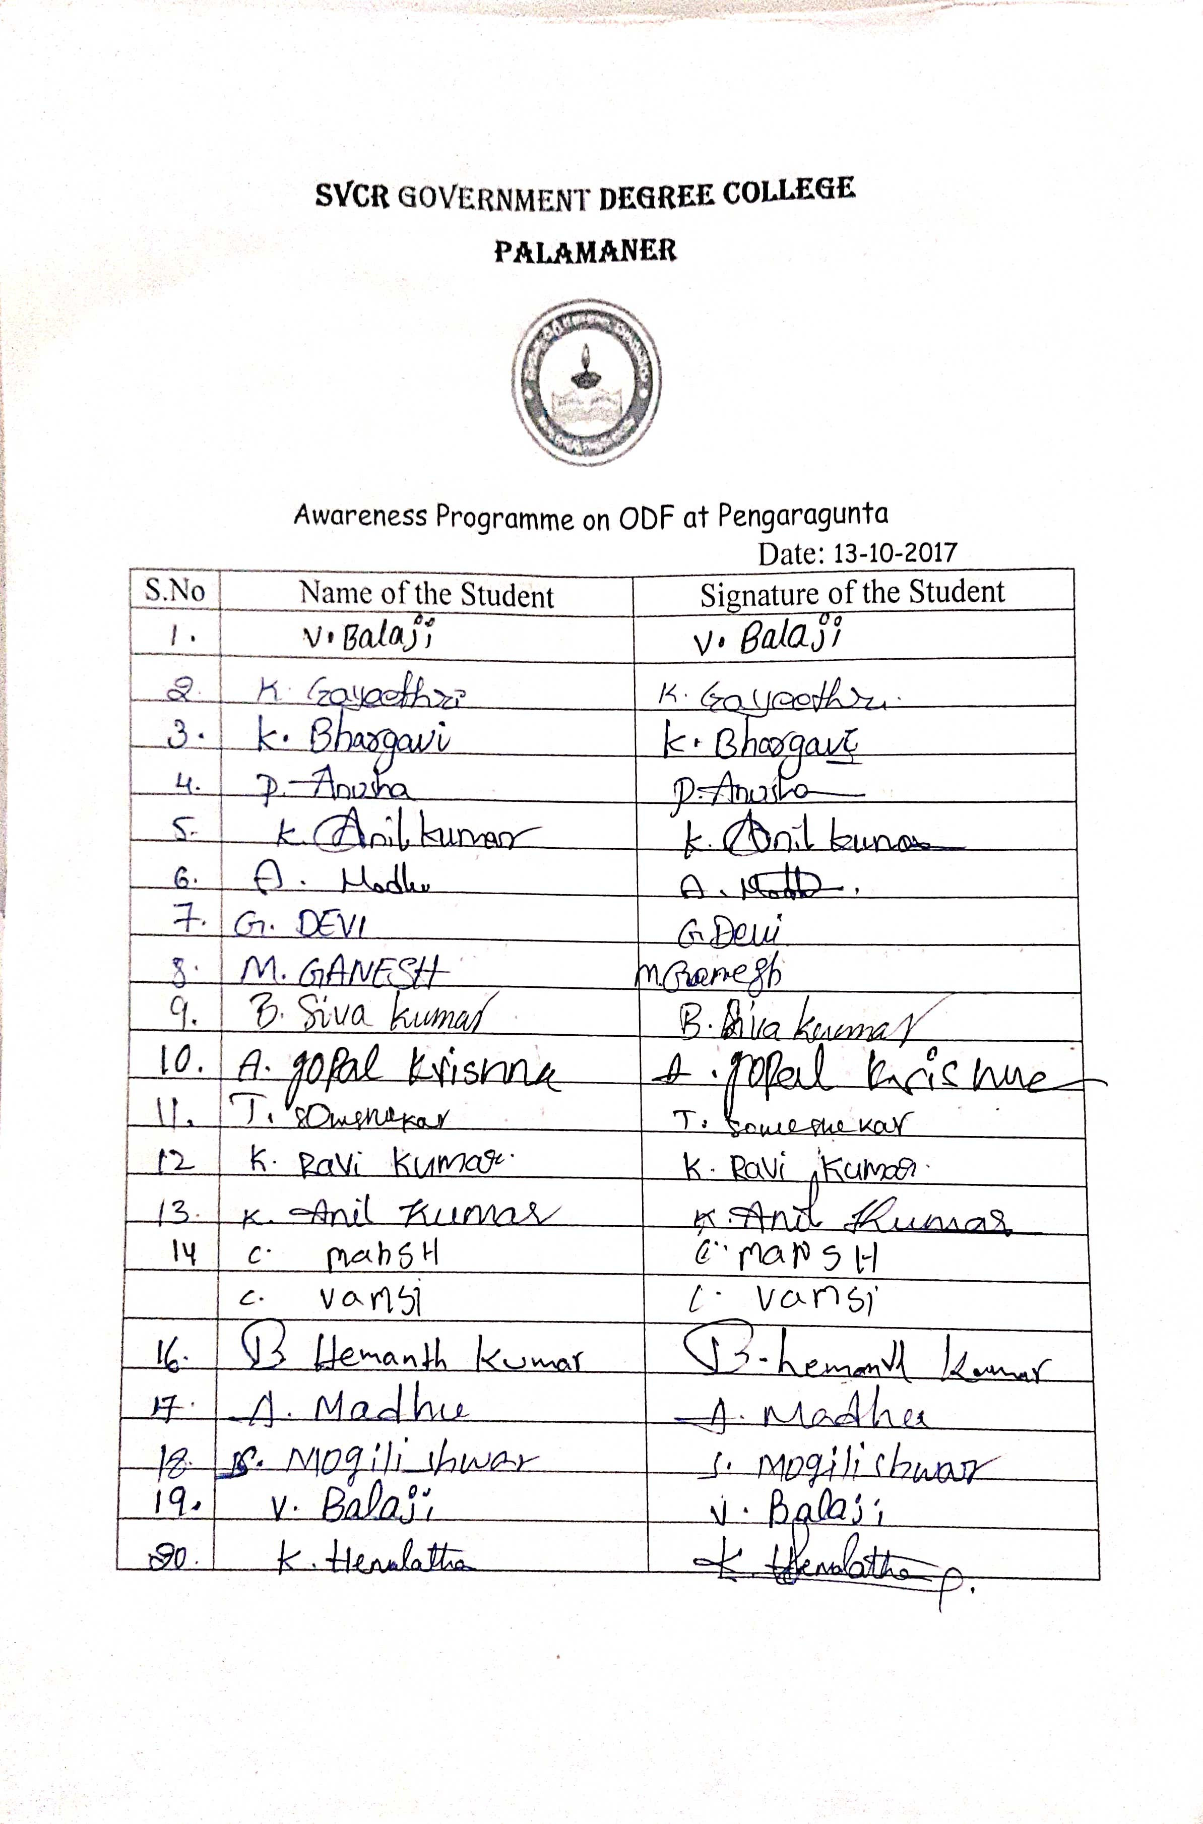
FEED BACK
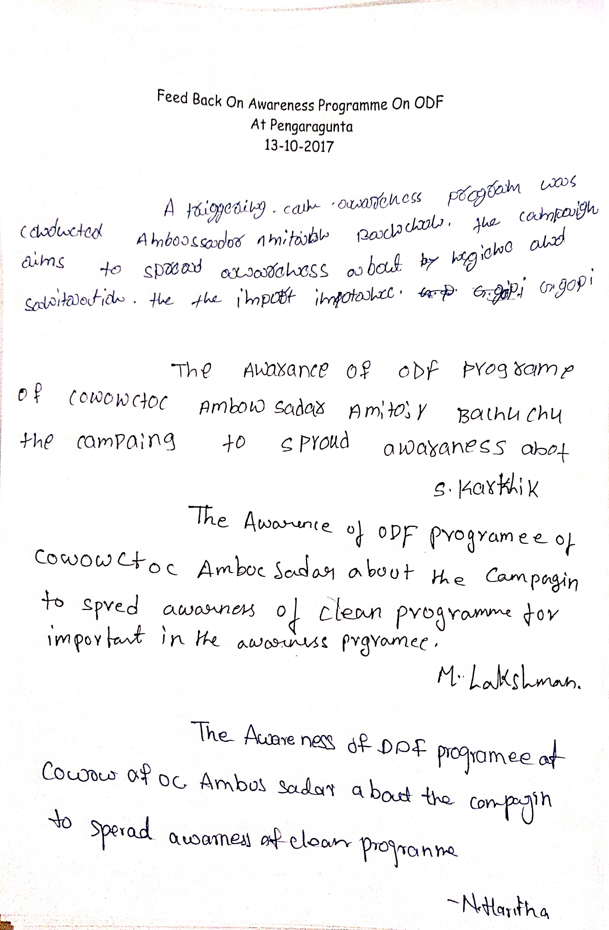
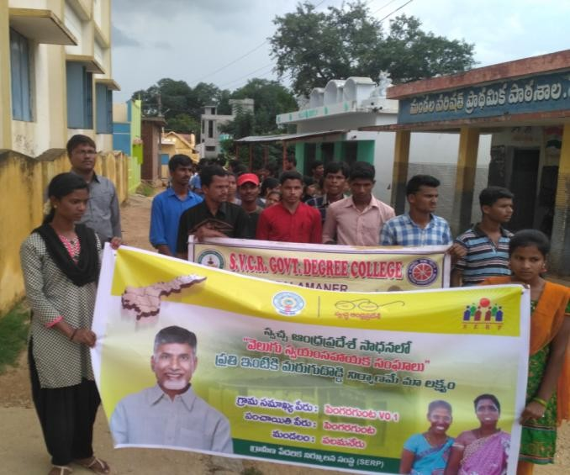
PHOTOS:
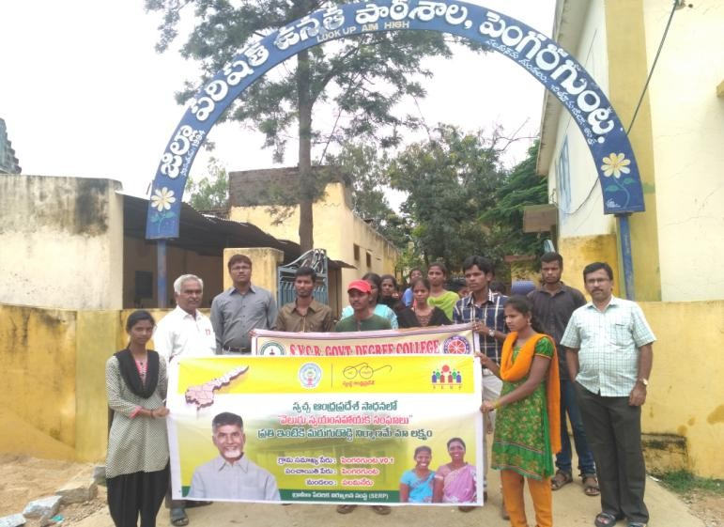
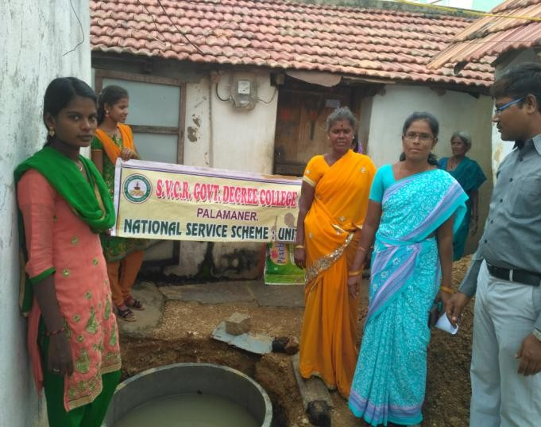
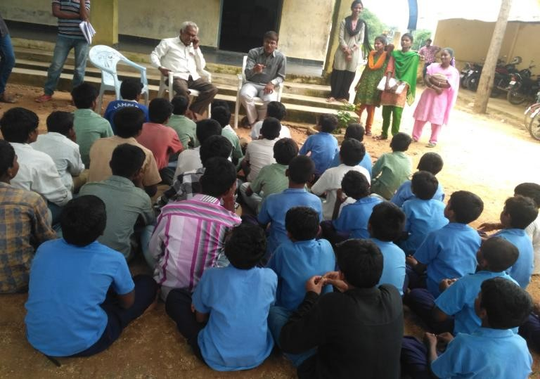

. SVCR GOVT DEGREE COLLEGE
PALAMANER
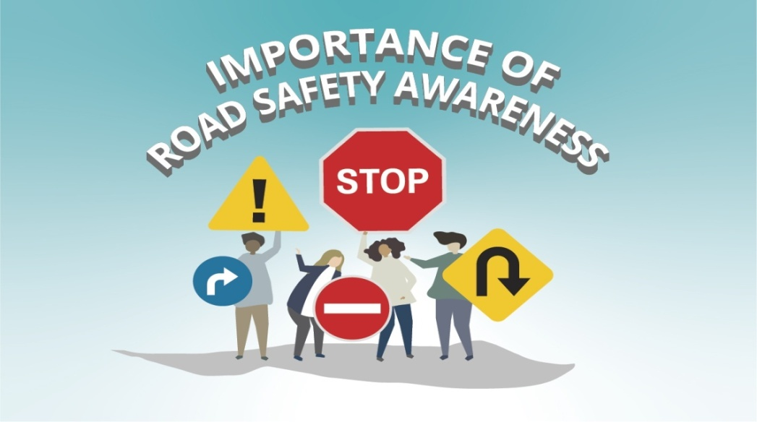

PROGRAM NAME:AWARENESS ON GETTING DRIVING LICENSE&ROAD
SAFETY
PROGRAM DATE: 20.10.2017
TIME: 11.00 AM
VENUE: VERANDA
RESOURCE PERSON: DEPARTMENT OF POLICE, PALAMANER

CIRCULAR
The Department of Road Transport Office in collaboration with the department of Police conducted drive for enrolment in getting driving license. The students and the staff have to attend the meeting that is going to be conducted in the Varandah of the ground floor at 11 AM.
OBJECTIVE OF THE PROGRAMME:
- To motivate the students to go for putting application for driving license.
REPORT OF THE PROGRAMME:
NSS Unit of the college organized Awareness Programme on Driving Licence & Road Safety Measures on 20th October 2017. The Chief Guest for the programme was Sri. Sivalingaiah, Motorvehicle Inspector, Palamaner. He created awareness among the students and NSS Volunteers about the method to get driving license, road safety measures that are to be taken to avoid accidents. His team distributed the pamphlets on Traffic rules and Road Safety precautions to the students. The Principal, NSS Programme Officers, Teaching Staff and NSS volunteers and students participated in the awareness programme.

OUT COME:
The students get motivated and applied for driving license.

SIGNATURE OF THE STUDENTS:
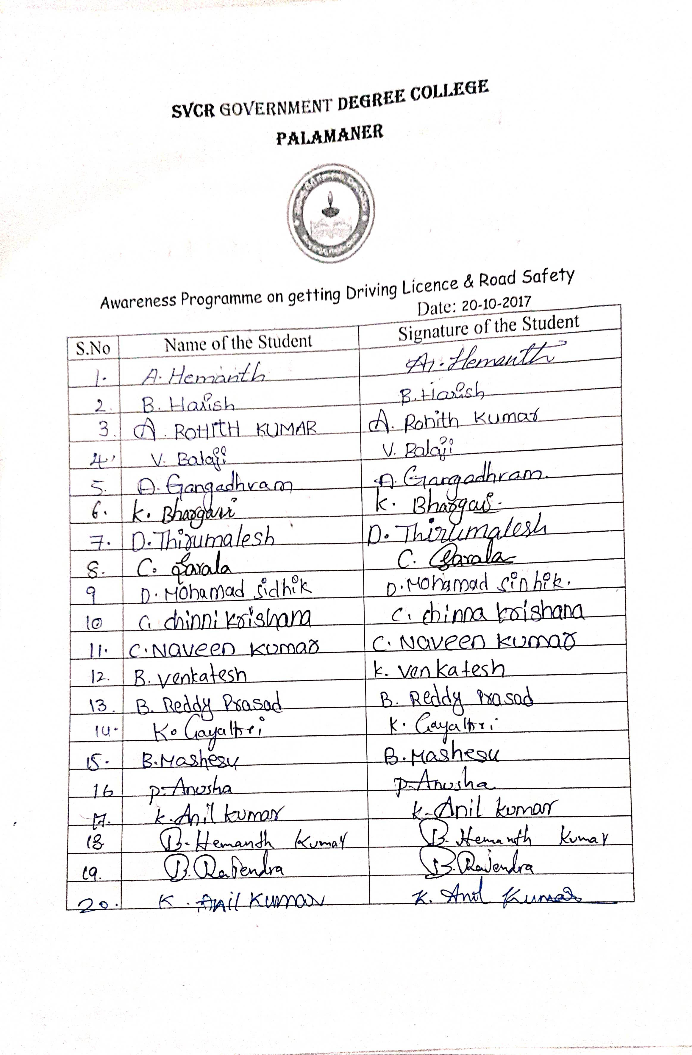

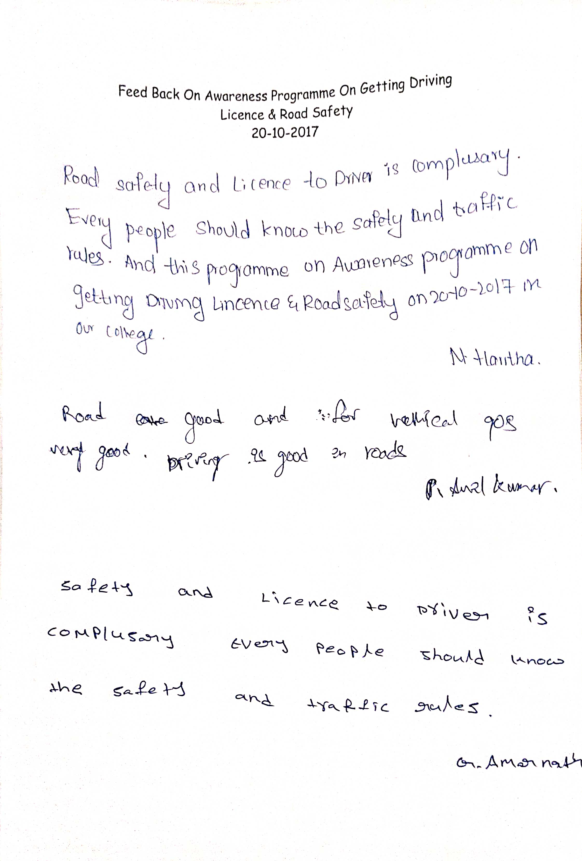
FEED BACK:
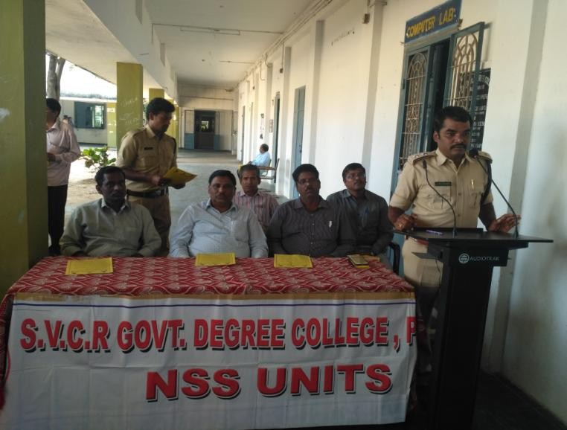
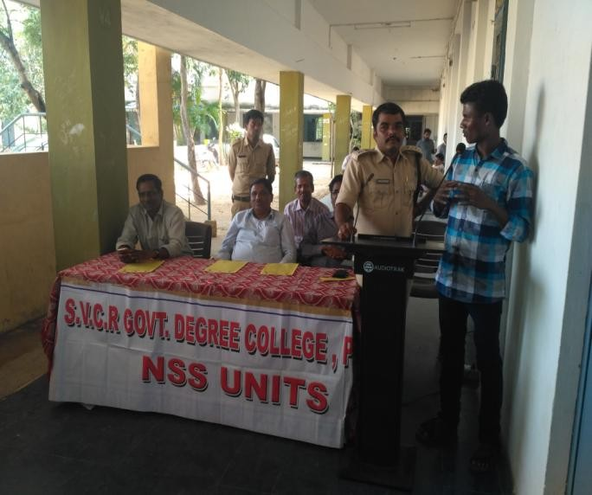
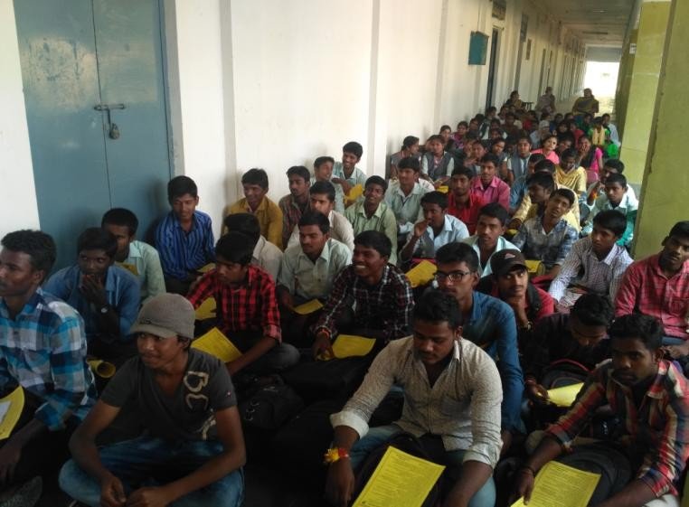
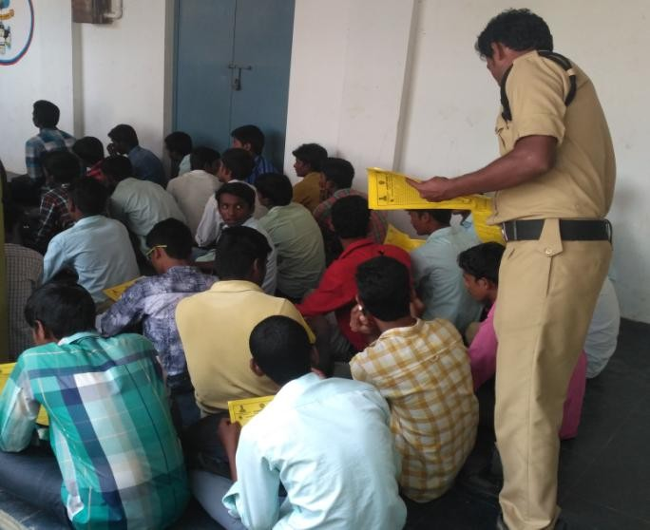
PHOTOS:

. SVCR GOVT DEGREE COLLEGE
PALAMANER

PROGRAM NAME: Vanam-ManamProgramme
PROGRAM DATE: 28.10.2017
TIME: 09.00 AM
VENUE: COLLEGE GROUND
RESOURCE PERSON: COLLEGE

OBJECTIVE OF THE PROGRAMME:
To plant the sapling in the campus.
REPORT OF THE PROGRAMME:
As per the circular of Government of Andhrapradesh, NSS Unit of thecollegeorganizedVanamManam-SaplingsPlantationprogrammeintheCollege campus on 28th October 2017.The Principal, Vice-Principal, NSSProgramme Officer, Teaching, Non-teaching staff, NSS volunteers of thecollege have actively participated in the Vanam-Manam Programme and atotal of61saplingswere planted

OUT COME:
The saplings are planted in the campus.

SIGNATURE OF THE STUDENTS:
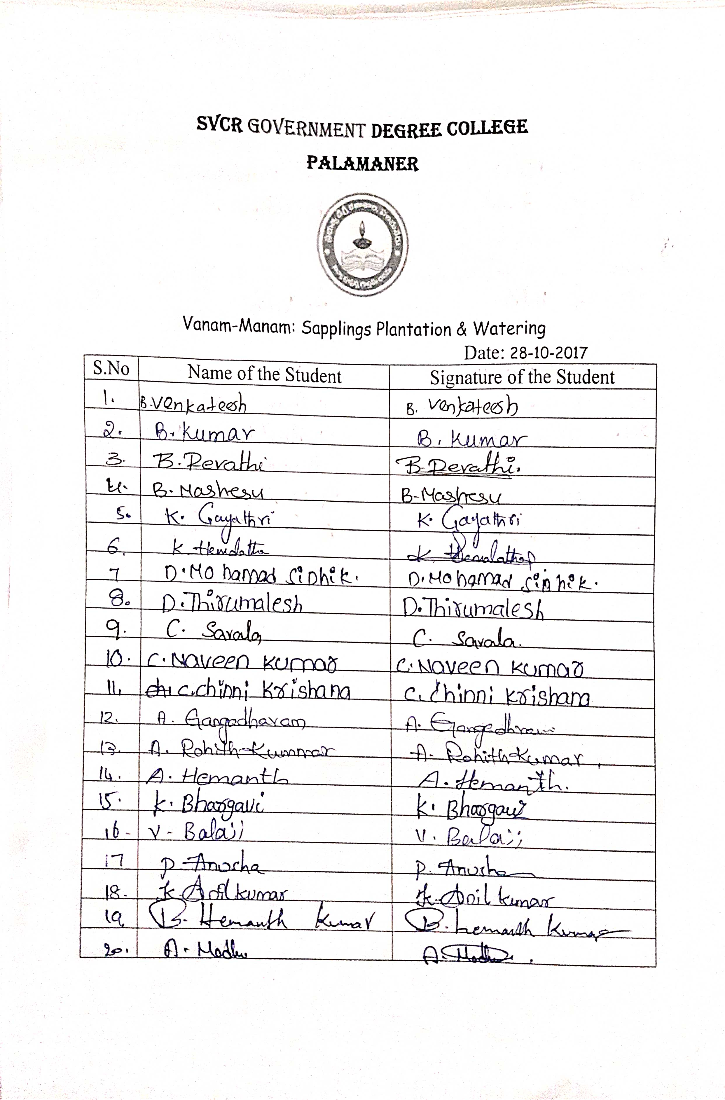

FEED BACK:
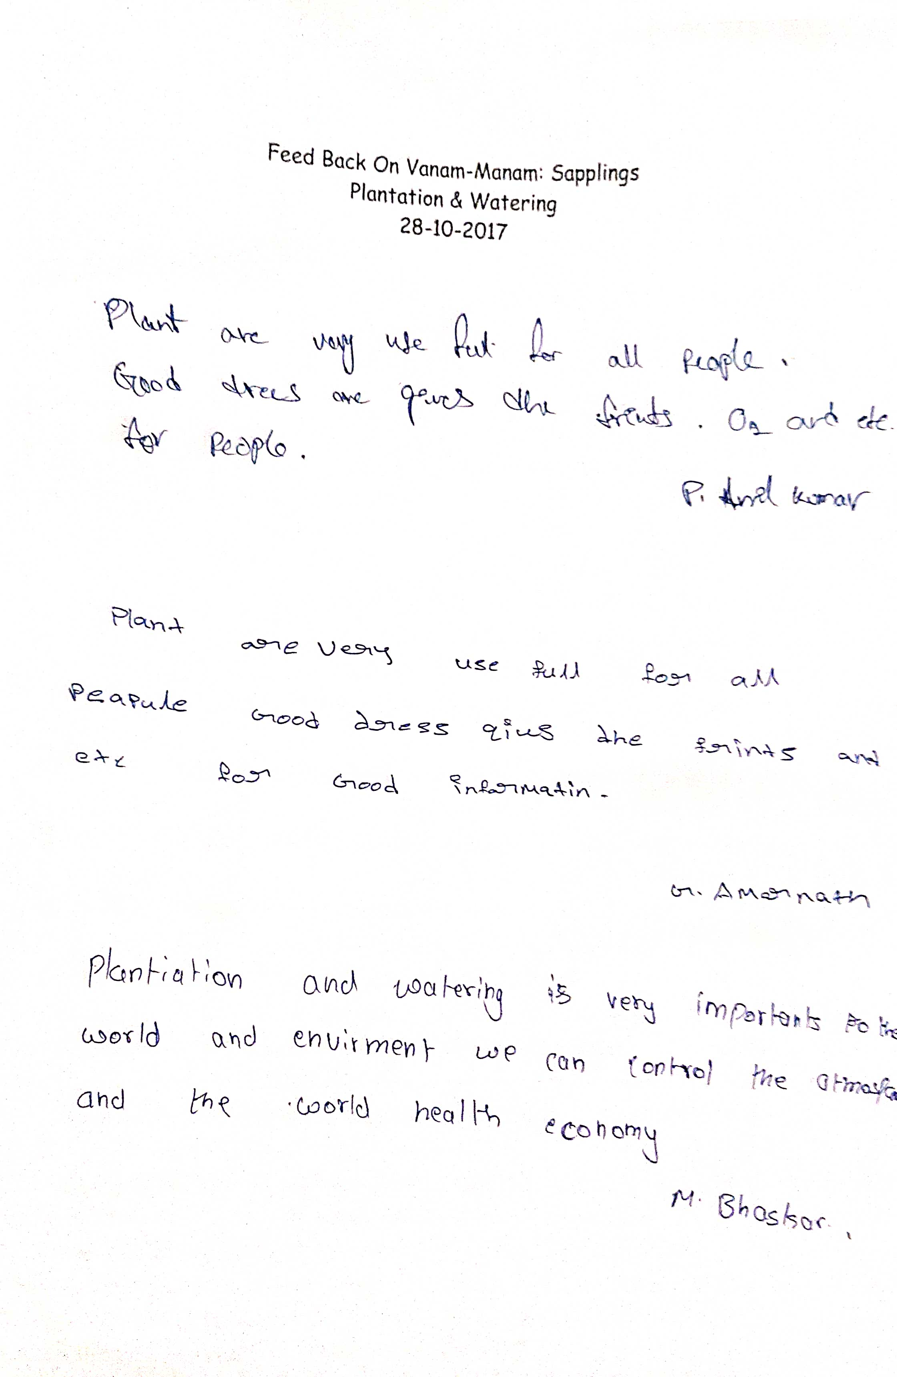
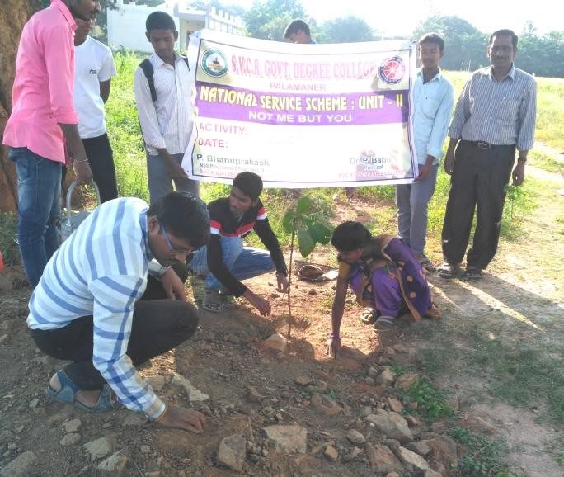
PHOTOS:
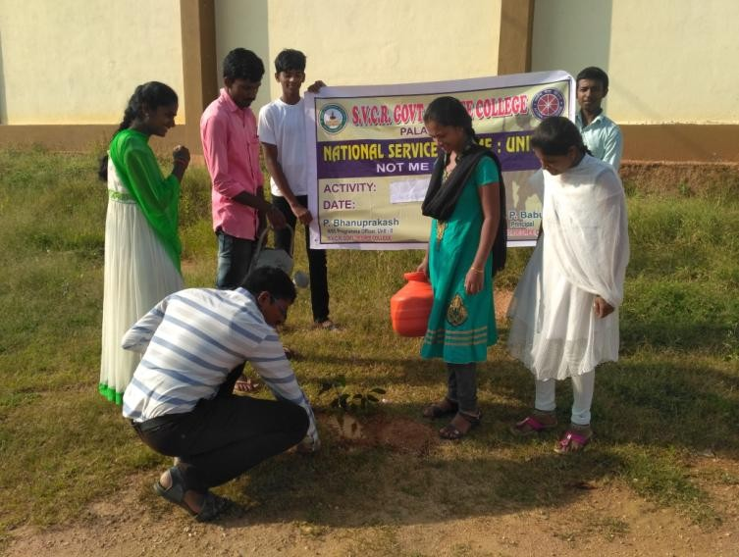
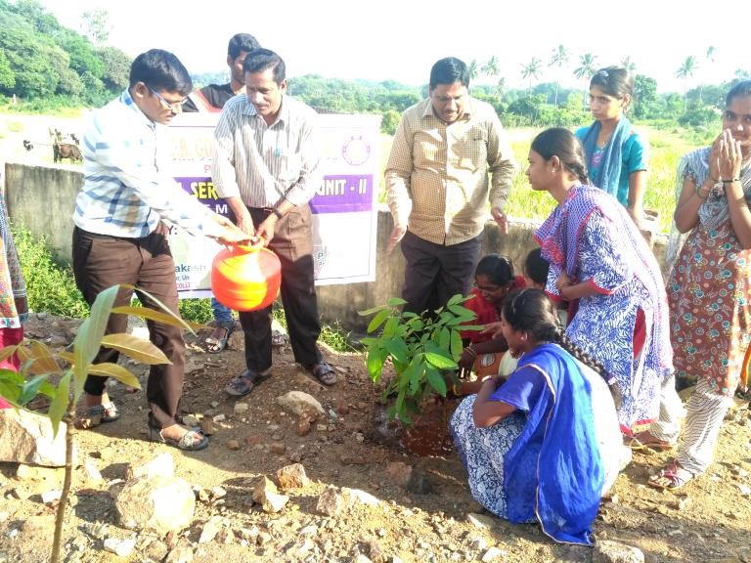
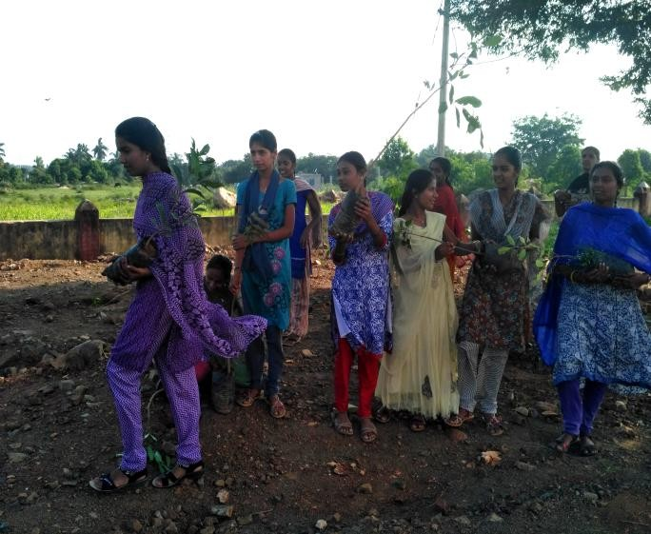

SVCR GOVT DEGREE COLLEGE
PALAMANER

PROGRAM NAME: NATIONAL UNITY DAY
PROGRAM DATE: 31.10.2017
TIME: 09.00 AM
VENUE: GROUND
RESOURCE PERSON: COLLEGE
CIRCULAR
All the staff and the students are instructed to celebrate the National Unity Day on 31.10.2017, at 9 AM.

OBJECTIVE OF THE PROGRAMME:
The objective of the program is to recall the sacrifice made by the great leader of India, Sardar Vallabhai Patel.
REPORT OF THE PROGRAMME:
National Unity Day was observed on 31st October 2017 on the Birth Anniversary of SardarVallabh Bhai Patel. The NSS Unit of our college successfully observed this day.On thisoccasion, the NSSvolunteers,NCCcadetsandstudentscombinetookactivepartin“National Unity Oath Ceremony” in the college. The Principal of our college Dr. P. Babu addressedthe students about national unity. His speech recalled the life history of Sardar VallabbhaiPatel and his contributions for integrating India during post independence period. Finally, theprogram was concluded through National Anthem. Further, NSS Programme Officer, Teaching,Non-teaching staff, NSS volunteers, NCC cadets of the college have actively involved in the“RunforUnity”.

OUT COME:
The students and the staff praised the activities of Sardar Vallabhai Patel and his contributions.
A friendly and cooperative Run for Unity is done.

SIGNATURE OF THE STUDENTS:

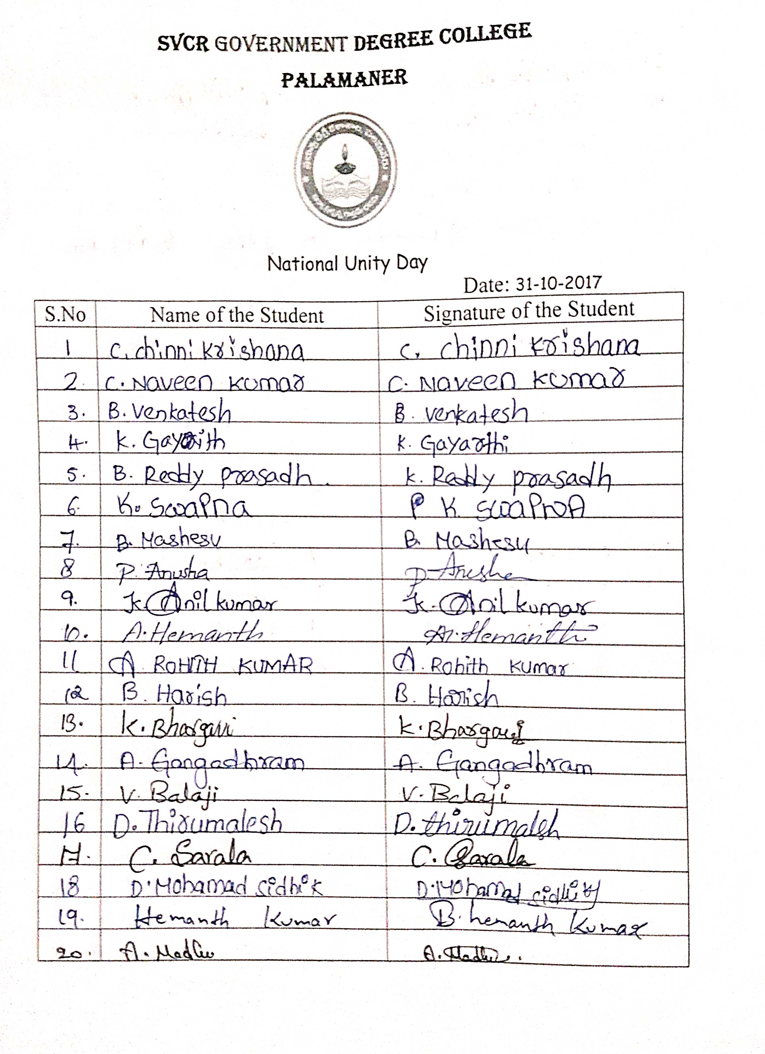

FEED BACK:
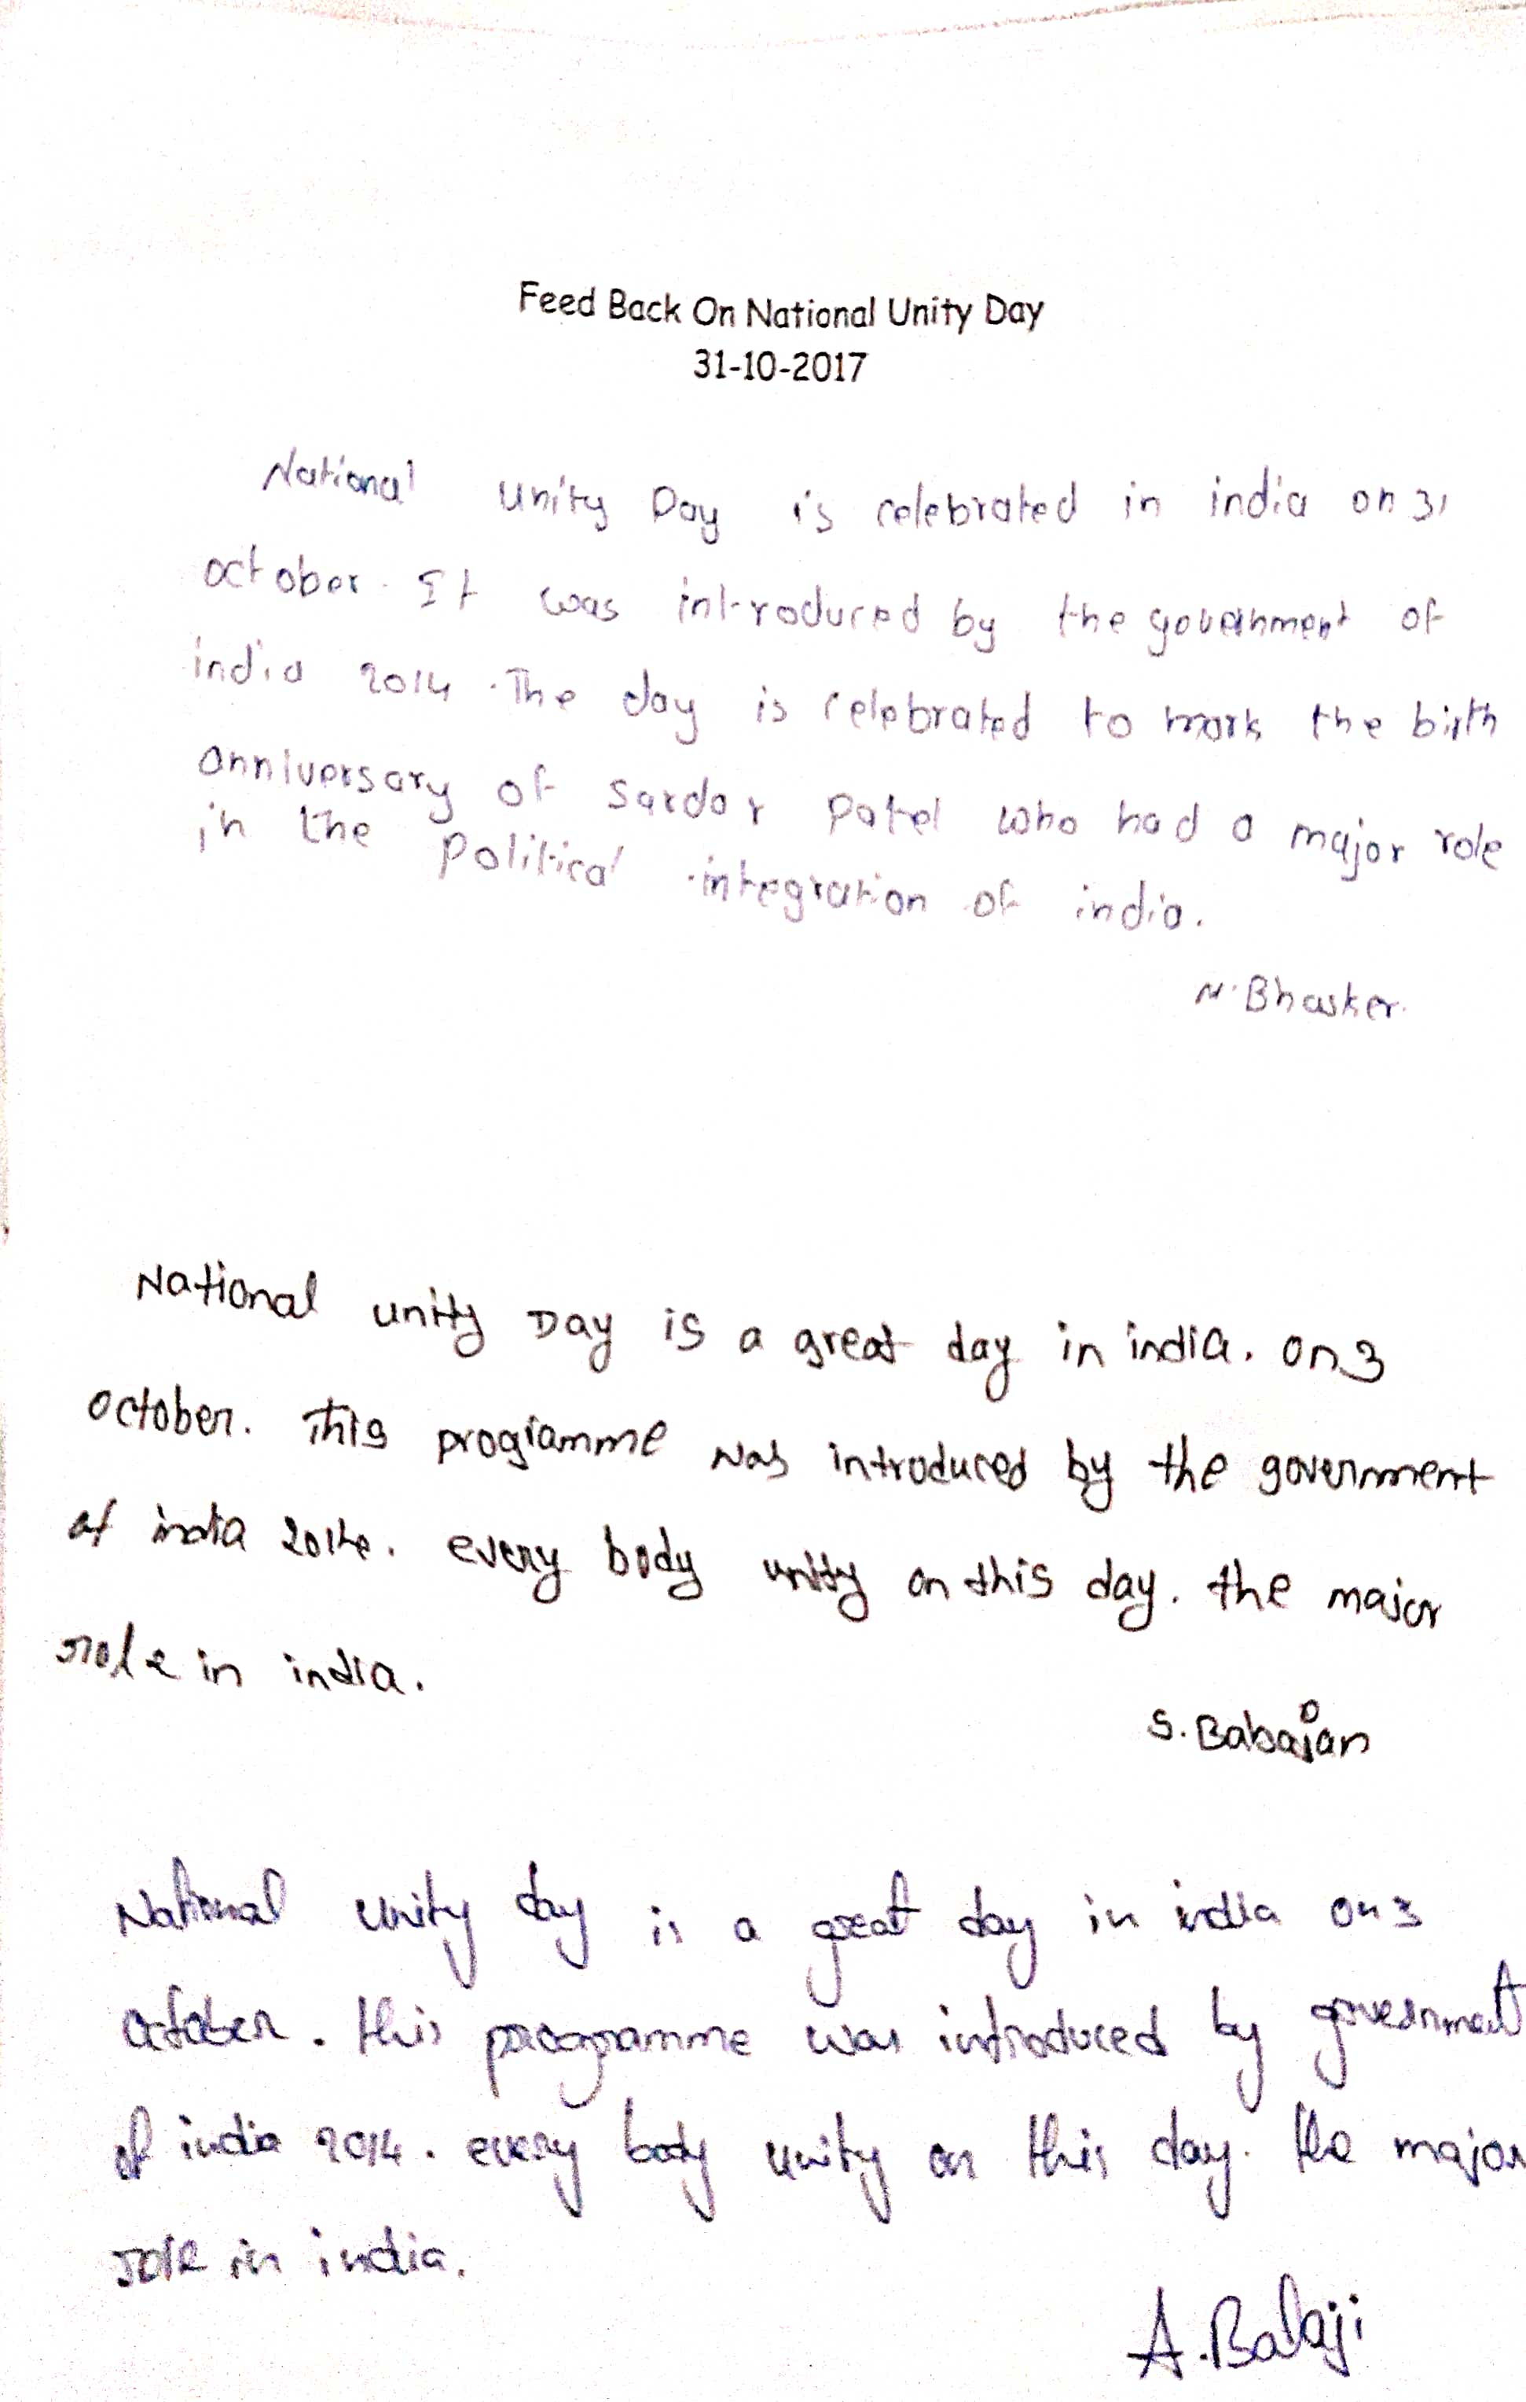
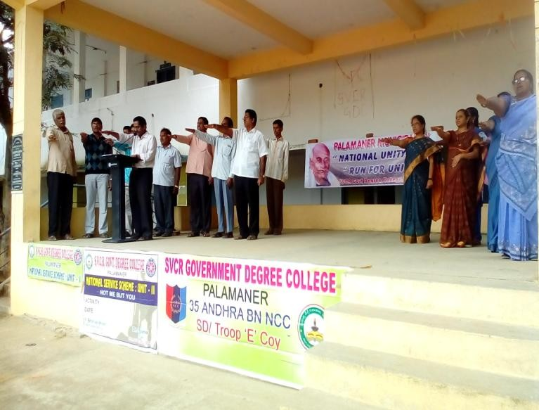
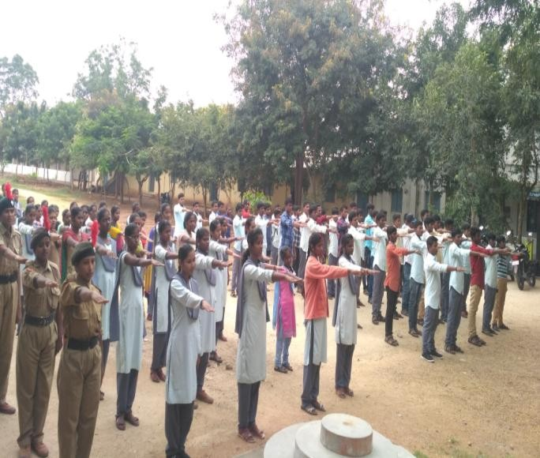
PHOTOS:
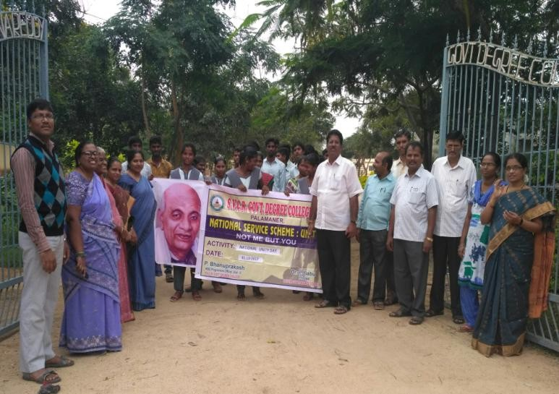
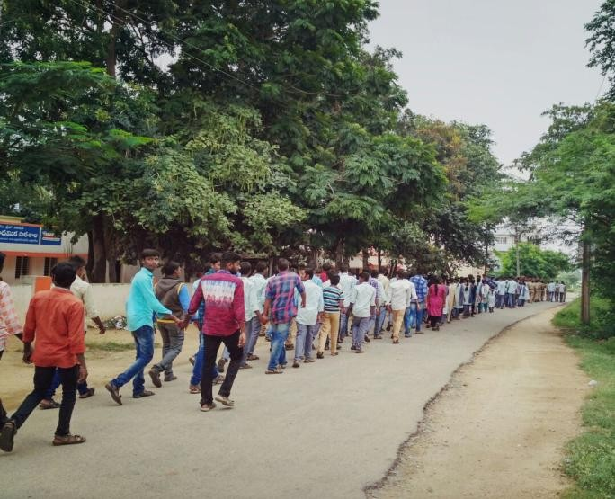

. SVCR GOVT DEGREE COLLEGE
PALAMANER
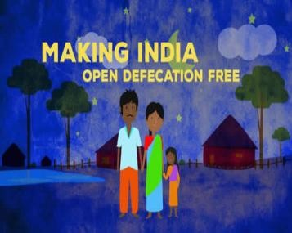

PROGRAM NAME: AWARENESS PROGRAMME ON “OPEN DEFECATION FREE”
PROGRAM DATE: 18.11.2017
TIME: 09.00 AM
VENUE: T. ODDURU
RESOURCE PERSON: NSS UNIT

CIRCULAR
To make India Open Defication Free a campaign is going to be conducted by the NSS unit -I in T. Vadduru village. The program officer Sri E. Chandra Naidu will conduct the campaign. Hence all the volunteers and the interested students can attend the the campaign.

Sd/-
Principal
OBJECTIVE OF THE PROGRAMME:
The objective of the campaign to make India “Open Defecation Free”.
To create awareness among the villagers on the hazards of open defecation.
REPORT OF THE PROGRAMME:
NSS Unit organized awareness Programme on “Open Defecation Free” (ODF) at T. OdduruVillageon18thNovemeber2017.Awarenessrallyon“OpenDefecationFree” was conducted in the village by NSS Volunteers. The rally wasinaugurated by Sri. Krisnappa, Sarpanch, T. Odduru. Sri. Lakshmipathy,Health Supervisor; Smt. Nagamani, ANM, Palamaner, School teachers,NSS PO and NSS Volunteers took active role in conducting the rally.Later, the volunteers involved in door to door campaign and explainedthemtouseIHHLschemesponsoredbyGovt ofA.Ptomakethevillage ODF. The volunteers also briefed the villagers about contamination from open defecationwhichleadsto waterpollution andspreadsdiseaseslikediarrhea,choleraetc.

OUT COME:
High rate of people availed of the opportunity and constructed toilets.
SIGNATURE OF THE STUDENTS:
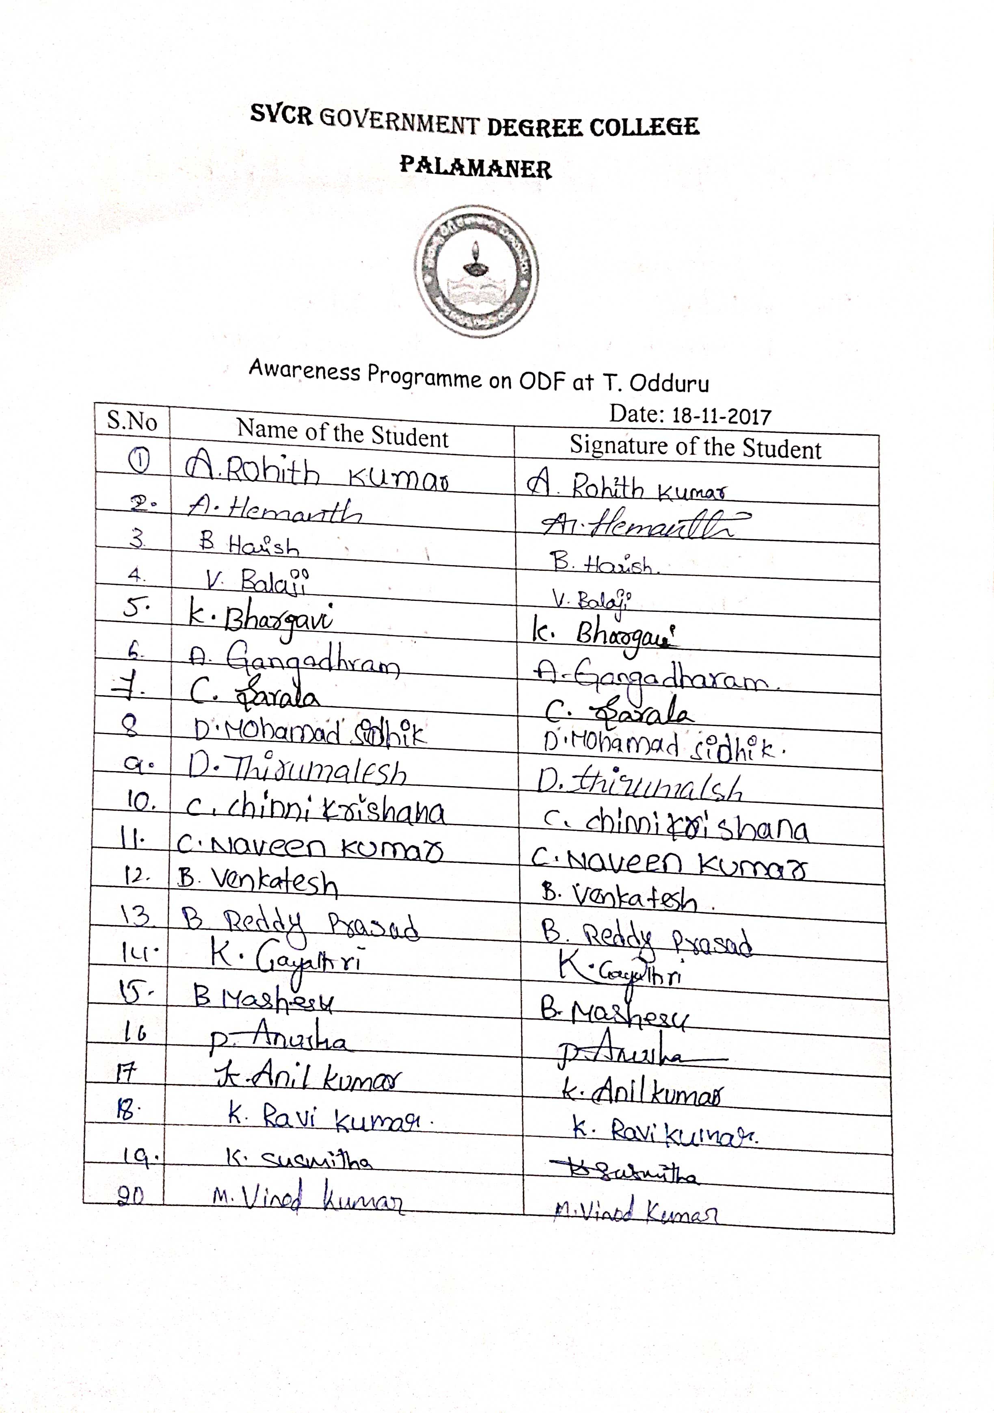

FEED BACK:
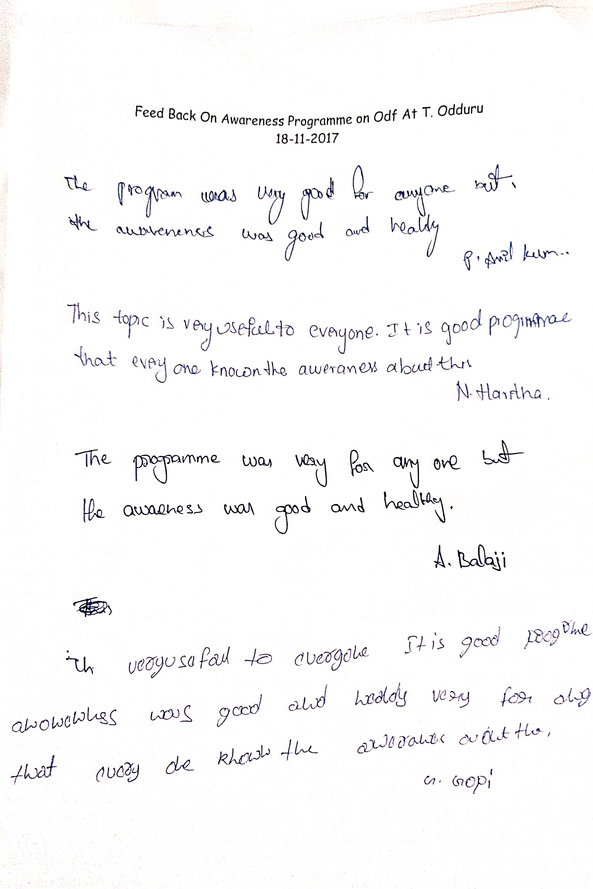

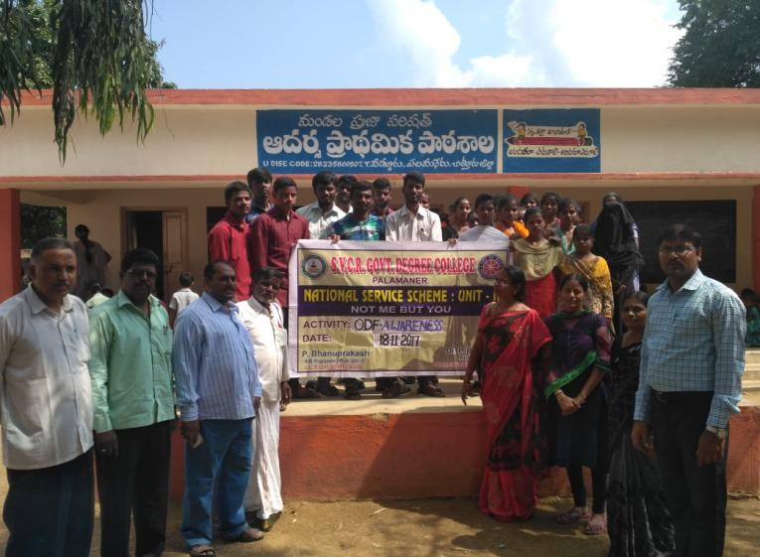
PHOTOS:
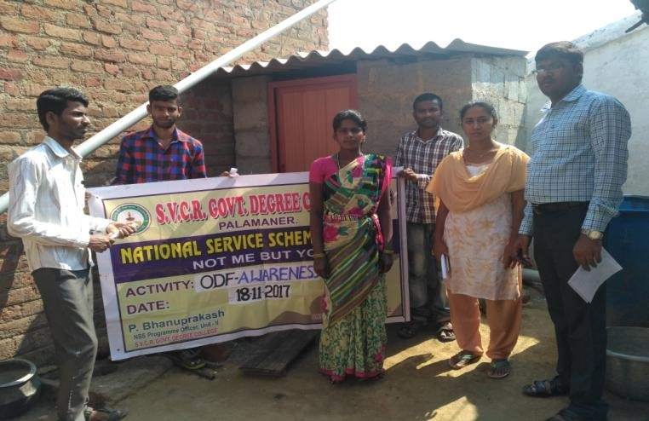
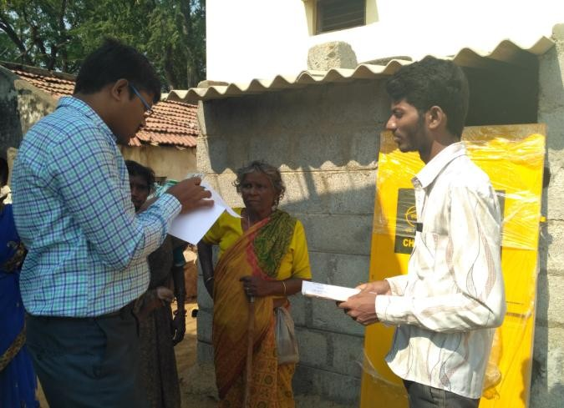
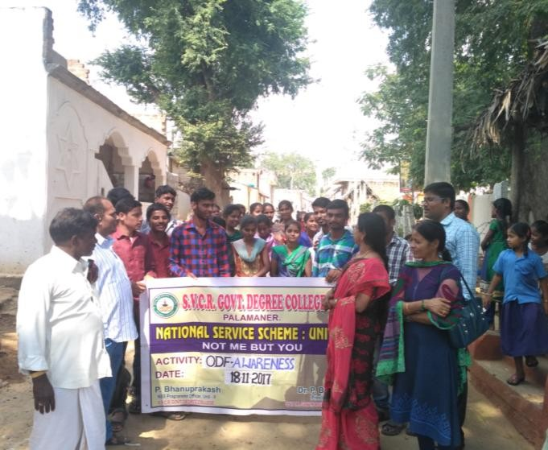

SVCR GOVT DEGREE COLLEGE
PALAMANER

PROGRAM NAME: BLOOD DONATION CAMP
PROGRAM DATE: 24.11.2017
TIME: 09.00 AM
VENUE: SVCR GOVT.DEGREE COLLEGE PALAMANER
RESOURCE PERSON: NSS UNIT

CICULAR
A service oriented Blood Donation Camp is going to be conducted on 24.11.2017 by the NSS, NCC and RRC of the college. The interested candidates can attend the program and the eligible can donate blood.

OBJECTIVE OF THE PROGRAMME:
To make the students to donate blood.
To sensitize the students on the necessity of donating blood.
REPORT OF THE PROGRAMME:
A blood donation camp was organized on 24th November 2017 by the NSS Unit of the college and in association with Blood bank, Govt Hospital, Chittoor. Sri. Durga Prasad, Health Officer and his team of six members worked throughout the day to collect blood. The blood donation camp is inaugurated by the Principal, Dr. P. Babu. A week before the camp, created awareness and encouraged students to donate blood without any apprehension. NSS Program Officer and 39 students came forward to donate blood and a total of 34 units of blood were collected. Principal in his presidential remarks congratulated the NSS Unit and Blood Bank team for having organized an event of social benefit and also assured to support for similar events in the days to come. P. Bhanuprakash and E. Chandra Naidu, NSS Program Officers, NSS Volunteers have taken great efforts to conduct programme smoothly. Refreshments were provided to those who donated their blood, Medical team and to the NSS volunteers.

OUT COME:
39 students donated blood.
More number of students came forward to donate blood.
SIGNATURE OF THE STUDENTS:
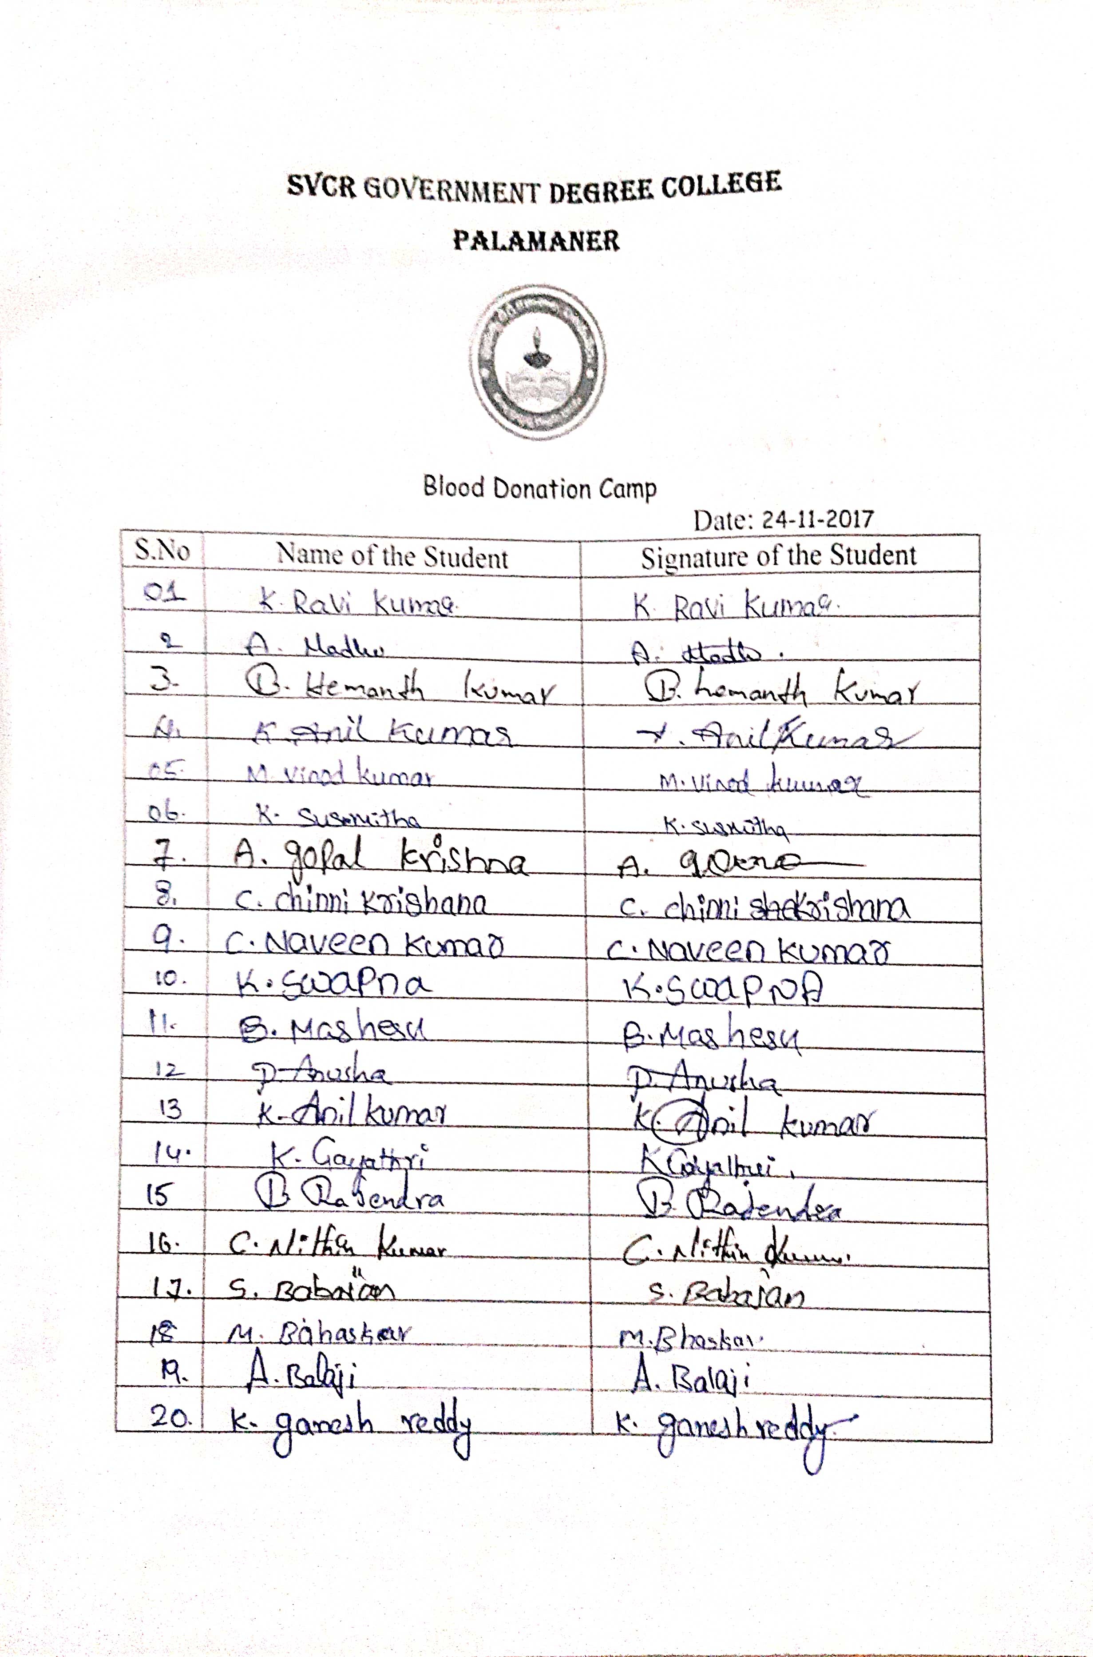
FEED BACK:

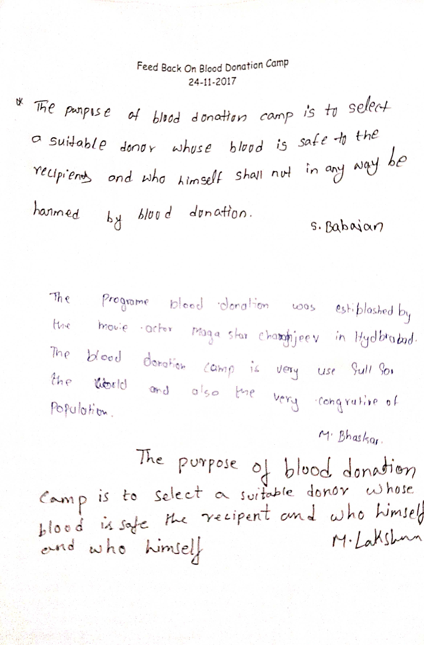
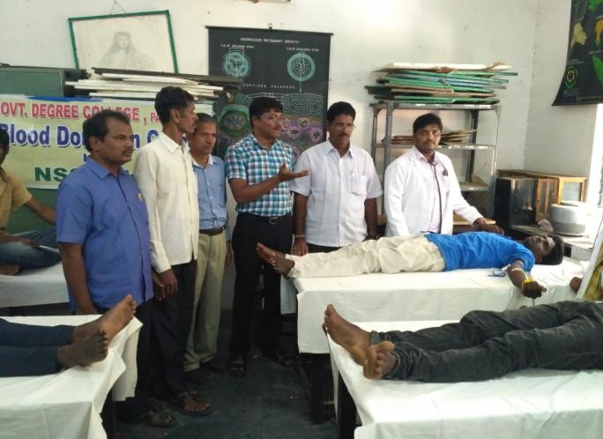
PHOTOS:
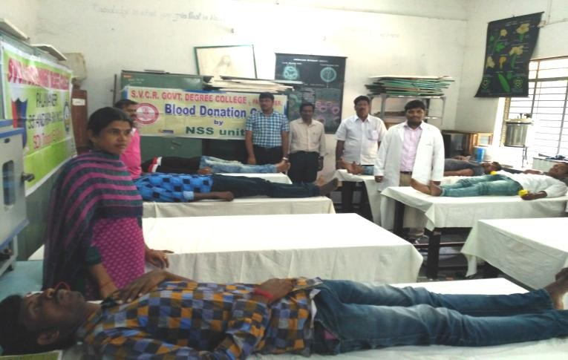
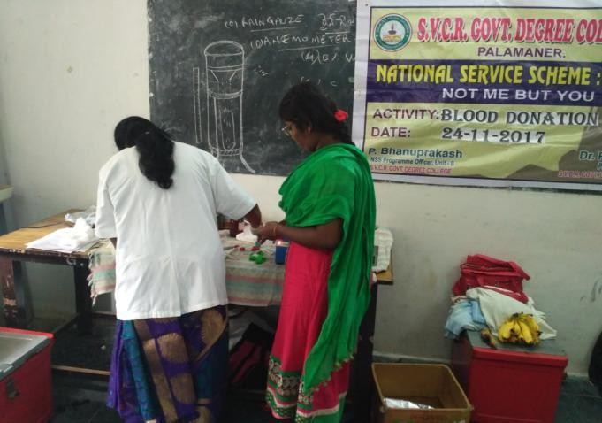
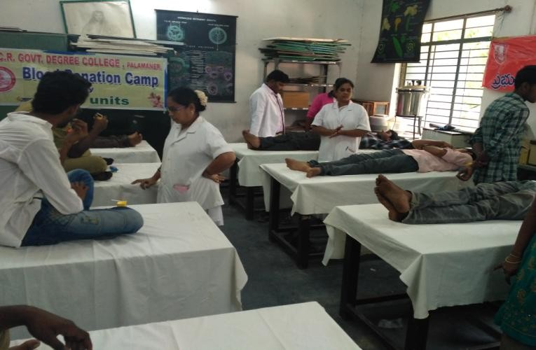

SVCR GOVT DEGREE COLLEGE
PALAMANER

PROGRAM NAME: OPEN DEFECATION FREE SURVEY
PROGRAM DATE: 25.11.2017
TIME: 10.00 AM
VENUE: JALLIPETA AND MUDIVARIPALLI VILLAGES OF PALAMANER
RESOURCE PERSON: NSS UNIT

CIRCULAR
The NSS volunteers are going to conduct ODF survey in Jallipeta and Mudivaripalli villages on 25.11.20217. Interested staff can accompany them.

OBJECTIVE OF THE PROGRAMME:
The objective of the program is to sensitize the villagers on the hazards caused by open defecation and to motivate them to construct toilets.
REPORT OF THE PROGRAMME:
NSS volunteers involved in ODF Survey in Jallipeta and Mudivaripalli Villages of Palamaner. Thevolunteers took survey in 261 households of the villages and created awareness to constructIndividual House Hold Latrine. In our survey we found that 74 household were already utilizingthe toilets, toilets in 151 households were under construction and the remaining houses wereapplied for IHHLScheme by Govtof A.P. After awareness onODF mostof thehousesconstructedtoiletsandwereunderutilization.

OUT COME:
More toilets were built in villages with the sensitization done by the students.

SIGNATURE OF THE STUDENTS:
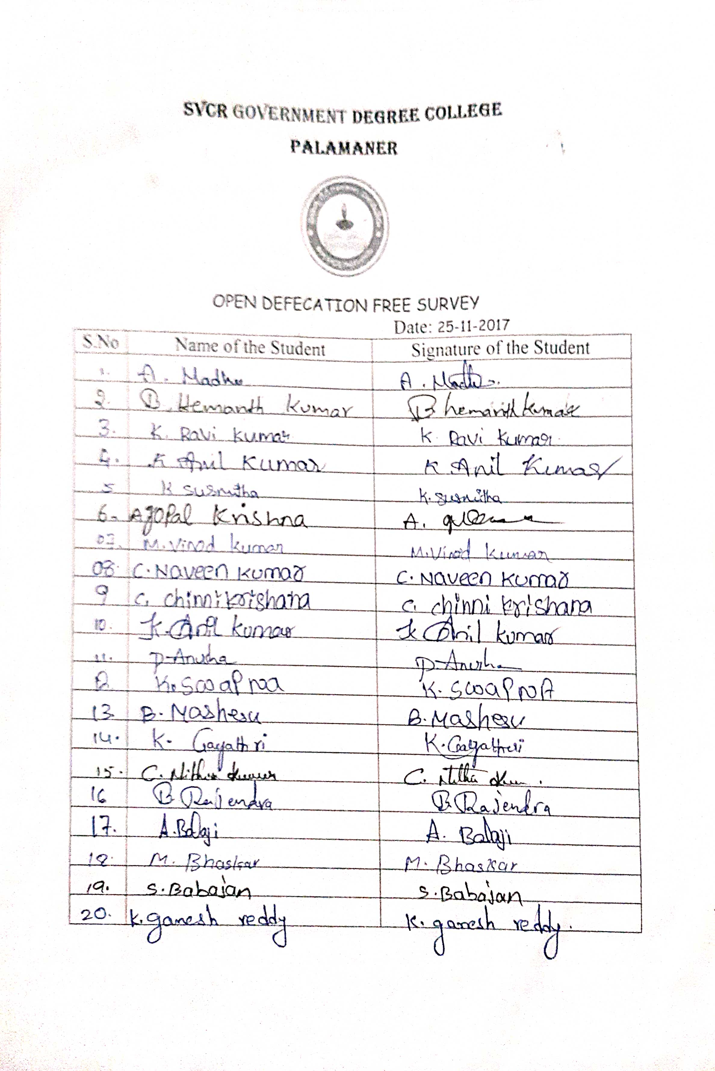

PHOTOS:
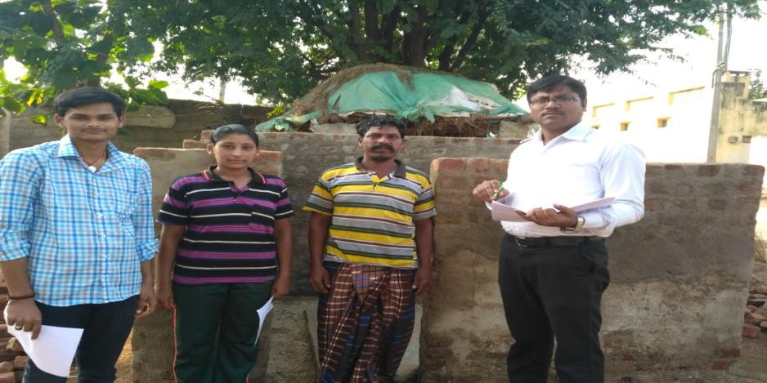

SVCR GOVT DEGREE COLLEGE
PALAMANER

PROGRAM NAME: AWARENESSRALLYON AIDS
PROGRAM DATE: 01.12.2017
TIME: 09.00 AM
VENUE: ON ROAD
RESOURCE PERSON: COLLEGE

CIRCULAR
The NSS, NCC and RRC units of the college are going to conduct a rally on creating awareness on HIV AIDS among the uneducated citizens of the town on 01.12.20218. All the students and the staff must participate in the rally.

OBJECTIVE OF THE PROGRAMME:
The objective of the program is to educate the citizens of the town on the deadly disease HIV AIDS. To promote an environment for a healthy society by the students.
REPORT OF THE PROGRAMME:
AIDS awareness rally was organized by the NSS units of the college on 1st December 2017. NSS volunteers participated in AIDS Awareness rally from College to Gudiyattham Road. This rally was aimed to create awareness about Causes and Preventive measures of HIV/AIDS. This rally was also intended in demolishing the various myths that go around in the society about the spreading of AIDS.
OUT COME:
The students participated in the rally and sensitized the uneducated citizens on the deadly effects of the disease HIV AIDS.

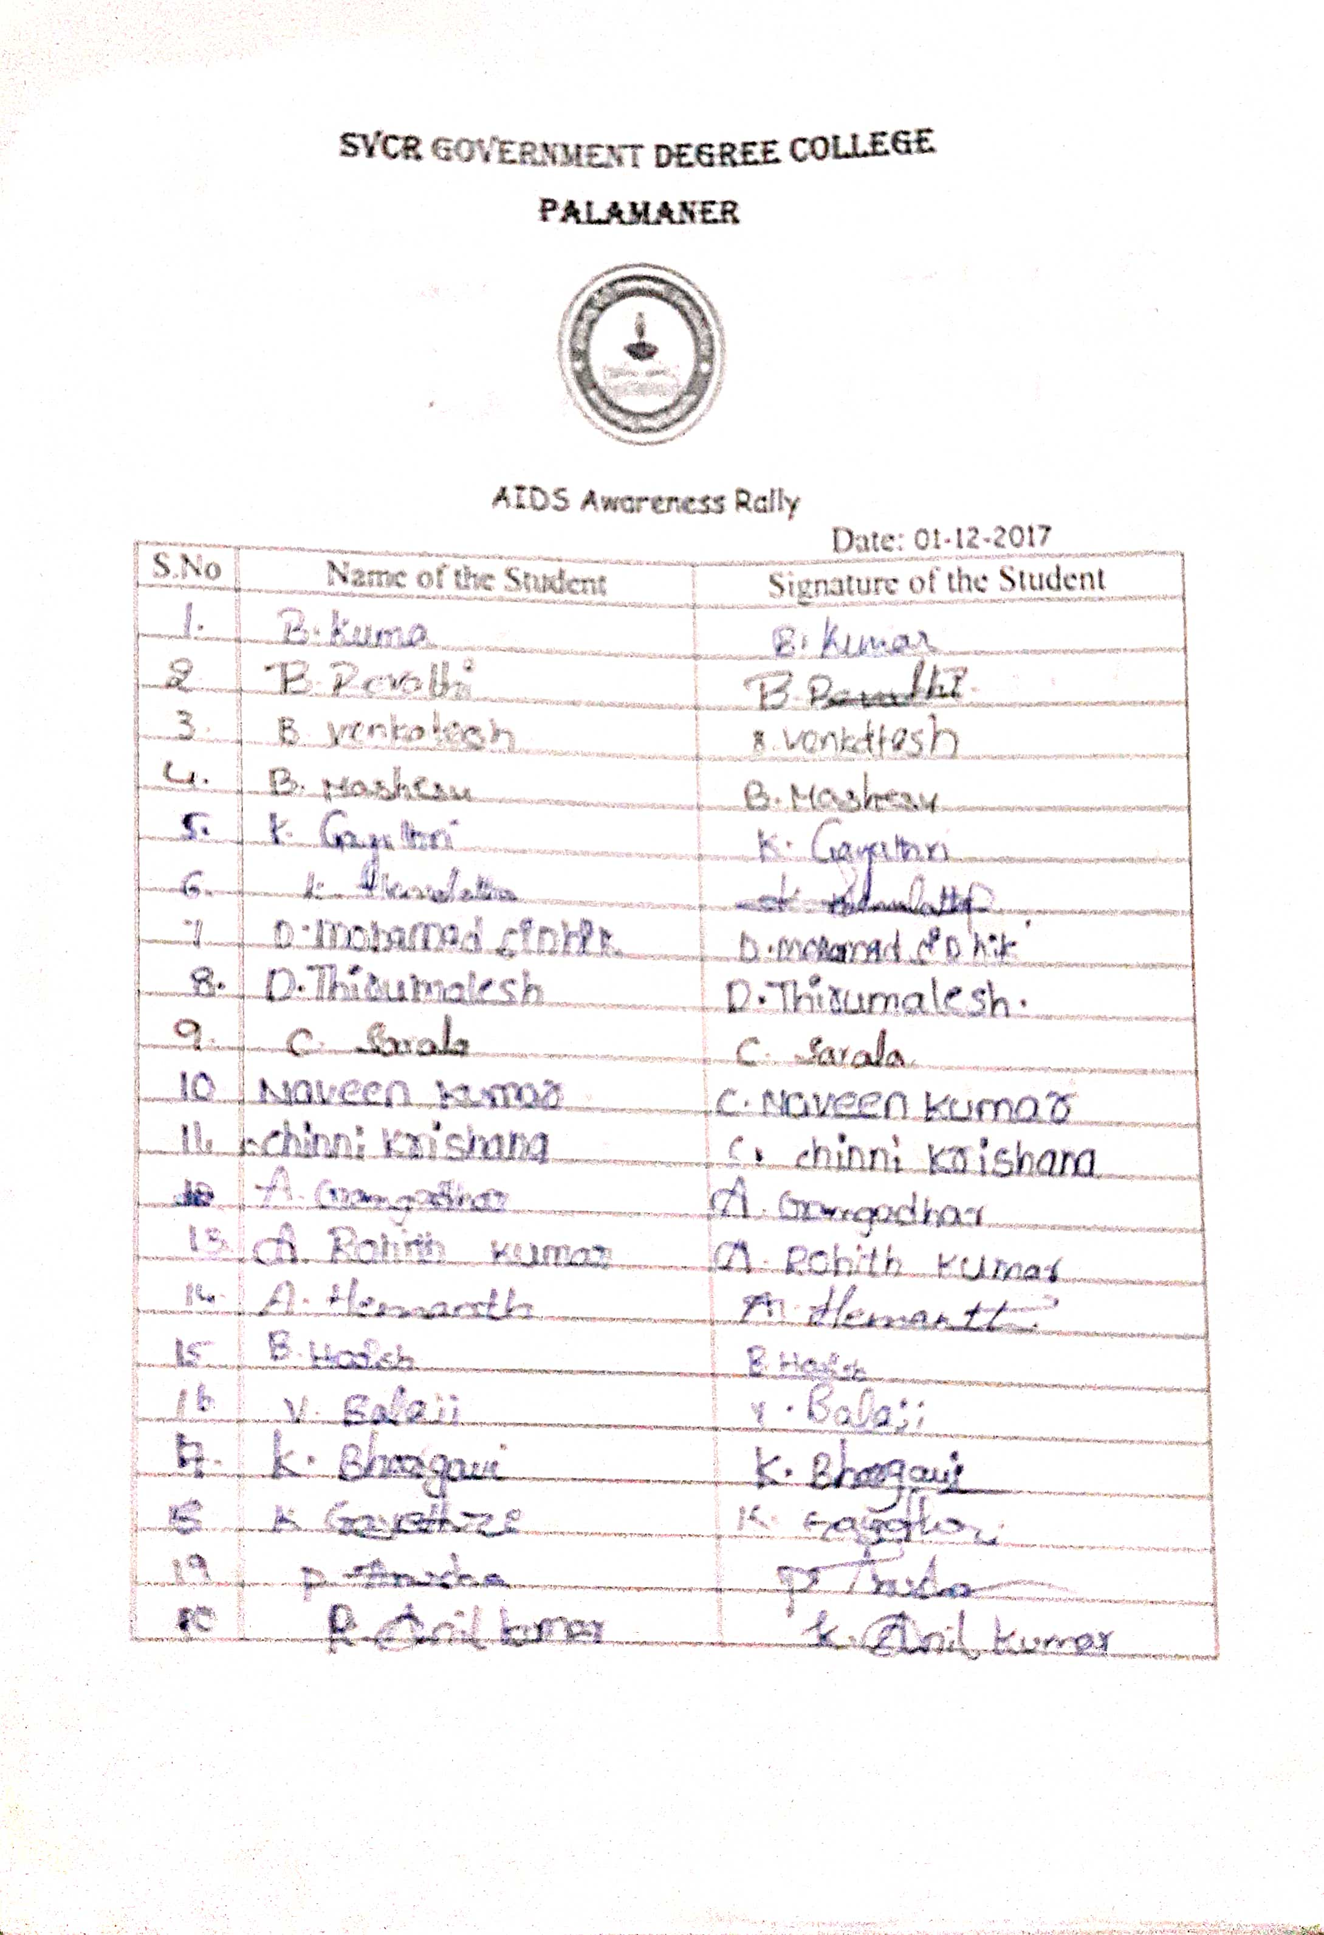
SIGNATURE OF THE STUDENTS:

PHOTOS:
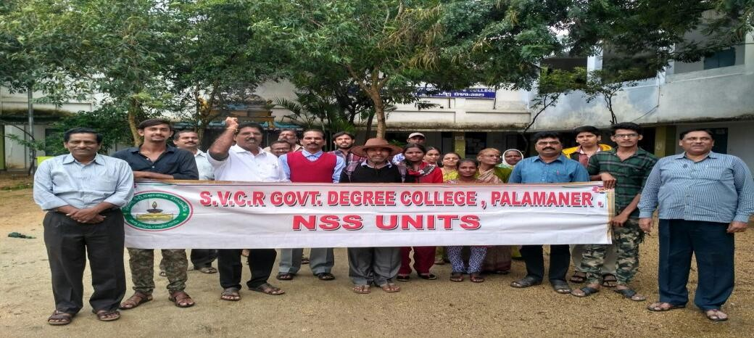

SVCR GOVT DEGREE COLLEGE
PALAMANER
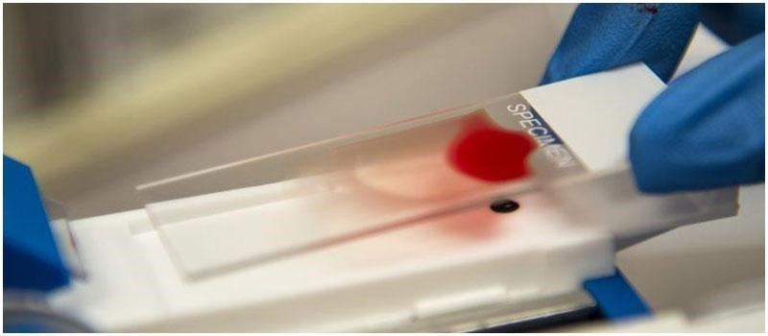

PROGRAM NAME: BLOODGROUPIDENTIFICATION PROGRAMME
PROGRAM DATE: 06.02.2018
TIME: 09.00 AM
VENUE: SVCR GOVT.DEGREE COLLEGE, PALAMANER
RESOURCE PERSON: HEALTH DEPARTMENT OF PALAMANER

CIRCULAR
All the students and the staff are hereby informed that the blood grouping will be done by the students of Zoology. Hence, all must attend the program.

OBJECTIVE OF THE PROGRAMME:
To know about blood group of the students.
To encourage the students to do blood grouping.
REPORT OF THE PROGRAMME:
The NSS unit in association with the Department of Zoology & Chemistry, SVCR GDC, Palamanerorganized the Blood Group Identification Programme for the college students on 06th February2018.The blood group of 112 students was identified through this Programme. Out of whichuniversal donors are 37 students, 12 students are universal acceptors. 96% of the student bloodgroup is positive (+).The remaining 4% of blood samples of the students doesn’t have Rhesusfactor and hence the blood group is negative. We are maintaining the blood group database ofourcollegestudentstoarrangebloodonthespot totheneedy patientsinemergency.

OUT COME:
Blood grouping was done for many students.

SIGNATURE OF THE STUDENTS:
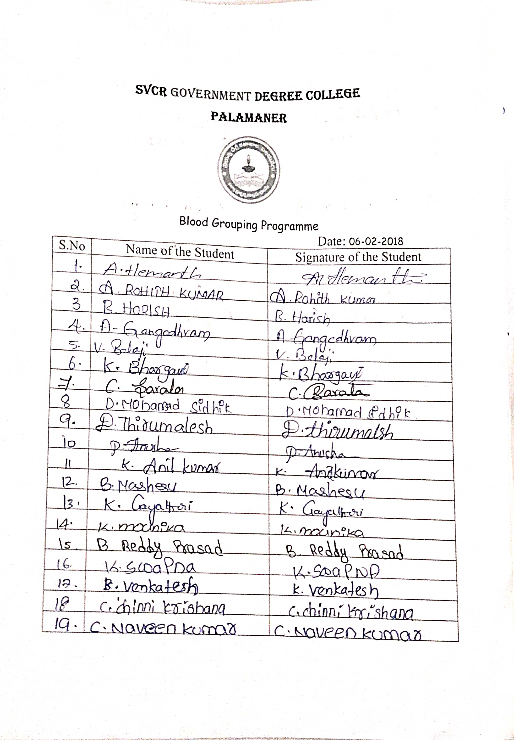
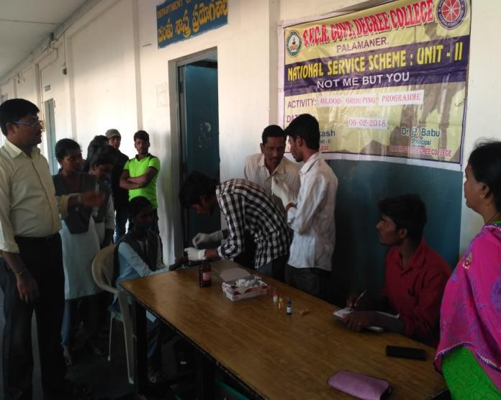
PHOTOS:
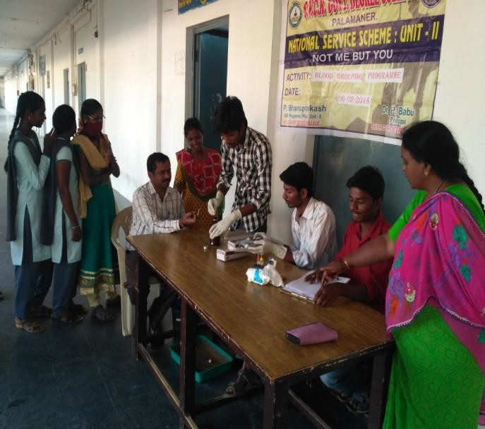
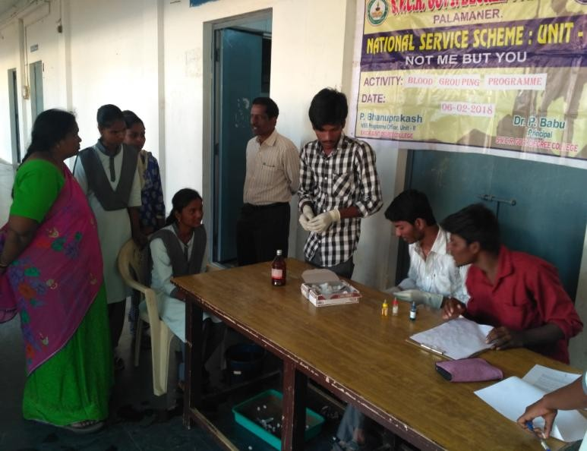
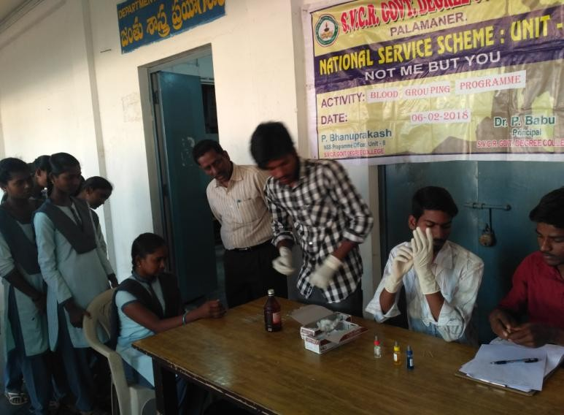

SVCR GOVT DEGREE COLLEGE
PALAMANER
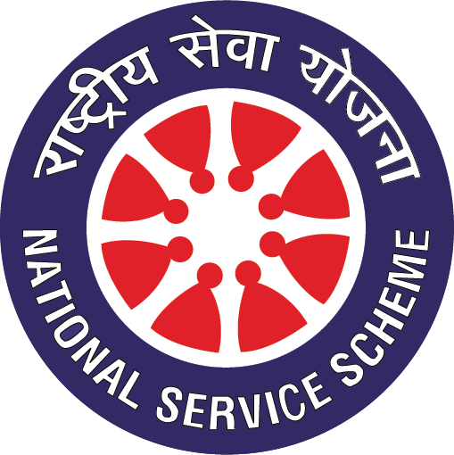

PROGRAM NAME: Participation of NSS Volunteers in Camps
PROGRAM DATE: 24.10.2017 TO 28.10.2017
TIME: 09.00 AM
VENUE: ROOM NO: 18
RESOURCE PERSON: NSS UNIT
OBJECTIVE OF THE PROGRAMME:
- To make students to motivate to participate in team work activities.
REPORT OF THE PROGRAMME:
- Four NSS volunteers of the college participated in State Level Residential IntegrationCamp organized by Department of Youth Services, Govt. of Andhra Pradesh at C.B.R.AcademyofSports &Education,Kethanakonda,KrishnaDistrict.
- OurVolunteersparticipatedinUniversitylevelYouthFestivalConductedatS.V.University, Tirupati.
- NSS Volunteers also Participated inDRC activitiesheld atvarious collegesinthedistrict.
OUT COME:
The students are well motivated to attend the programs of such varieties.

SIGNATURE OF THE STUDENTS:
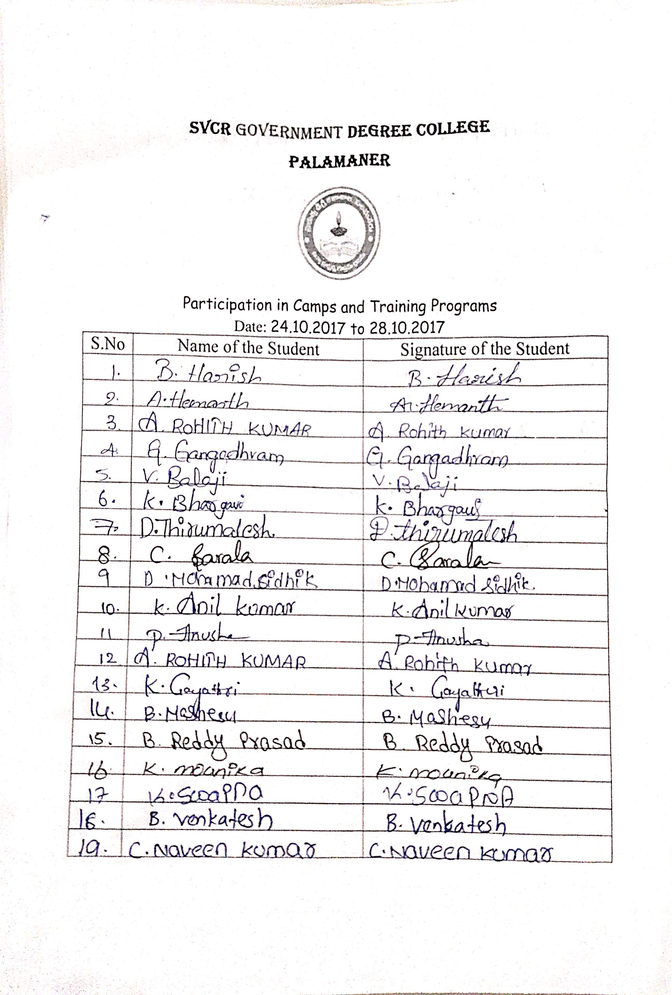
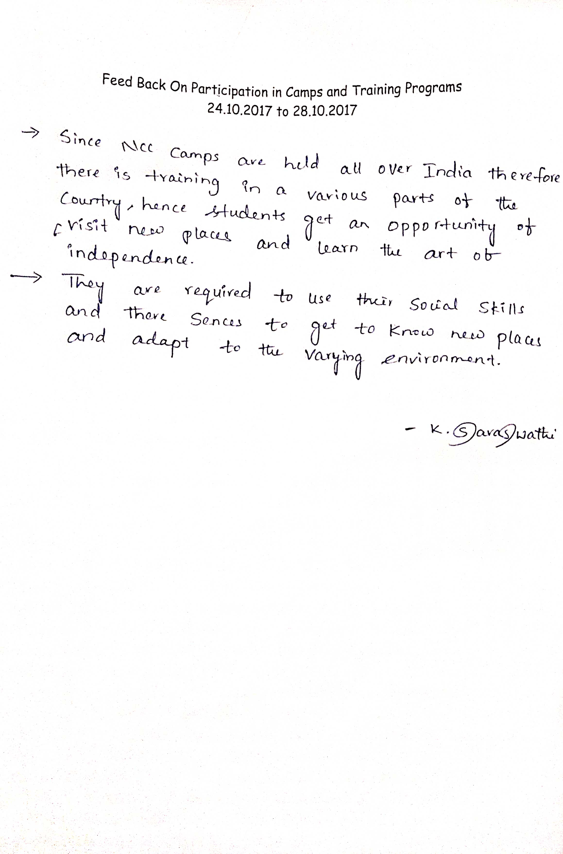
FEED BACK:

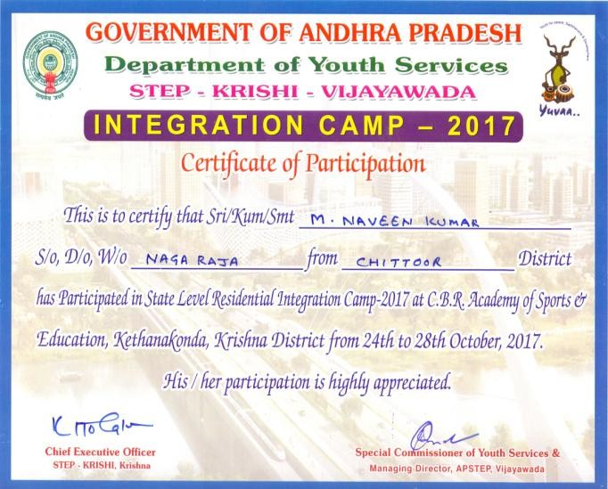
CERTIFICATES:
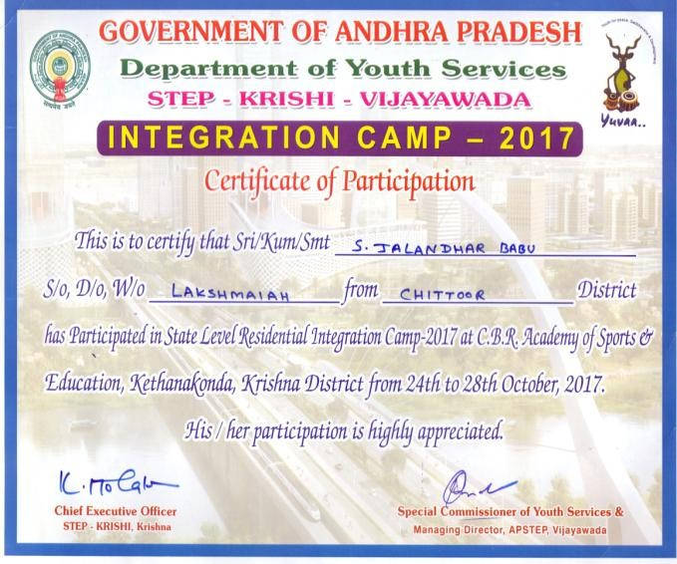
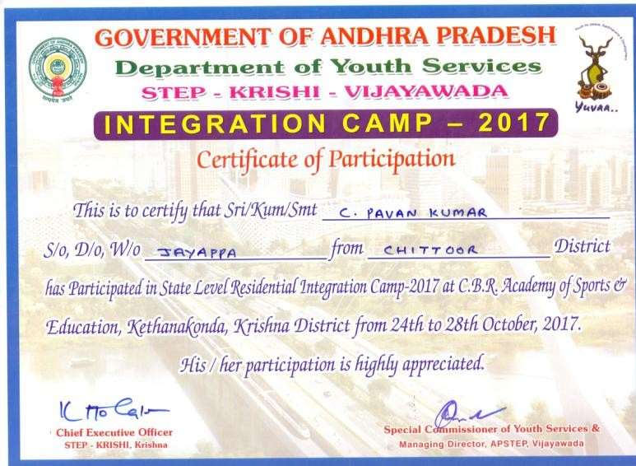
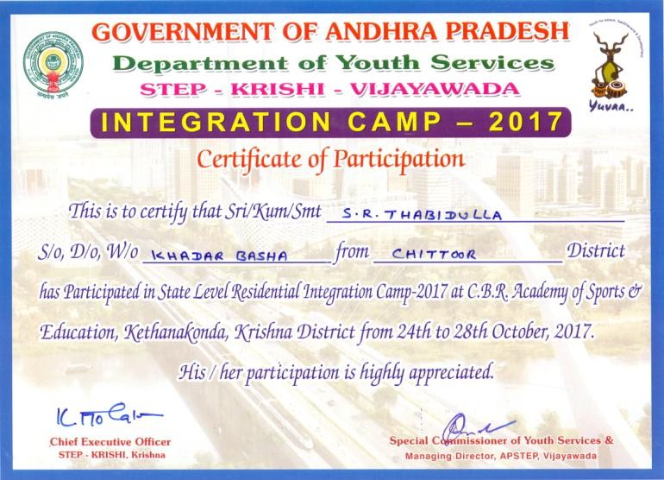

SVCR GOVT DEGREE COLLEGE
PALAMANER

PROGRAM NAME : WORLD ENVIRONMENT DAY
PROGRAM DATE : 05.06.2018
TIME : 10.00 AM
VENUE : COLLEGE GROUND
RESOURCE PERSON : PRINCIPAL

OFFICE OF THE PRINCIPAL
SVCR GOVT. DEGREE COLLEGE
Re-accredited by NAAC with 'B' Grade
==============================================================================

Dated: 04/06/2018

CIRCULAR

This is to inform all the students and the staff tomorrow (05.06.2018) our college is going to conduct “World Environment Day" celebrations. This year, India is the global host of 2018 World Environment Day. With “Beat the Plastic Pollution” as the theme for this year’s edition, the world is coming together to combat single-use plastic pollution. Hence, all the staff has to attend along with their students to create awareness for the protection of the environment.

Sd/-
Principal

OBJECTIVES OF THE PROGRAMME:
- To raise awareness about protecting the environment
- To take action for the protection of our environment.
REPORT OF THE PROGRAMME:

It is the duty of every citizen to clear and make the mother earth clean. The usage of plastic is growing every day. So awareness on ban the plastic is very much in need. The students and the staff of the college conducted a rally on the hazards committed by the plastic. The students cleared the plastic debris in and around the college to make the spectators get awareness on the cleanliness. The rally is made in the nearby streets of the town.

OUTCOMES:
- The students and the staff cleared plastic debris.
- The staff and the students conducted a rally to create awareness.
SIGNATURE OF THE STUDENTS:
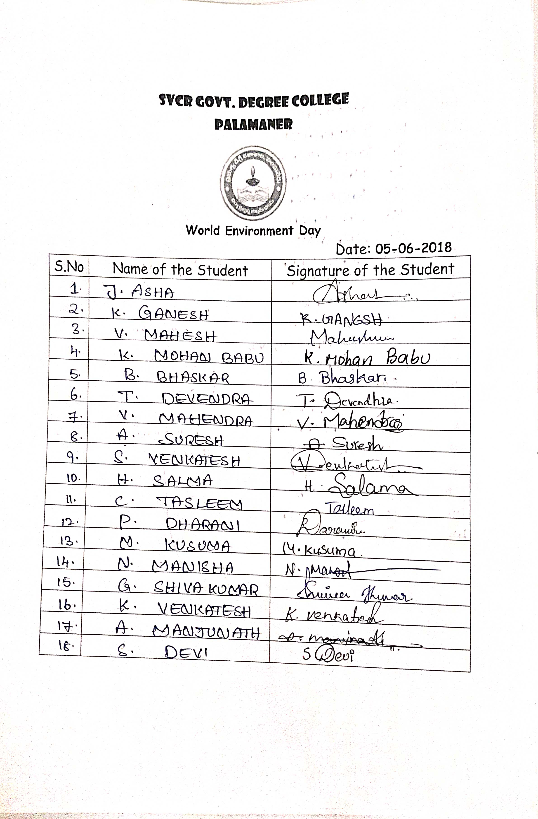

FEED BACK:
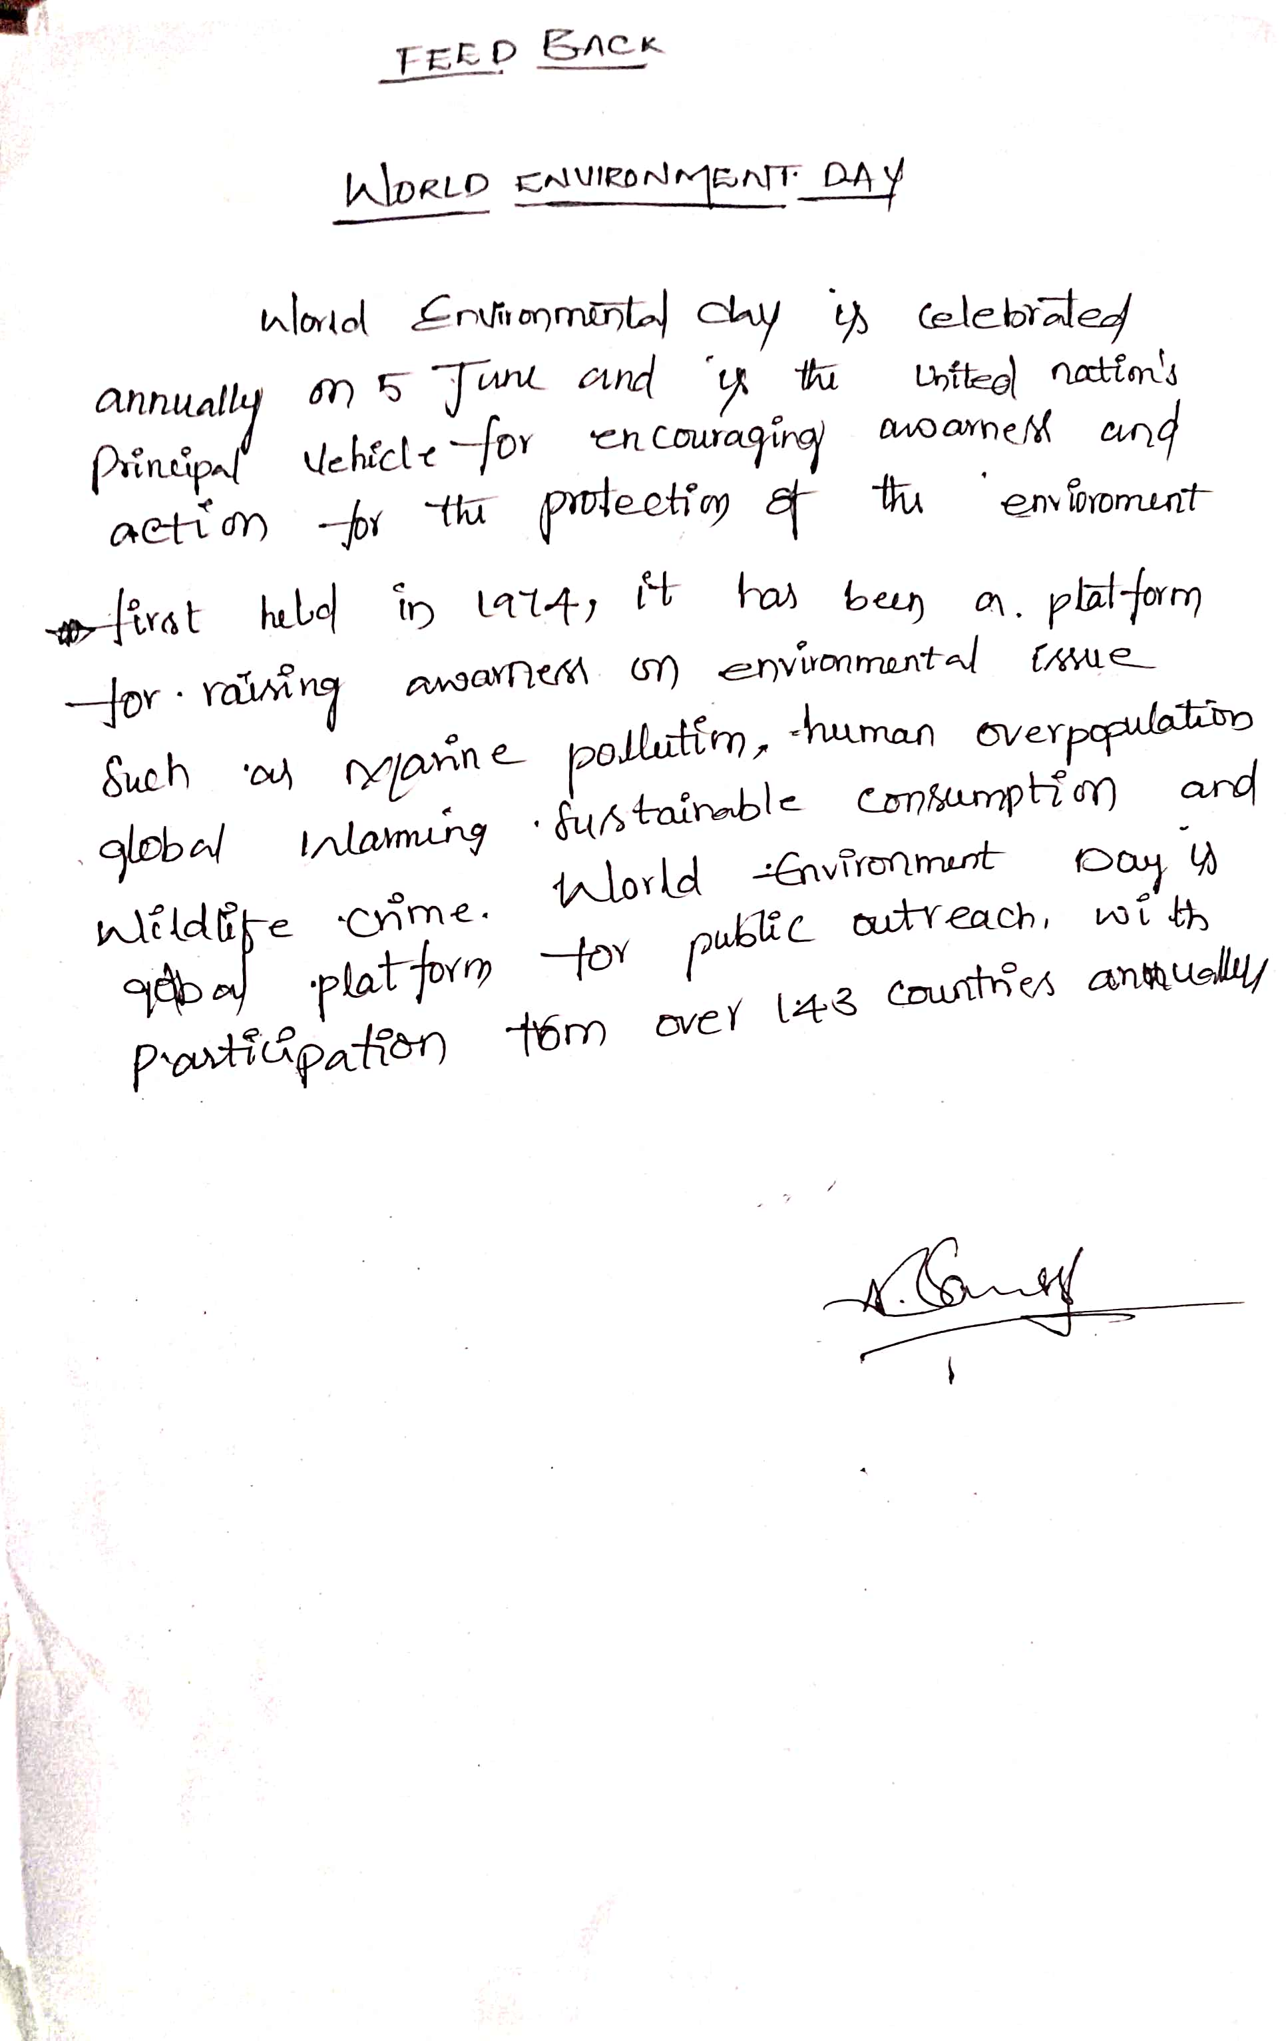

PHOTOS
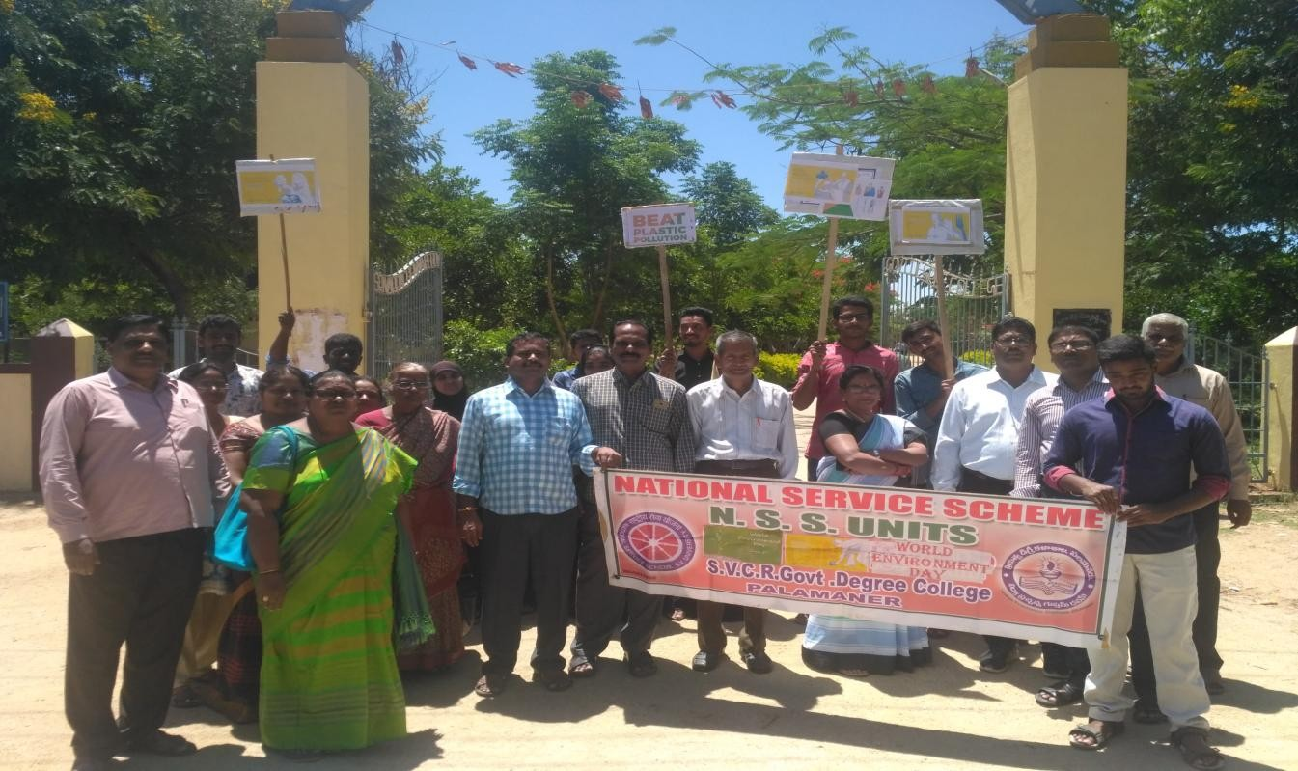
SVCR GOVT DEGREE COLLEGE
PALAMANER
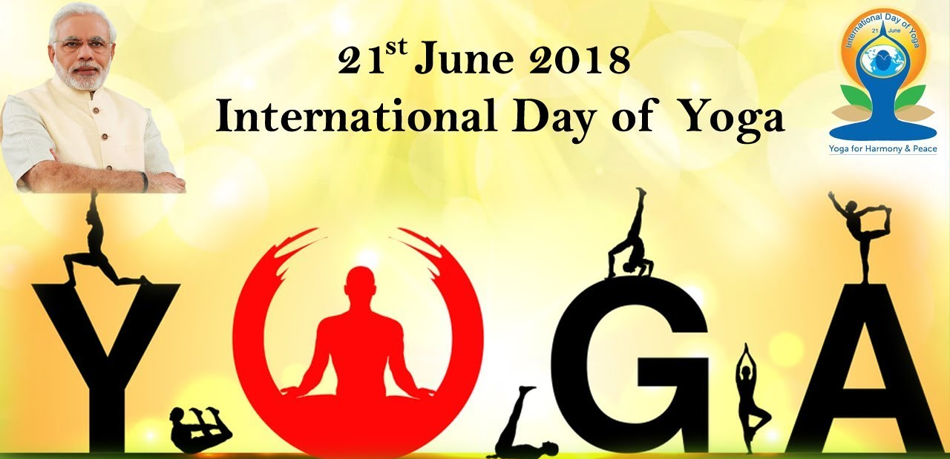

PROGRAM NAME : INTERNATIONAL YOGA DAY
PROGRAM DATE : 21.06.2018
TIME : 10.00 AM
VENUE : COLLEGE CORRIDOR
RESOURCE PERSON : COLLEGE
OFFICE OF THE PRINCIPAL
SVCR GOVT. DEGREE COLLEGE
Re-accredited by NAAC with 'B' Grade
==============================================================================

Dated: 20/06/2018

CIRCULAR

This is to inform all the students and the staff tomorrow (21.06.2018) our college is going to conduct “International Yoga Day" celebrations. This year’s theme is ‘Yoga for Peace’. Yoga is explored to serve as a connecting tool between countries and people of different horizons. Hence, all the staff has to attend along with their students. The main aim is to create awareness on the importance of staying fit and healthy.

Sd/-
Principal

OBJECTIVES OF THE PROGRAMME:
- To create an awareness on the importance of staying fit and healthy.
- To practice various yoga asanas (or postures) and pranayamas (or breathing exercises).
REPORT OF THE PROGRAMME:
The Esha Yoga Guru came to the college to teach the importance of Yoga. He played the CD and explained the need for doing yoga. He explained at length the good effects that we receive when we practice yoga continuously. The students and the staff practiced yoga along with him. The day yield good results to all.

OUTCOMES:
- The students and the staff learnt to do yoga.
- They understood the benefits of practicing yoga.

SIGNATURE OF THE STUDENTS:

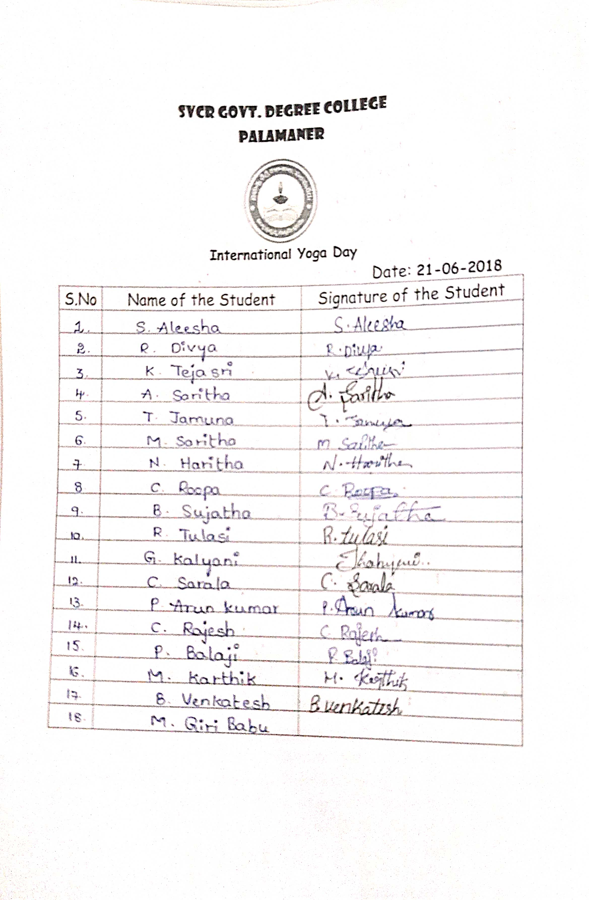

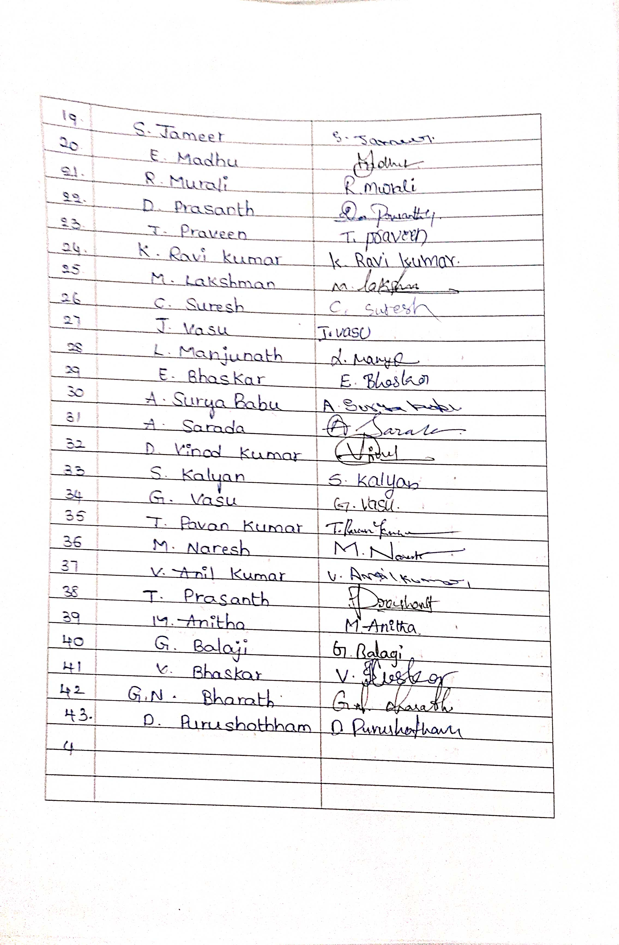
FEED BACK:
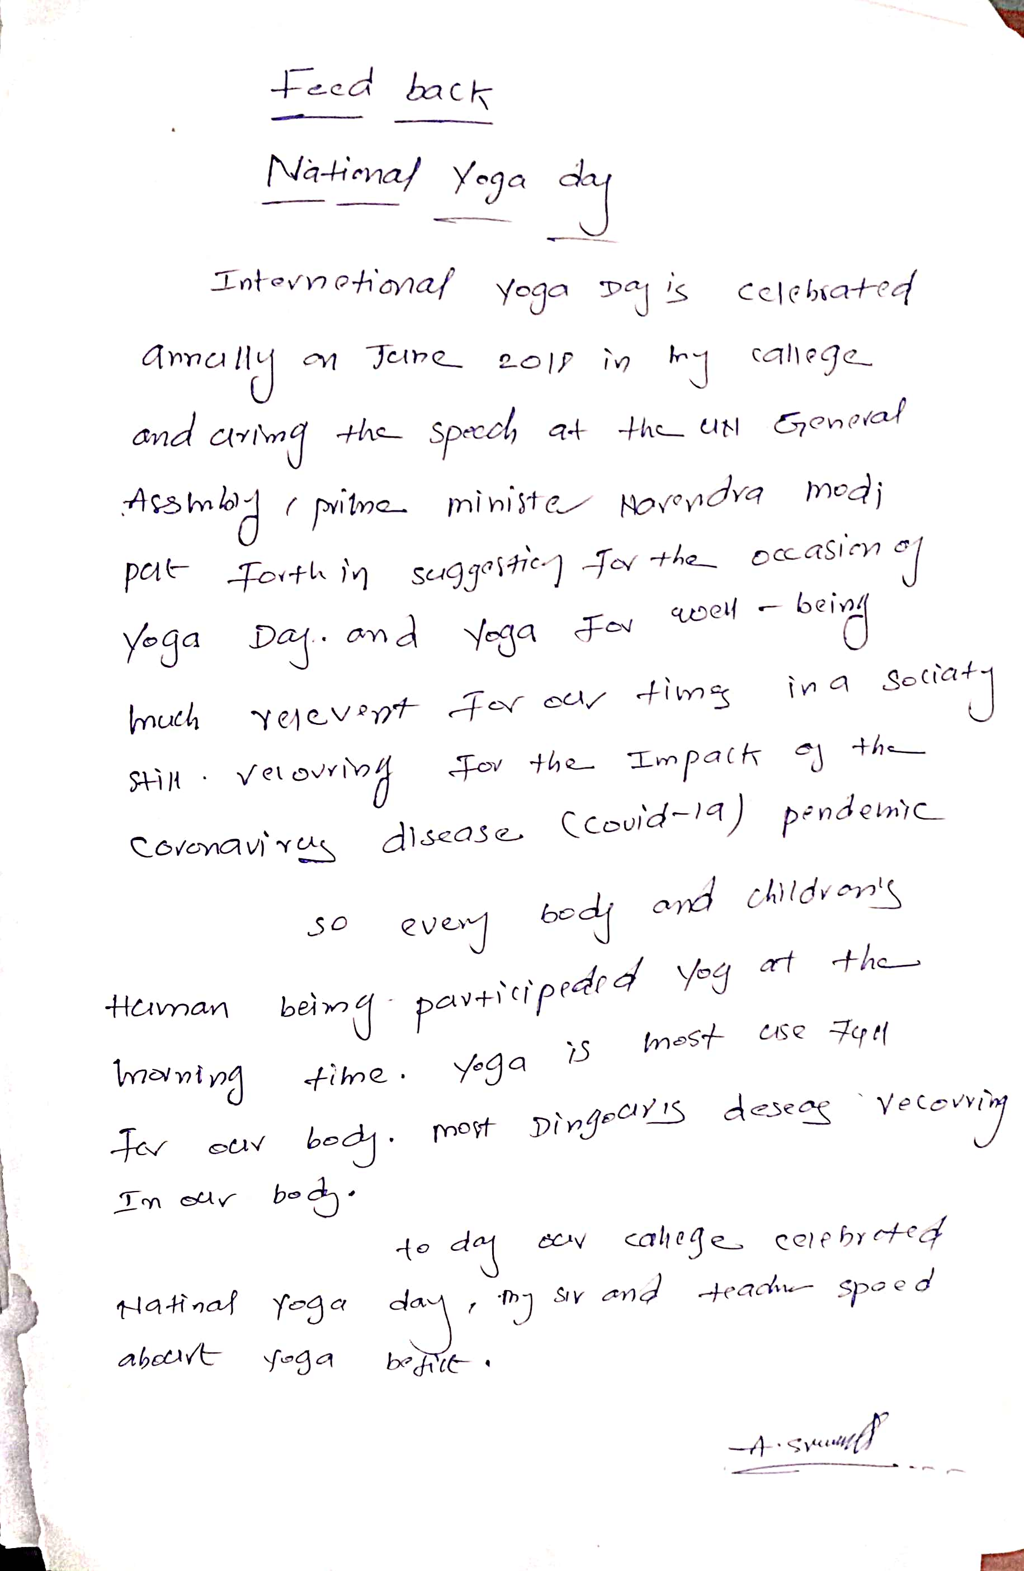

PHOTOS
INTERNATIONALYOGADAY (21-06-2018)

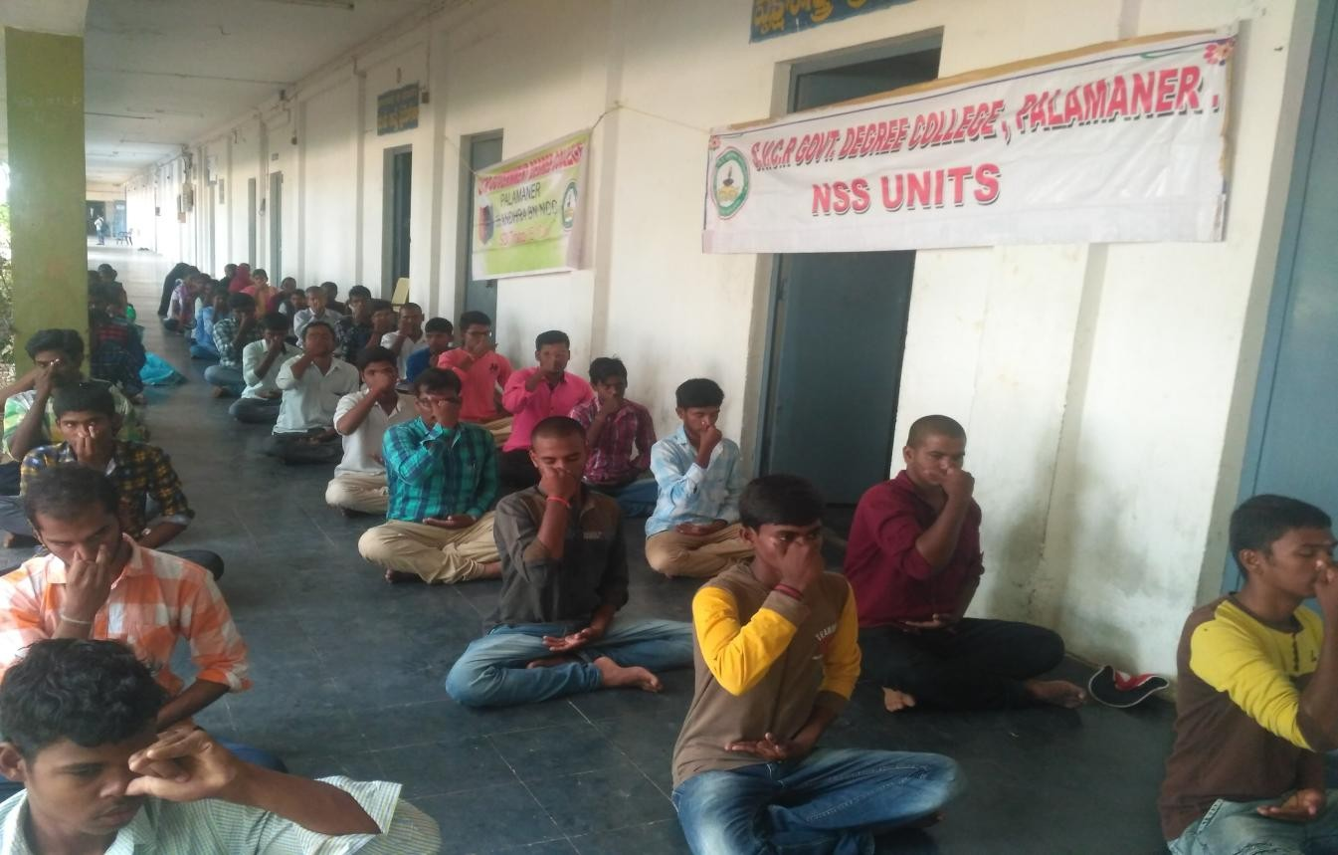
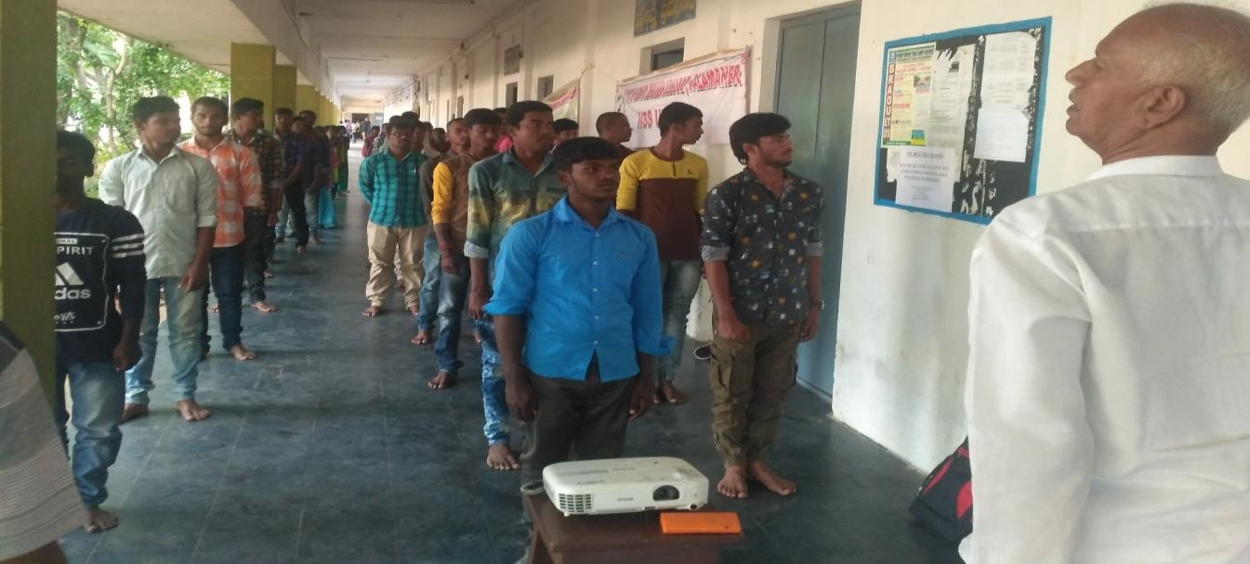
SVCR GOVT DEGREE COLLEGE
PALAMANER

PROGRAM NAME : AWARENESS RALLY ON ROAD SAFETY
PROGRAM DATE : 09.07.2018
TIME : 10.00 AM
VENUE : COLLEGE
RESOURCE PERSON : RAMBHUPAL, SI, PALAMANER
SVCR GOVT. DEGREE COLLEGE
Re-accredited by NAAC with 'B' Grade
==============================================================================

Dated: 08/07/2018

CIRCULAR

This is to inform all the students and the staff tomorrow (09.07.2018) our college is going to conduct a rally to create awareness on “ROAD SAFETY”. Over 15,0000 people in India are killed every year due to traffic accidents. For a day average of 400 fatalities, India has one of the highest rates of accidents in the whole world. One of the prime reasons for these accidents is negligence of road safety norms and traffic signs. Road safety rules are not only limited to be used by motorists and drivers but also by pedestrians, cyclists, and others. Road safety campaigns are an important way to spread awareness among people about road safety measures and rules. Hence, all the staff and students have to attend this awareness rally.

OBJECTIVES OF THE PROGRAMME:
- To spread awareness among people about road safety measures and rules.
- To explain the same to all the people.
REPORT OF THE PROGRAMME:

The Sub Inspector of Police of Palamaner conducted a meeting on the need for driving safely. The students conducted a rally. In the rally the students explained the vehicle owners to wear helmet while driving in the streets. They explained the need for safety. If one is safe they can make others too safe. The same message is explained to the people. The rally is started from the college headed by Sri Rambhupal, Sub Inspector of Palamaner.

OUTCOMES:
1. An awareness is created among the students and the public.
2. The students learnt to be safe and they became the ambassadors for the fact.

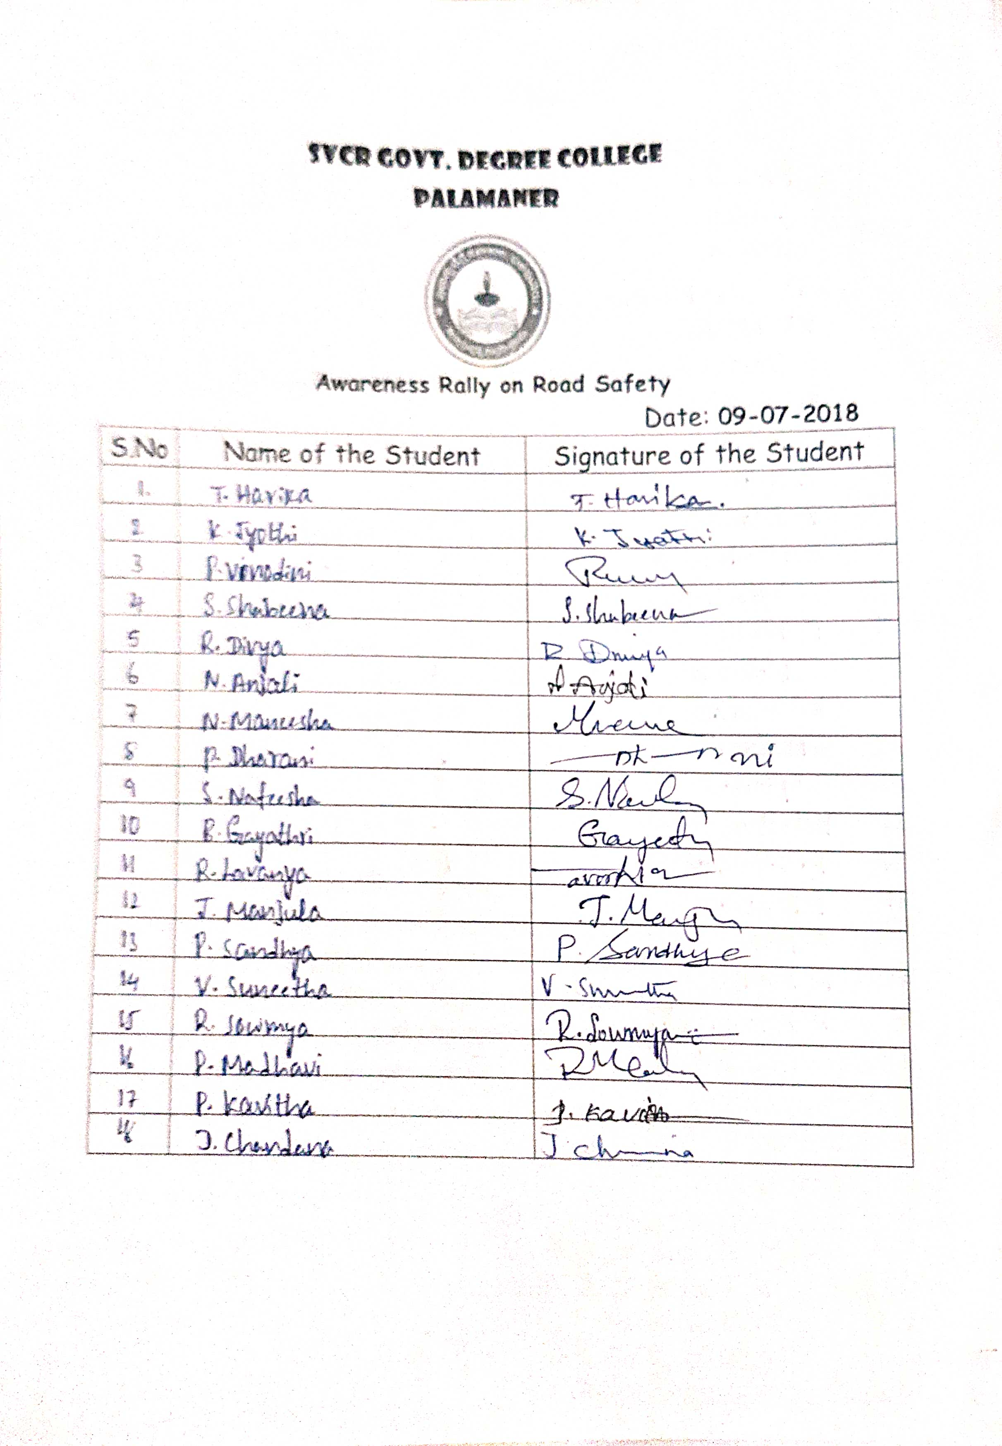
SIGNATURE OF THE STUDENTS:

FEED BACK:
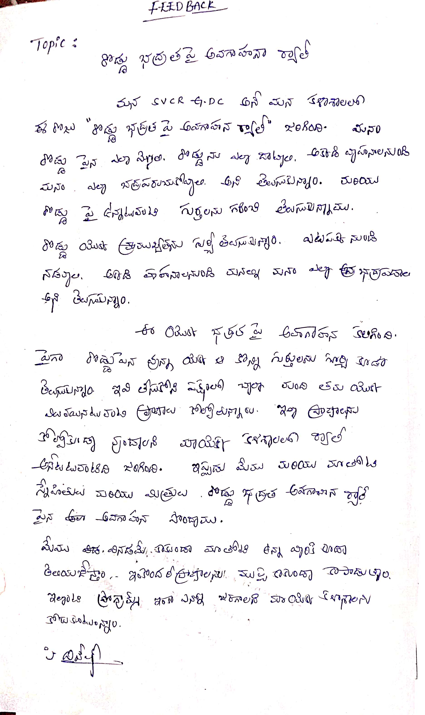
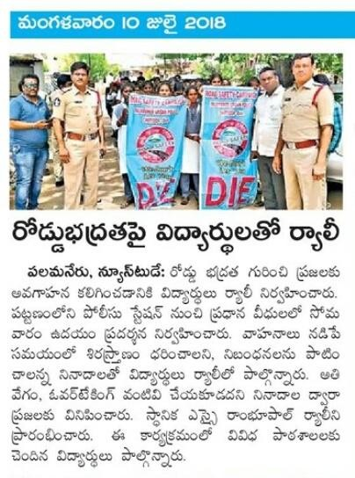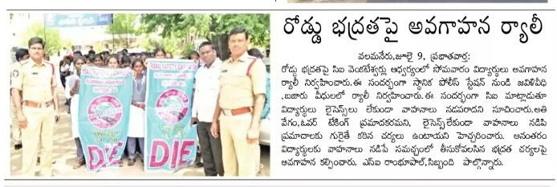
SVCR GOVT DEGREE COLLEGE
PALAMANER
PROGRAM NAME : VANAM MANAMPROGRAMME
PROGRAM DATE : 04.08.2018
TIME : 10.00 AM
VENUE : COLLEGE CAMPUS
RESOURCE PERSON : DR.P.BABU, PRINCIPAL
OFFICE OF THE PRINCIPAL
SVCR GOVT. DEGREE COLLEGE
Re-accredited by NAAC with 'B' Grade
==============================================================================

Dated: 03/08/2018

CIRCULAR

This is to inform that as per the instructions of Govt. of Andhra Pradesh, Vanam – Manamprogramme is conducted in college campus on 04/08/2018. In this connection, as a part of the green drive, saplings will be planted to keep environment green. All the students and staff are directed to attend this massive tree plantation programme.

Sd/-
Principal

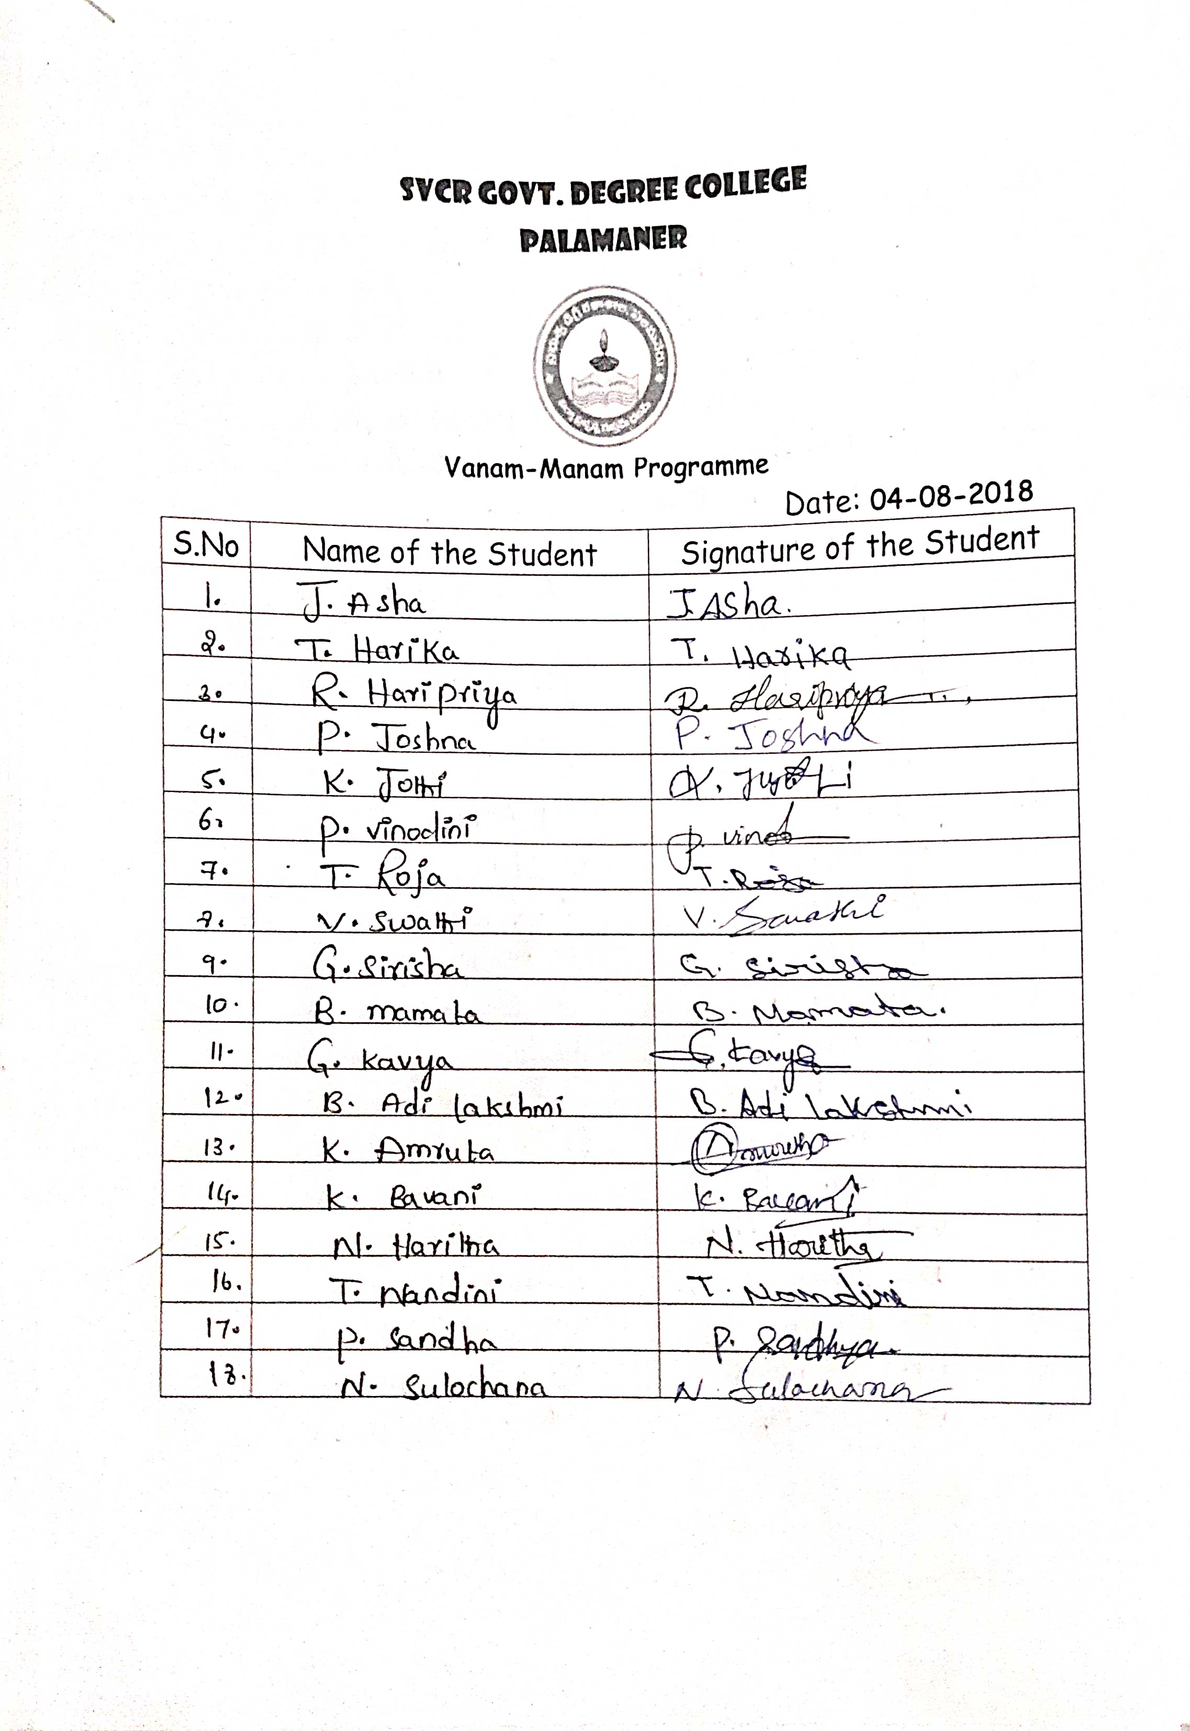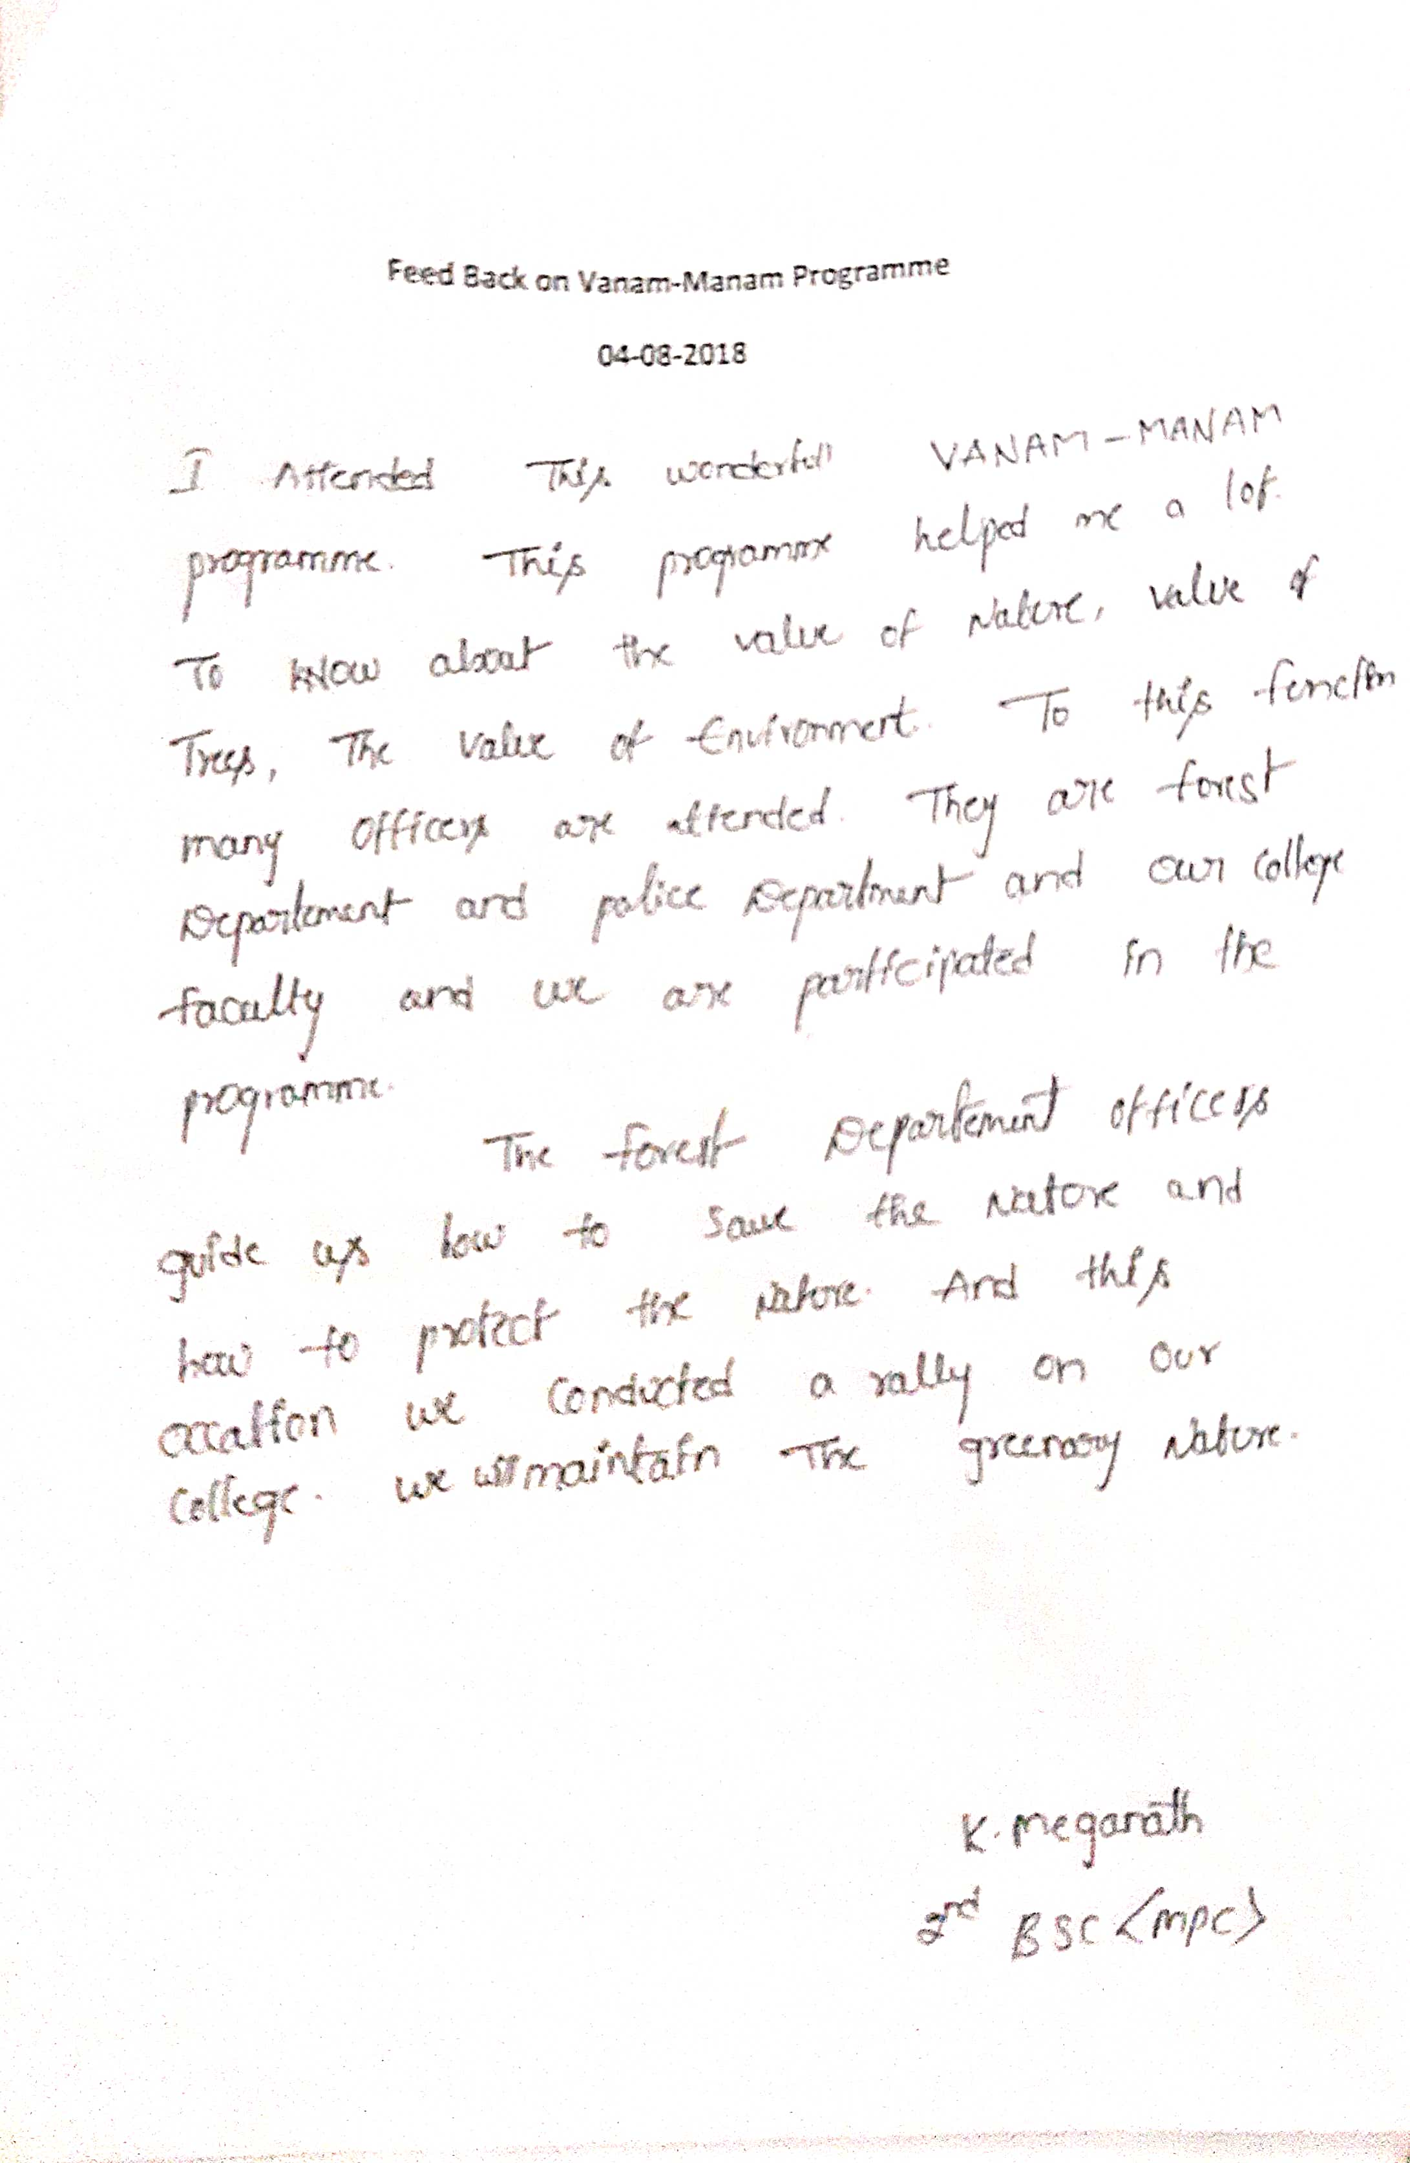
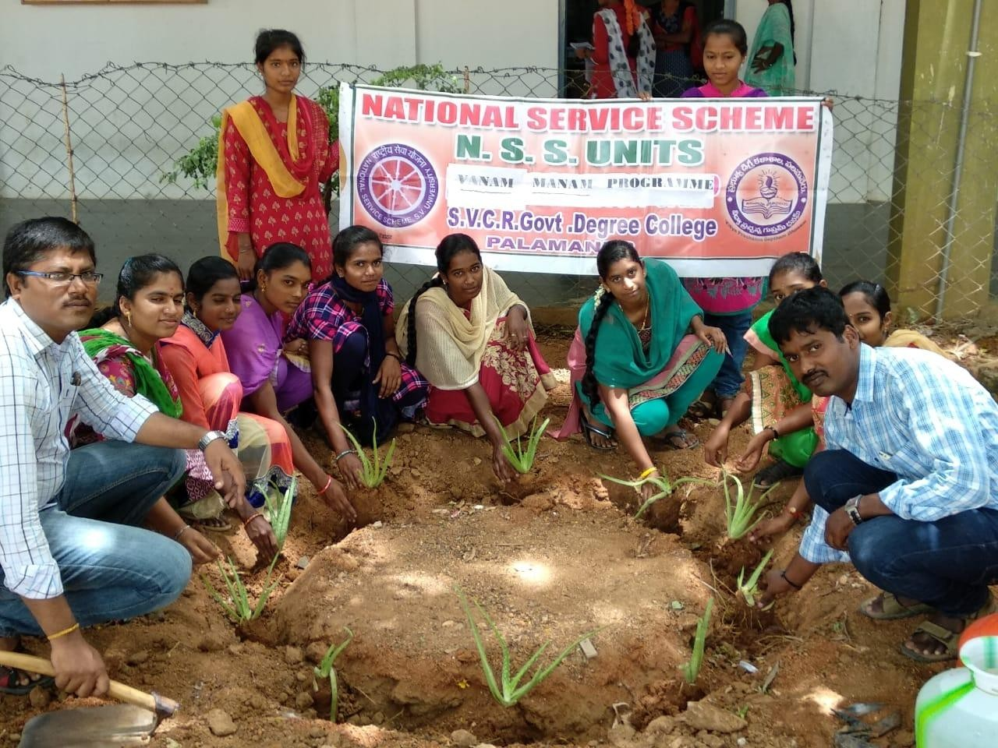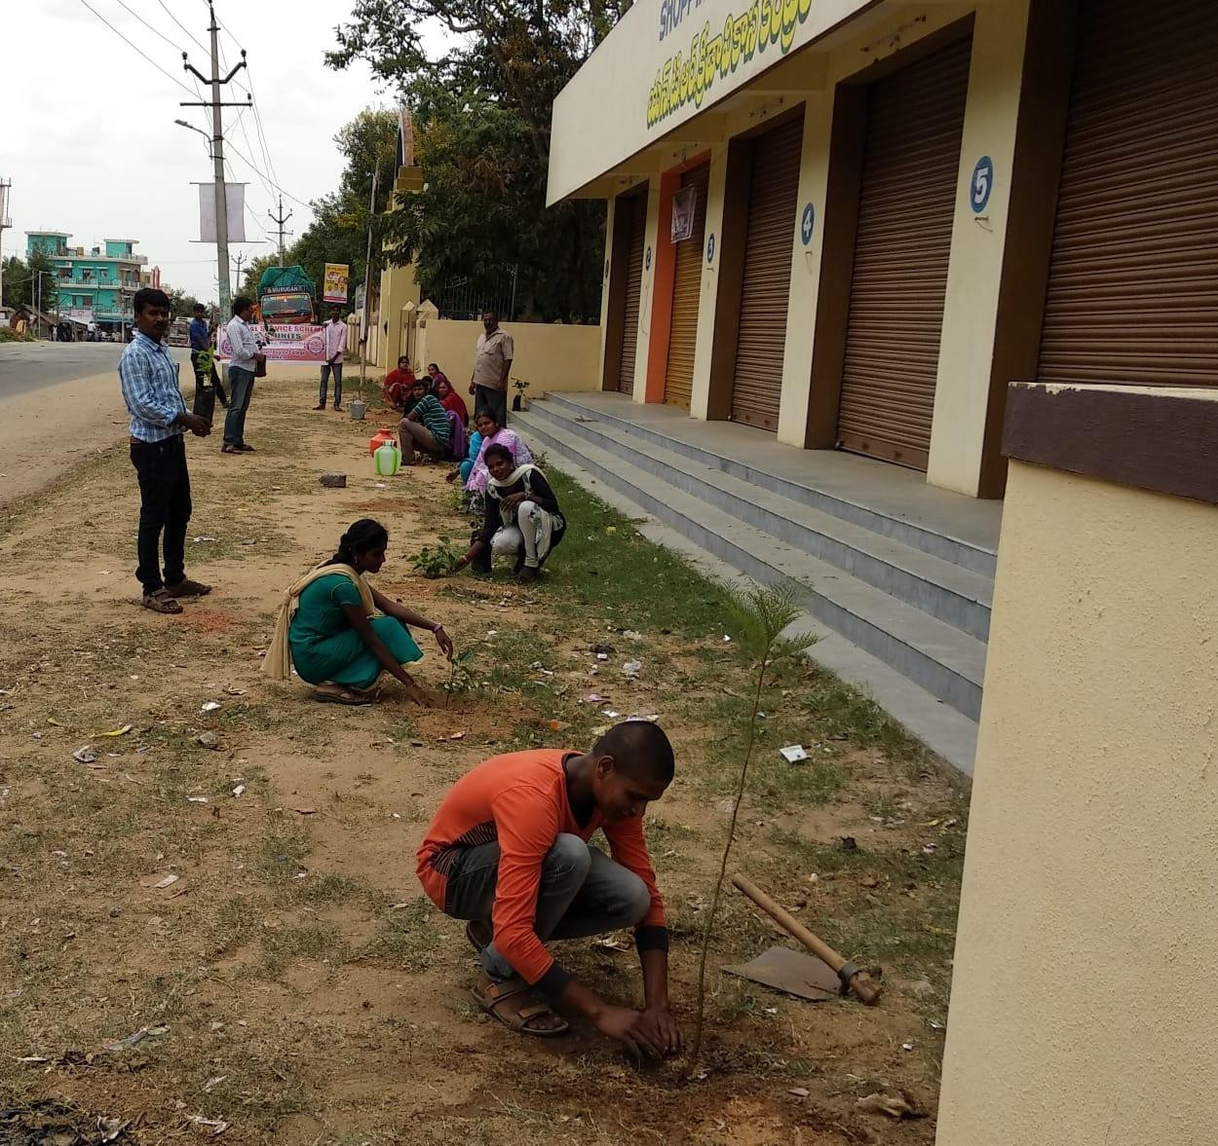
SVCR GOVT DEGREE COLLEGE
PALAMANER
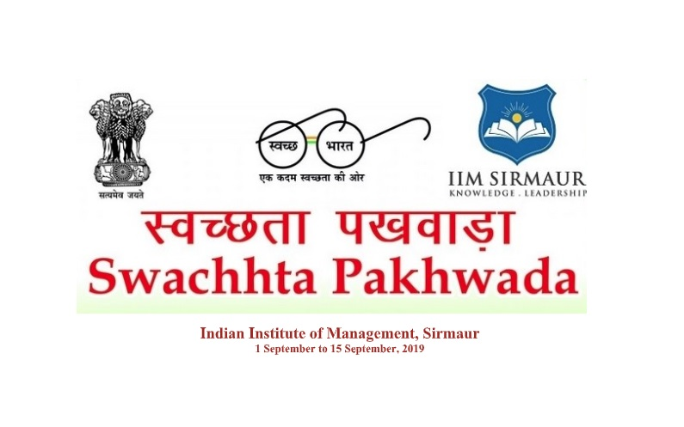

PROGRAM NAME : SWACHHTA PACKWADA PROGRAMME
PROGRAM DATE : 10.08.2018
TIME : 10.00 AM

OFFICE OF THE PRINCIPAL
SVCR GOVT. DEGREE COLLEGE
Re-accredited by NAAC with 'B' Grade
==============================================================================

Dated: 09/08/2018

CIRCULAR

The Swachh Bharat Abhiyan, launched on 02.10.2014 across the country as a national movement, is the most significant cleanliness campaign by the Government of India. According to the Government, a clean India would be the best tribute India could pay to Mahatma Gandhi on his 150 birth anniversary in 2019. The Government’s mantra is ‘Na gandagikarenge, Na karnedenge.’ By inviting people to participate in the drive, the SwachhtaAbhiyan has turned into a National Movement. A sense of responsibility has been evoked among the people through the Clean India Movement. Hence, all the staff and students are instructed to participate in SwachataPackwadaProgramme

Sd/-
Principal
OBJECTIVES OF THE PROGRAMME:
- To evoke a sense a responsibility among the students through Clean India movement.
- To create awareness in the nearby villages about cleanliness
- To imbibe government’s mantra ‘Na gandagikarenge, Na karnedenge’ in students.
REPORT OF THE PROGRAMME:
The students and the NCC and NSS volunteers moved around the college and cleaned the streets.
They explained the inhabitants of the streets the need for clean activities.
They made the locals as the part of their program in cleaning and created awareness on the diseases that are caused due to unhygienic conditions.
Saplings were planted at T.S. Agraharam a temple located nearby the college.

OUTCOMES:
- The students explained the need for cleanliness.
- The students get motivated by these activities.

SIGNATURE OF THE STUDENTS:

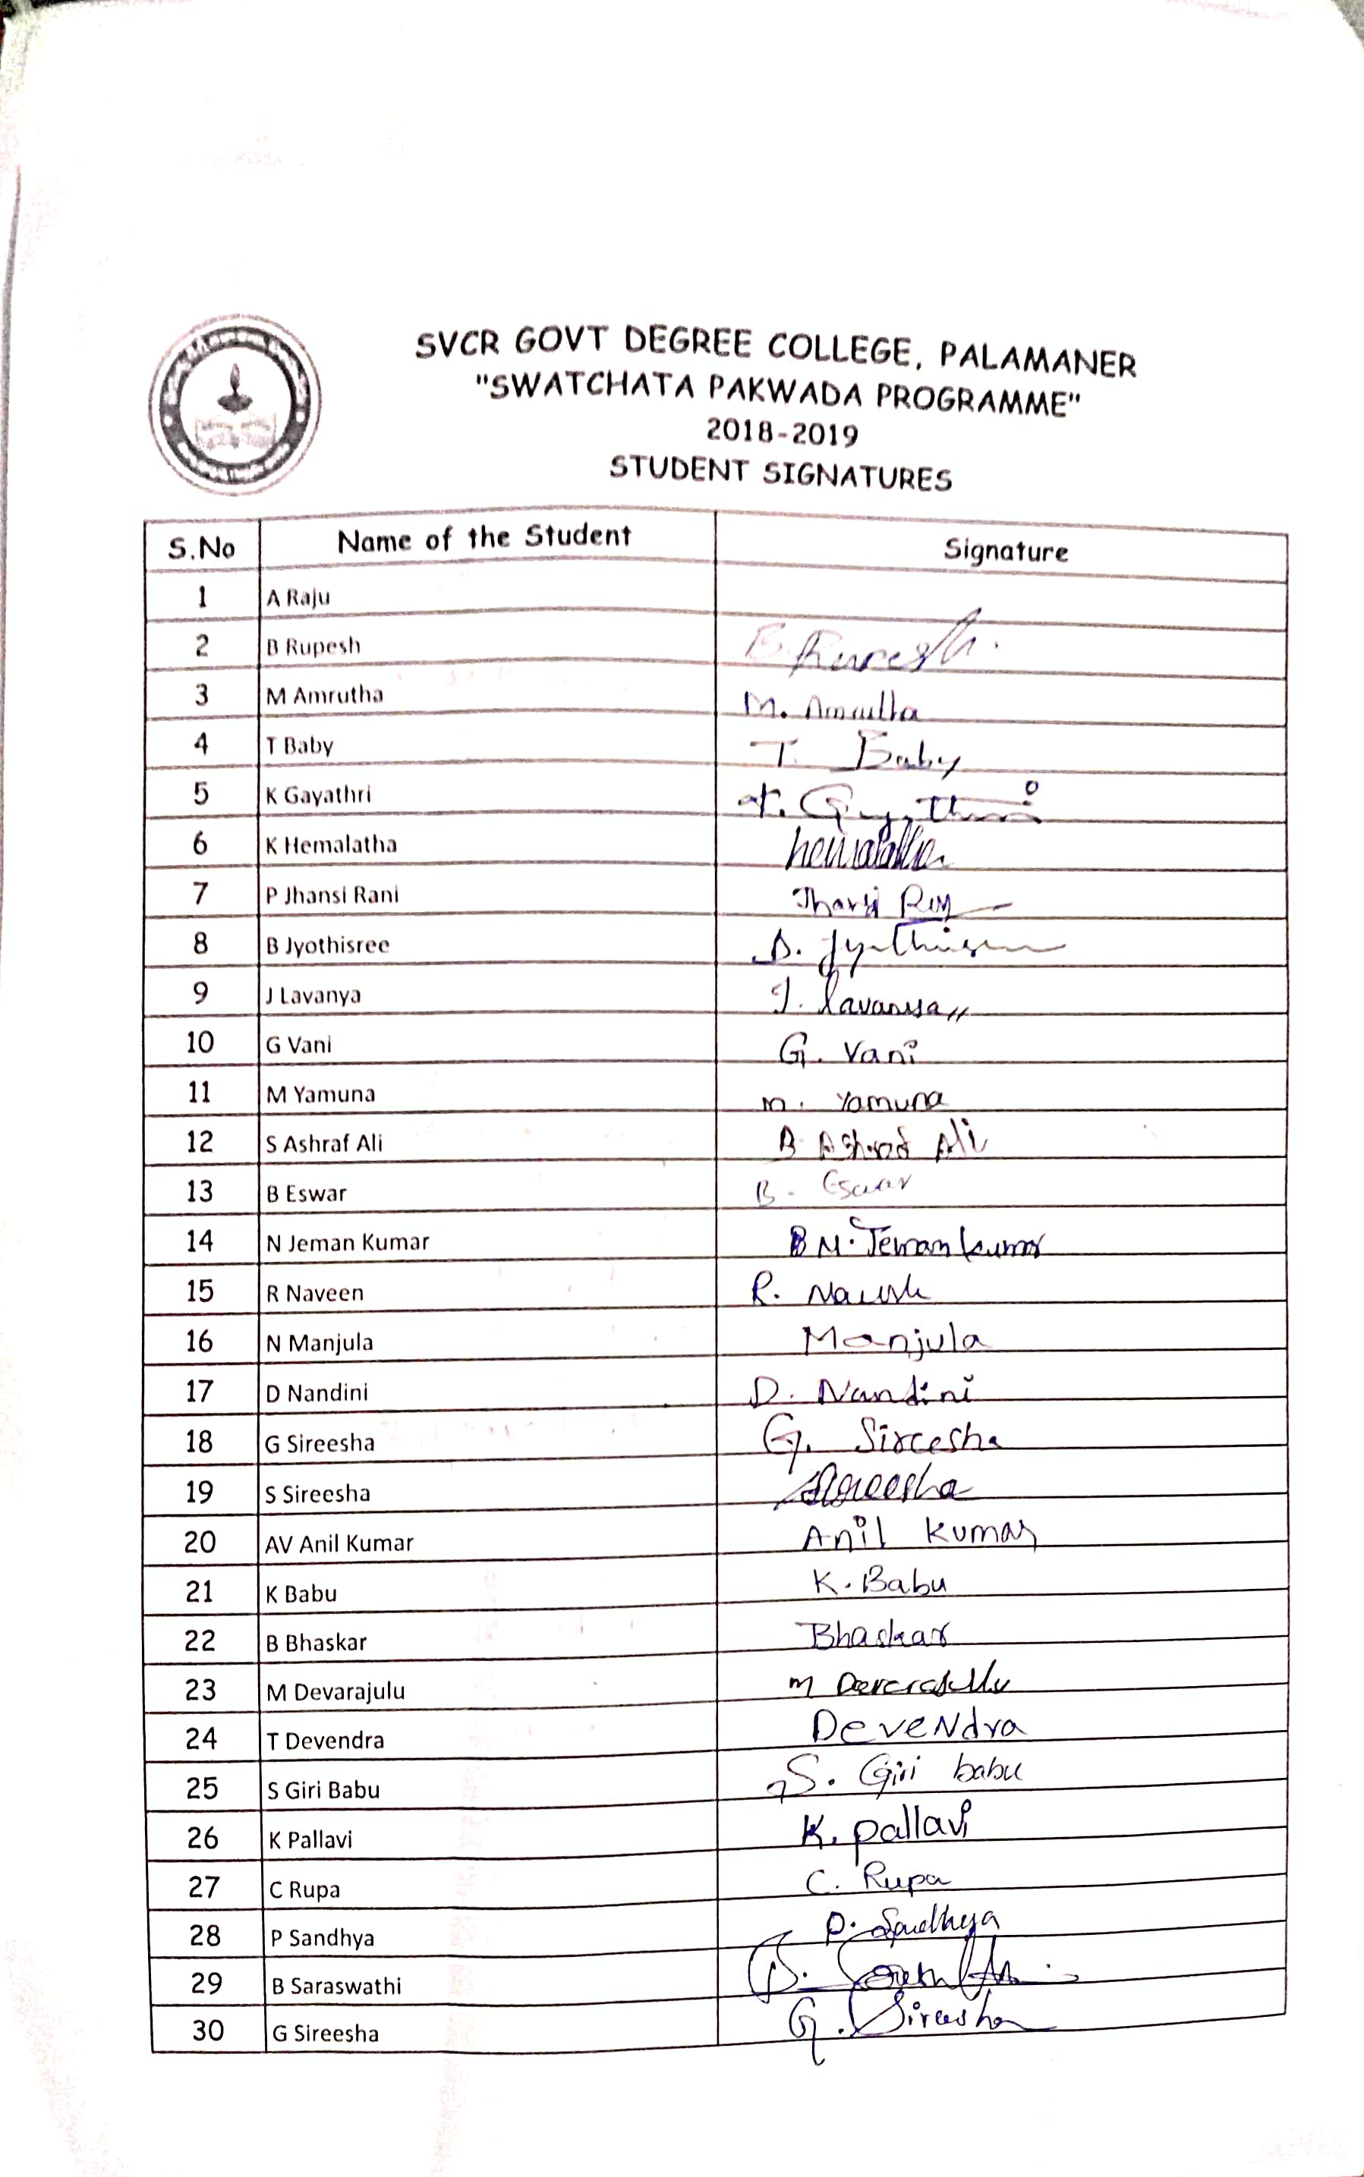
FEED BACK:
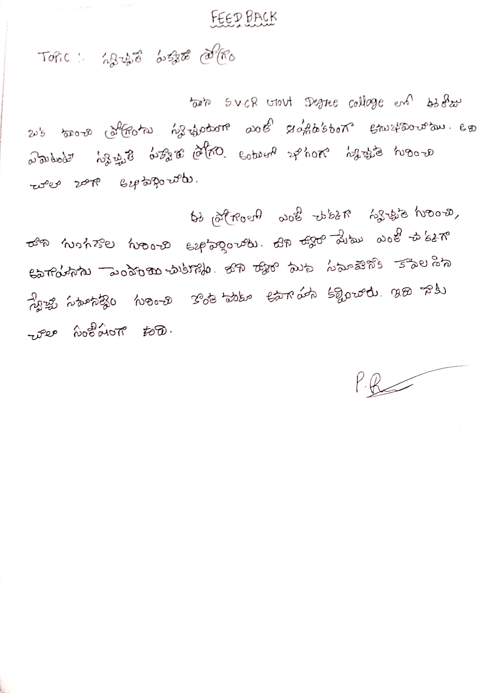
PHOTOS
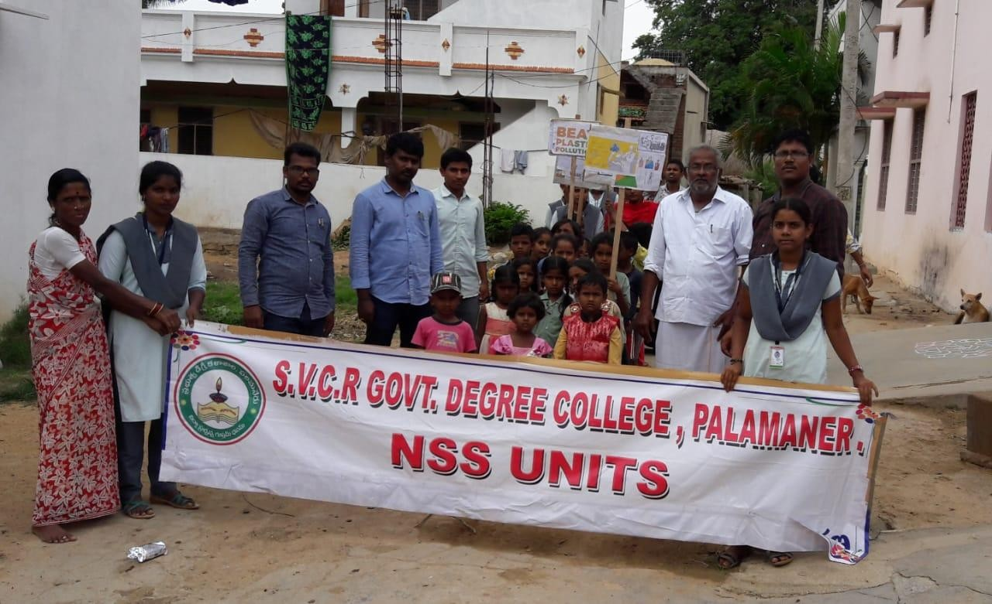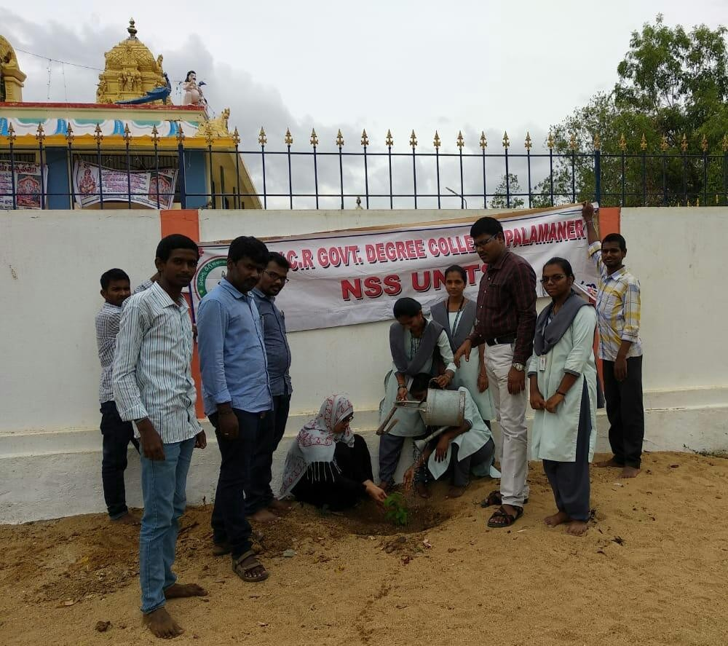
SVCR GOVT DEGREE COLLEGE
PALAMANER

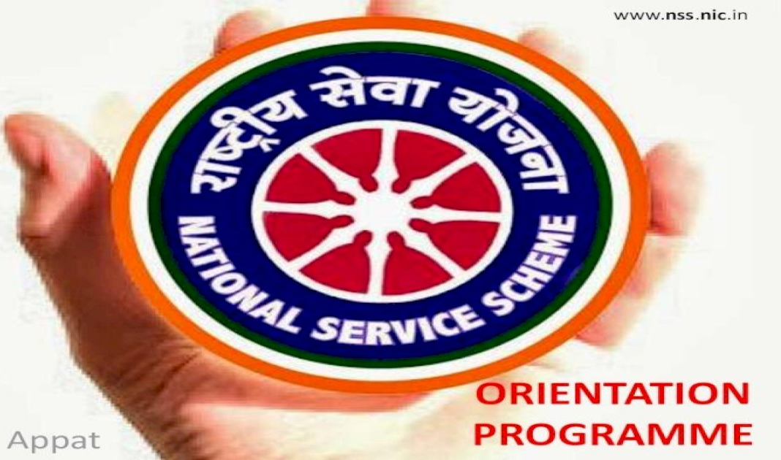

PROGRAM NAME : NSS ORIENTATION PROGRAMME
PROGRAM DATE : .04.09.2018
TIME : 10.00 AM
VENUE : SEMINAR HALL
RESOURCE PERSON : DR.P.BABU, PRINCIPAL

NATIONAL SERVICE SCHEME
SVCR GOVT. DEGREE COLLEGE
Re-accredited by NAAC with 'B' Grade
==============================================================================

Dated: 03/09/2018

CIRCULAR
This is to inform that an orientation programme is organized for the benefit of all NSS volunteers of both NSS Unit-1 and Unit-2 on 04th September 2018 in the Seminar Hall from 10:00 am to 4:00 pm. All volunteers are requested to attend this mandatory orientation programme. Please bring one passport size photo of yourself.

Sd/-
Programme officer
Unit – 1 and Unit - 2
OBJECTIVES OF THE PROGRAMME:
- To explain the activities of NSS.
- To motivate the students to join NSS.
REPORT OF THE PROGRAMME:
The NSS unit II of the college conducted an orientation on NSS in the college. The motivators from Jana Vignana Vedika, Sri Yugandhar and Sri Giridhar Murthy have been invited as the guests of honour. The Principal presided over the meeting. The NSS program officer explained the need for NSS in the college and the Guests of Honour explained need for service in the society. The motivated students are ready to join hands in serving the society.

OUTCOMES:
- Students learnt the need for serving the society.
- Most of the students came forward to organize such services.

SIGNATURE OF THE STUDENTS:
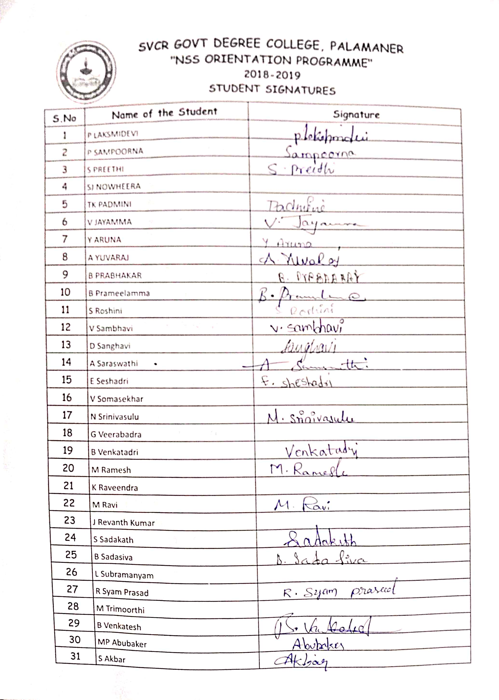
FEED BACK:
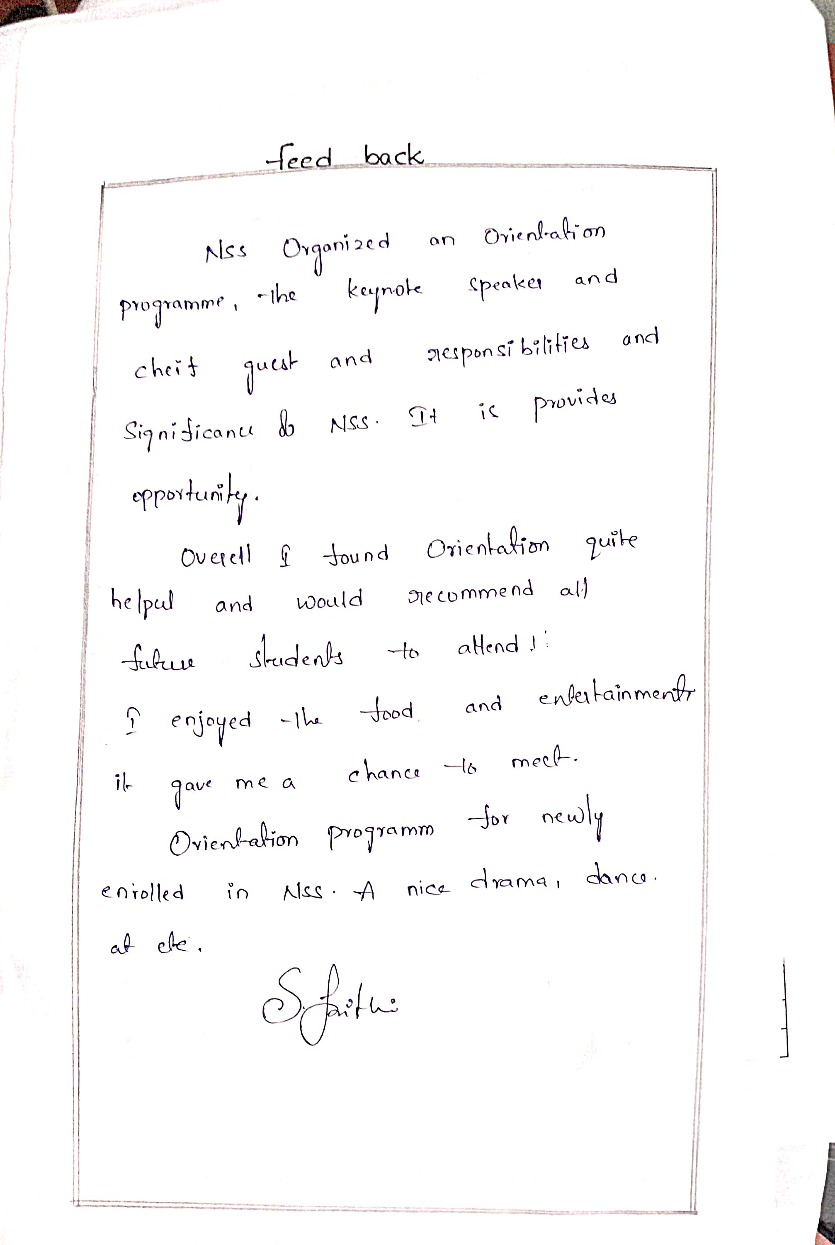
PHOTOS
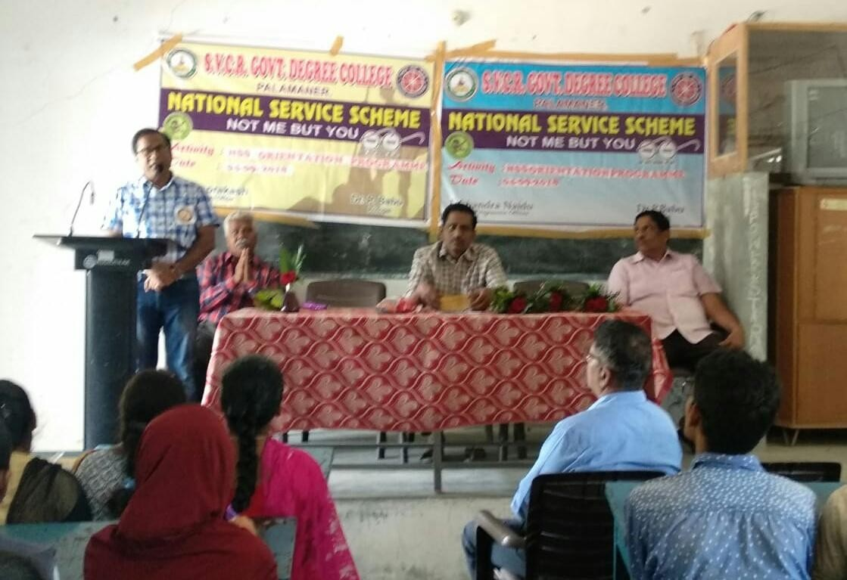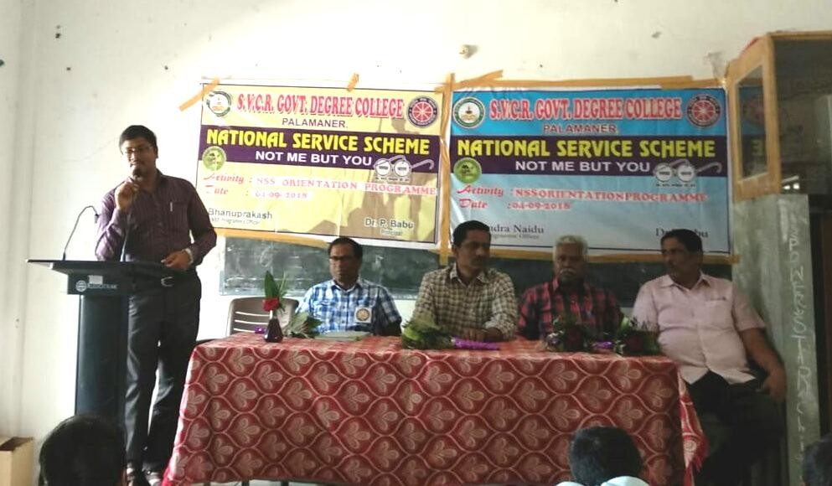
SVCR GOVT DEGREE COLLEGE
PALAMANER

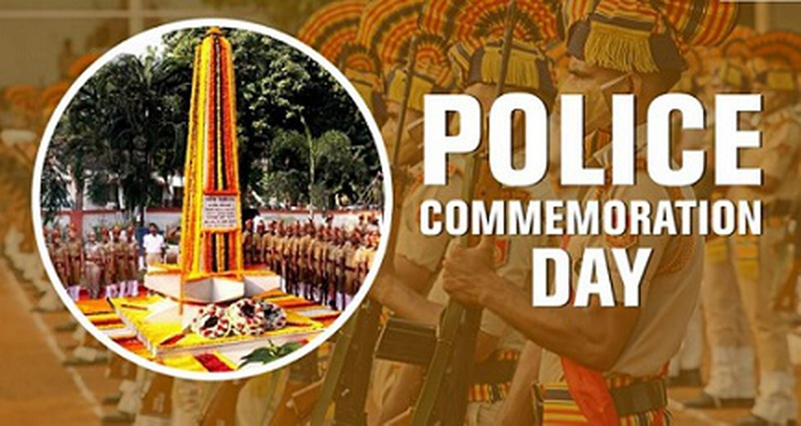

PROGRAM NAME : POLICE COMMEMORATION DAY RALLY
PROGRAM DATE : 01.10.2018
TIME : 10.00 AM
VENUE : COLLEGE CAMPUS
RESOURCE PERSON : DR.P.BABU, PRINCIPAL
OFFICE OF THE PRINCIPAL
SVCR GOVT. DEGREE COLLEGE
Re-accredited by NAAC with 'B' Grade
==============================================================================

Dated: 27/07/2018

CIRCULAR

This is to inform that a rally is being organized on the occasion of POLICE COMMEMORATION DAY. In this connection all the NCC, NSS volunteer, staff and students are instructed to prepare for the rally and assemble near Sri Varra Chenna Reddy statue by 11:00 AM.

Sd/-
Principal
OBJECTIVES OF THE PROGRAMME:
- To learn about the sacrifices made by the police for the society.
- To create awareness on the sacrifice of the police in the public.
REPORT OF THE PROGRAMME:
The Department of Police visited the college and brought awareness on the sacrifice made by the police. In collaboration with the Police Department
The sacrifice made by the police is praised in the rally. The students carried the flags and gave the hailing slogans in the commemorative rally. This rally made the Public to consider the cause of the Police in an empathetic way.

OUTCOMES:
- The students understood the sacrifice done by the police for the society.
- They created awareness in the public on the same topic.

SIGNATURE OF THE STUDENTS:
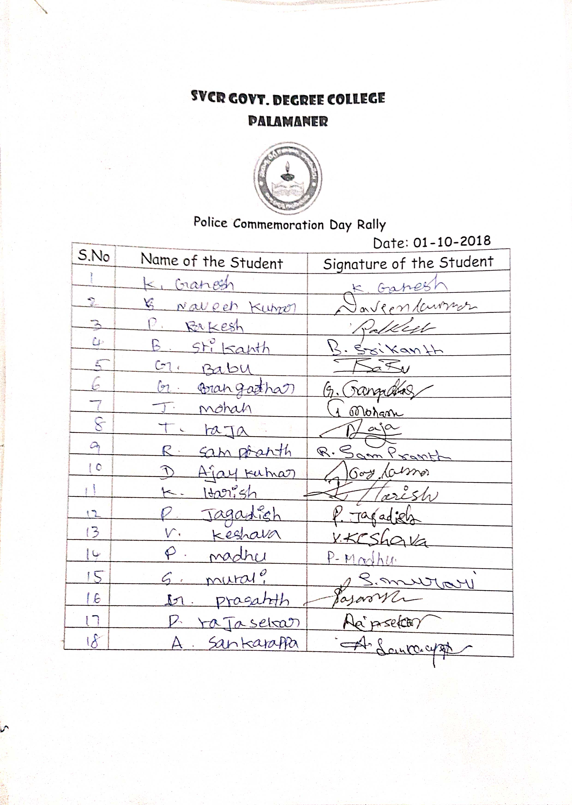
FEED BACK:
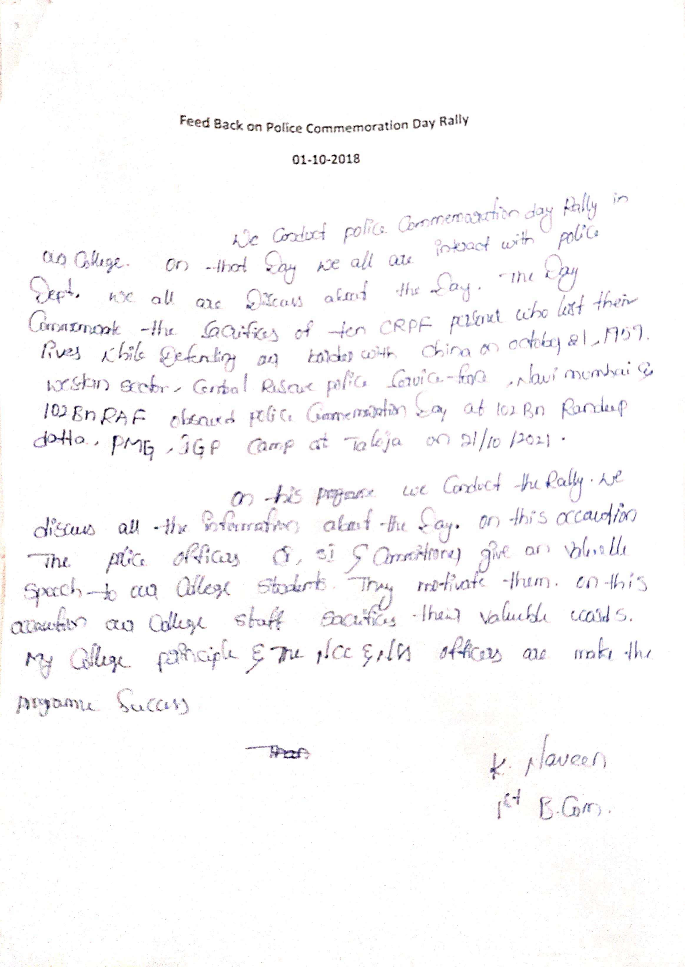

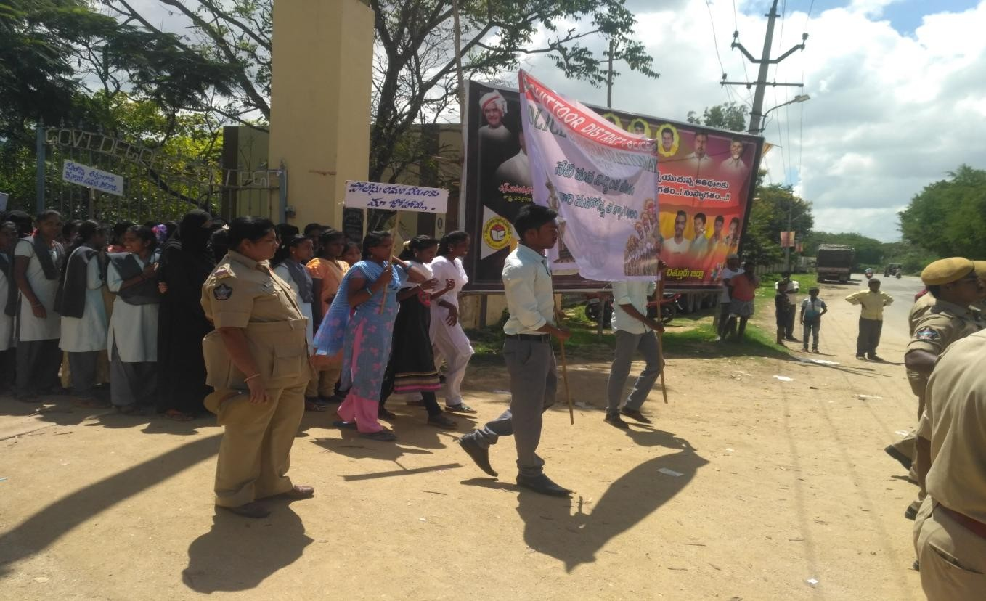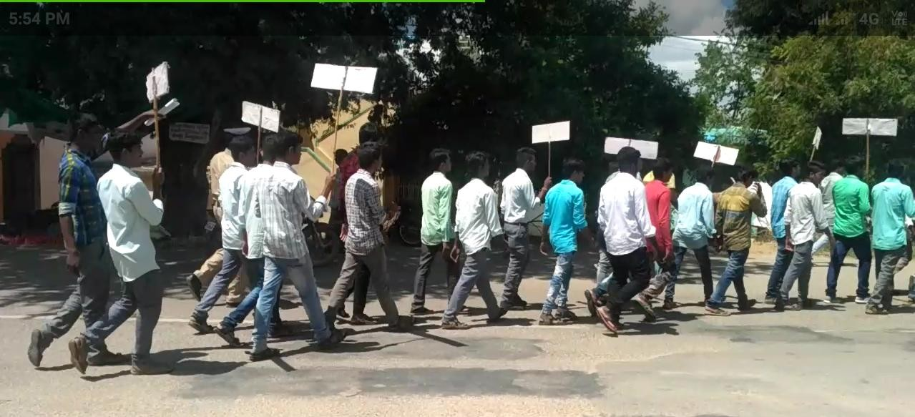 PHOTOS
SVCR GOVT DEGREE COLLEGE
PALAMANER

PROGRAM NAME : WORLD AIDS DAY
PROGRAM DATE : 01.12.2018
TIME : 11.00 AM
VENUE : VIRTUAL CLASS ROOM
RESOURCE PERSON : DR.P.BABU, PRINCIPAL

OFFICE OF THE PRINCIPAL
SVCR GOVT. DEGREE COLLEGE
Re-accredited by NAAC with 'B' Grade
==============================================================================

Dated: 30/11/2018

CIRCULAR

Every December 1st, we celebrate World AIDS Day. This day is an opportunity to raise awareness, educate and improve understanding of HIV as a global public health problem. WHO will join global partners to commemorate World AIDS Day under the theme “Know Your Status”. This will also be an occasion to celebrate the 30th anniversary of World AIDS Day – a pioneering global health campaign first initiated by WHO in 1988. Hence, all the staff are instructed to attend the programme which is conducted in Virtual Classroom from 11:00 AM onwards.

Sd/-
Principal
OBJECTIVES OF THE PROGRAMME:
- To bring awareness on AIDS among the students.
- To follow a hygienic based life to make a healthy society.
REPORT OF THE PROGRAMME:
The International Aids Day is conducted in the college. The medical Officer of Kolamasanapalle Dr. Mallikarjuna and his team visited the college. They explained the need for being clean and the need for cultivating good habits. The CHO Smt Kalyanamma explained the need for following healthy habits. Sri. T. Lakshmipathi and Sri Jayasankar, Health Officers explained the hazards of HIV – AIDS. They explained the students to take the message to the villages and bring awareness in the uneducated common men in their villages.
An oath is made by the students to say no to unhealthy habits.

OUTCOMES:
- The students get educated on the health hazards.
- They can spread the same message to the villagers.

FEED BACK:

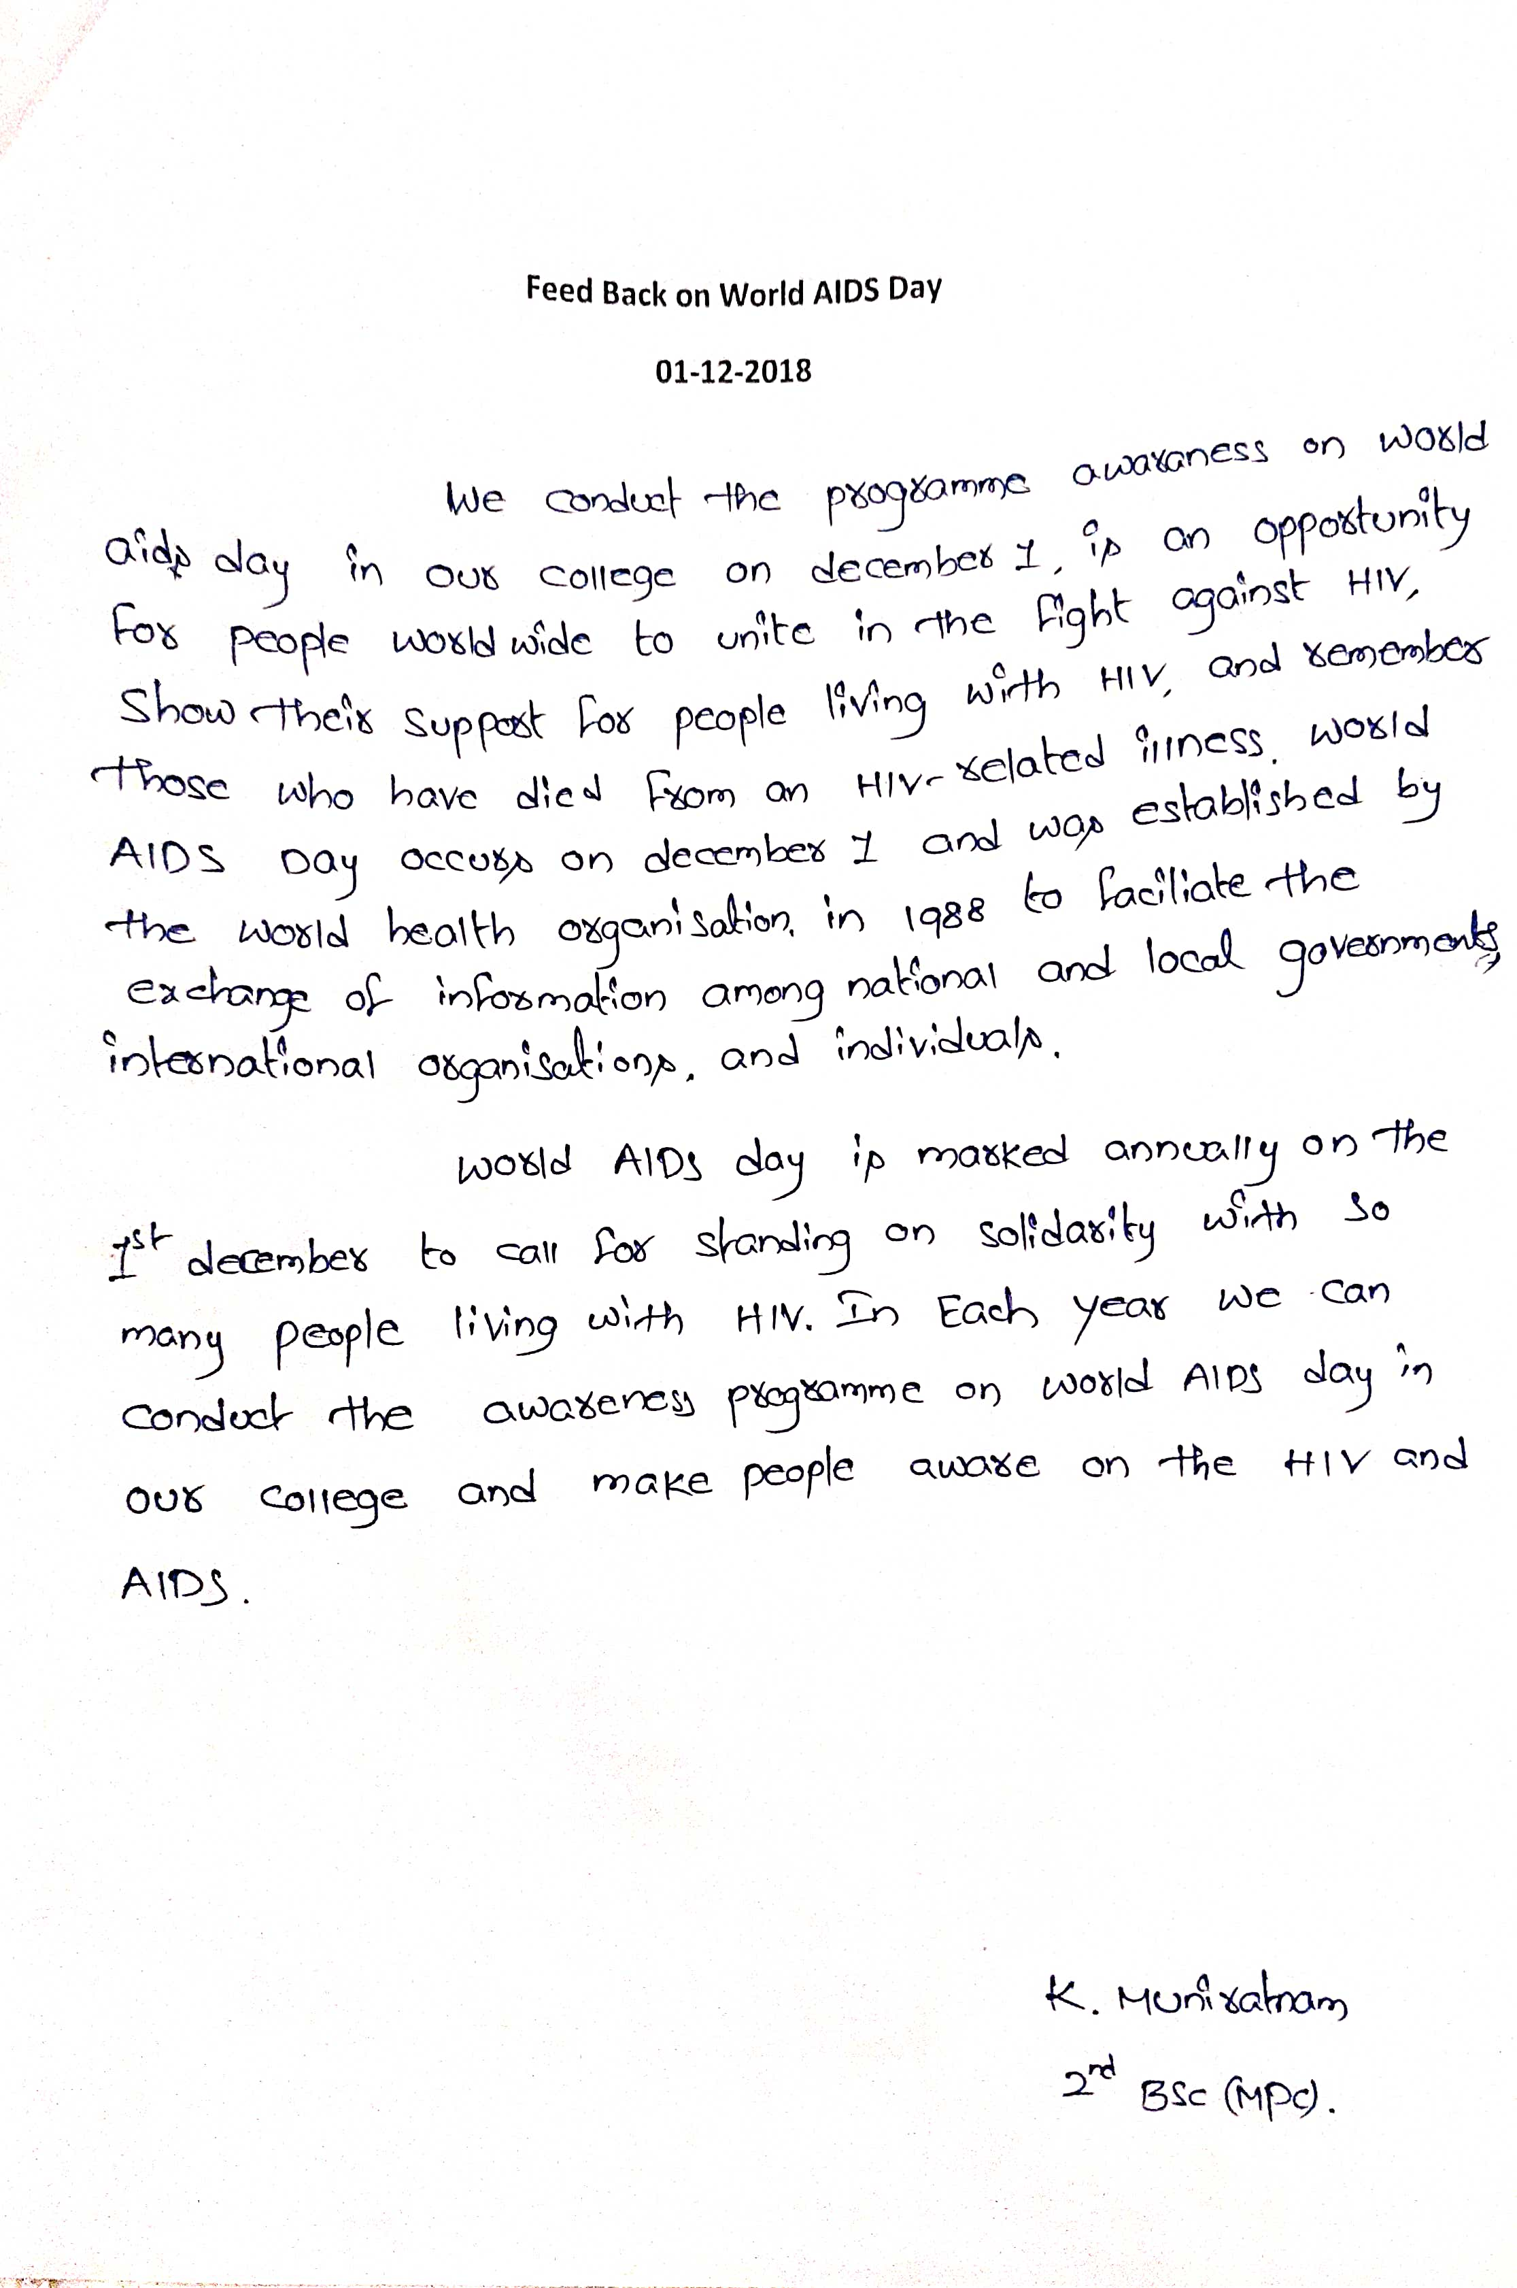
PHOTOS
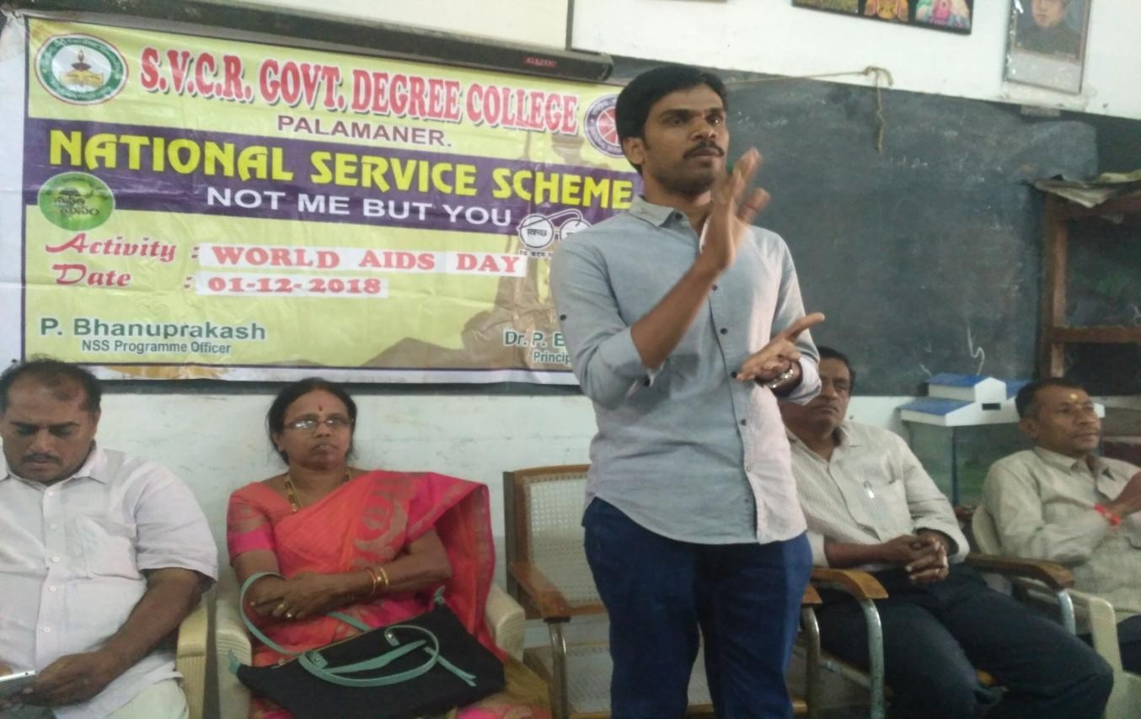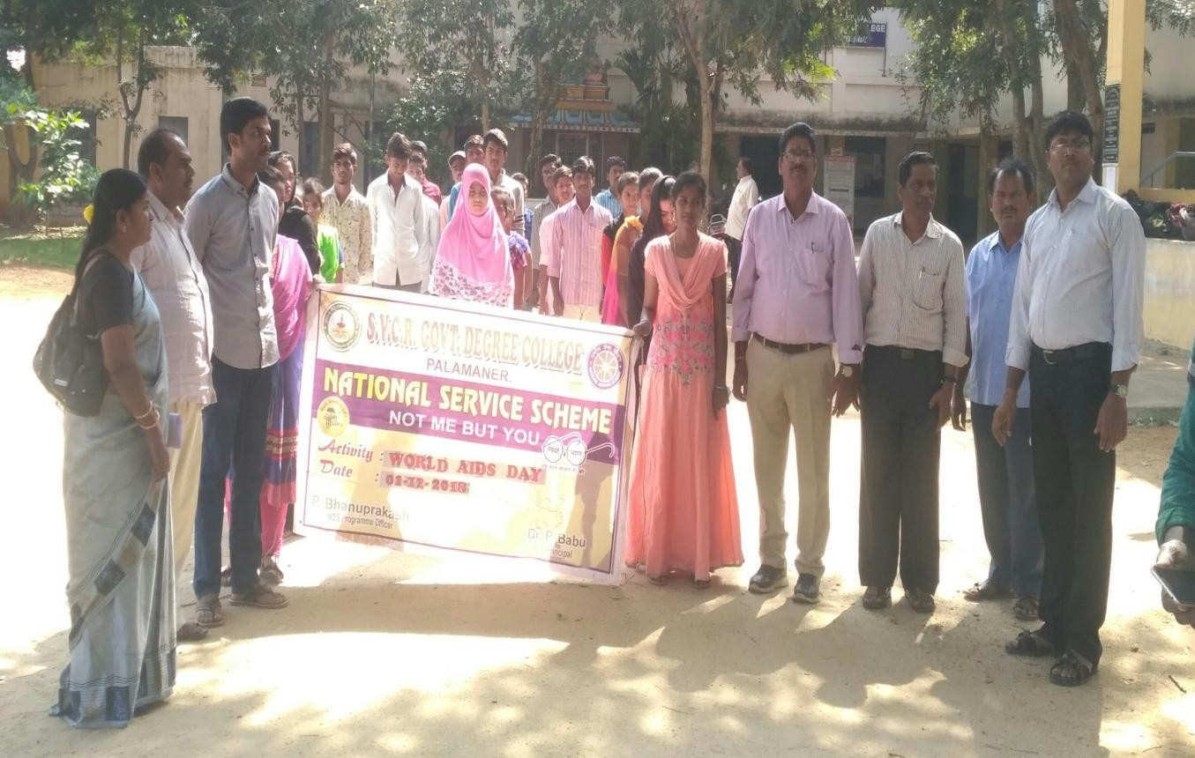
SVCR GOVT DEGREE COLLEGE
PALAMANER

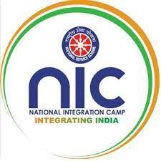

PROGRAM NAME : NATIONAL INTEGRATION CAMP
PROGRAM DATE : 15.12.2018 TO 21.12.2018
TIME : 10.00 AM
VENUE :
RESOURCE PERSON :
NATIONAL SERVICE SCHEME
SVCR GOVT. DEGREE COLLEGE
Re-accredited by NAAC with 'B' Grade
==============================================================================

Dated: 13/12/2018

CIRCULAR

This is to inform that a National Integration Camp is organized from 15.12.2018 to 21.12.2018. All volunteers are requested to prepare for this programme and assemble at Sri Varra Chenna Reddy statue on 14.12.2018, evening 4:00 PM. Please bring one passport size photo of yourself.

Sd/-
Programme officer
Unit – 1 and Unit - 2
REPORT OF THE PROGRAMME:
04 students from the college and o1 NSS program officer Sri Bhanu Prakash visited the National Integration camp at Guntur. The camp is organized by the Government of India; The Ministry of Youth Affairs and Sports. Volunteers from all over India visited the place. The students and the officer represented the S V Univeristy, Tirupati. The students presented a mime show and won applause from all the participants.

SIGNATURE OF THE STUDENTS:
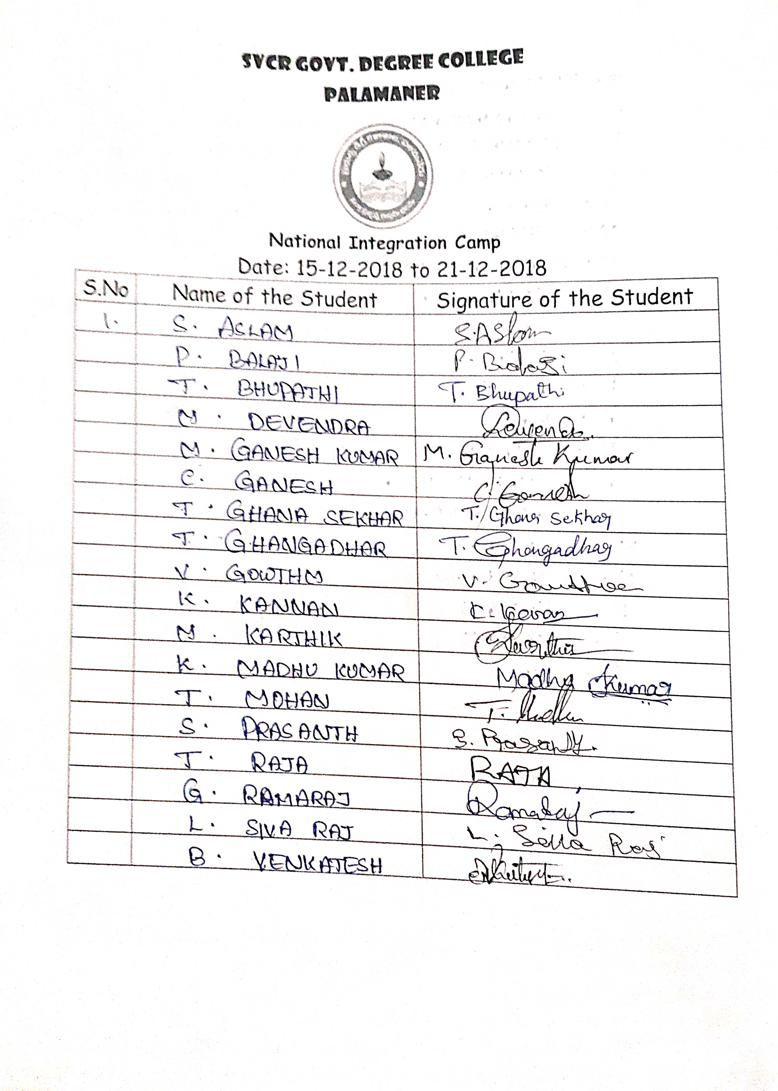

FEED BACK:

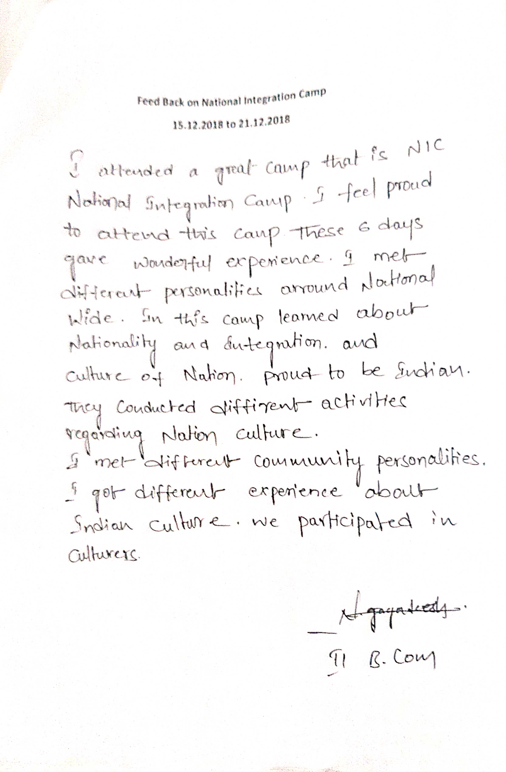
PHOTOS
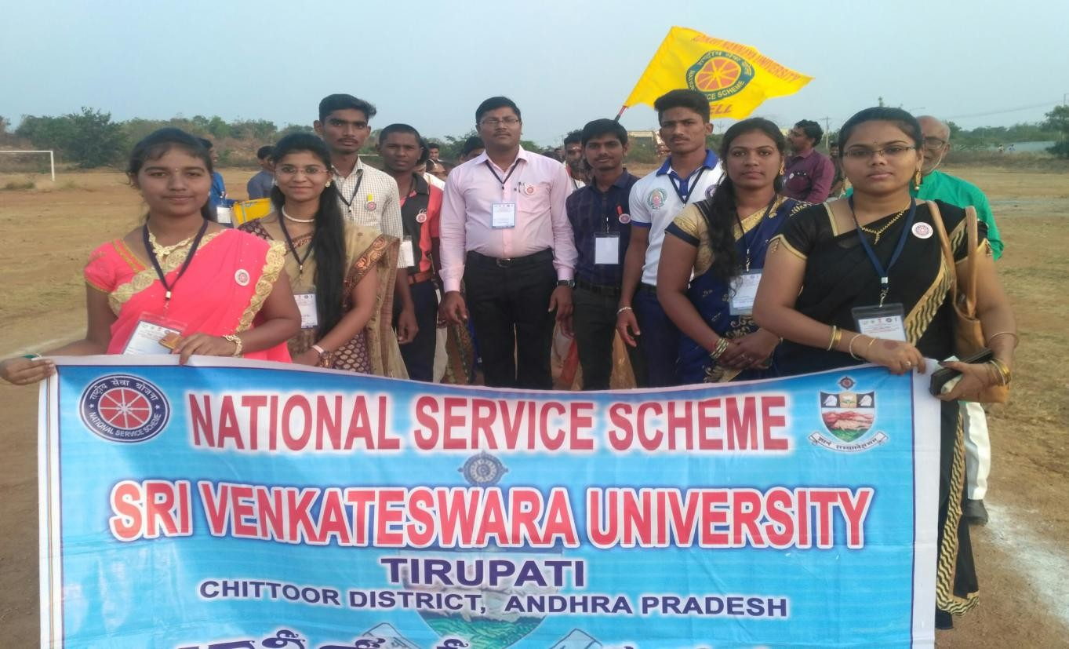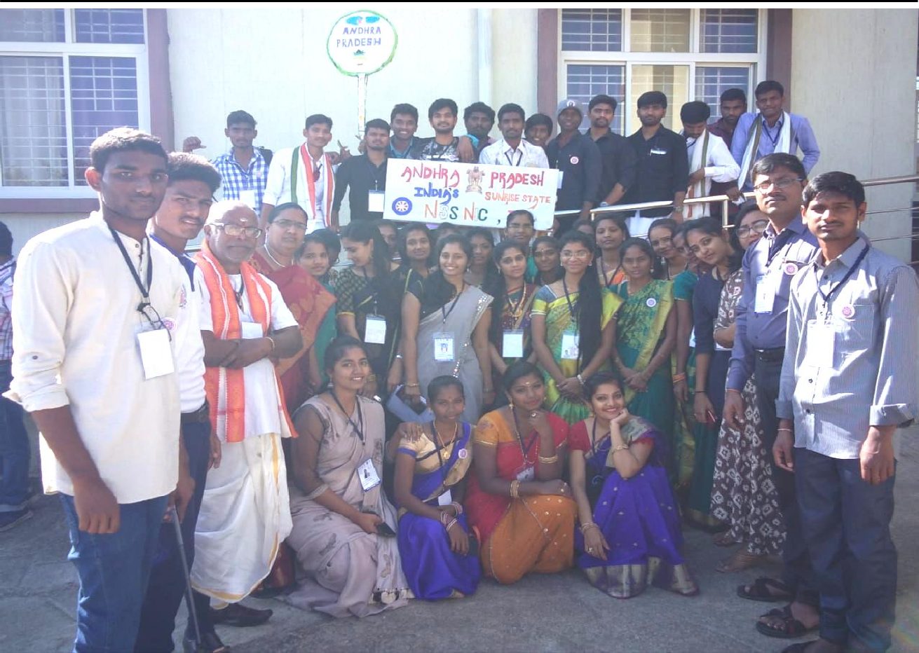
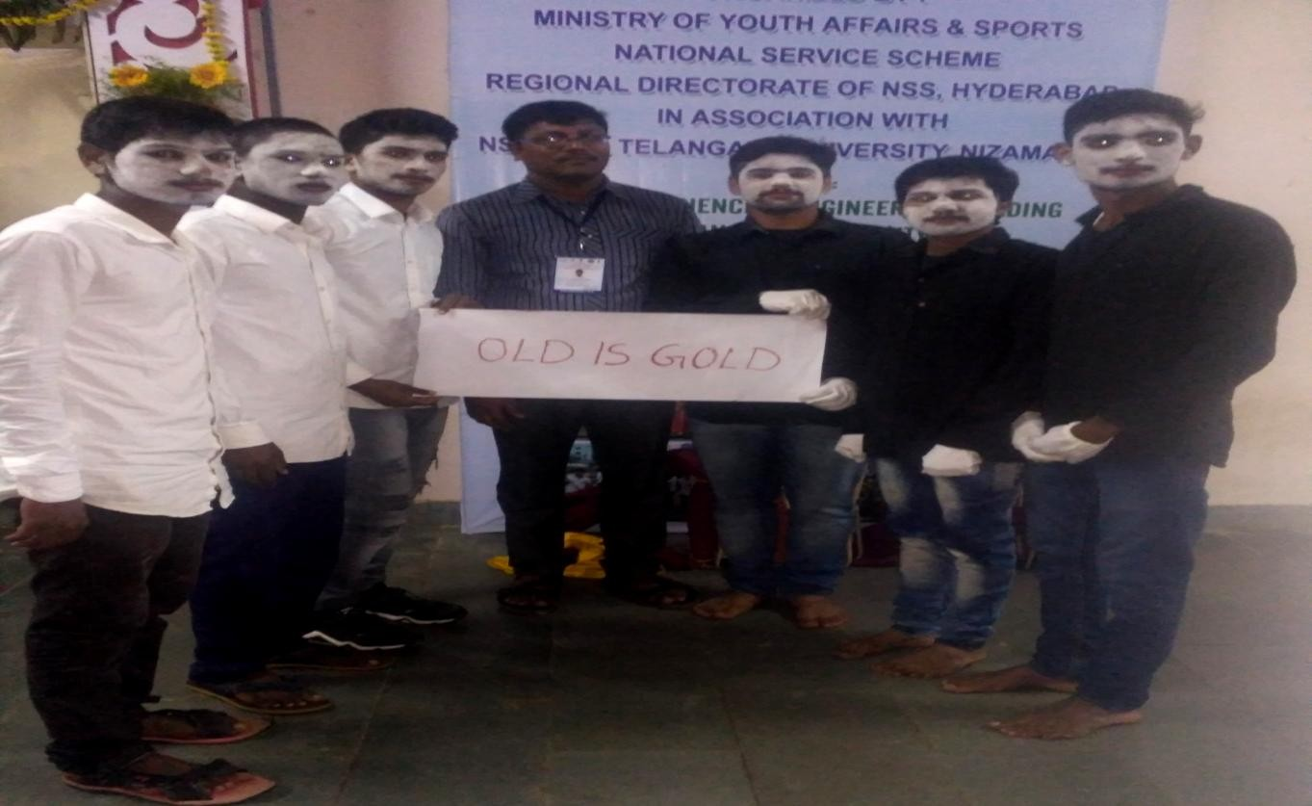

SVCR GOVT DEGREE COLLEGE
PALAMANER

PROGRAM NAME : | INTERNATIONAL YOGA DAY
PROGRAM DATE : | 21-06-2019
TIME : | 10:00 AM
VENUE : | COLLEGE CAMPUS
RESOURCE PERSON : | Smt. VANI, YOGA MASTER, Chittoor

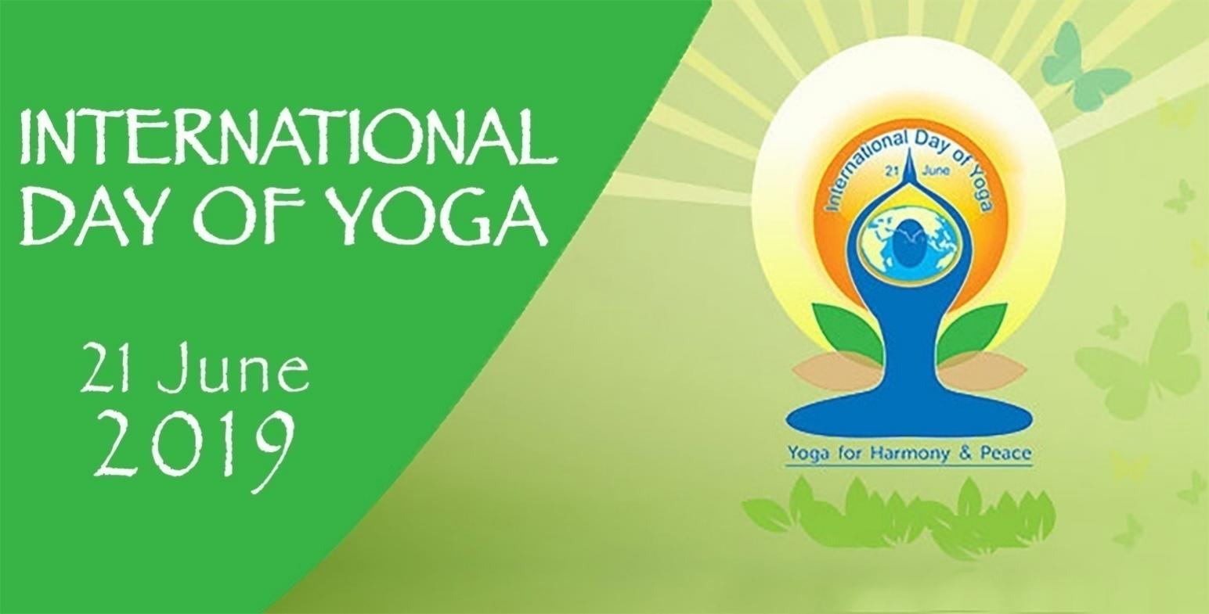

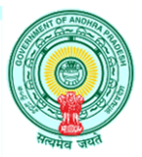
OFFICE OF THE PRINCIPAL
SVCR GOVT. DEGREE COLLEGE
Re-accredited by NAAC with 'B' Grade
Present: Dr. P. Babu, M.Sc, Ph.D

Dated: 04/06/2018

CIRCULAR

This is to inform all the students and the staff tomorrow (05.06.2018) our college is going to conduct “World Environment Day" celebrations. This year, India is the global host of 2018 World Environment Day. With “Beat Plastic Pollution” as the theme for this year’s edition, the world is coming together to combat single-use plastic pollution. Hence, all the staff has to attend along with their students to create awareness for the protection of the environment.

Sd/-
Principal

OBJECTIVES OF THE PROGRAMME:
- To learn Yoga asanas.
- To practice yoga in daily life.

REPORT OF THE PROGRAMME:
The NSS Unit of the college celebrated International Day of Yoga in the college on 21st June, 2019 to raise awareness among the staff and students about the many benefits of practicing Yoga. Smt. Vani, Yoga Master, Yoga Association Secretary, Chittoor handled the training session and addressed the students that Yoga is an ancient physical, mental and spiritual practice that originated in India. She said that the word „yoga‟ symbolize the union of body and consciousness. She explained and created awareness on Yoga and its benefits. She emphasized that Yoga postures, Pranayama and Meditation are a holistic fitness package which improves health, and physical strength hand gives mental strength. He was given training on different Yoga Asanas, Pranayamam and Meditation which aims at developing mental and physical fitness and relieving from stress through regular practice. The Principal, Staff, NSS volunteers and students Village have been actively practiced different Yoga asanas, Pranayamam and Meditation.

OUTCOMES:
- The students practiced yoga and learn it well.
- The students can practice it every day.

SIGNATURE OF THE STUDENTS:
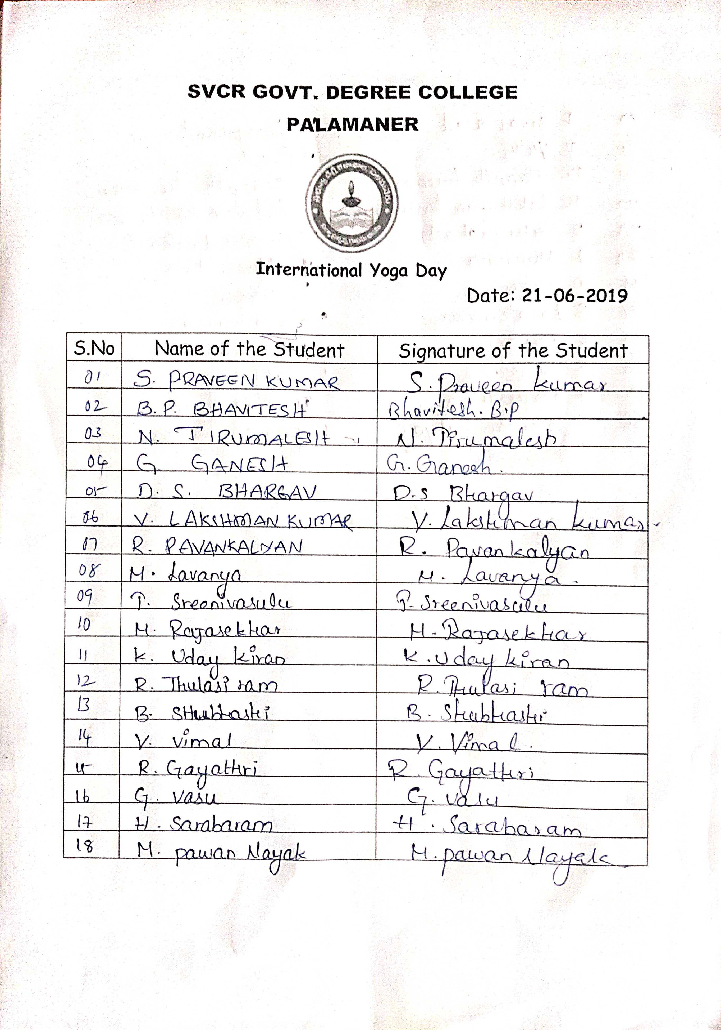
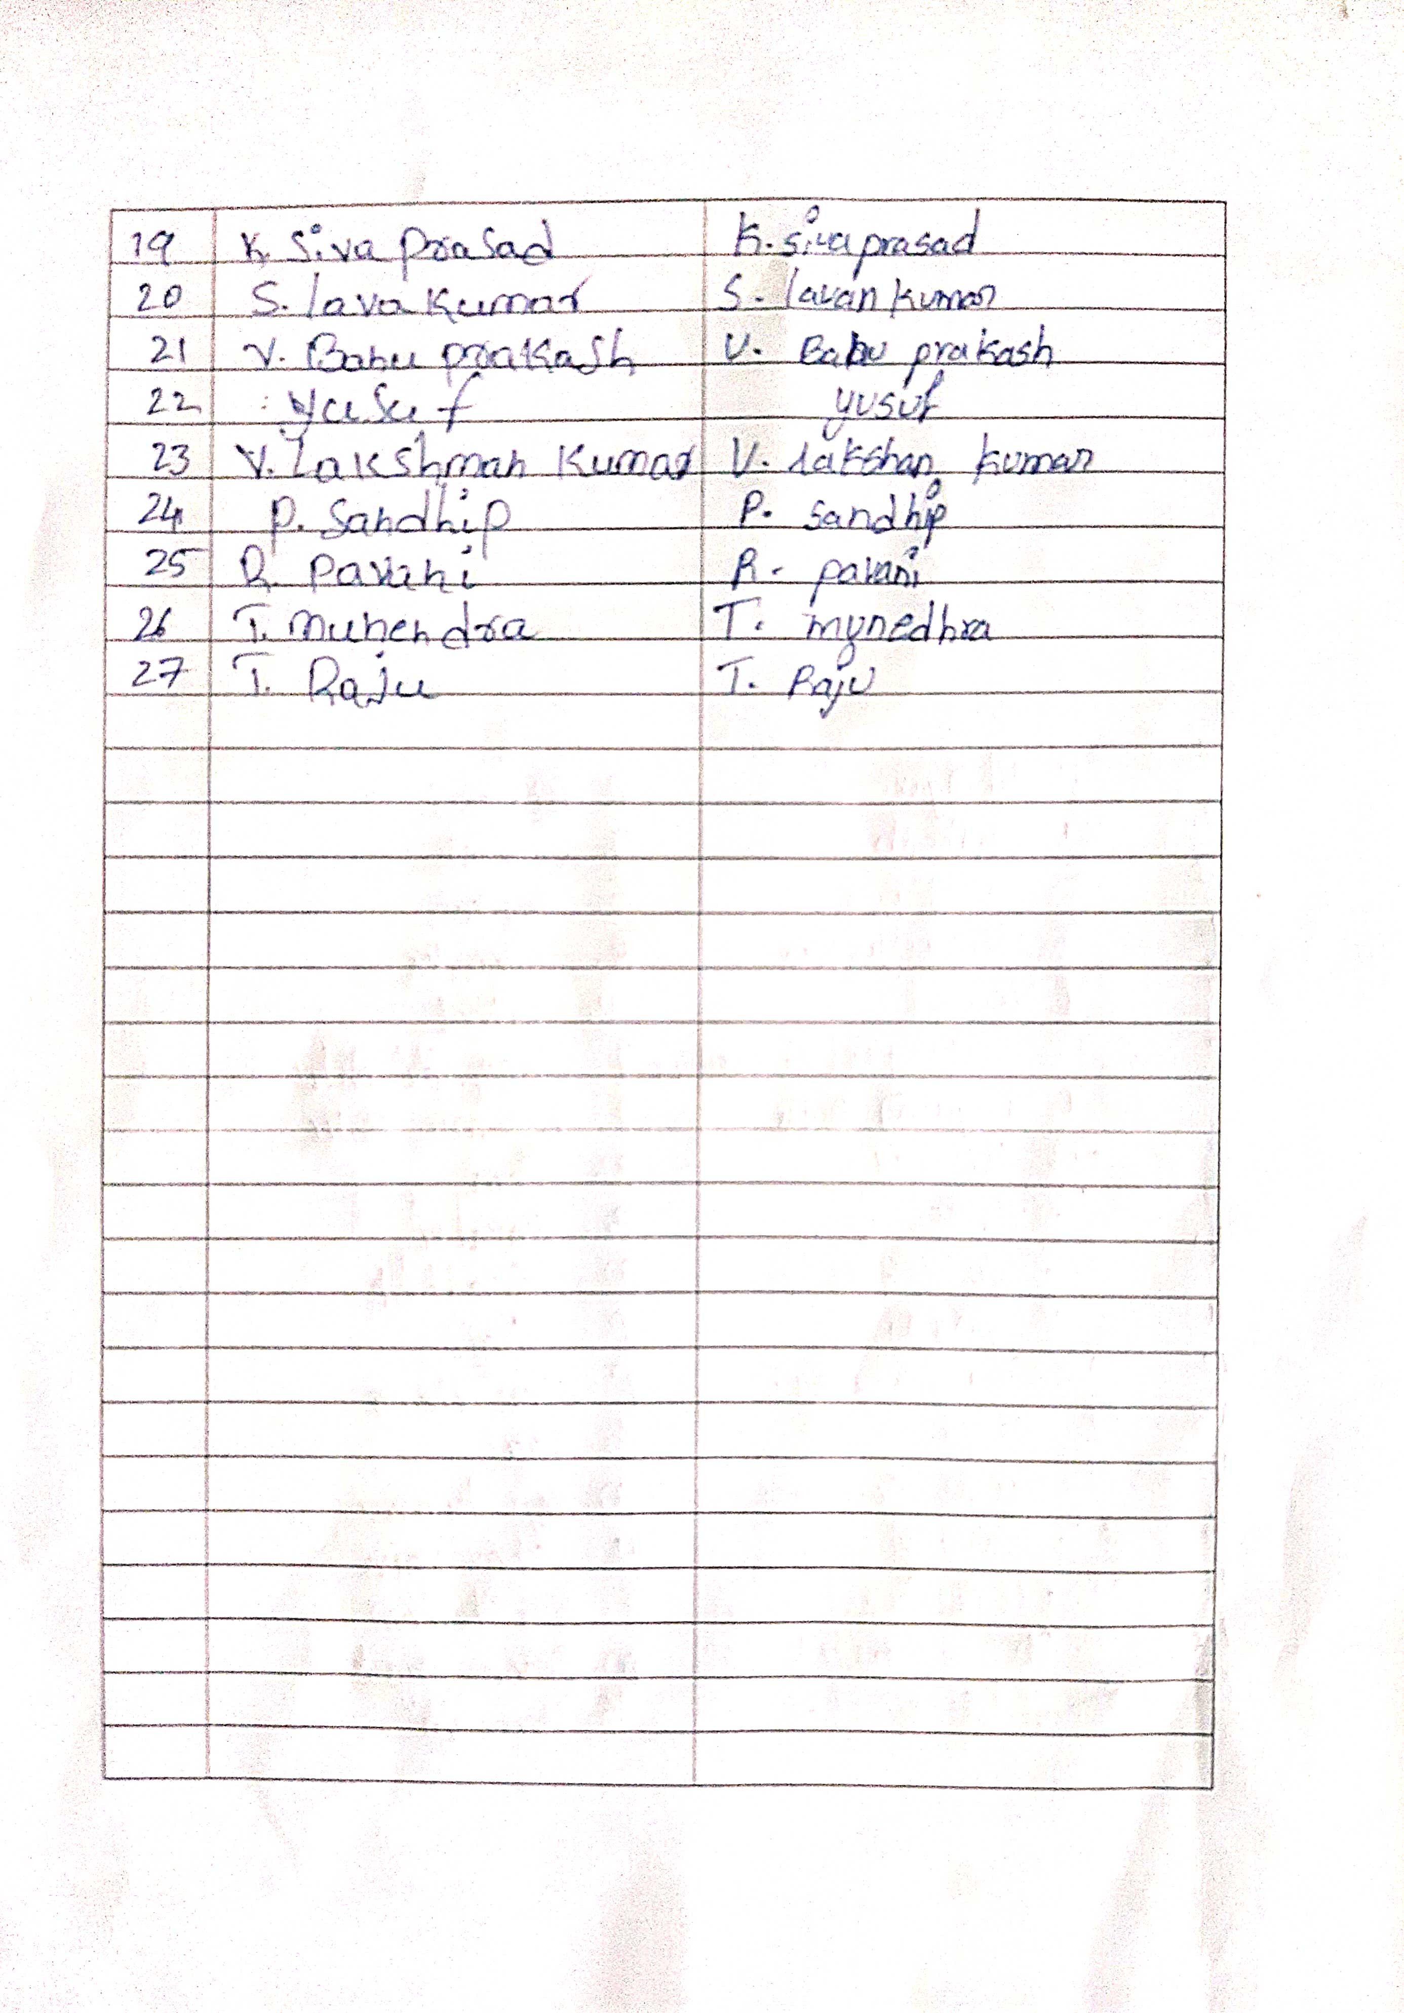
FEED BACK:
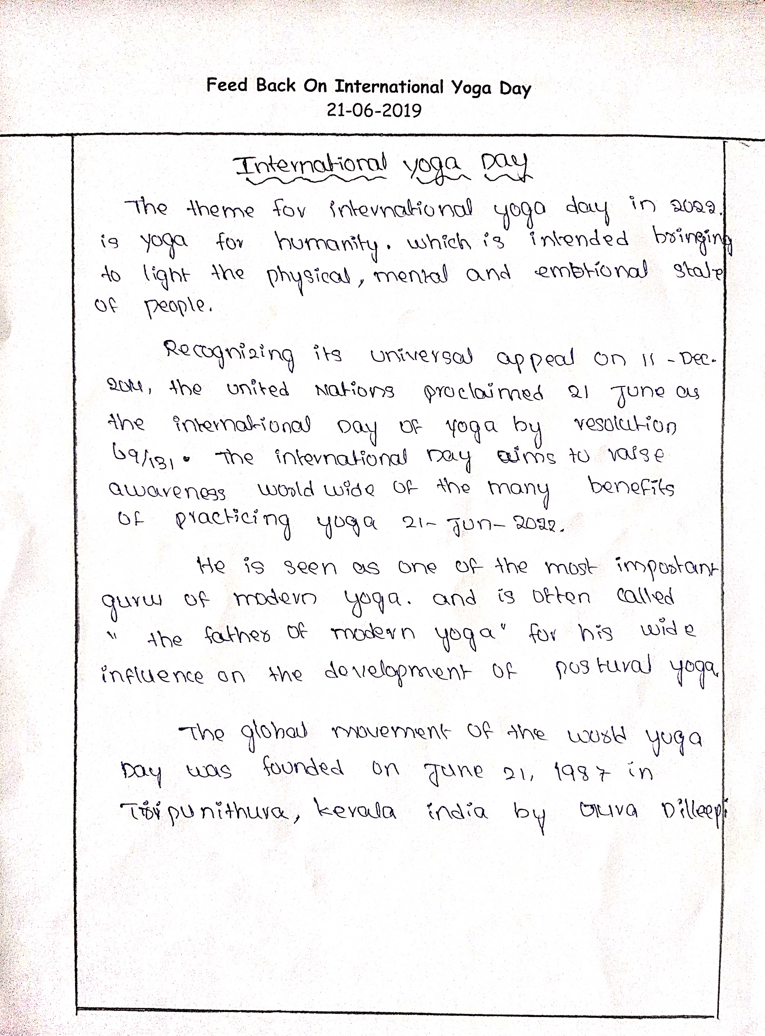

PHOTOS

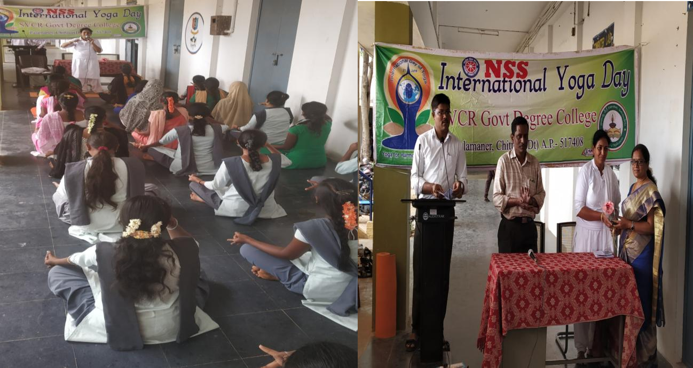
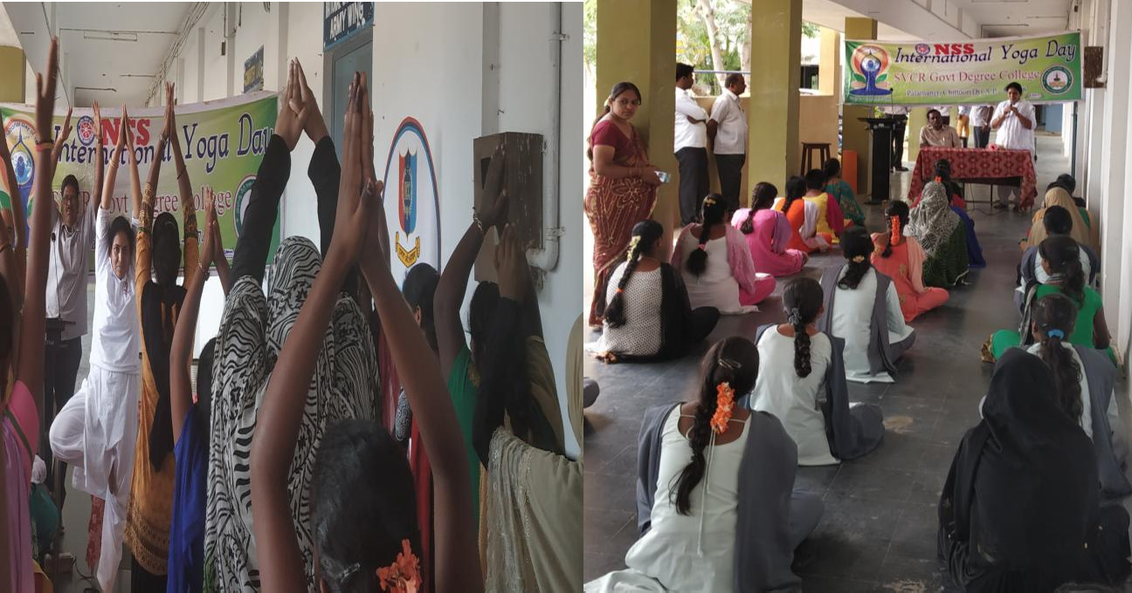
SVCR GOVT DEGREE COLLEGE
PALAMANER
PROGRAM NAME : | VANAM MANAM PROGRAMME
PROGRAM DATE : | 09-07-2019
TIME : | 10:00 AM
VENUE : | COLLEGE CAMPUS
RESOURCE PERSON : | Sri Chandra Mohan S.I., Palamaner
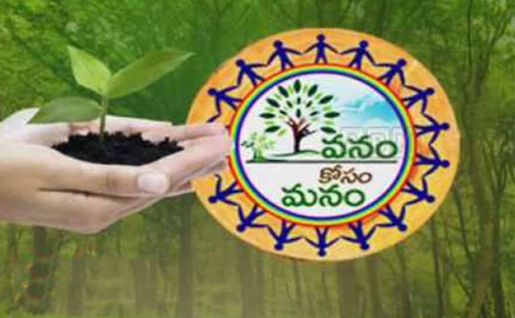

OFFICE OF THE PRINCIPAL
SVCR GOVT. DEGREE COLLEGE
Re-accredited by NAAC with 'B' Grade
Present: Dr. P. Babu, M.Sc, Ph.D

Dated: 08/07/2019

CIRCULAR

This is to inform that as per the instructions of Govt. of Andhra Pradesh, Vanam – Manam programme is conducted in college campus on 09/07/2019. In this connection, as a part of the green drive, saplings will be planted to keep environment green. All the students and staff are directed to attend this massive tree plantation programme.

Sd/-
Principal

OBJECTIVES OF THE PROGRAMME:
- To Nurture plants with care.
- To take care of the plants that are planted.

REPORT OF THE PROGRAMME:
NSS Unit of the college organized Vanam Manam-Sapling Plantation Programme inthe College campus on9th July2019. The plantation programme is inauguratedbyour Principal Dr. P. Babu andSri Chandra Mohan, S.I, Palamaner. Principal appealedto adopt at least two saplings per volunteer.The NSS Programme officer, teaching& non-teaching staff, SHE team Police, Palamaner, NSS volunteers and studentshave actively participated in the programme and a total of 52 saplings of differentvarietieshavebeenplantedneartotheborewellofthecollege.

OUTCOMES:
- Green campus is initiated.
- The plants are taken care by the students.

FEED BACK:
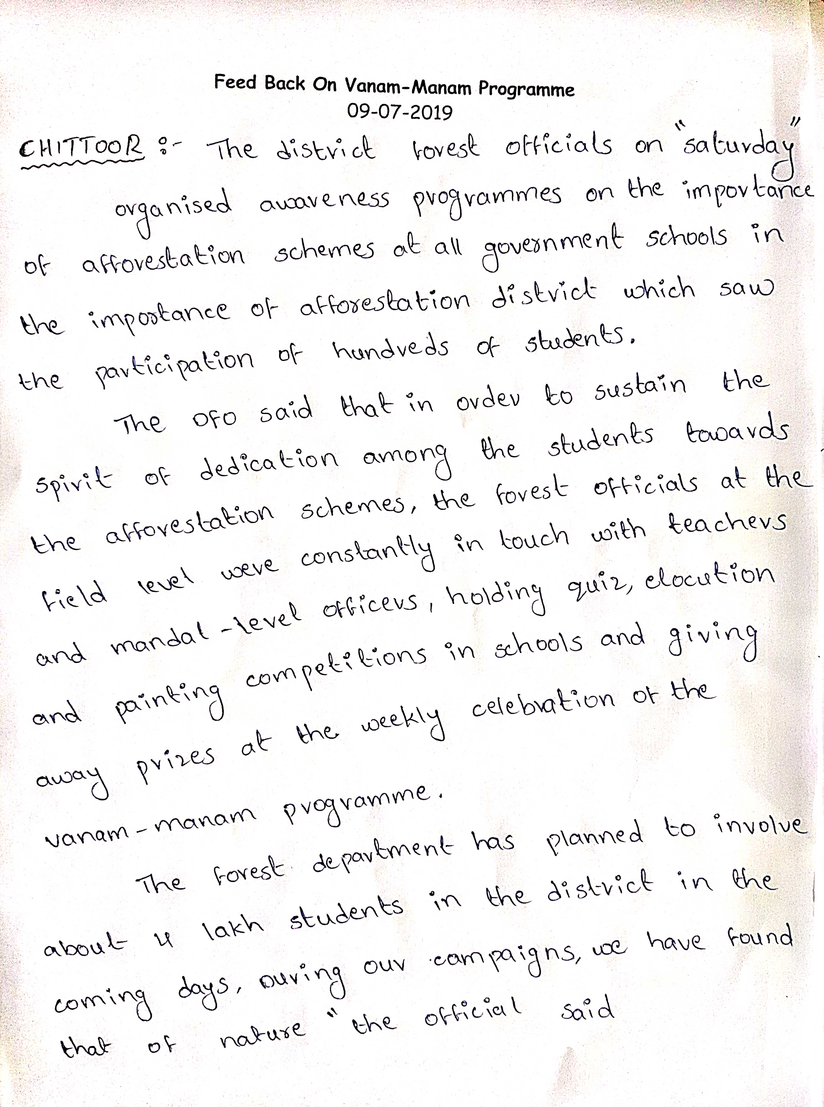

PHOTOS
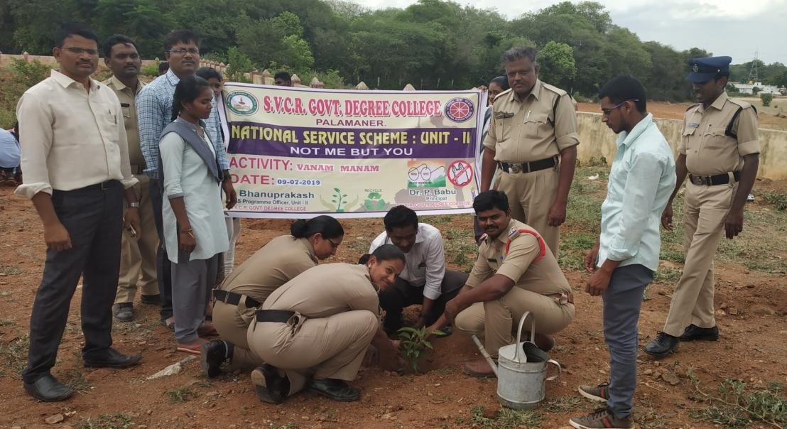
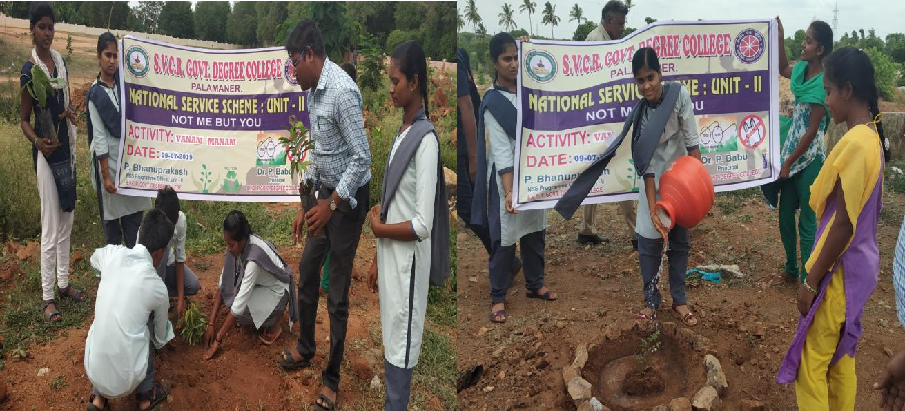
PRESS CLIPPINGS
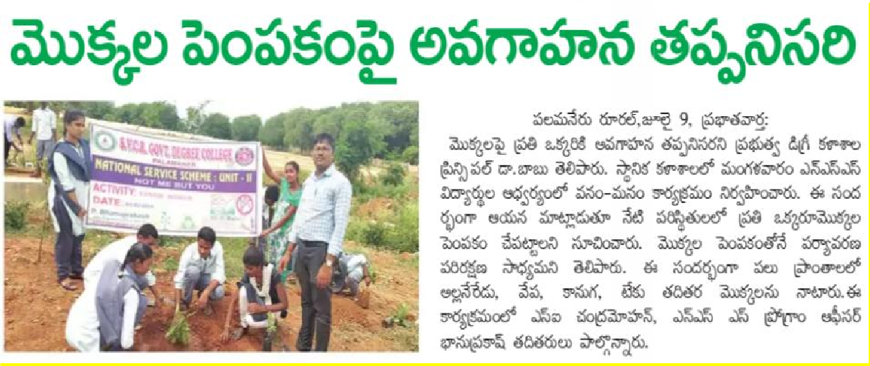
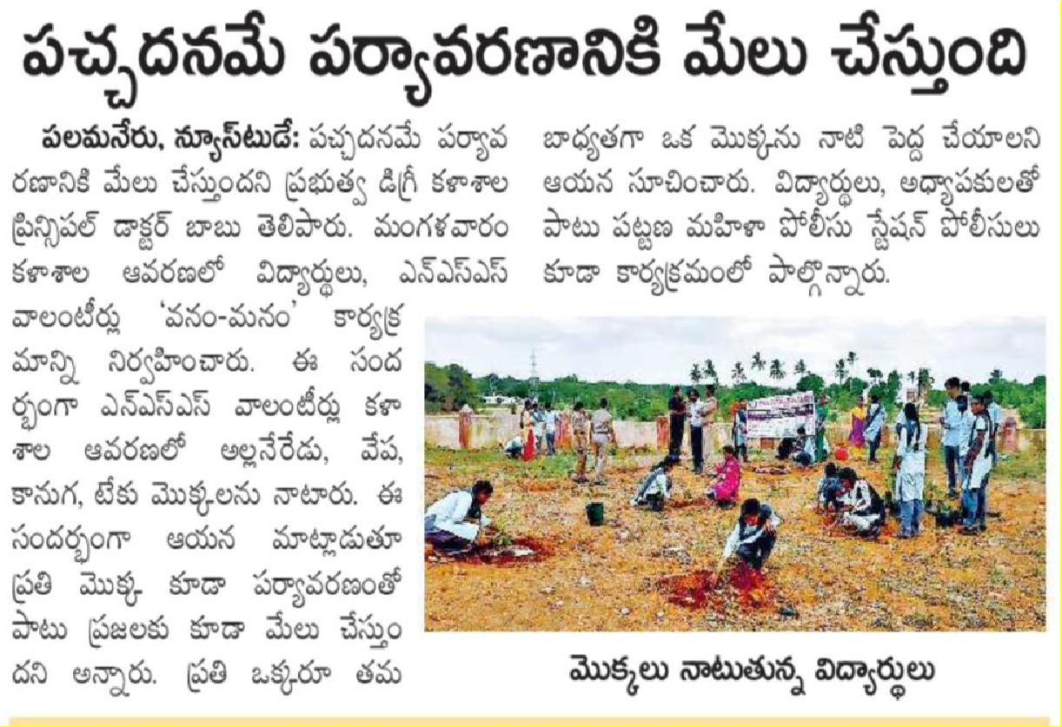
SVCR GOVT DEGREE COLLEGE
PALAMANER
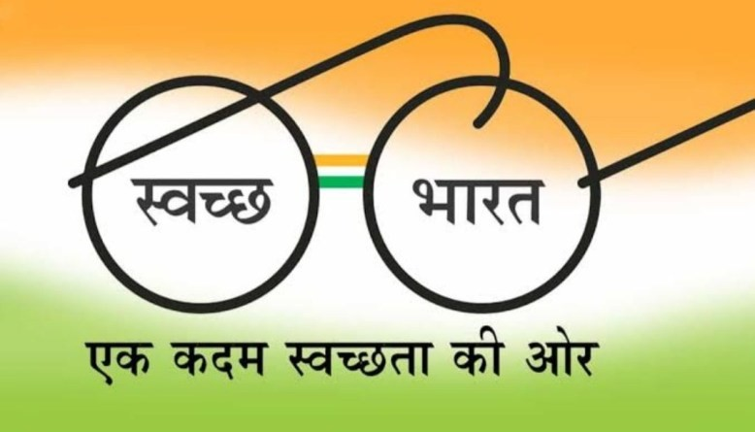
PROGRAM NAME : | SWACHH BHARAT IN THE ADOPTED VILLAGE: B JARRAVARI PALLI
PROGRAM DATE : | 18-07-2019
TIME : | 10:00 AM
VENUE : | B. JARRAVARI PALLI
RESOURCE PERSON : | Sri. GUNASEKHAR REDDY, HM

OFFICE OF THE PRINCIPAL
SVCR GOVT. DEGREE COLLEGE
Re-accredited by NAAC with 'B' Grade
Present: Dr. P. Babu, M.Sc, Ph.D

Dated: 17/07/2019

CIRCULAR

This is to inform that Swachh Bharath Programme will be conducted in B. Jarravari Palli Village on 18 July 2019. Hence, all the interested students and NSS volunteers are instructedto actively participate in this programme. Contact Dr.G.Chinna Reddy, Lecturer in Chemistry for more information.

Sd/-
Principal

OBJECTIVES OF THE PROGRAMME:
- To learn doing seva to all the people.
- To extend services to the villages.

REPORT OF THE PROGRAMME:
NSS Volunteers Organized Swachh Bharath Prgoramme in B. Jarravari Palli Village.NSS Volunteers explained the importance of Personal hygiene to the M.P.P schoolstudents. Weeds & plastic waste were removed, few saplings were planted, andwatered the other plants in the school premises with help of school children.Pitswere made by NSS volunteers to develop garden near the entrance gate of theschool.Dr. G. ChinnaReddy-Lecturerinchemistry,SriGunasekharReddy-H.Mactivelyinvolvedintheactivity.

OUTCOMES:
- The village is made clean.
- The plastic is removed from the village.

SIGNATURE OF THE STUDENTS:
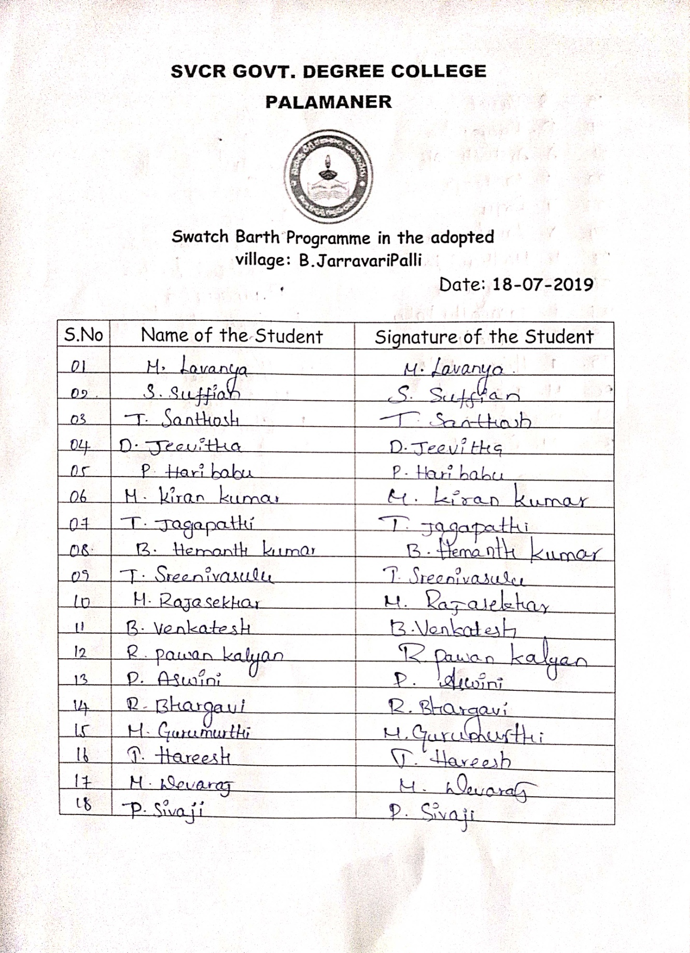

FEED BACK:
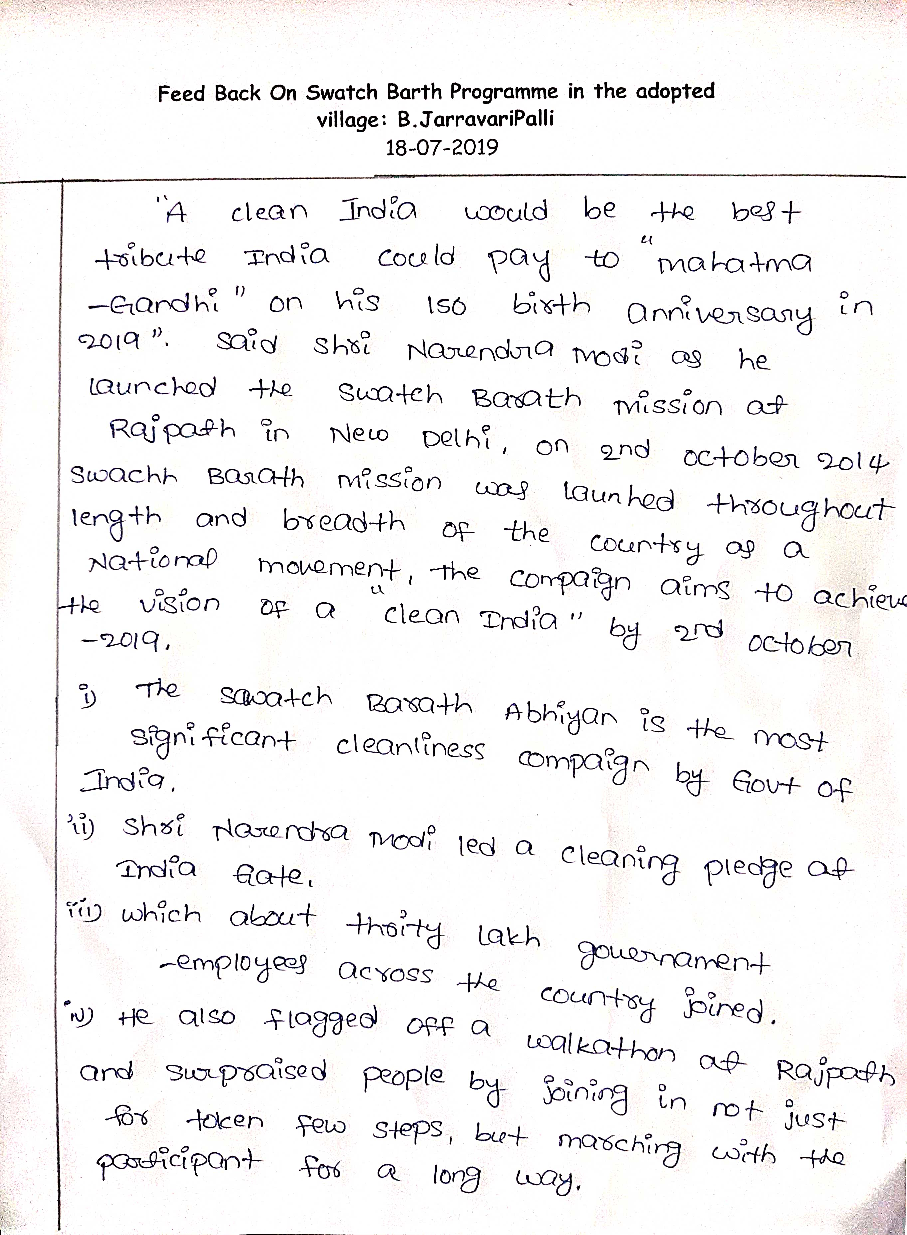

PHOTOS
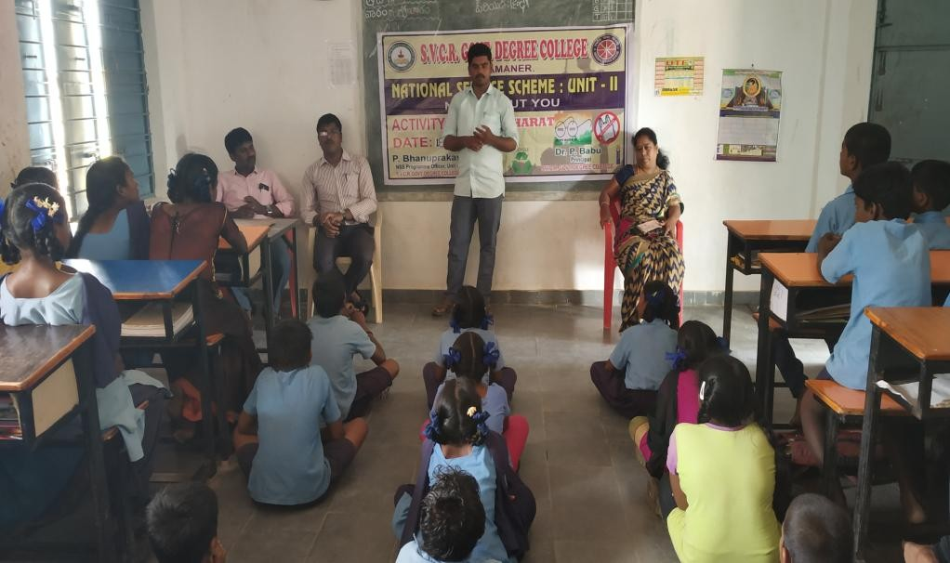
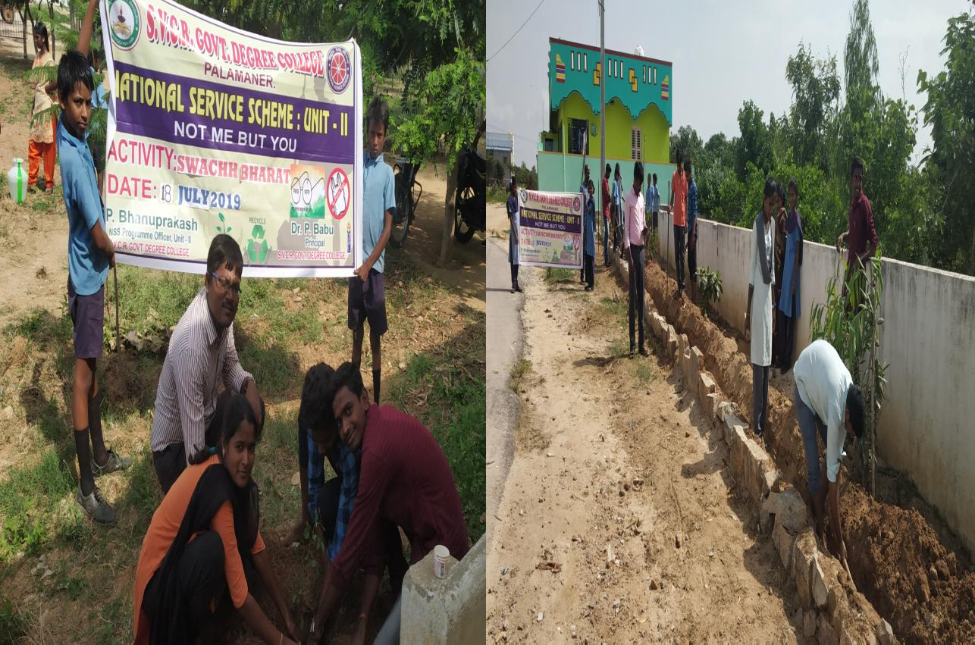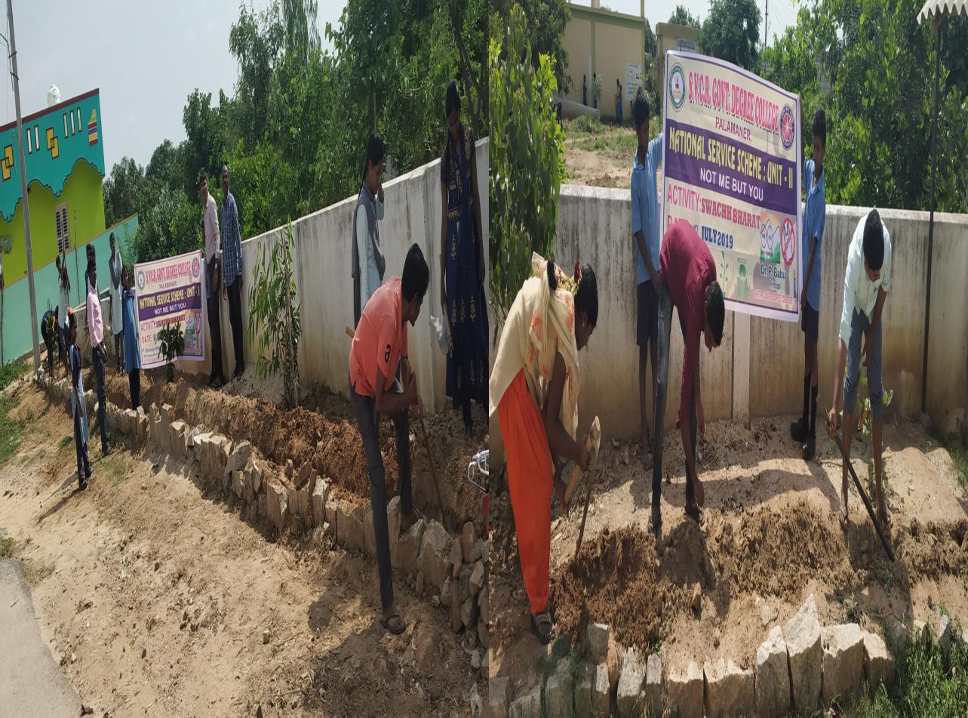

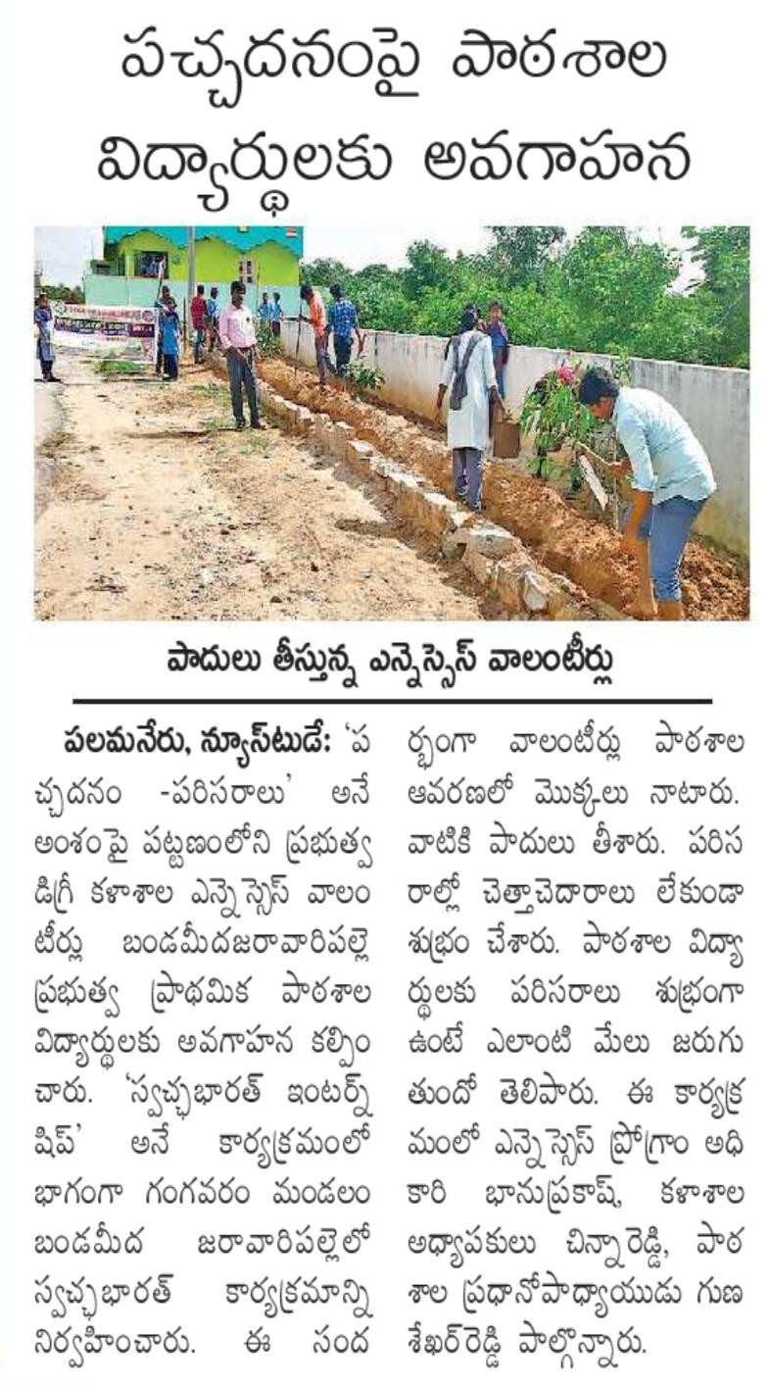
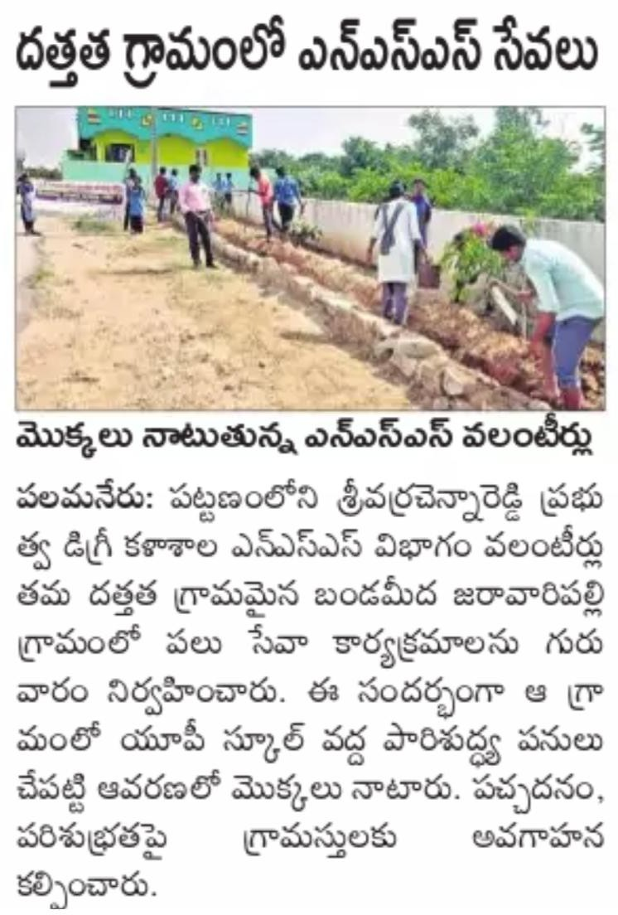
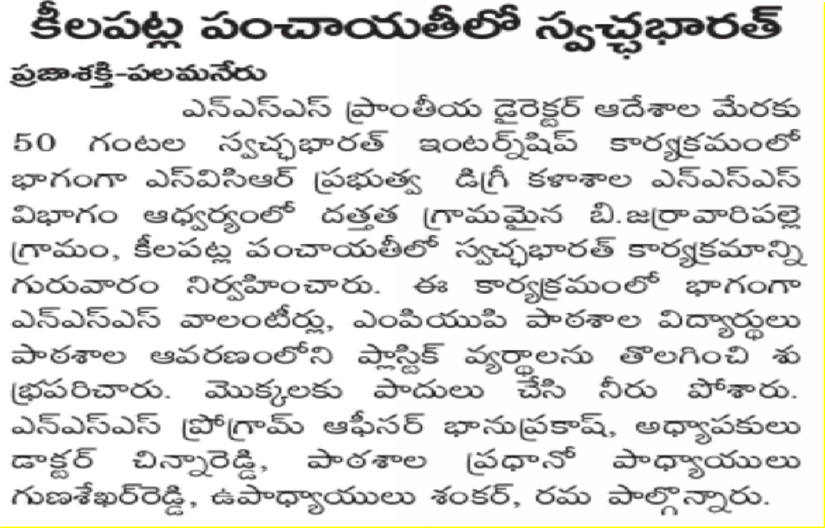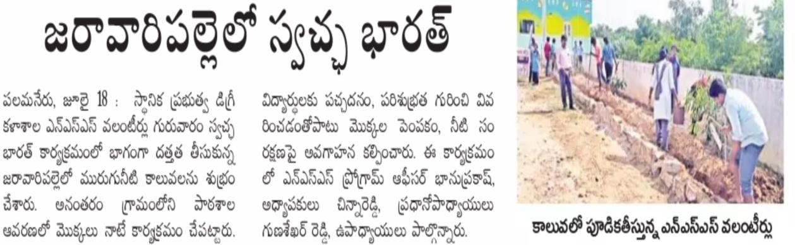
SVCR GOVT DEGREE COLLEGE
PALAMANER
PROGRAM NAME : | 600 SAPLINGS TRANSPORTATION FROM THE FOREST DEPARTMENT NURSERY
PROGRAM DATE : | 25-07-2019
TIME : | 10:00 AM
VENUE : | FOREST DEPARTMENT NURSERY
RESOURCE PERSON : | DR. P. BABU, PRINCIPAL
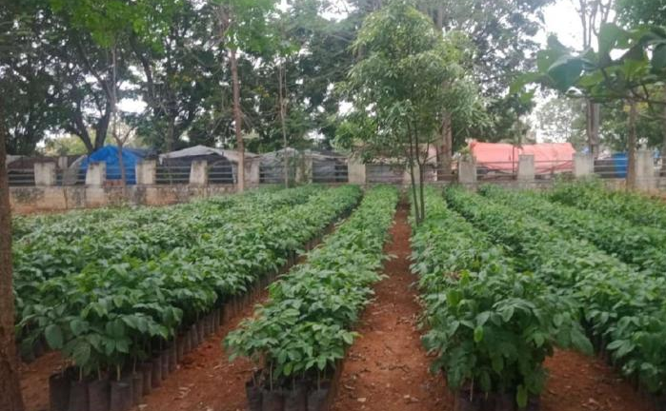

OFFICE OF THE PRINCIPAL
SVCR GOVT. DEGREE COLLEGE
Re-accredited by NAAC with 'B' Grade
Present: Dr. P. Babu, M.Sc, Ph.D

Dated: 23/07/2019

CIRCULAR

This is to inform that 600 saplings are to be transported from the Forest department nursery to our college campus on 25 July 2019. Hence, all the interested students and NSS volunteers are instructed to actively participate in this programme.

Sd/-
Principal

OBJECTIVES OF THE PROGRAMME:
- To learn the methods of taking care of the plants.
- To make students partners in making the campus green.

REPORT OF THE PROGRAMME:
NSS Volunteers of the college actively involved in transporting 600 Saplings ofdifferent varieties from Forest department Nursery, to the college campus. Thesaplingswerekeptinorderbasedontheirvariety.

OUTCOMES:
- The students took care of the saplings.
- The students learnt to bifurcate the saplings.

SIGNATURE OF THE STUDENTS:
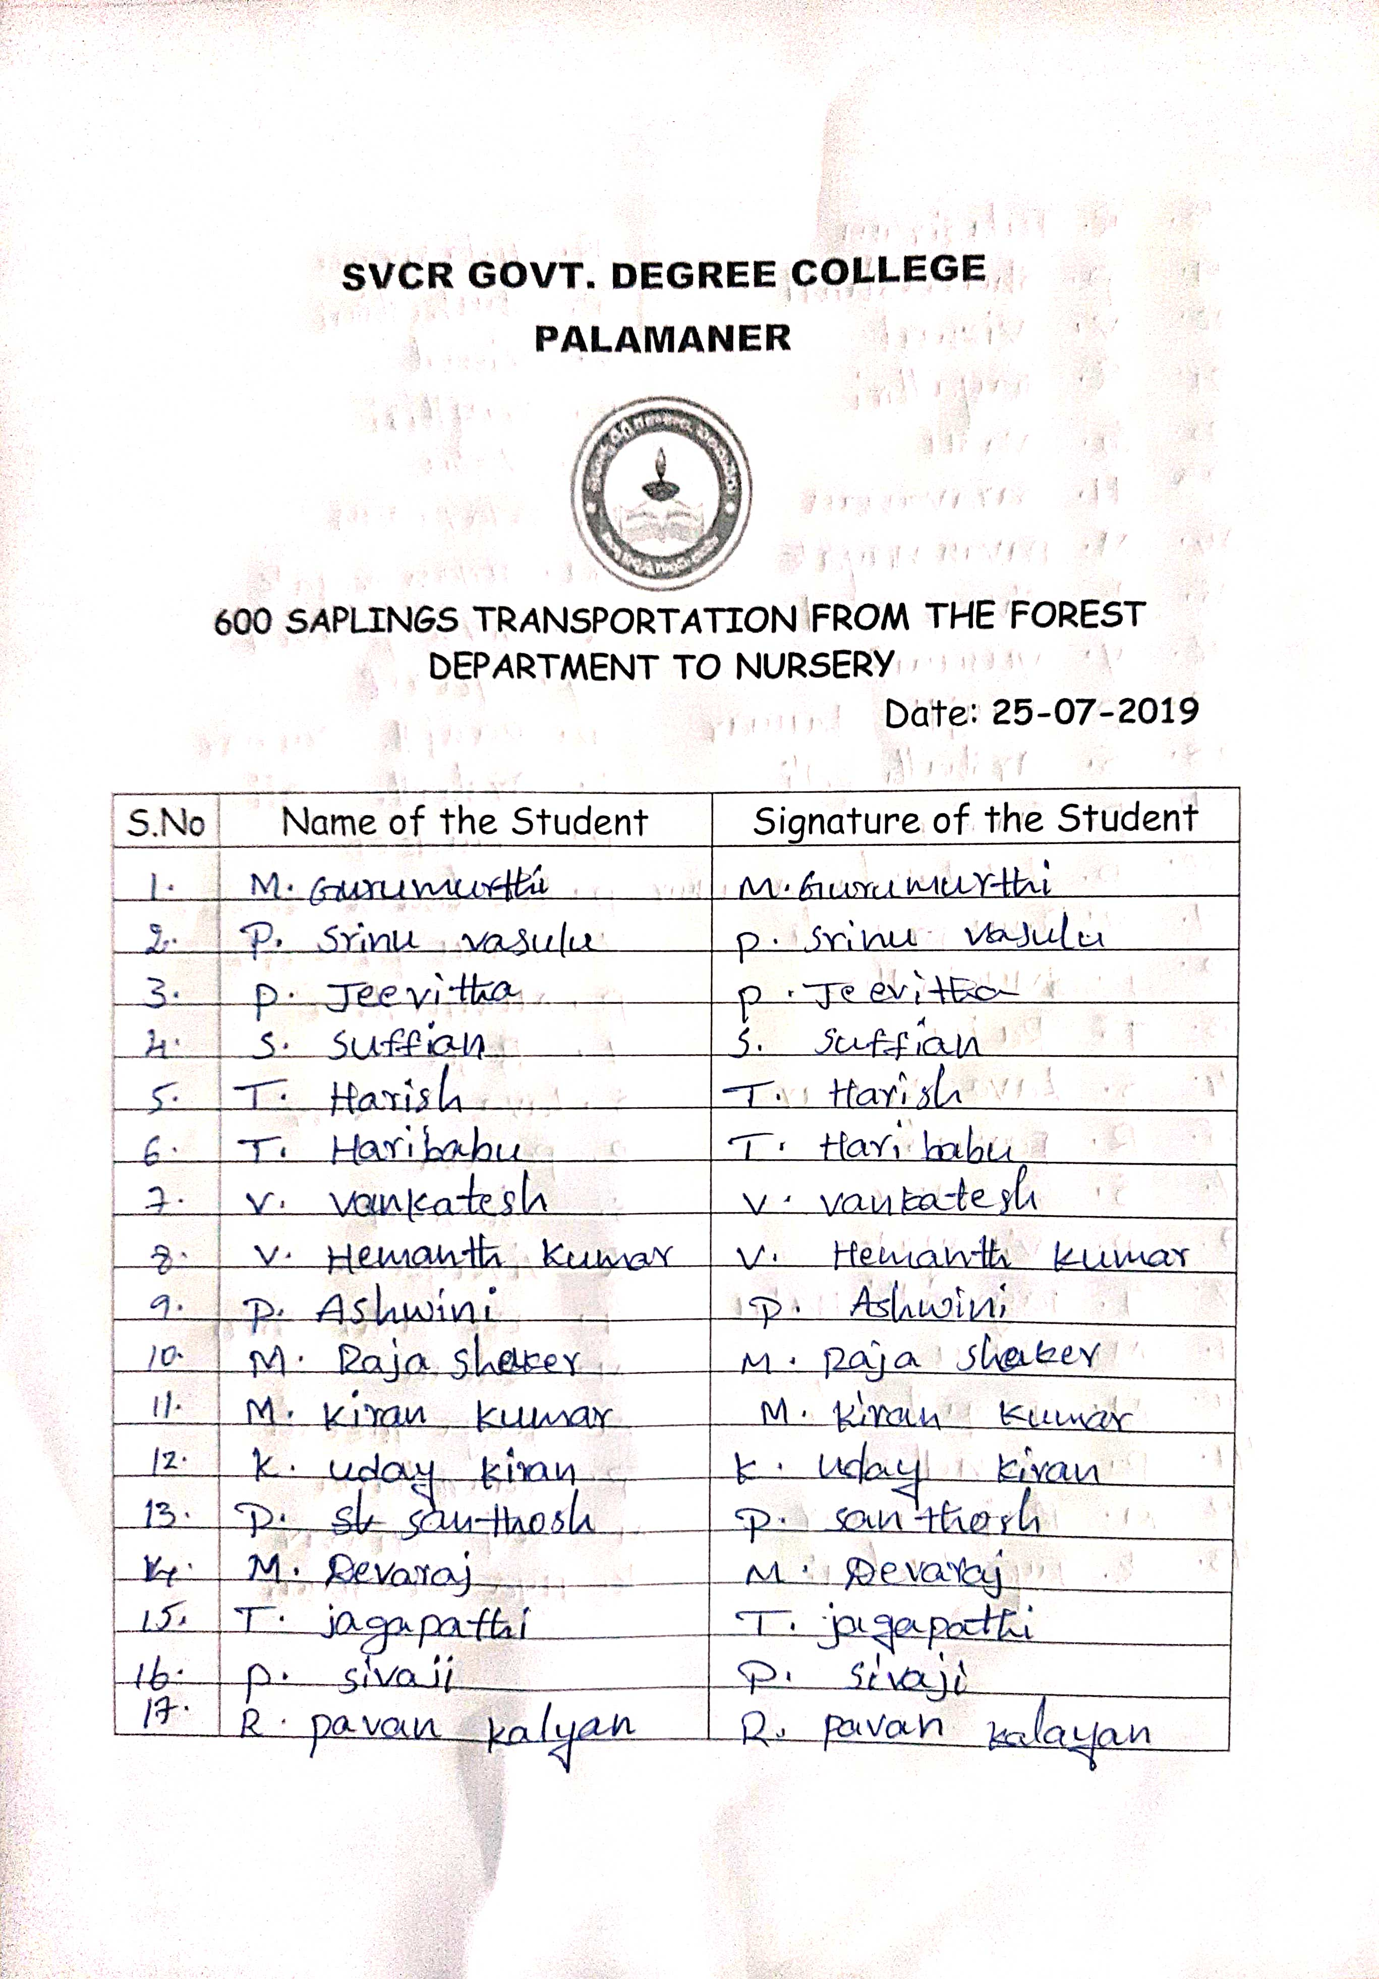
FEED BACK:
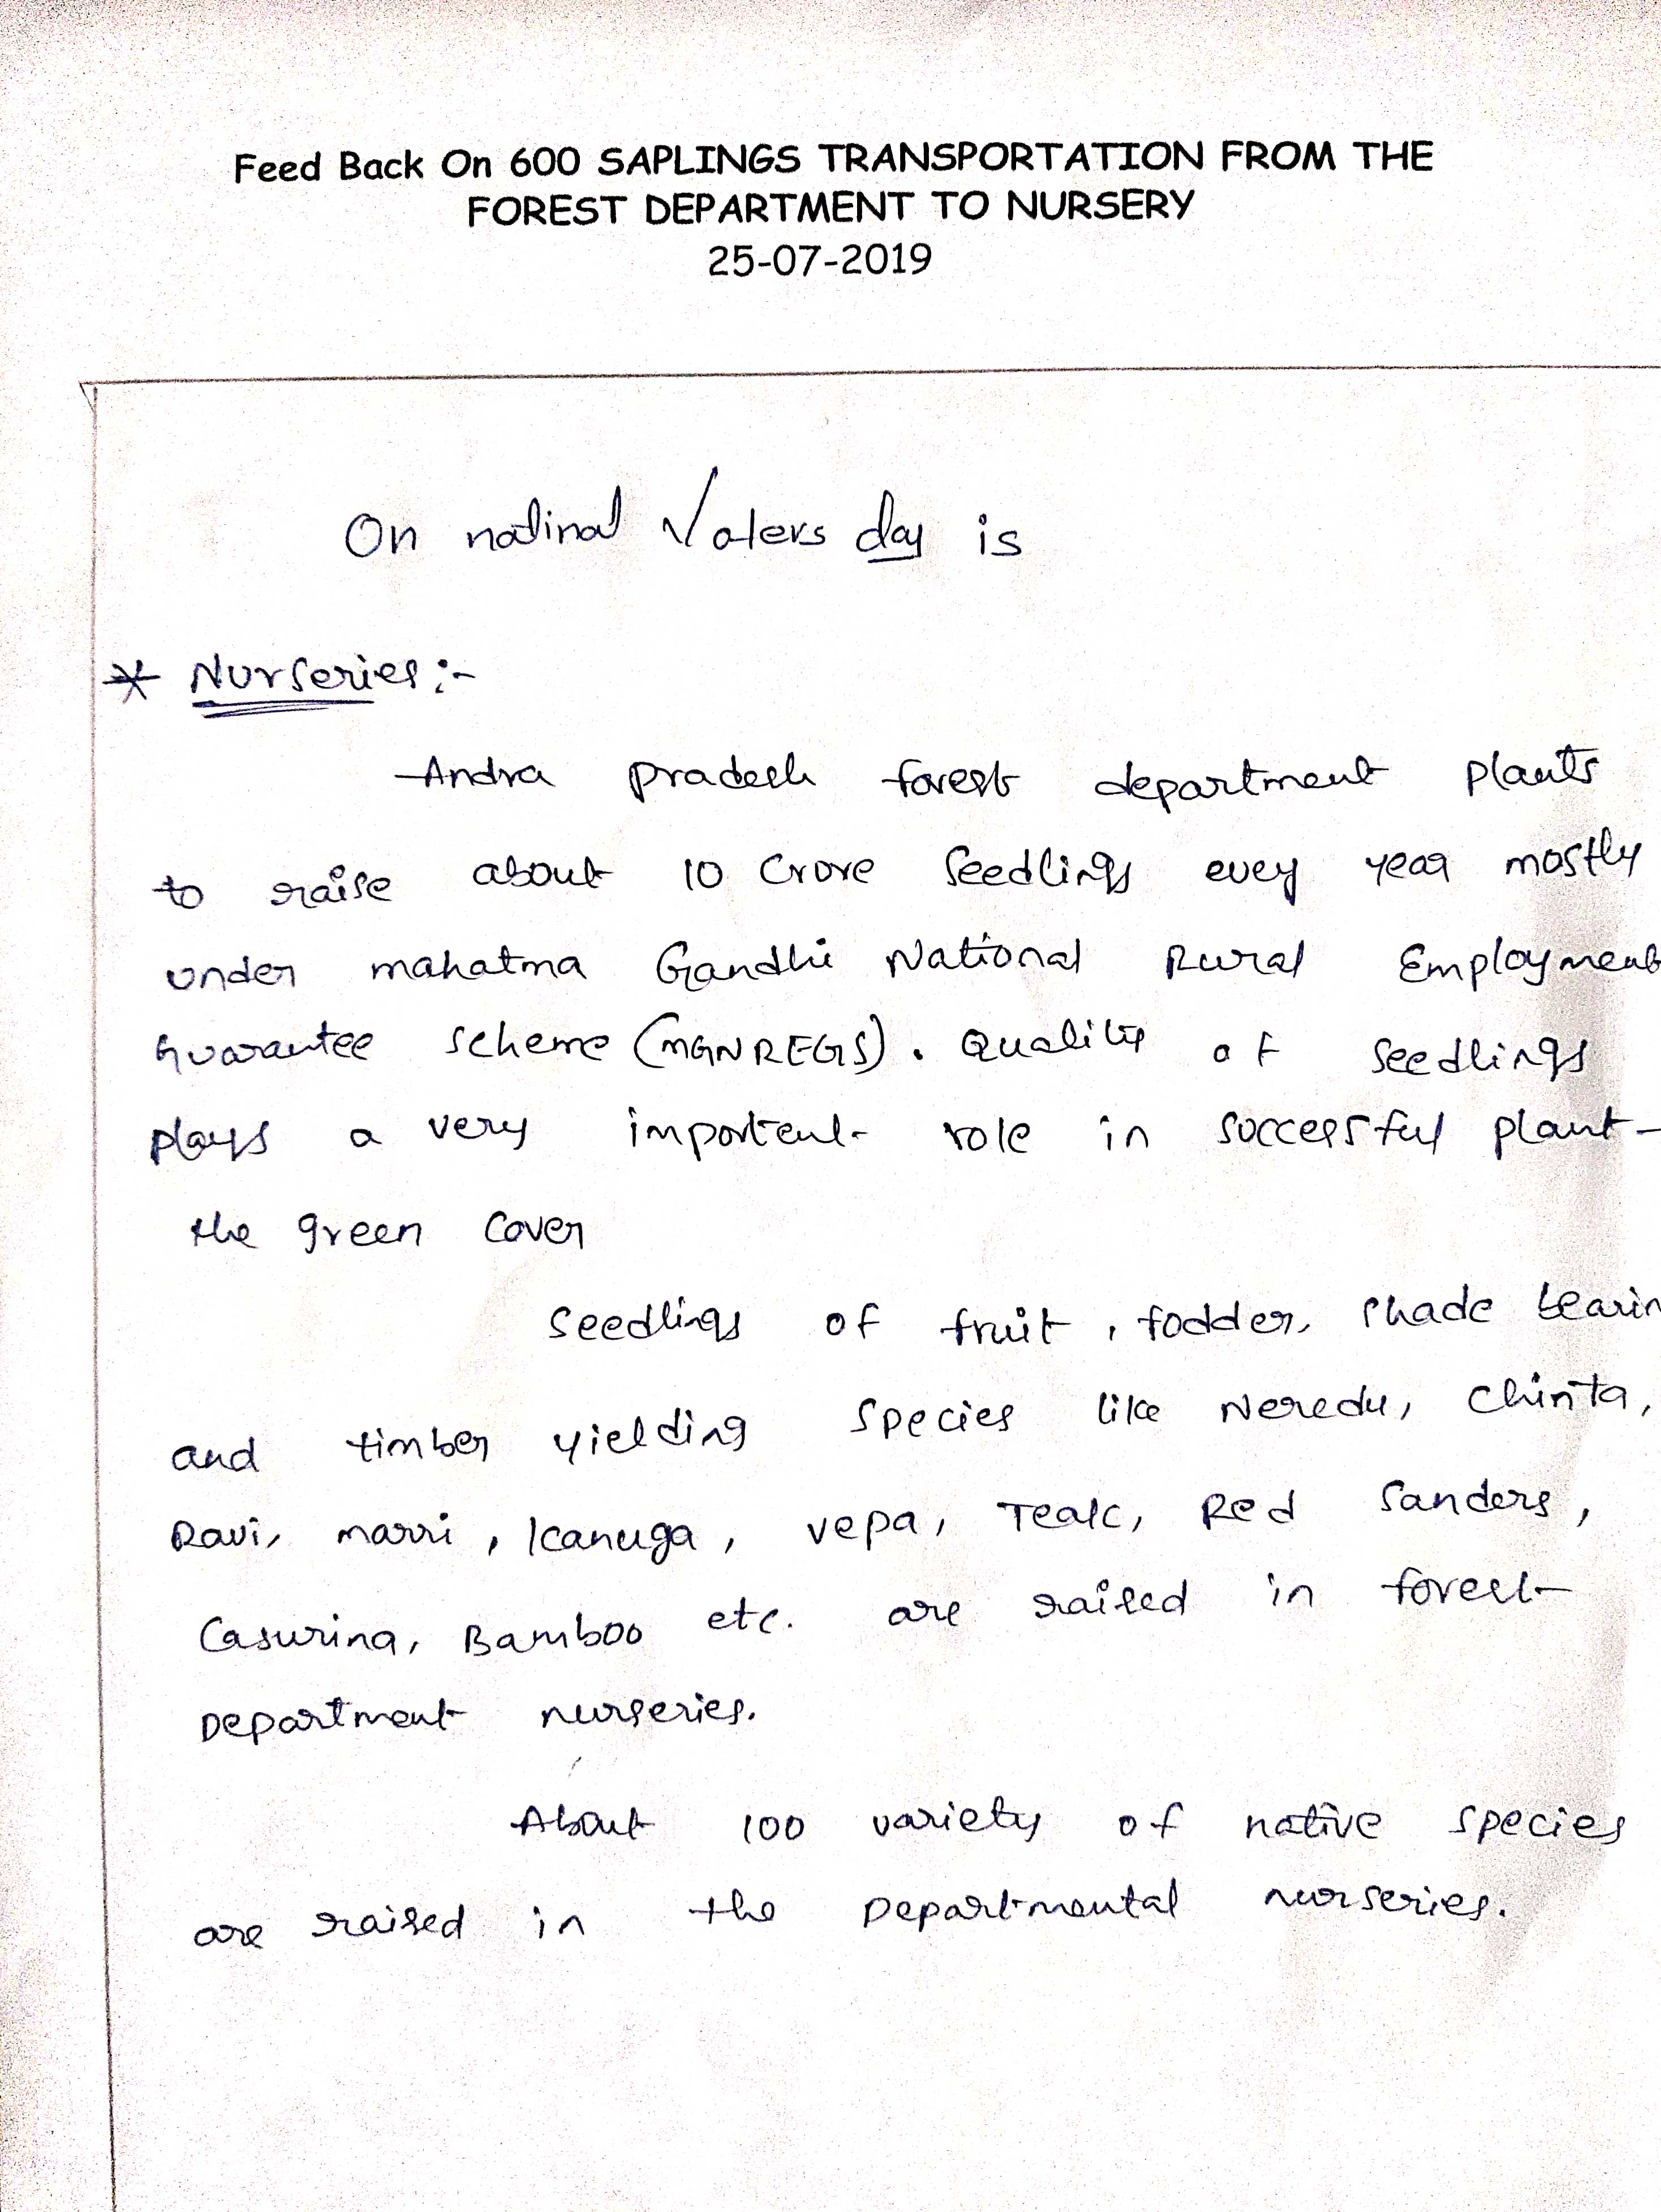

PHOTOS

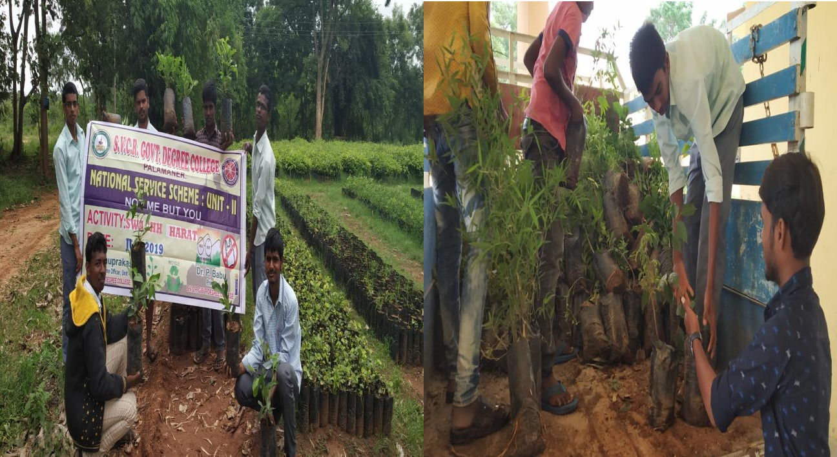

SVCR GOVT DEGREE COLLEGE
PALAMANER

PROGRAM NAME : | VANAM MANAM – MASSIVE SAPLINGS PLANTATION PROGRAMME
PROGRAM DATE : | 26 & 27-07-2019
TIME : | 10:00 AM
VENUE : | COLLEGE CAMPUS
RESOURCE PERSON : | DR. P. BABU, PRINCIPAL

NATIONAL SERVICE SCHEME
UNIT 1 & UNIT 2
SVCR GOVT. DEGREE COLLEGE
Re-accredited by NAAC with 'B' Grade

Dated: 25/07/2019

CIRCULAR

This is to inform that NSS Units 1 & 2 of our college is oraganizing a “Massive Saplings Plantation Programme” in the college on 26th and 27th July, 2019. A total of 180 saplings will be planted in our college campus. Hence, all the interested students and NSS volunteers are instructed to actively participate in this programme.

Sd/-
NSS Programme Officers
Unit 1 & 2
OBJECTIVES OF THE PROGRAMME:
- To nurture the plants.
- To make the campus green and clean.

REPORT OF THE PROGRAMME:
Massive Sapling Plantation Programme was organized by the NSS Unit of the college on 26 & 27th July 2019. Through this programme a total of 180 saplings of different varieties like Gulmohar, Bamboo, Alla neredu, Teak, Neem, Pongamia, Pippala, Badam, Gangireni etc. have been planted in the premisis of college. Dr. P. Babu-Principal, P. Bhanuprakash-NSS Programme officer, teaching & non-teaching staff, NSS volunteers and students have actively involved in the programme.

OUTCOMES:
- Saplings were distributed by the students.
- The planted saplings were taken care by the students.

SIGNATURE OF THE STUDENTS:
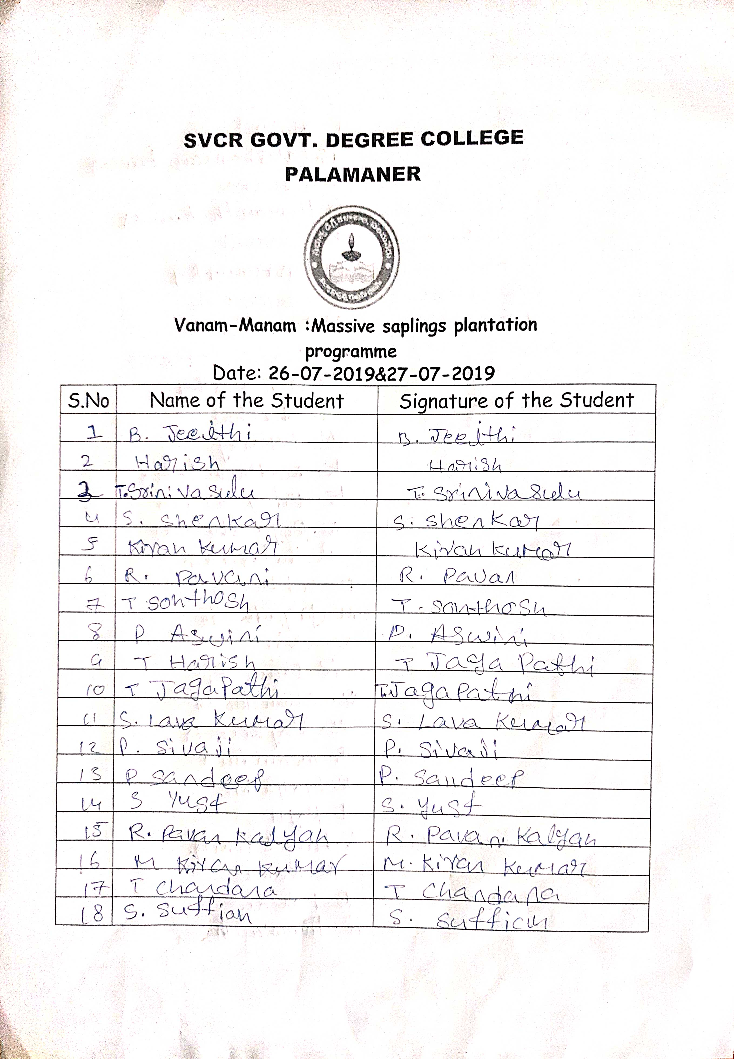

FEED BACK:
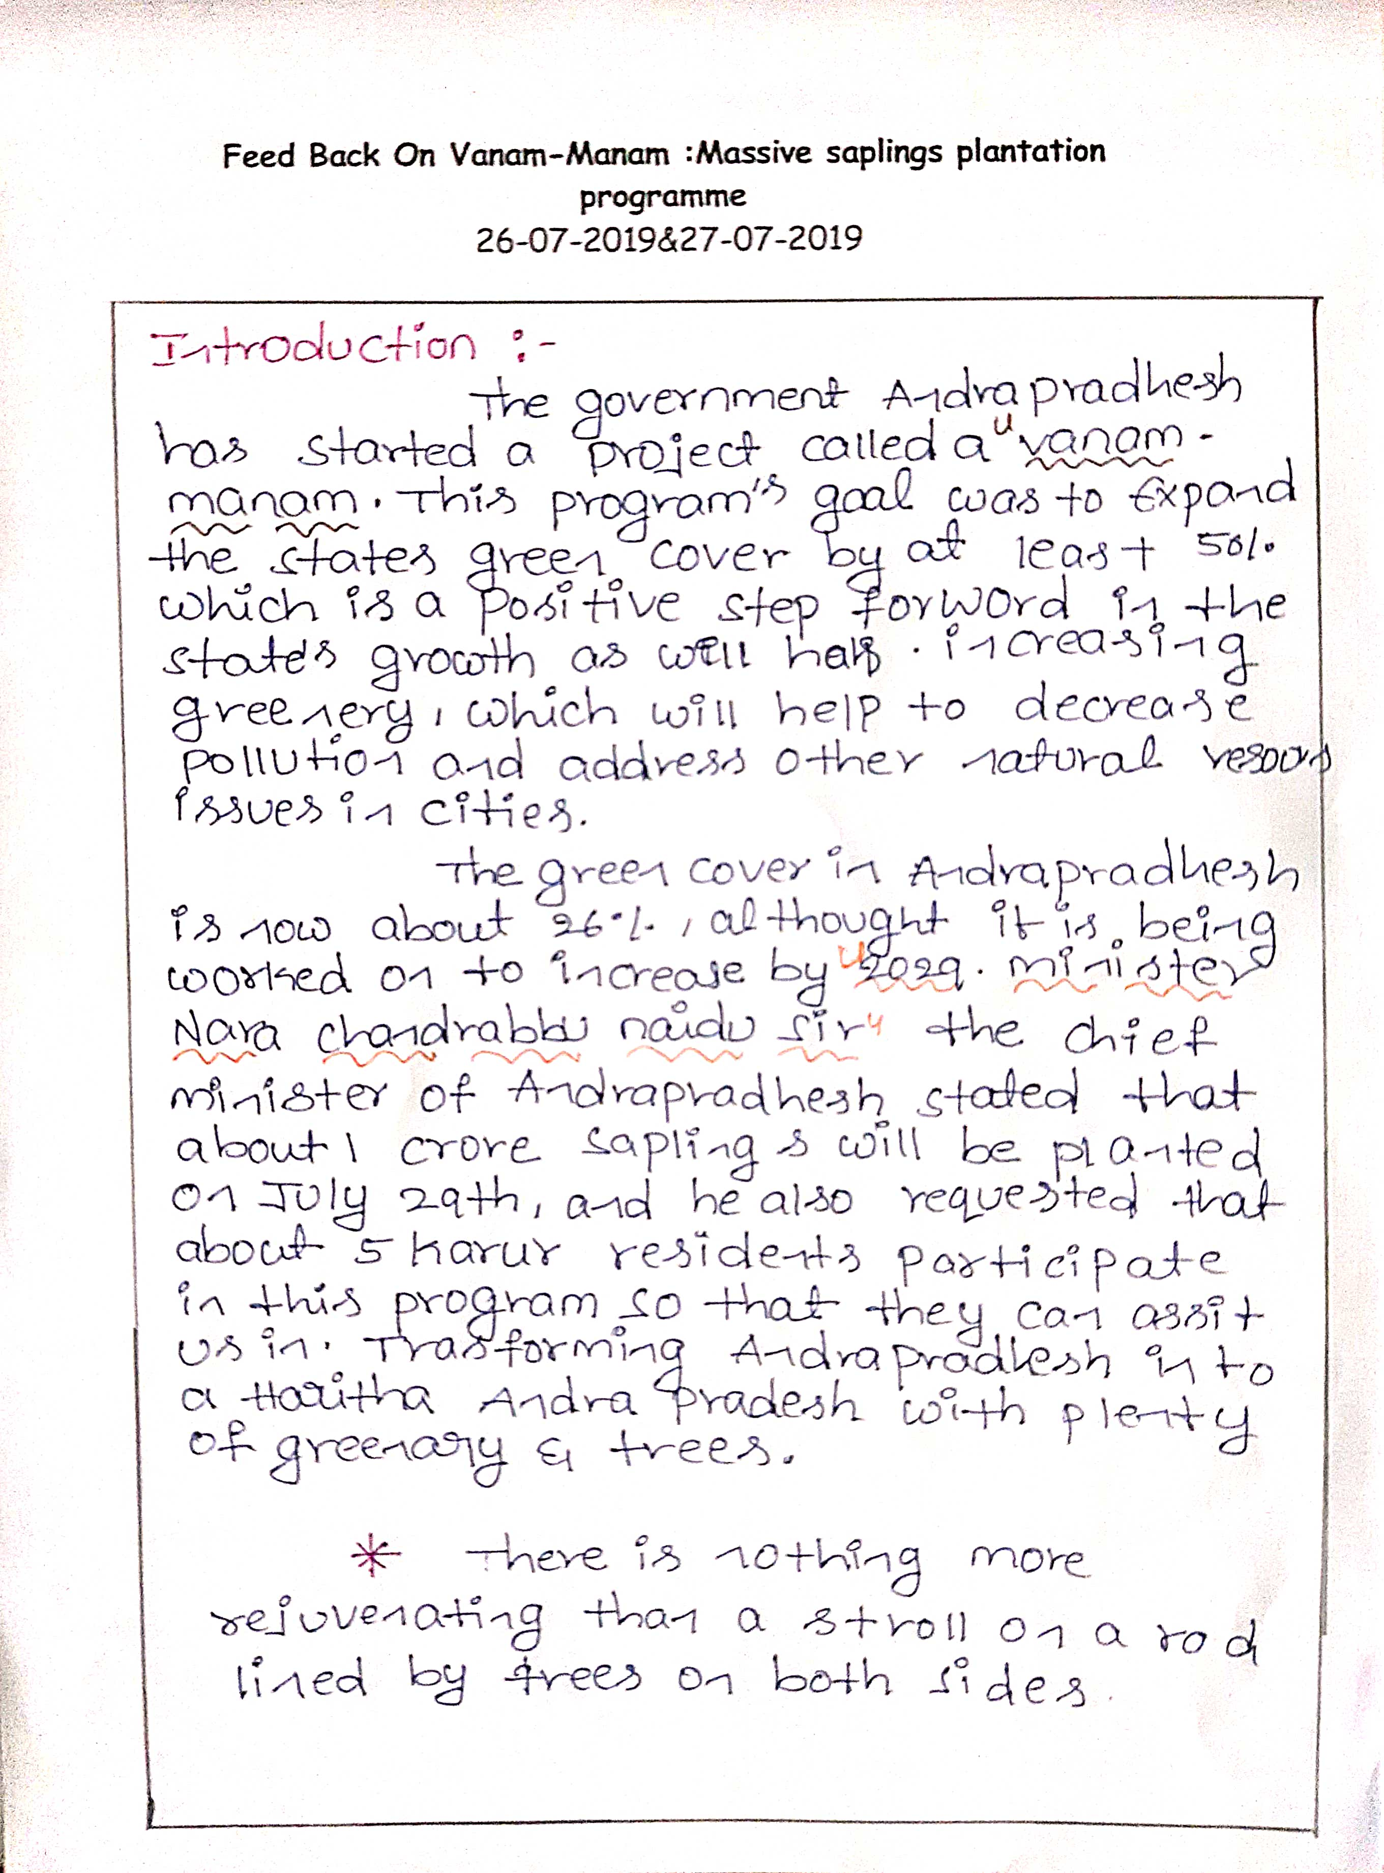

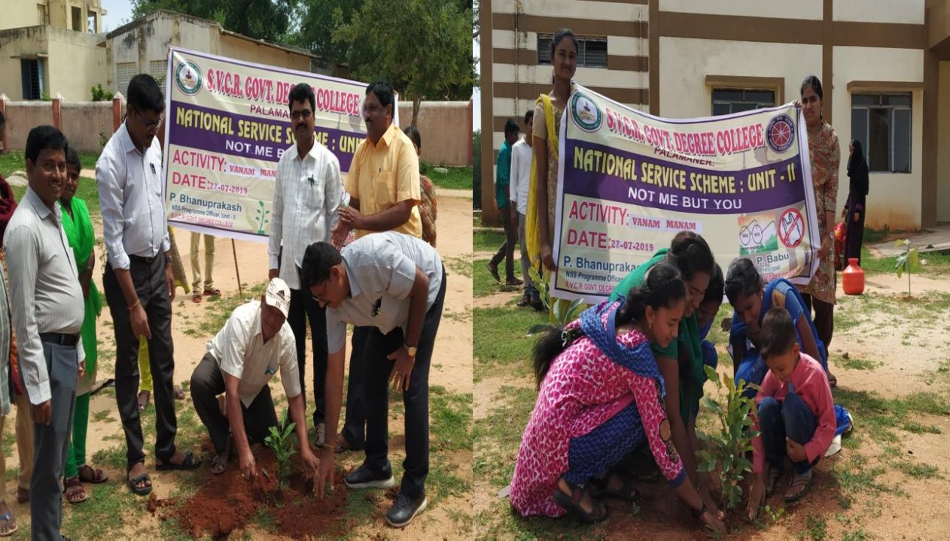
PHOTOS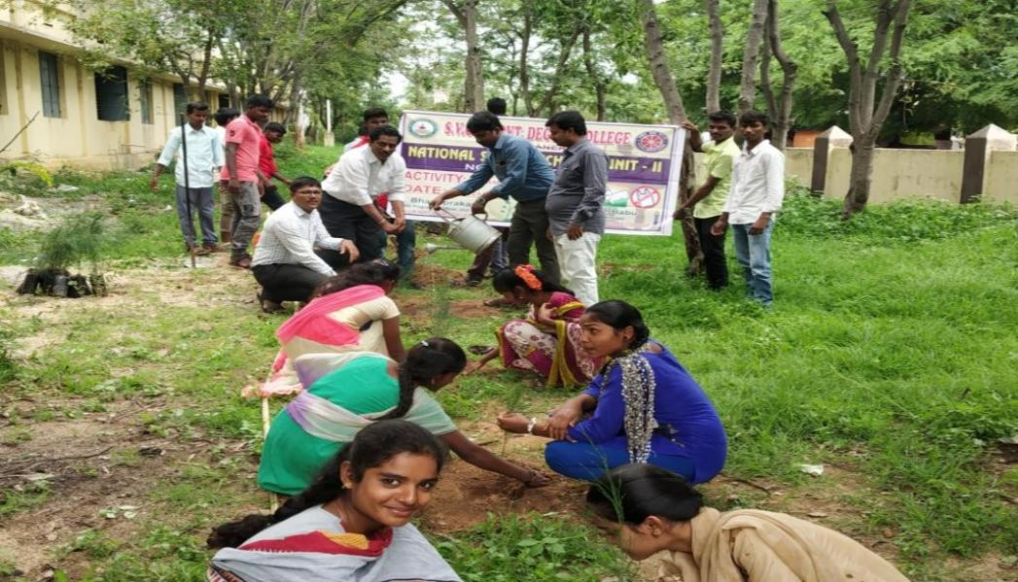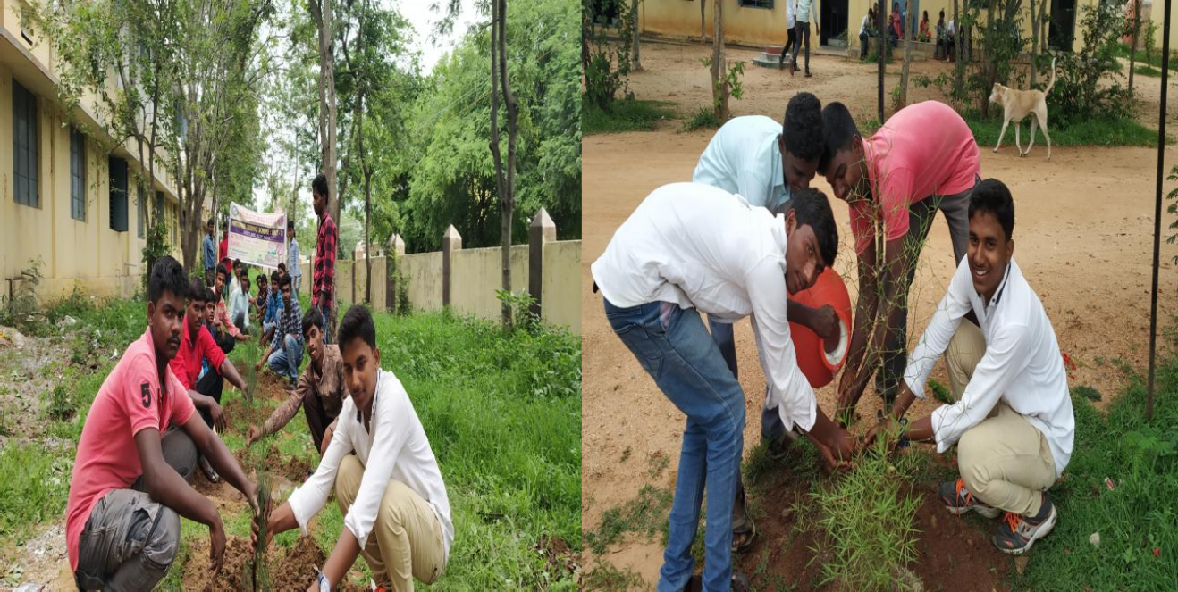
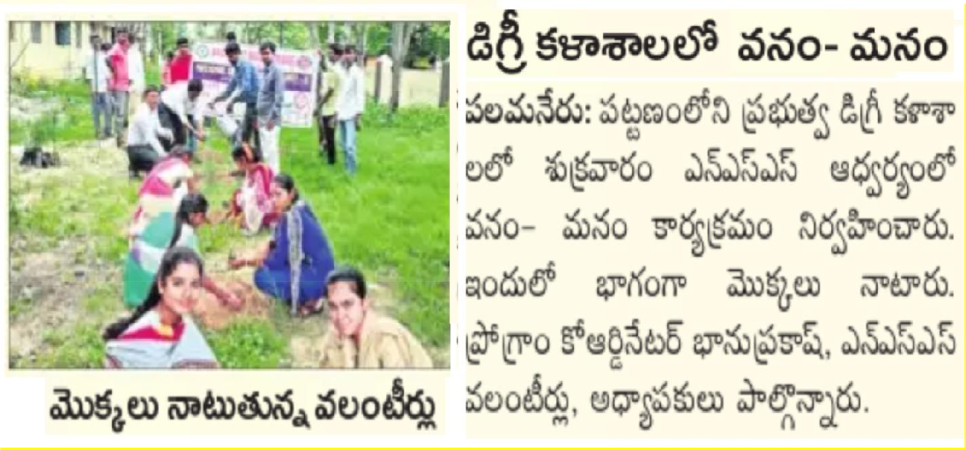
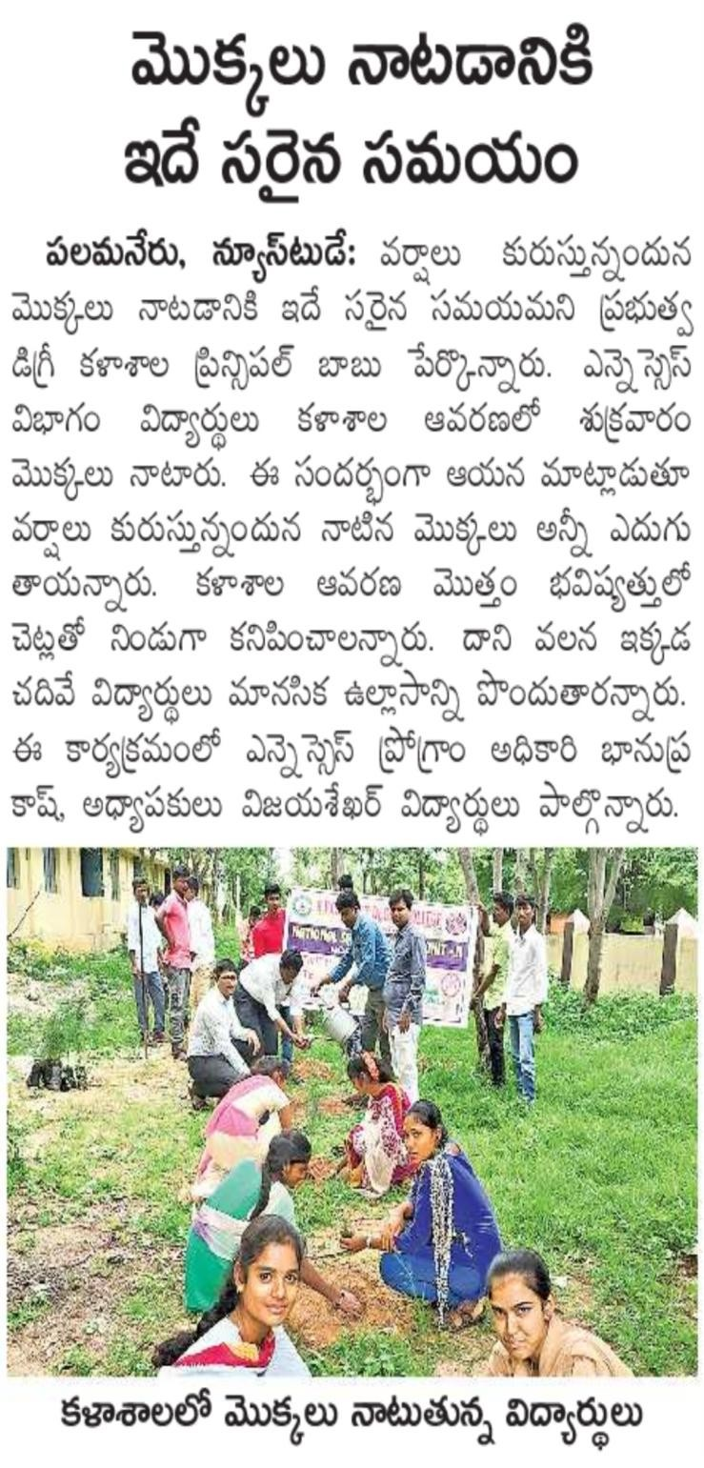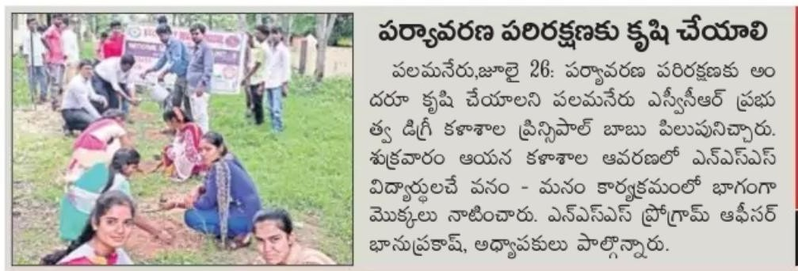

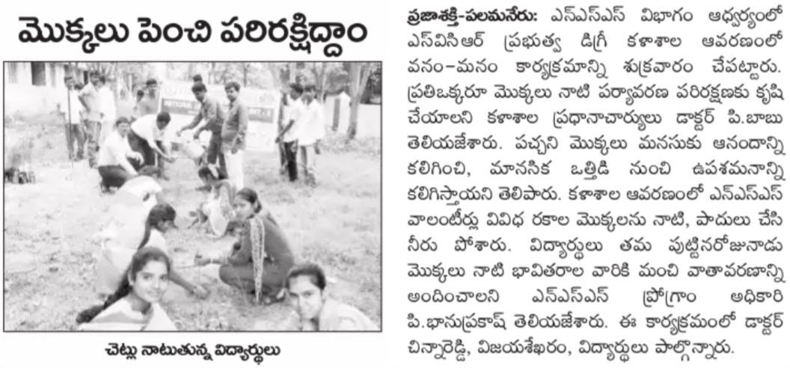
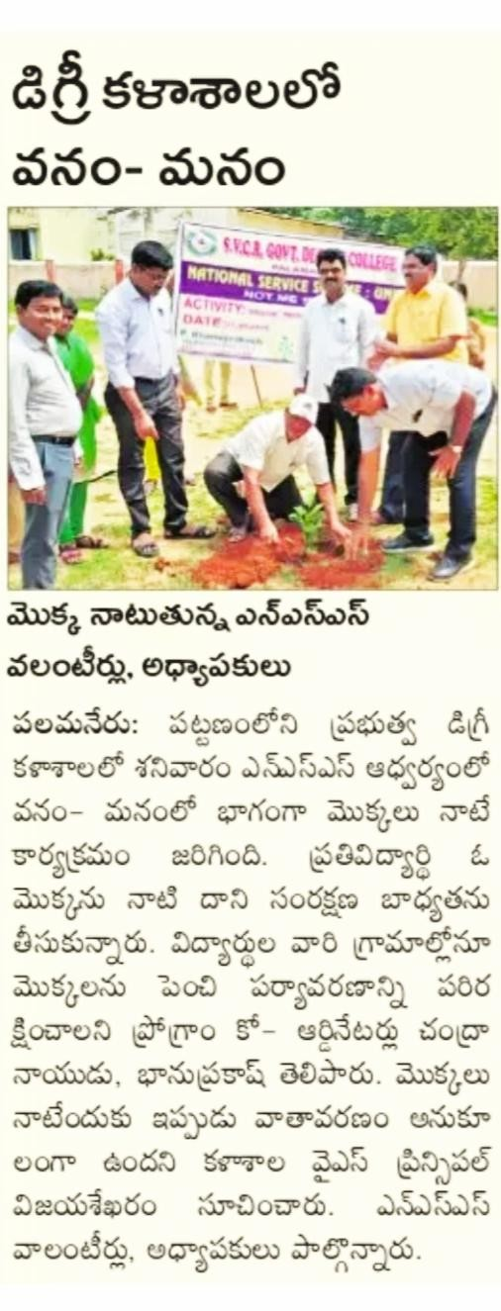
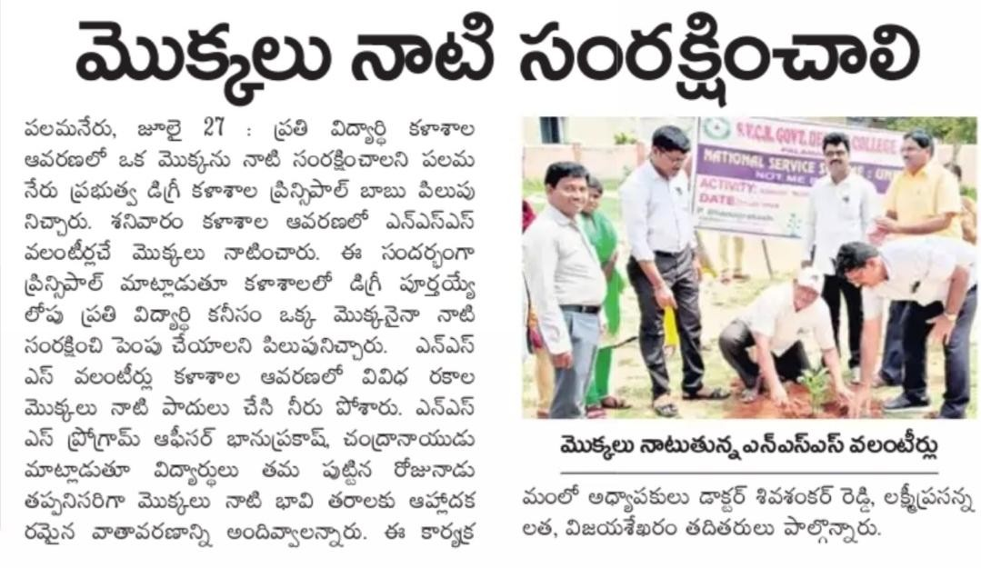
SVCR GOVT DEGREE COLLEGE
PALAMANER

PROGRAM NAME : | NSS ORIENTATION PROGRAMME
PROGRAM DATE : | 05-08-2019
TIME : | 10:00 AM
VENUE : | VIRTUAL CLASSROOM
RESOURCE PERSON : | Dr. G.CHINNA REDDY

NATIONAL SERVICE SCHEME
UNIT 1 & UNIT 2
SVCR GOVT. DEGREE COLLEGE
Re-accredited by NAAC with 'B' Grade

Dated: 04/08/2019

CIRCULAR

This is to inform that an orientation programme is organized for the benefit of all NSS volunteers of both NSS Unit-1 and Unit-2 on 05th August 2019 in the Seminar Hall from 10:00 am to 4:00 pm. All volunteers are requested to attend this mandatory orientation programme. Please bring one passport size photo of yourself.

Sd/-
NSS Programme Officers
Unit 1 & 2

OBJECTIVES OF THE PROGRAMME:
- To fill confidence and enthusiasm among the students.
- To promote the culture of seva among the students.

REPORT OF THE PROGRAMME:
An Orientation Programme for NSS Volunteers has been organized on 05th August,2019. Dr. G. Chinna Reddy, Lecturer in Chemistry congratulated the NSS volunteersfor their zeal toservethesocietythrough NSS andalsoemphasizedonthepersonalitydevelopment through NSS. Sri P. Bhanuprakash, Programme officer,NSS Unit, SVCR GDC given Power Point Presentation for all the newvolunteersabout the programme and activities to be carried out under the National ServiceScheme for the academic year 2019-20. Later, NSS Volunteers involved in theSwachha Kalasala-Campus Cleaning Programme. They removed the weeds and plasticwasteinthegardenareaofthecollegecampus

OUTCOMES:
- The students are motivated to do service through NSS.
- The students learnt the importance of serving for the poor and the needy.

SIGNATURE OF THE STUDENTS:

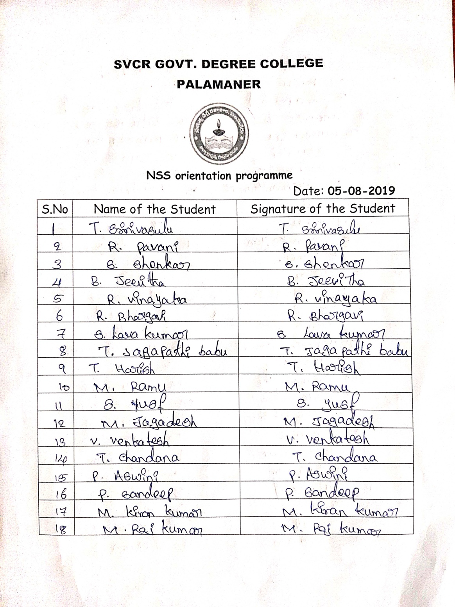
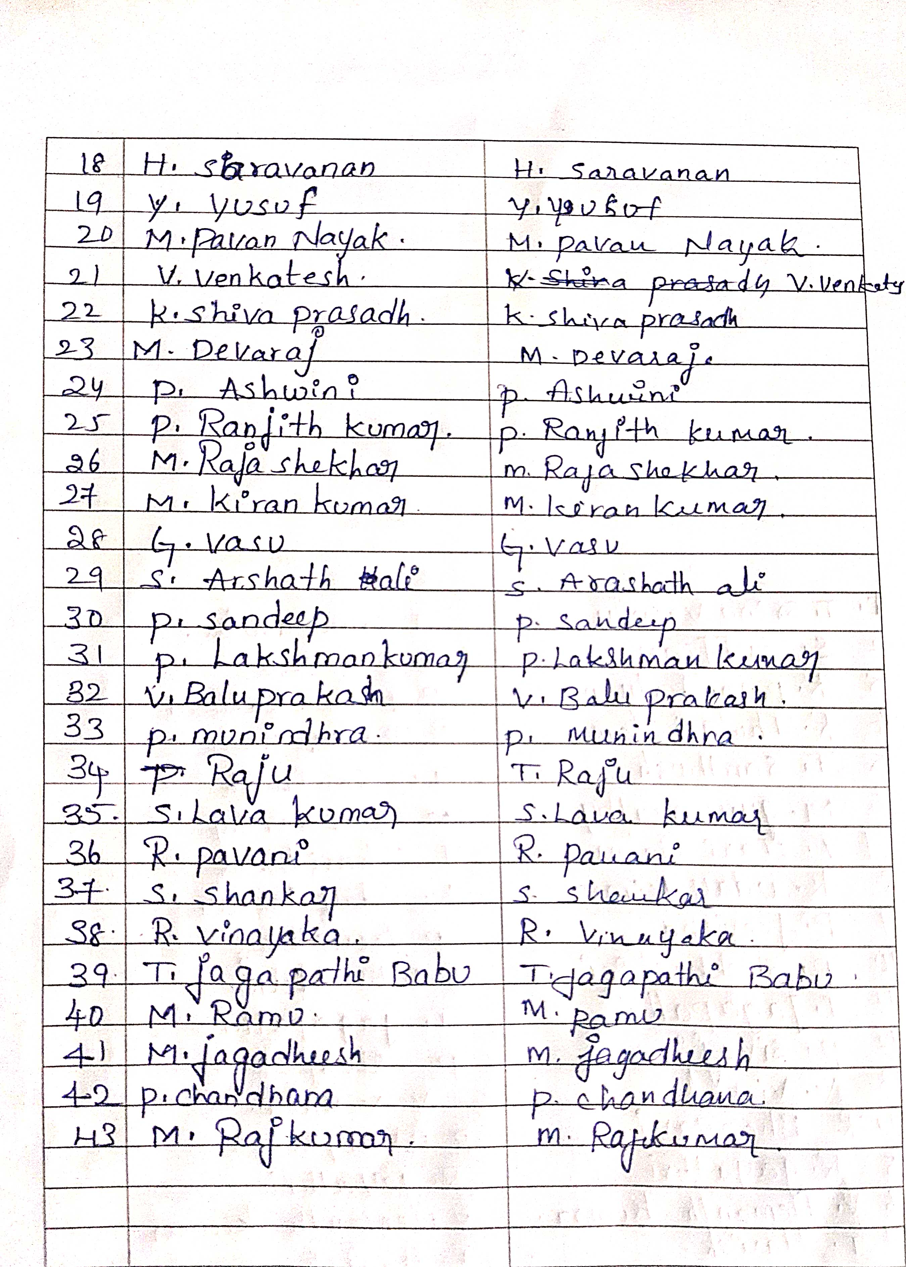
FEED BACK:
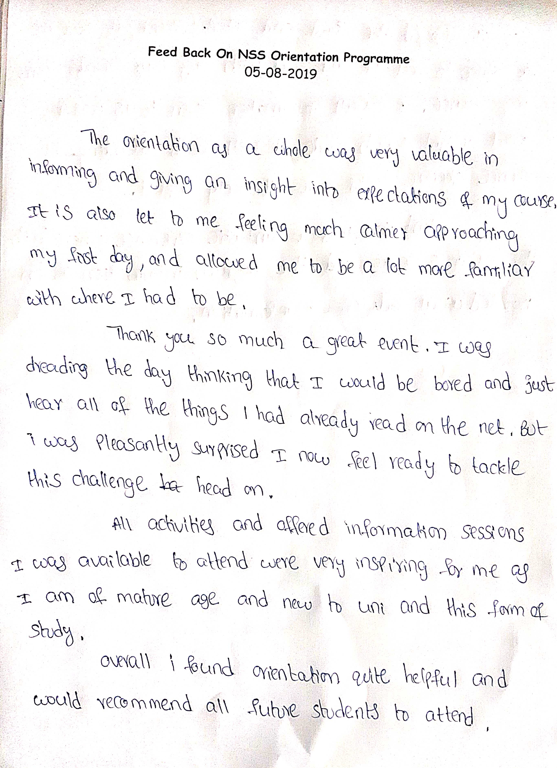
SVCR GOVT DEGREE COLLEGE
PALAMANER
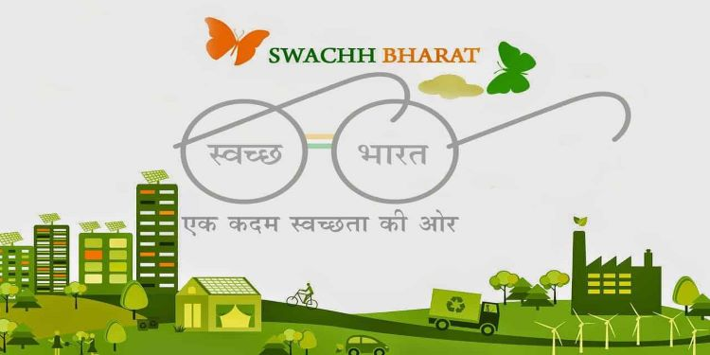

PROGRAM NAME : | SWACHH KALASALA – CAMPUS CLEANING PROGRAMME
PROGRAM DATE : | 19-09-2019
TIME : | 10:00 AM
VENUE : | BA WING
RESOURCE PERSON : | DR. P.BHANU PRAKASH

OFFICE OF THE PRINCIPAL
SVCR GOVT. DEGREE COLLEGE
Re-accredited by NAAC with 'B' Grade
Present: Dr. P. Babu, M.Sc, Ph.D

Dated: 18/09/2019

CIRCULAR

Inspired by Bapu’s vision, on 2 October 2014, the Indian government, under the leadership of Prime Minister Narendra Modi, made it a mission to make India clean by 2019 by eradicating open defecation, improving solid waste management, and making the citizens aware of the importance of cleanliness. In this connection, all the staff and students are requested to attend the SWACHH KALASALA program on 19.09.2019.

Sd/-
Principal

OBJECTIVES OF THE PROGRAMME:
- To clean the college.
- To make the campus dust and foliage free.

REPORT OF THE PROGRAMME:
NSS Volunteers involved in the Swachha Bharath-Clean & Green Programme. They removed the weeds and plastic waste in the B.A. wing of the college campus. Later, they watered the plants.

OUTCOMES:
- The campus was cleaned.
- The students removed the dust and foliage under the trees.

SIGNATURE OF THE STUDENTS:
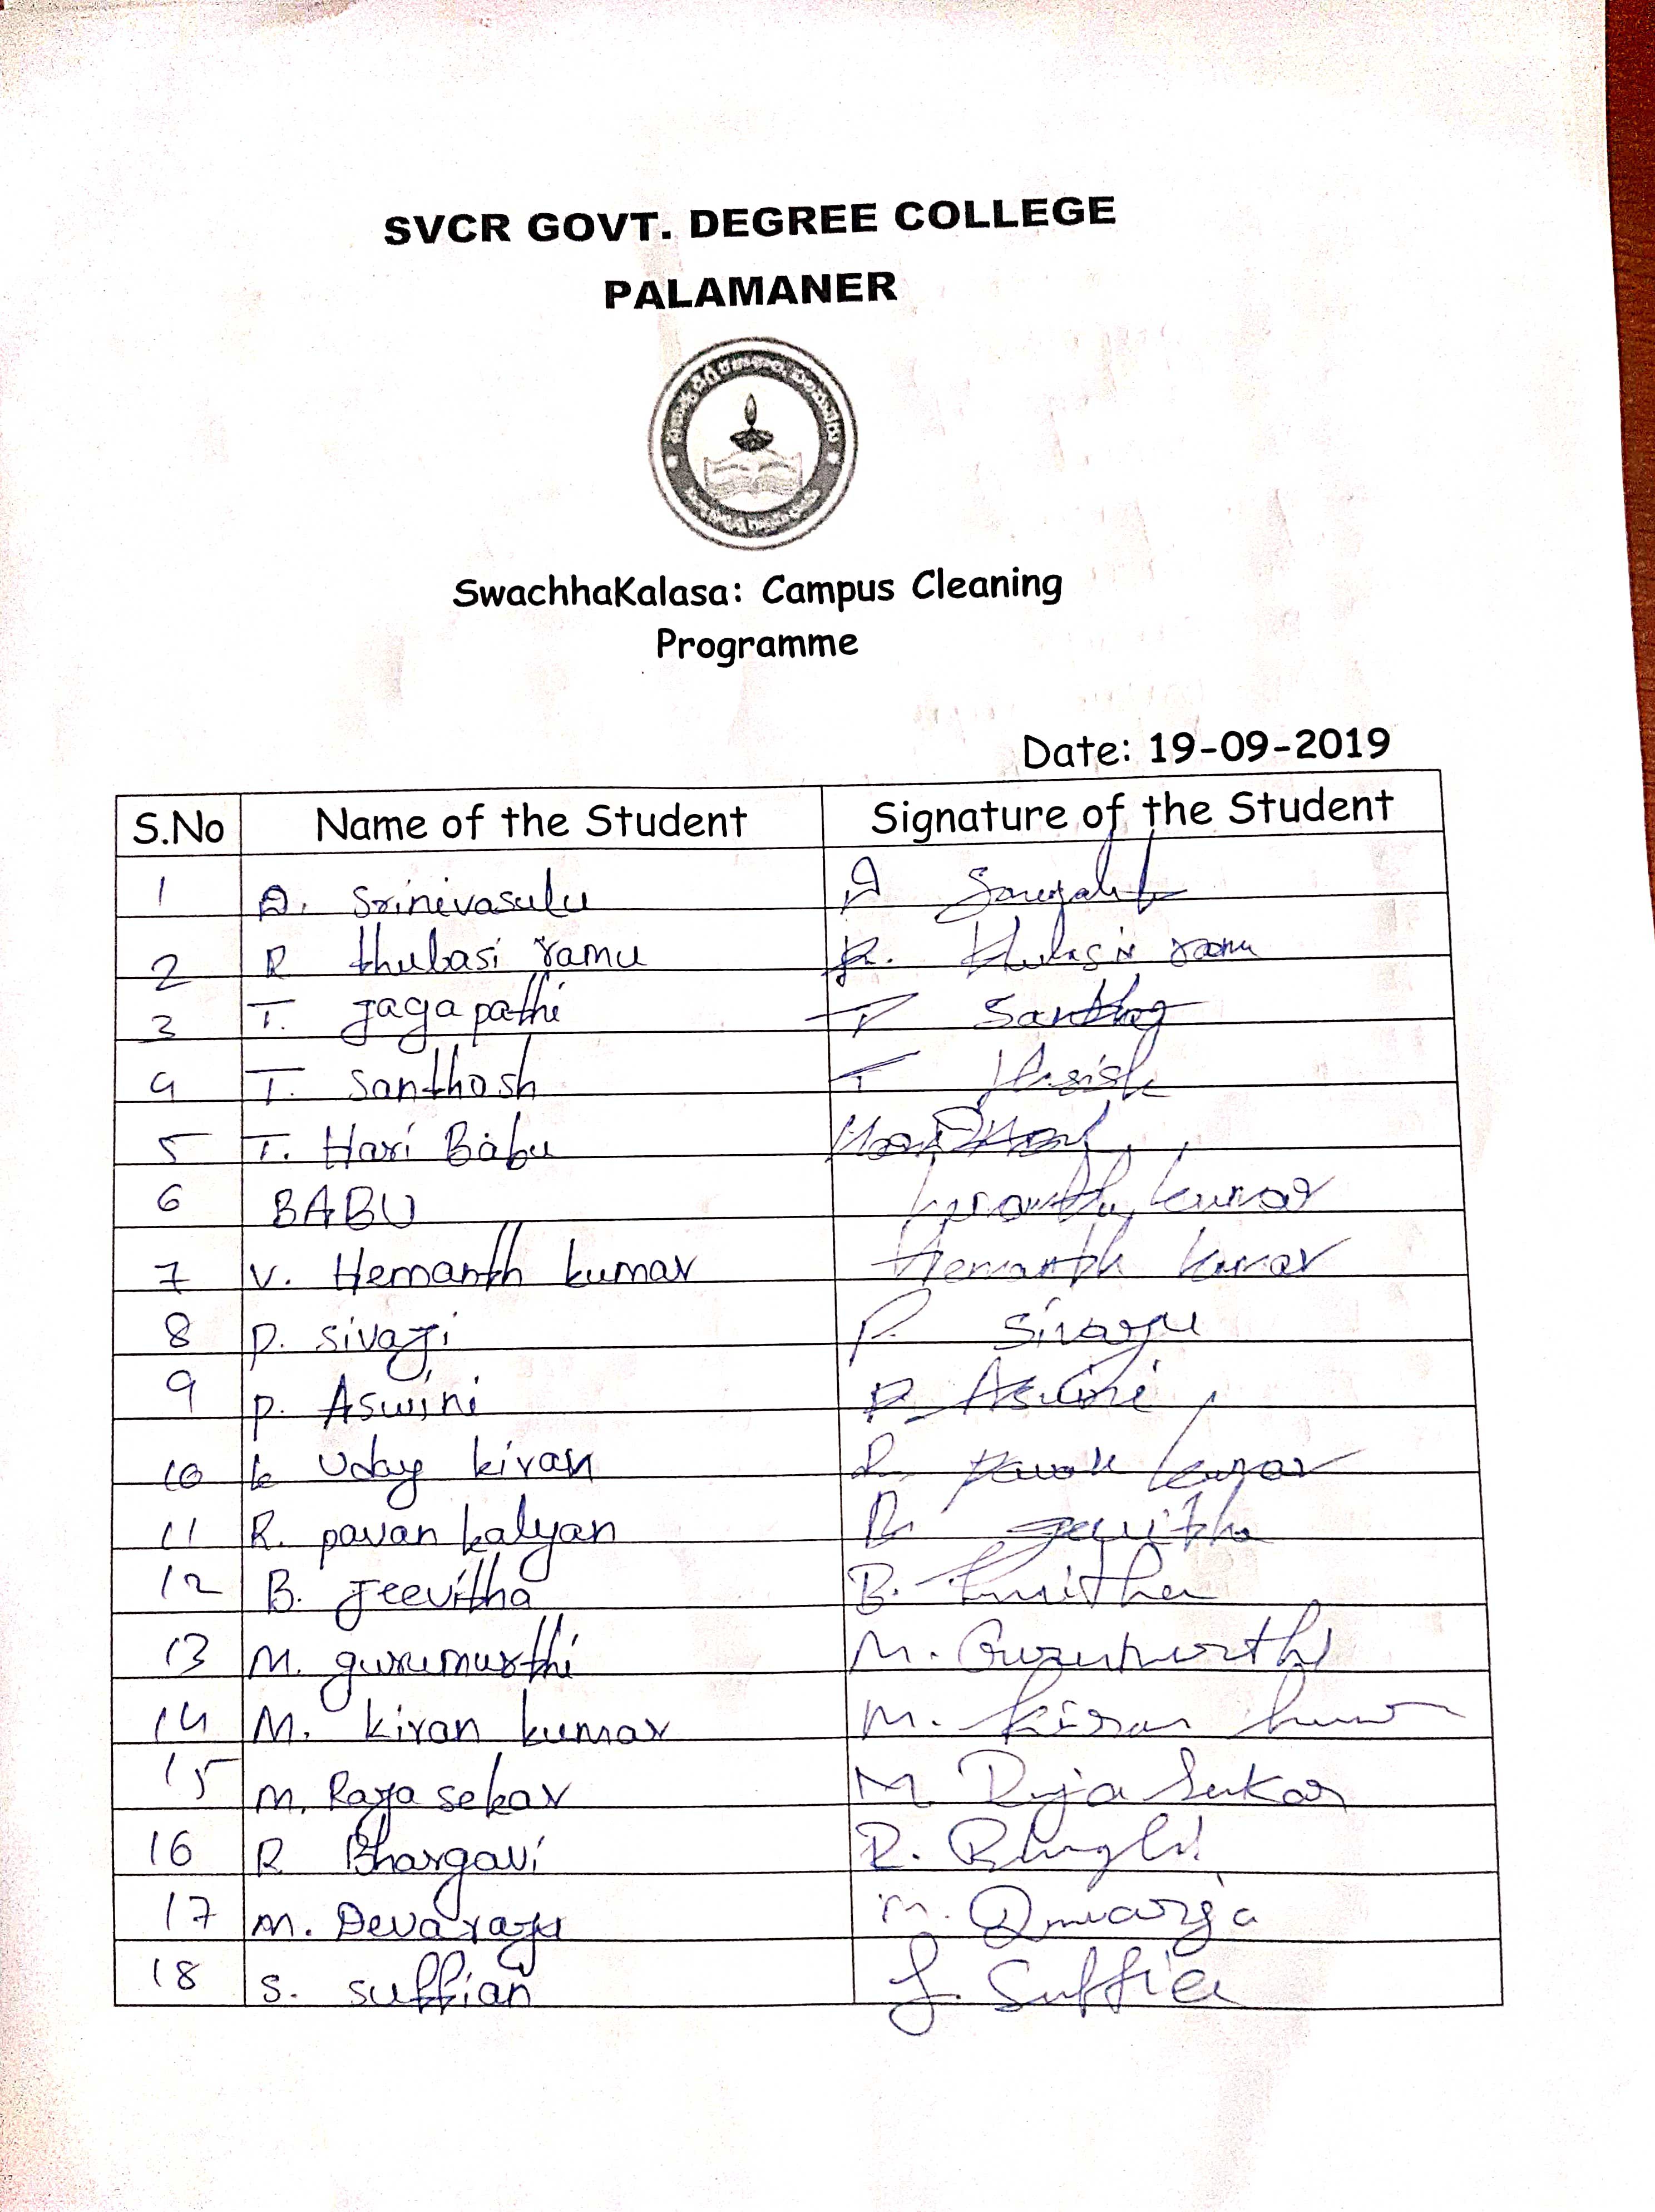
FEED BACK:
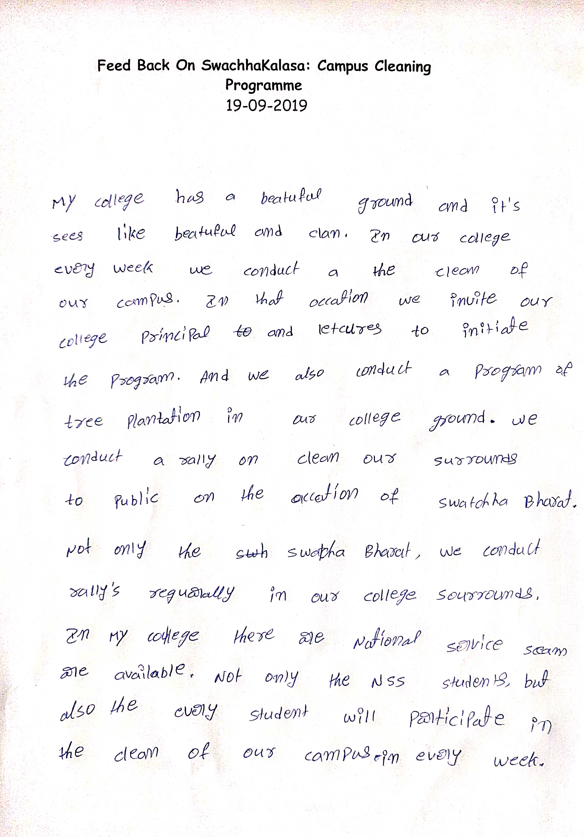
PHOTOS
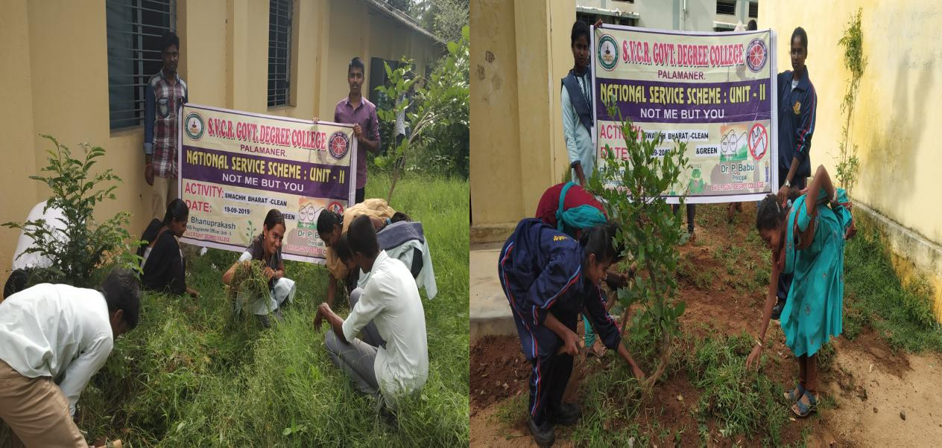

SVCR GOVT DEGREE COLLEGE
PALAMANER
PROGRAM NAME : | NSS DAY
PROGRAM DATE : | 24-09-2019
TIME : | 10:00 AM
VENUE : | COLLEGE CAMPUS
RESOURCE PERSON : | Sri P.Anand, Palamaner Parirakshana Samiti

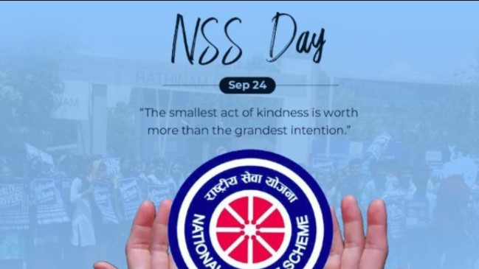

OFFICE OF THE PRINCIPAL
SVCR GOVT. DEGREE COLLEGE
Re-accredited by NAAC with 'B' Grade
Present: Dr. P. Babu, M.Sc, Ph.D

Dated: 23/09/2019

CIRCULAR

Every year 24th September is celebrated as NSS Day with appropriate programs and activities. In this regard, the college celebrates NSS Day on 24th September 2018 at Virtual Class Room, Room No 18. All the staff and students are instructed to attend the celebrations.

Sd/-
Principal

OBJECTIVES OF THE PROGRAMME:
- To motivate the students to join NSS.
- To learn the methods of Seva.

REPORT OF THE PROGRAMME:
NSS was formally launched on 24th September 1969, the birth centenary year of the Father of the Nation. 24th September is observed every year as NSS Day to sensitize youth of the nation about nation building competencies. NSS Day Golden Jubilee celebration was organized in the college and Dr. P. Babu, Principal of the college presided over the function. Sri. Anand, President, Palamaner Parirakshana Samithi acted as the Chief Guest. He appreciated the volunteers for taking up social service activities in the college and the adopted villages. He also encouraged the volunteers to take up more activities in the future. Sri. Yugandhar, General Secretary, Jana Vignana Vedika, Chittoor is the Guest of Honour for the function. He addressed the NSS volunteers that participation in NSS activities will help in the personality development. The NSS Program officers explained the aim and objectives of NSS. Elocution and essay writing completion held on the topic-“Role of NSS volunteer in nation building”. Prizes were distributed to the winners by the Dignitaries involved in the celebration.

OUTCOMES:
- The students get motivated to do seva.
- The students are encouraged to do service to the needy.

SIGNATURE OF THE STUDENTS:
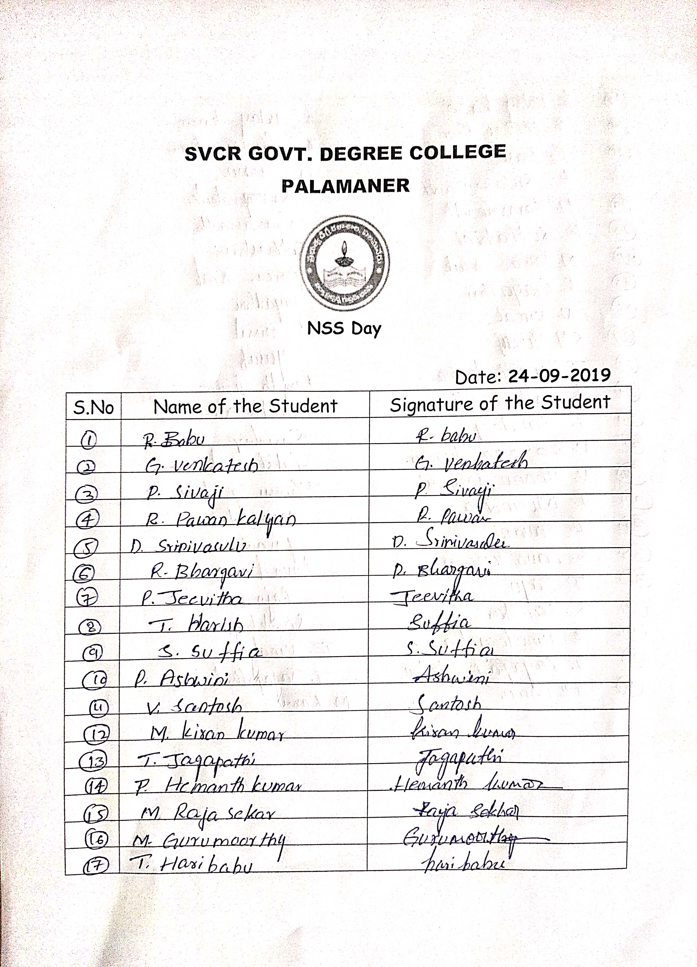
FEED BACK:
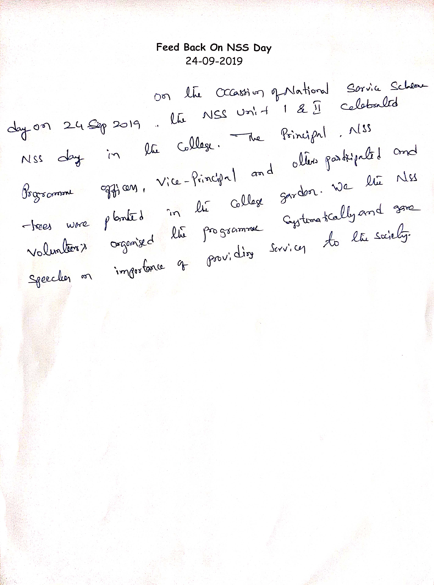
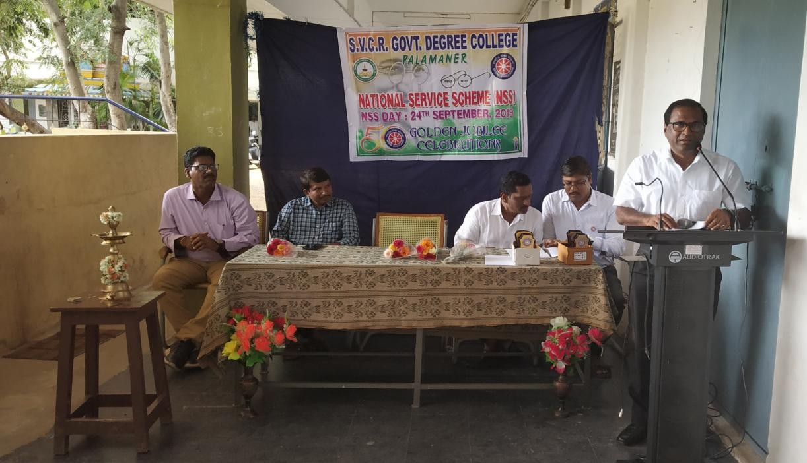
PHOTOS
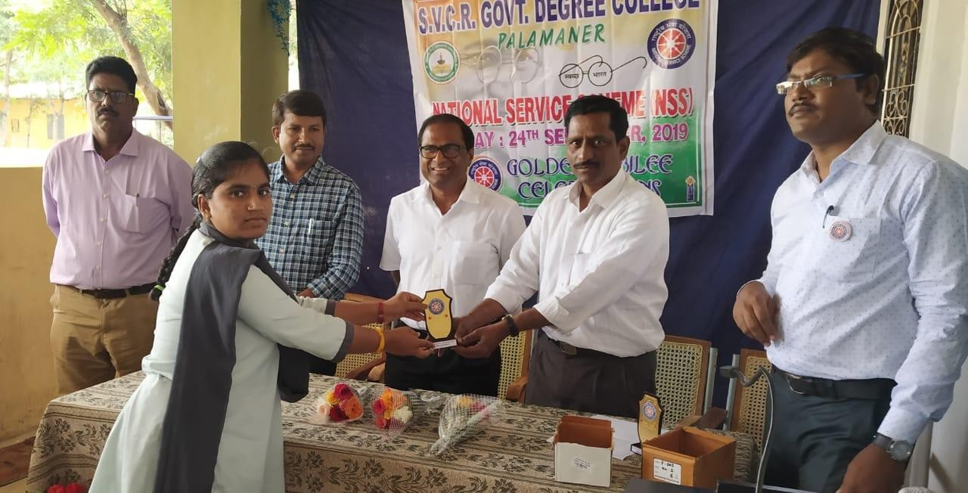
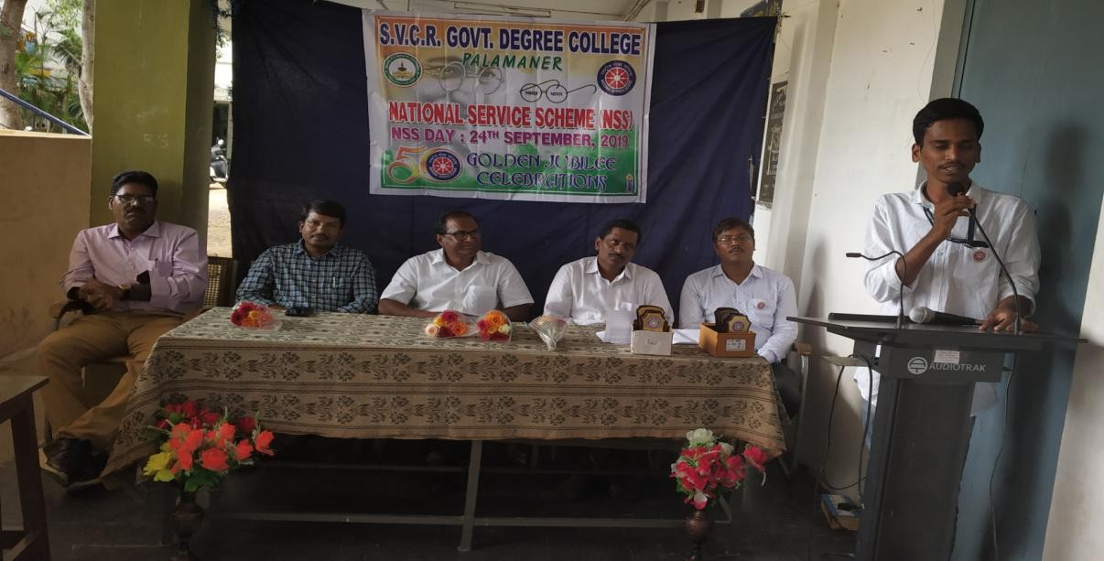
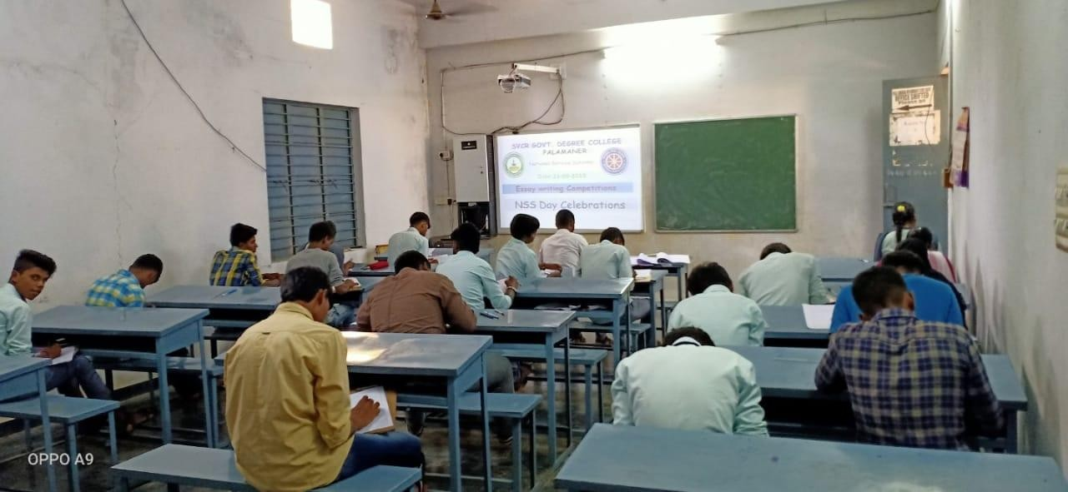
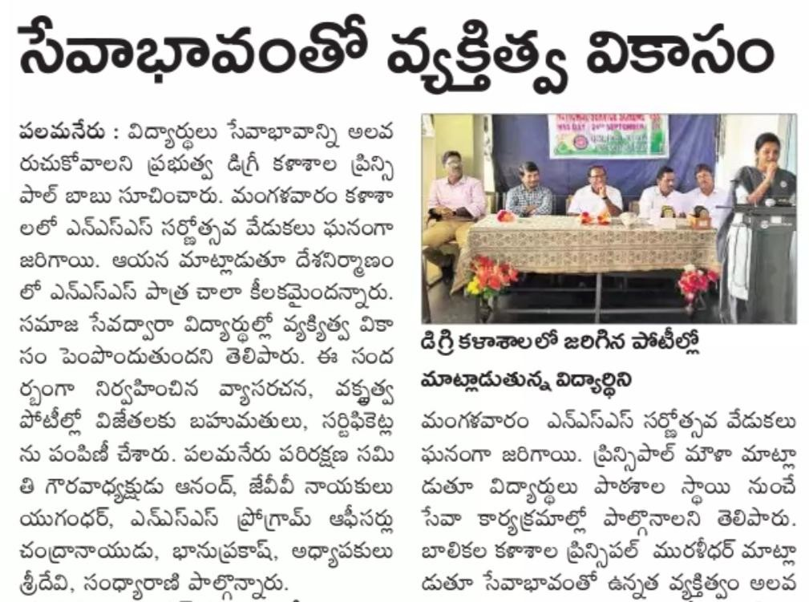
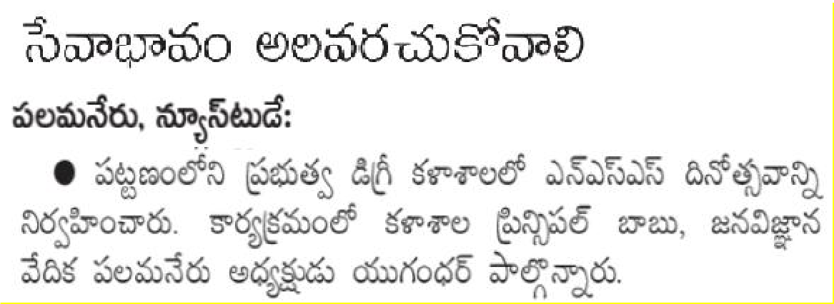

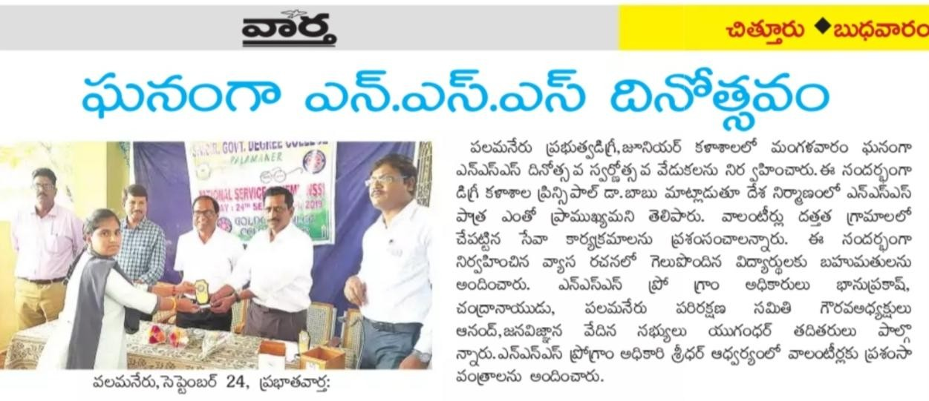
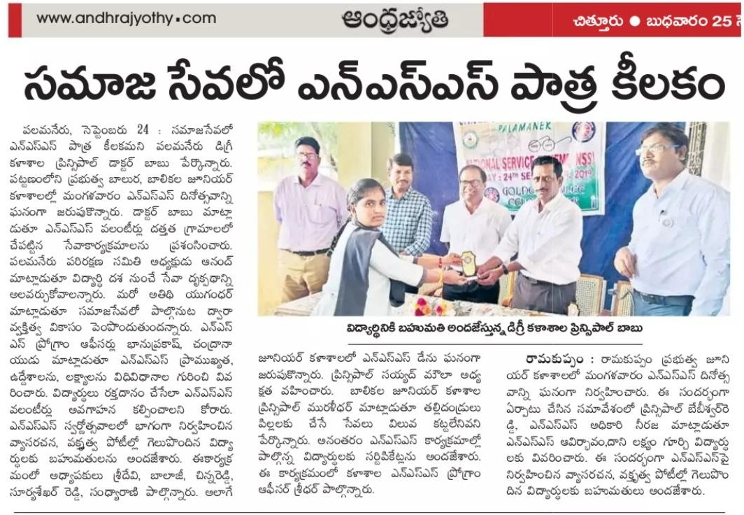
SVCR GOVT DEGREE COLLEGE
PALAMANER

PROGRAM NAME : | 150th Birth Anniversary of Mahatma Gandhi
PROGRAM DATE : | 03-10-2019 to 05-10-2019
TIME : | 10:00 AM
VENUE : | College Campus
RESOURCE PERSON : | Dr. P.Babu, Principal
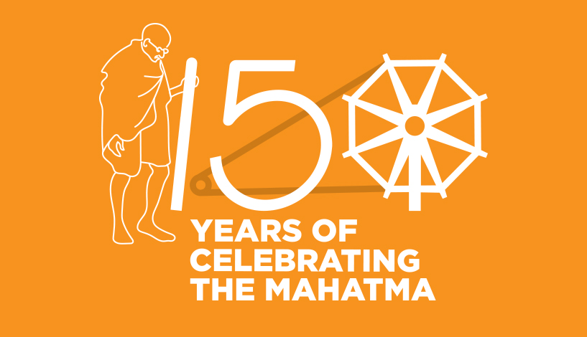

OFFICE OF THE PRINCIPAL
SVCR GOVT. DEGREE COLLEGE
Re-accredited by NAAC with 'B' Grade
Present: Dr. P. Babu, M.Sc, Ph.D

Dated: 01/10/2019
CIRCULAR

Government of India has decided to commemorate the 150th birth anniversary of Mahatma Gandhi, Father of the Nation, at national and international level to propagate his message. Gandhi Jayanti is also commemorated as the International Day of Non-Violence since 2007. In view of the significant and seminal contribution of Mahatma Gandhi to India and countries across the globe, his inspiration to leading political and philosophical personalities as also countless individuals and his relevance to disciplines such as politics, international relations, economics, spirituality, ecology, conflict resolution, sustainability, service to humanity and more, his concepts of compassion, non-violence, social justice, minimalism, peace and civil disobedience, NSS wing of our college is organizing three day celebrations from 03-10-2019 to 05-10-2019. The schedule is given below. All the staff and students are instructed to participate in these celebrations.

Date | Event
03-10-2019, FN | Awareness session
03-10-2019, AN | Peace walk
04-10-2019, FN | Rally on “Say No to single use plastic”
04-10-2019, AN | Saplings Plantation
05-10-2019 | Campus cleaning activity

Sd/-
Principal
OBJECTIVES OF THE PROGRAMME:
- To make students participants of the celebrations of Gandhi Jayanthi.
- To bring healthy environment in the society.

REPORT OF THE PROGRAMME:
150th Birth Anniversary Celebrations of the Father of the Nation 'Mahatma Gandhi' was organized by the NSS wing of SVCR GDC from 03-10-2019 to 05-10-2019. On the first day i.e., 03-10-2019, an awareness session is organized in the college to recall the principles of Gandhiji. Dr. P. Babu, Principal in his address congratulated all who were part of the program and talked about how this year the celebration of Gandhi Jayanti holds special significance. He stated that the birth of NSS has deep rooted connection with the ideals of Gandhi. Sri. M. Vijayasekharam, Vice-principal stressed on the need to aware the people on plastic pollution and to ban on single use plastic to reach the goals of Swachhta and also for a healthy pollutant free environment. Floral tributes were given to the Photos of Ganghiji and Lal Bahadur Shastriji by the teaching and non-teaching staff. The entire program was hosted by NSS Program Officer, P. Bhanupraaksh, while the vote of thanks was given by Dr .G. Sridevi. In the afternoon, a peace walk was organized to mark Mahatma Gandhi's 150th birth anniversary. Around 550 students participated in this Walk for Peace.

On the second day, to mark the occasion of Gandhi Jayanti an awareness rally on “Say No to Single-Use Plastic” from the College ground to the Palamner bus station. About NSS 65 volunteers participated in this rally to sensitise the public against the use of single-use plastic items. Students raised the slogans and also carried pictures that graphically depict the harmful effects of single-use plastic products and the alternatives for it. Later in the evening, saplings plantation programme was organized by the NSS Unit in the premises of the college.

On the third day, a total of 25 NSS volunteers participated in the campuscleaning activity. They were cleaned the surrounding of the garden and roads. Theyremovedalldebrisincludingpolythenebags.Duringthecleaningactivity,thevolunteers were made to feel about the importance ofproper disposal of debris into dust bins. Later in the evening, few more saplings were planted by the NSSvolunteers.

OUTCOMES:
- The students get awareness on the teachings of Gandhi.
- The students participated in the activities.

SIGNATURE OF THE STUDENTS:

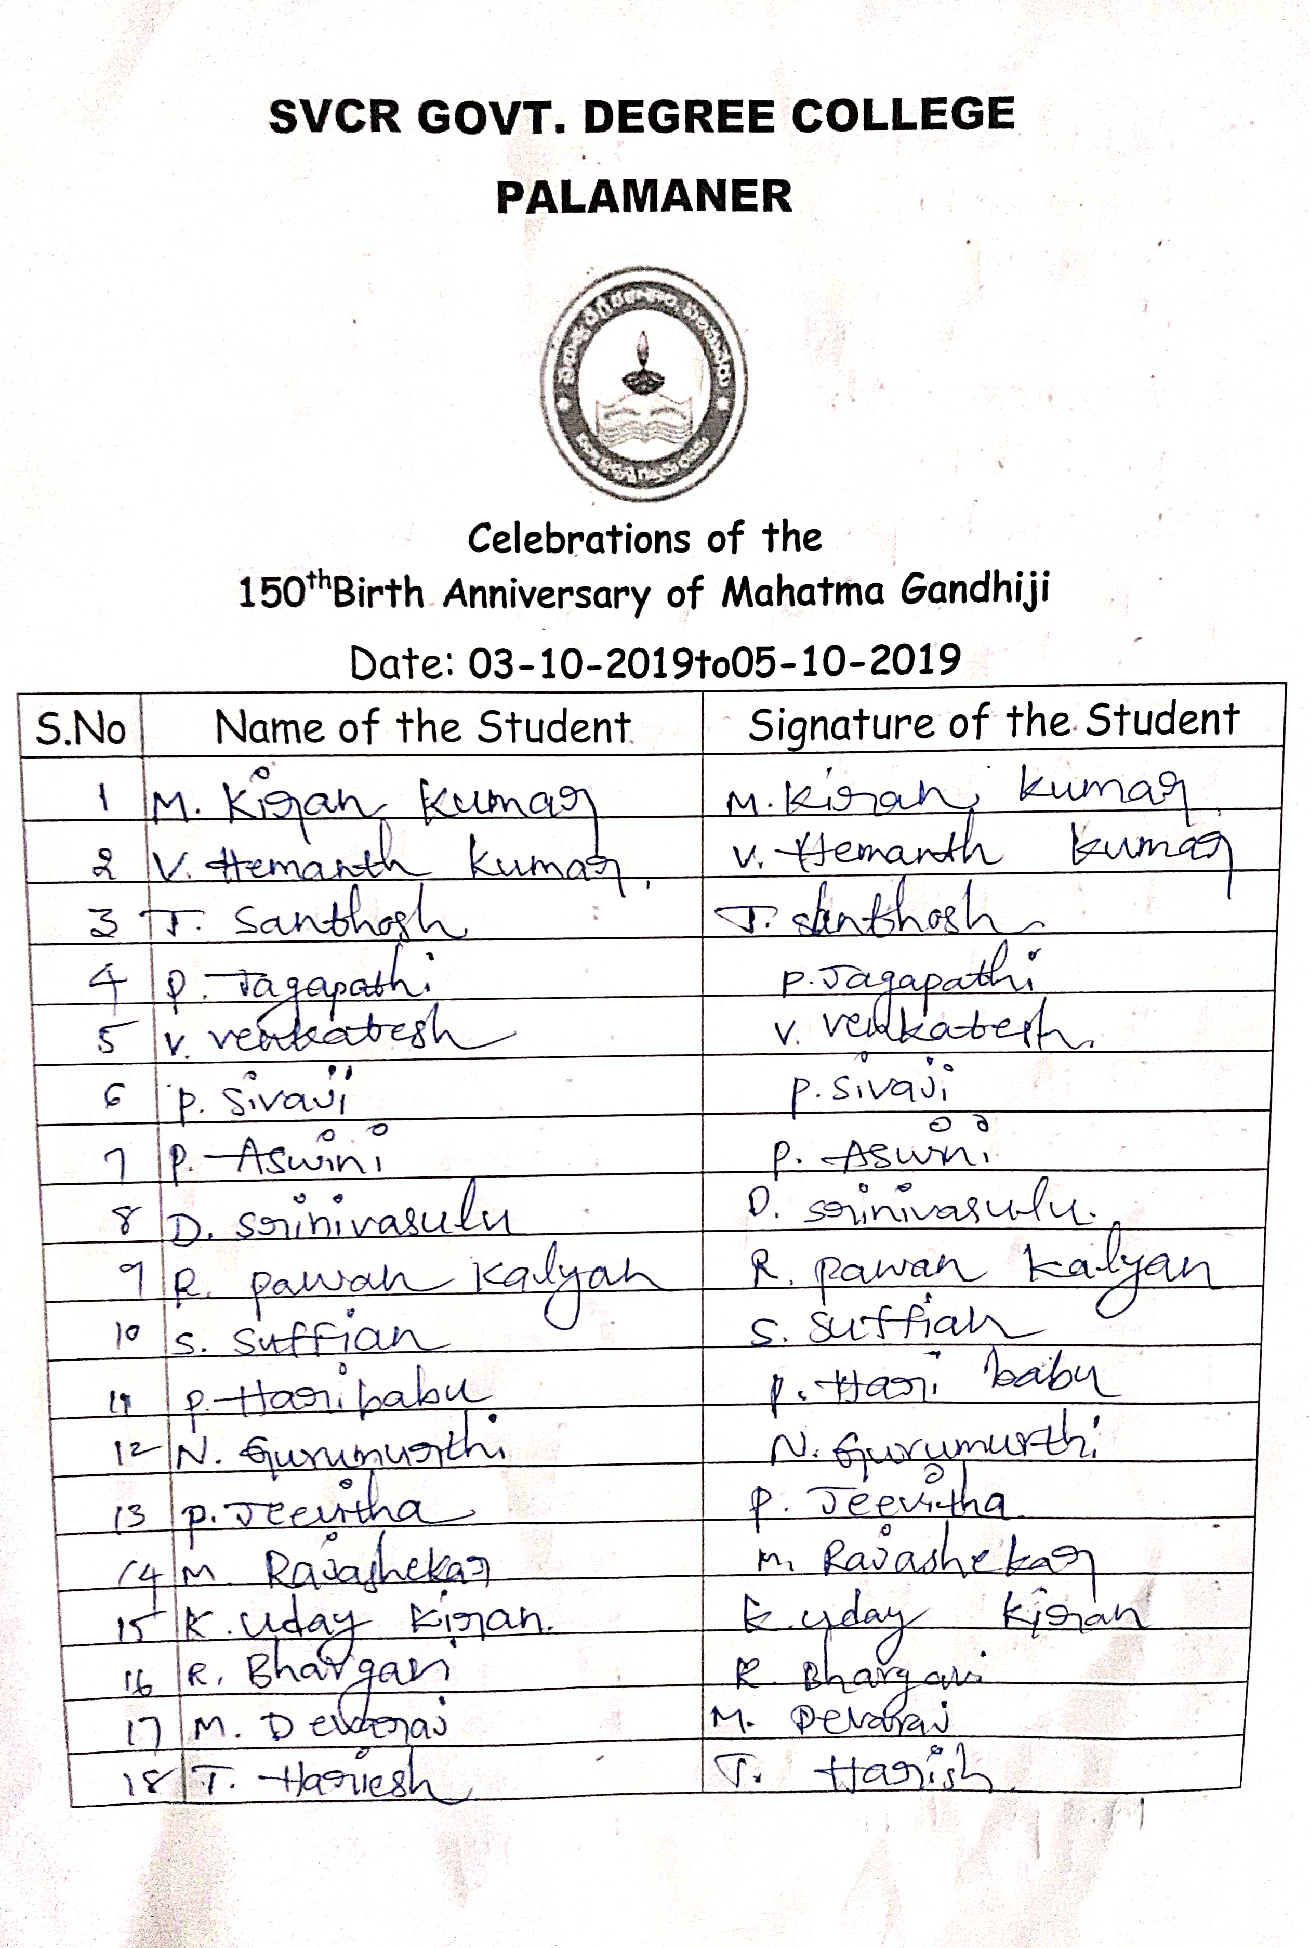
FEED BACK:
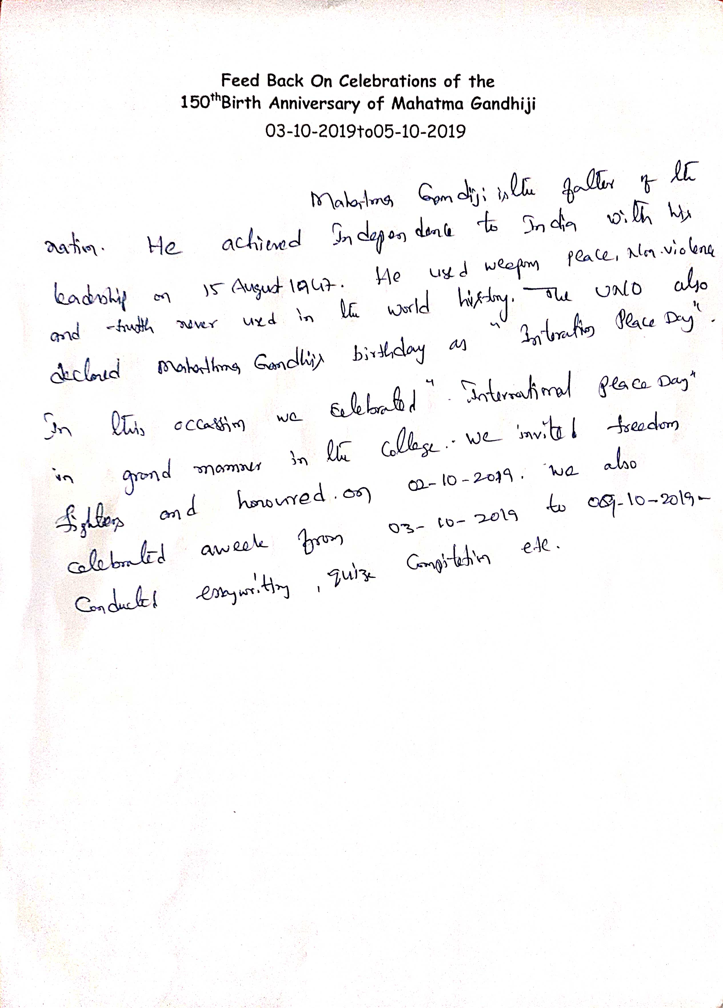

PHOTOS
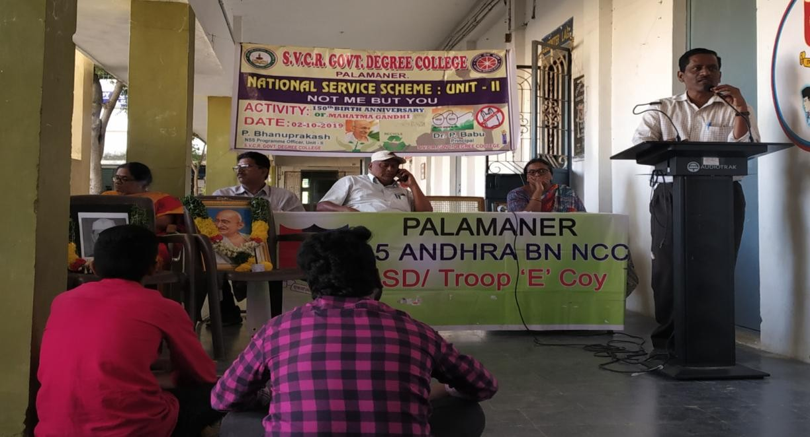
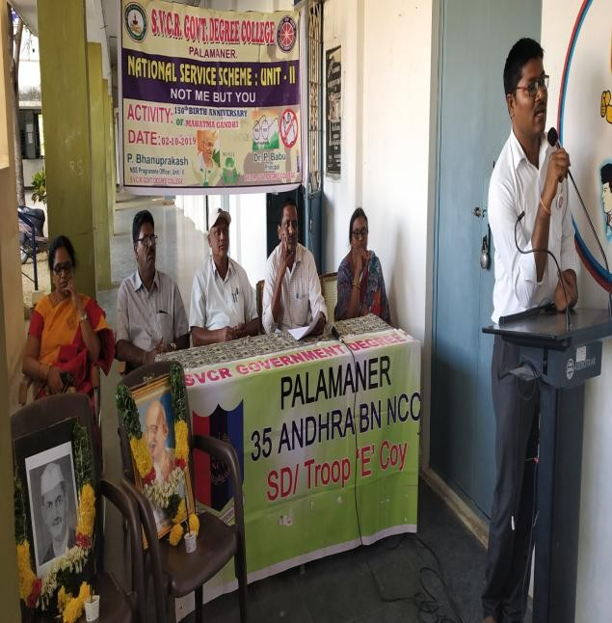

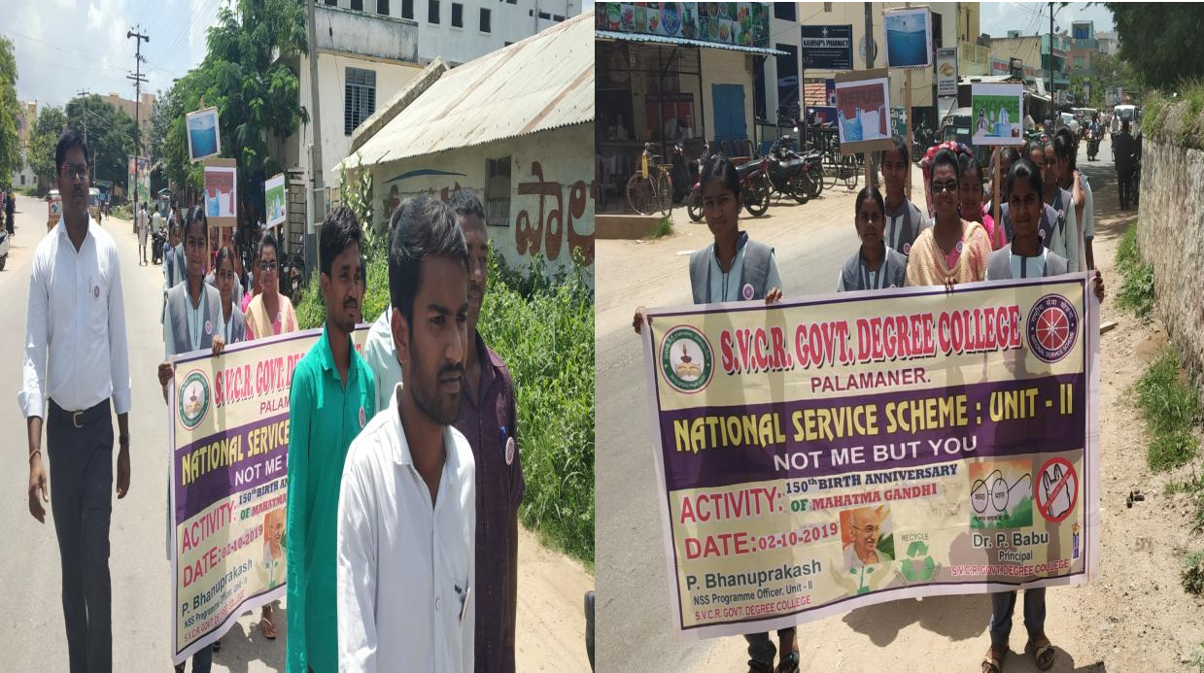
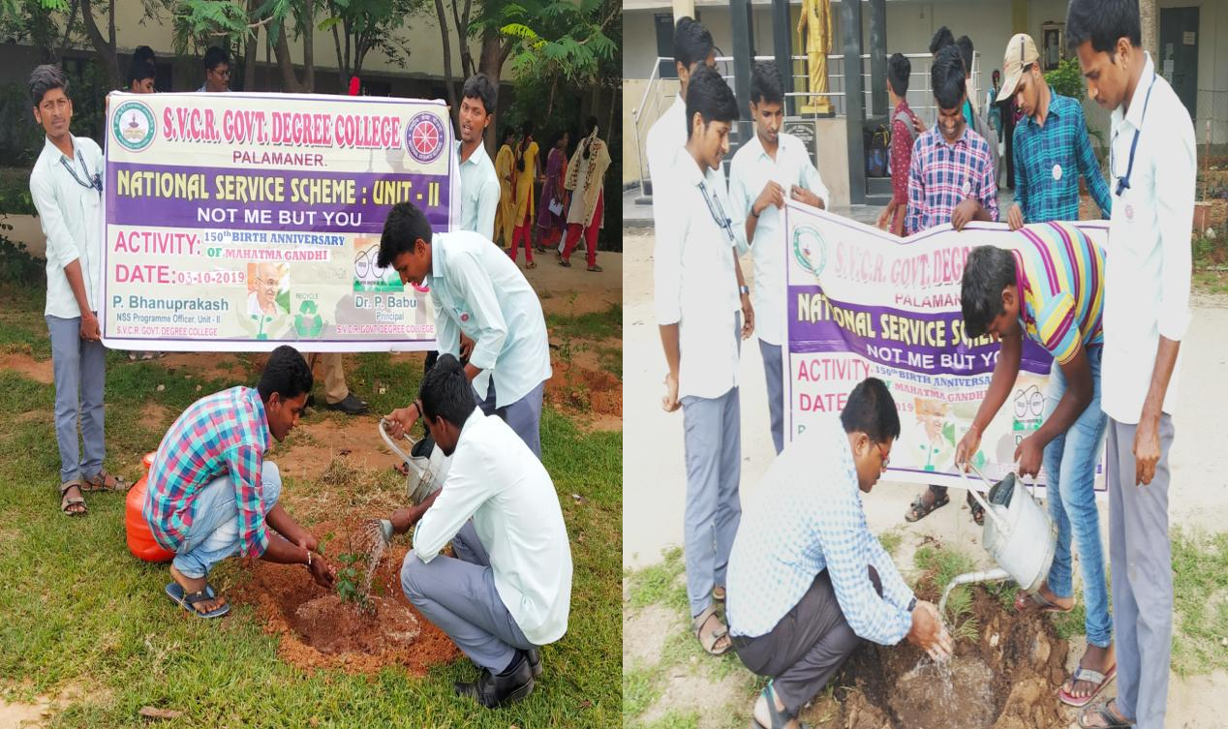
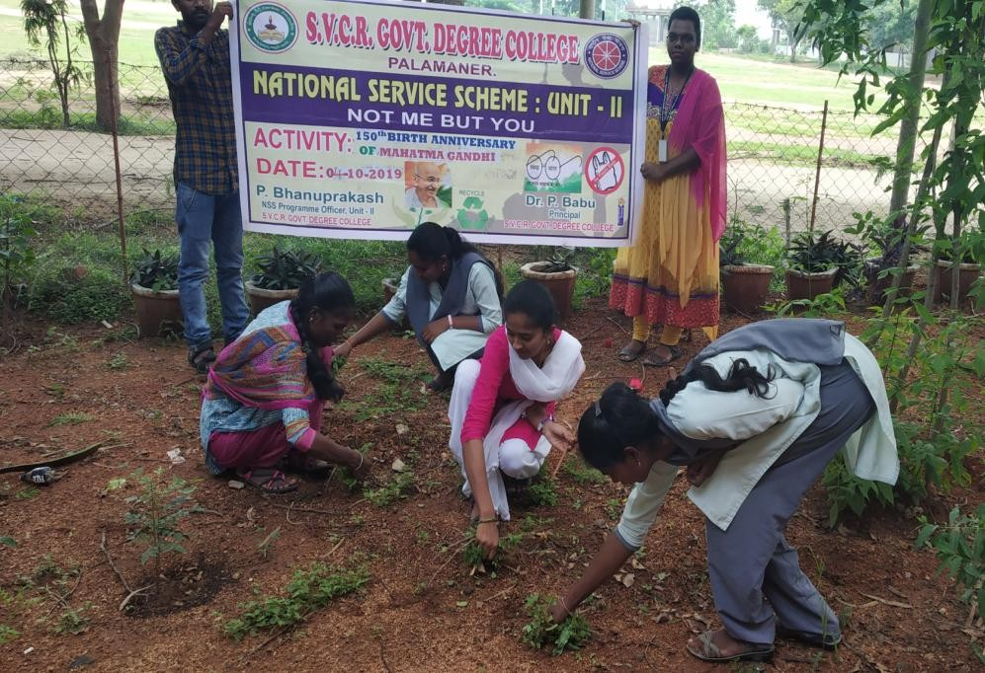
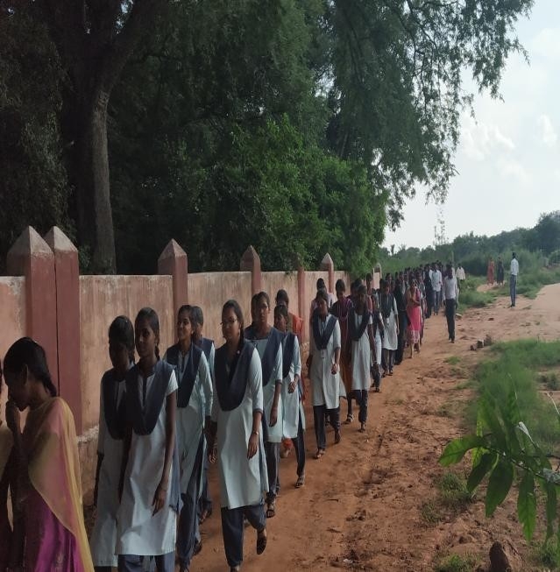
SVCR GOVT DEGREE COLLEGE
PALAMANER

PROGRAM NAME : | NATIONAL INTEGRATION CAMP
PROGRAM DATE : | 24-01-2020 to 30-01-2020
TIME : | 10:00 AM
VENUE : | Bangalore University, NSS Bhavan
RESOURCE PERSON : | Vice Chancellor, Bangalore University

OFFICE OF THE PRINCIPAL
SVCR GOVT. DEGREE COLLEGE
Re-accredited by NAAC with 'B' Grade
Present: Dr. P. Babu, M.Sc, Ph.D

Dated: 22/01/2020

CIRCULAR

Organised by National Service Scheme, National Integration Camps aim at fostering a feeling of national integration and greater understanding of various cultures by the youth of the country. A National Integration Camp will be organized at Bangalore City University from 24-01-2020 to 30-01-2020. Interested students are informed to contact Dr.P.Bhanu Prakash, Lecturer in Chemistry for more information.

Sd/-
Principal

REPORT OF THE PROGRAMME:
K. Jagadeesh Babu of NSS Unit, SVCR GDC participated in National Integration Camp from 24-01-2020 to 30-01-2020 organized by Bangalore University, NSS Bhavan, Jnanabharathi Campus, Bangalore.

SIGNATURE OF THE STUDENTS:
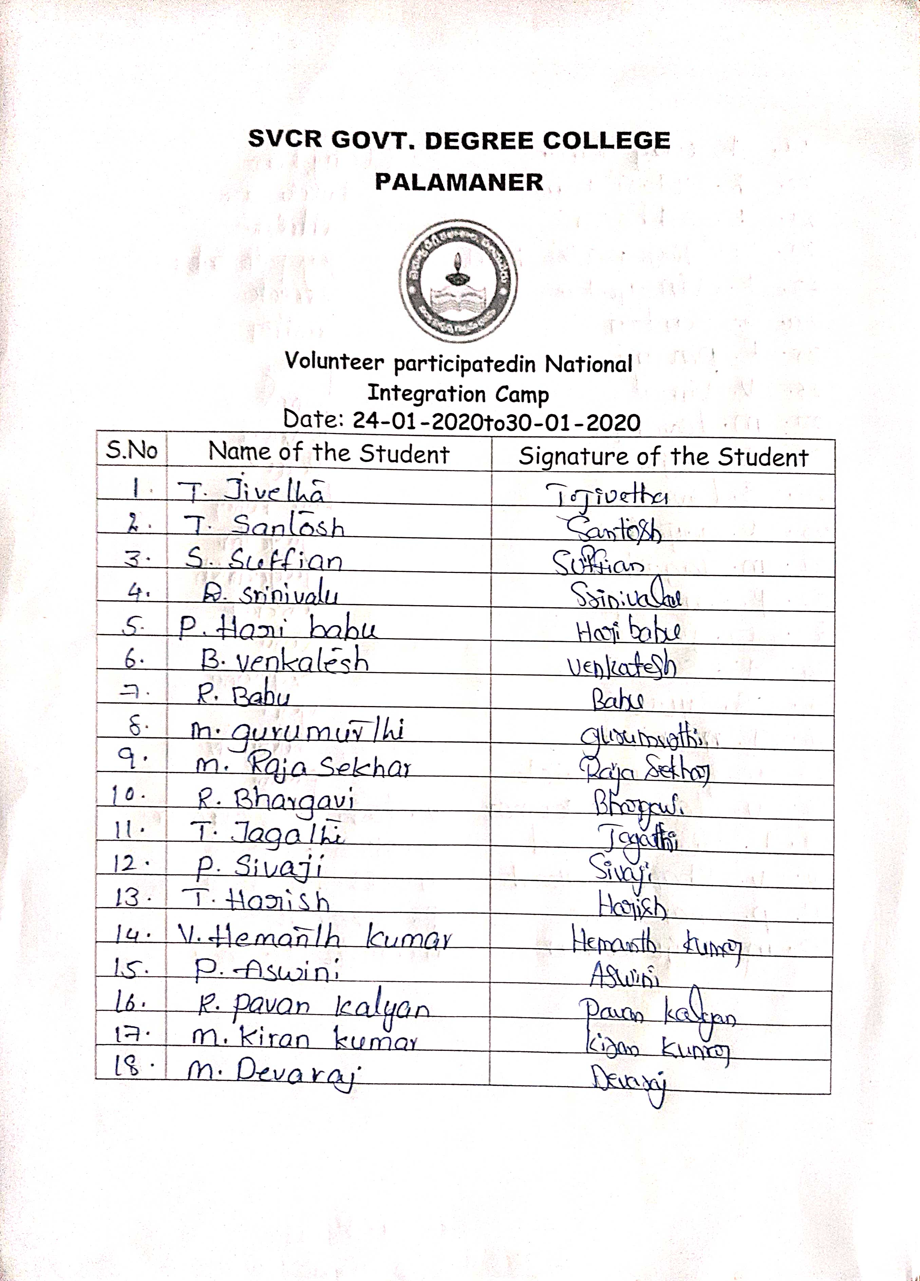
FEED BACK:
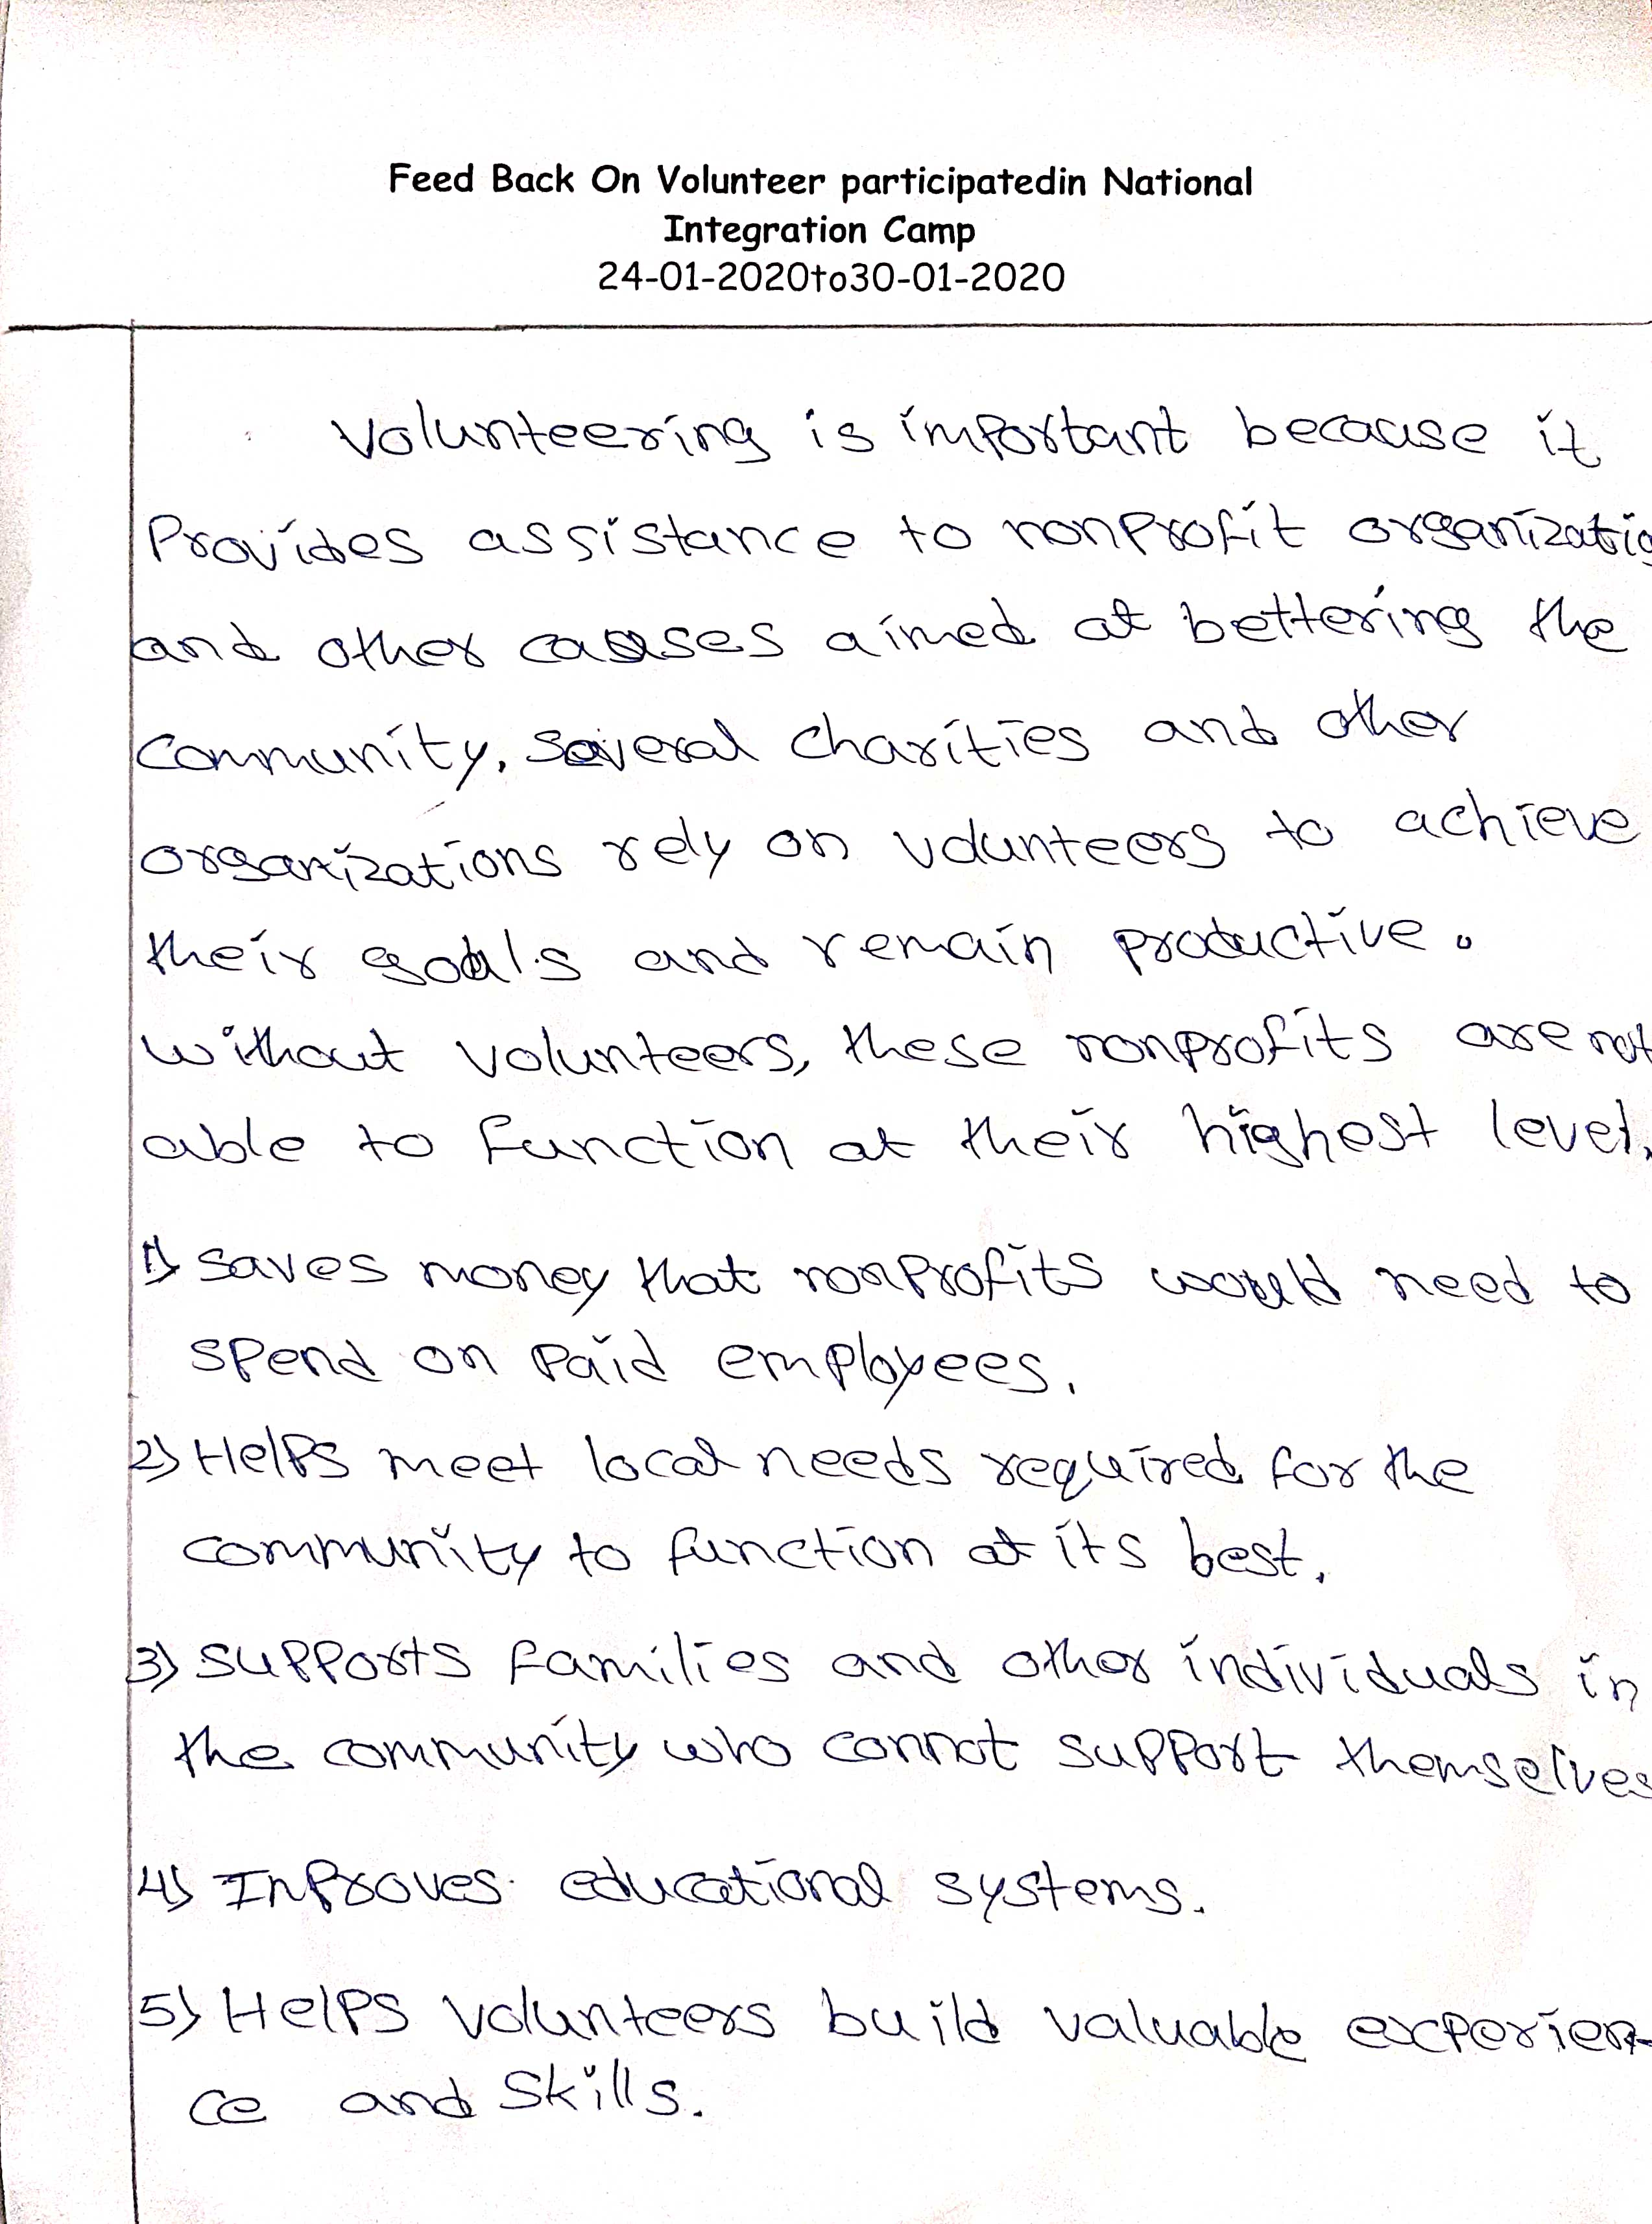

PHOTOS

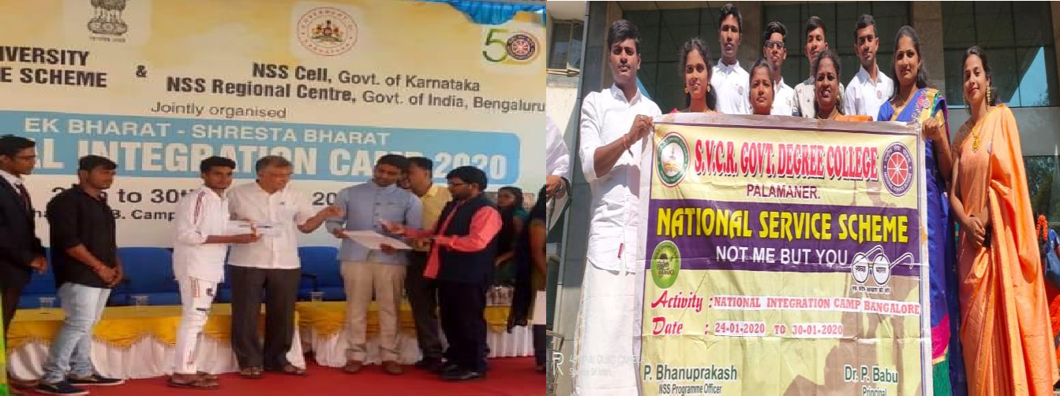
PROGRAM NAME : | BLOOD GROUPING
PROGRAM DATE : | 10-03-2020
TIME : | 11:00 AM
VENUE : | College Campus
RESOURCE PERSON : | Dr. P. Babu
SVCR GOVT DEGREE COLLEGE
PALAMANER

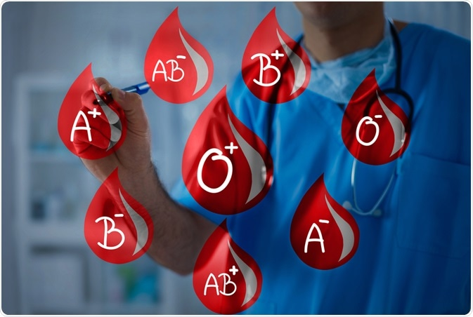

OFFICE OF THE PRINCIPAL
SVCR GOVT. DEGREE COLLEGE
Re-accredited by NAAC with 'B' Grade
Present: Dr. P. Babu, M.Sc, Ph.D

Dated: 08/03/2020

CIRCULAR

The department of Zoology will organize blood grouping program as an extension activity in association with NSS unit of SVCR Government Degree College on 10th March 2020. The objective of the program was to check the blood group of the students to enter the details in their identity card and to create awareness about significance of blood and blood groups. Interested students are informed to contact Dr. P.Bhanu Prakash, NSS Program Officer.

Sd/-
Principal
OBJECTIVES OF THE PROGRAMME:
- To make students to know about their blood group.
- To encourage the students to do blood grouping.

REPORT OF THE PROGRAMME:
The NSS unit in association with the Department of Zoology, SVCR GDC, Palamaner organized the Blood Group Identification Programme for the college students on 10th March 2020.The blood group of 128 students was identified through this Programme. We are maintaining the blood group database of our college students to arrange blood on the spot to the needy patients in emergency.

OUTCOMES:
- The students learned to which group they belong.
- The students who have done the activity learned it perfectly.

SIGNATURE OF THE STUDENTS:
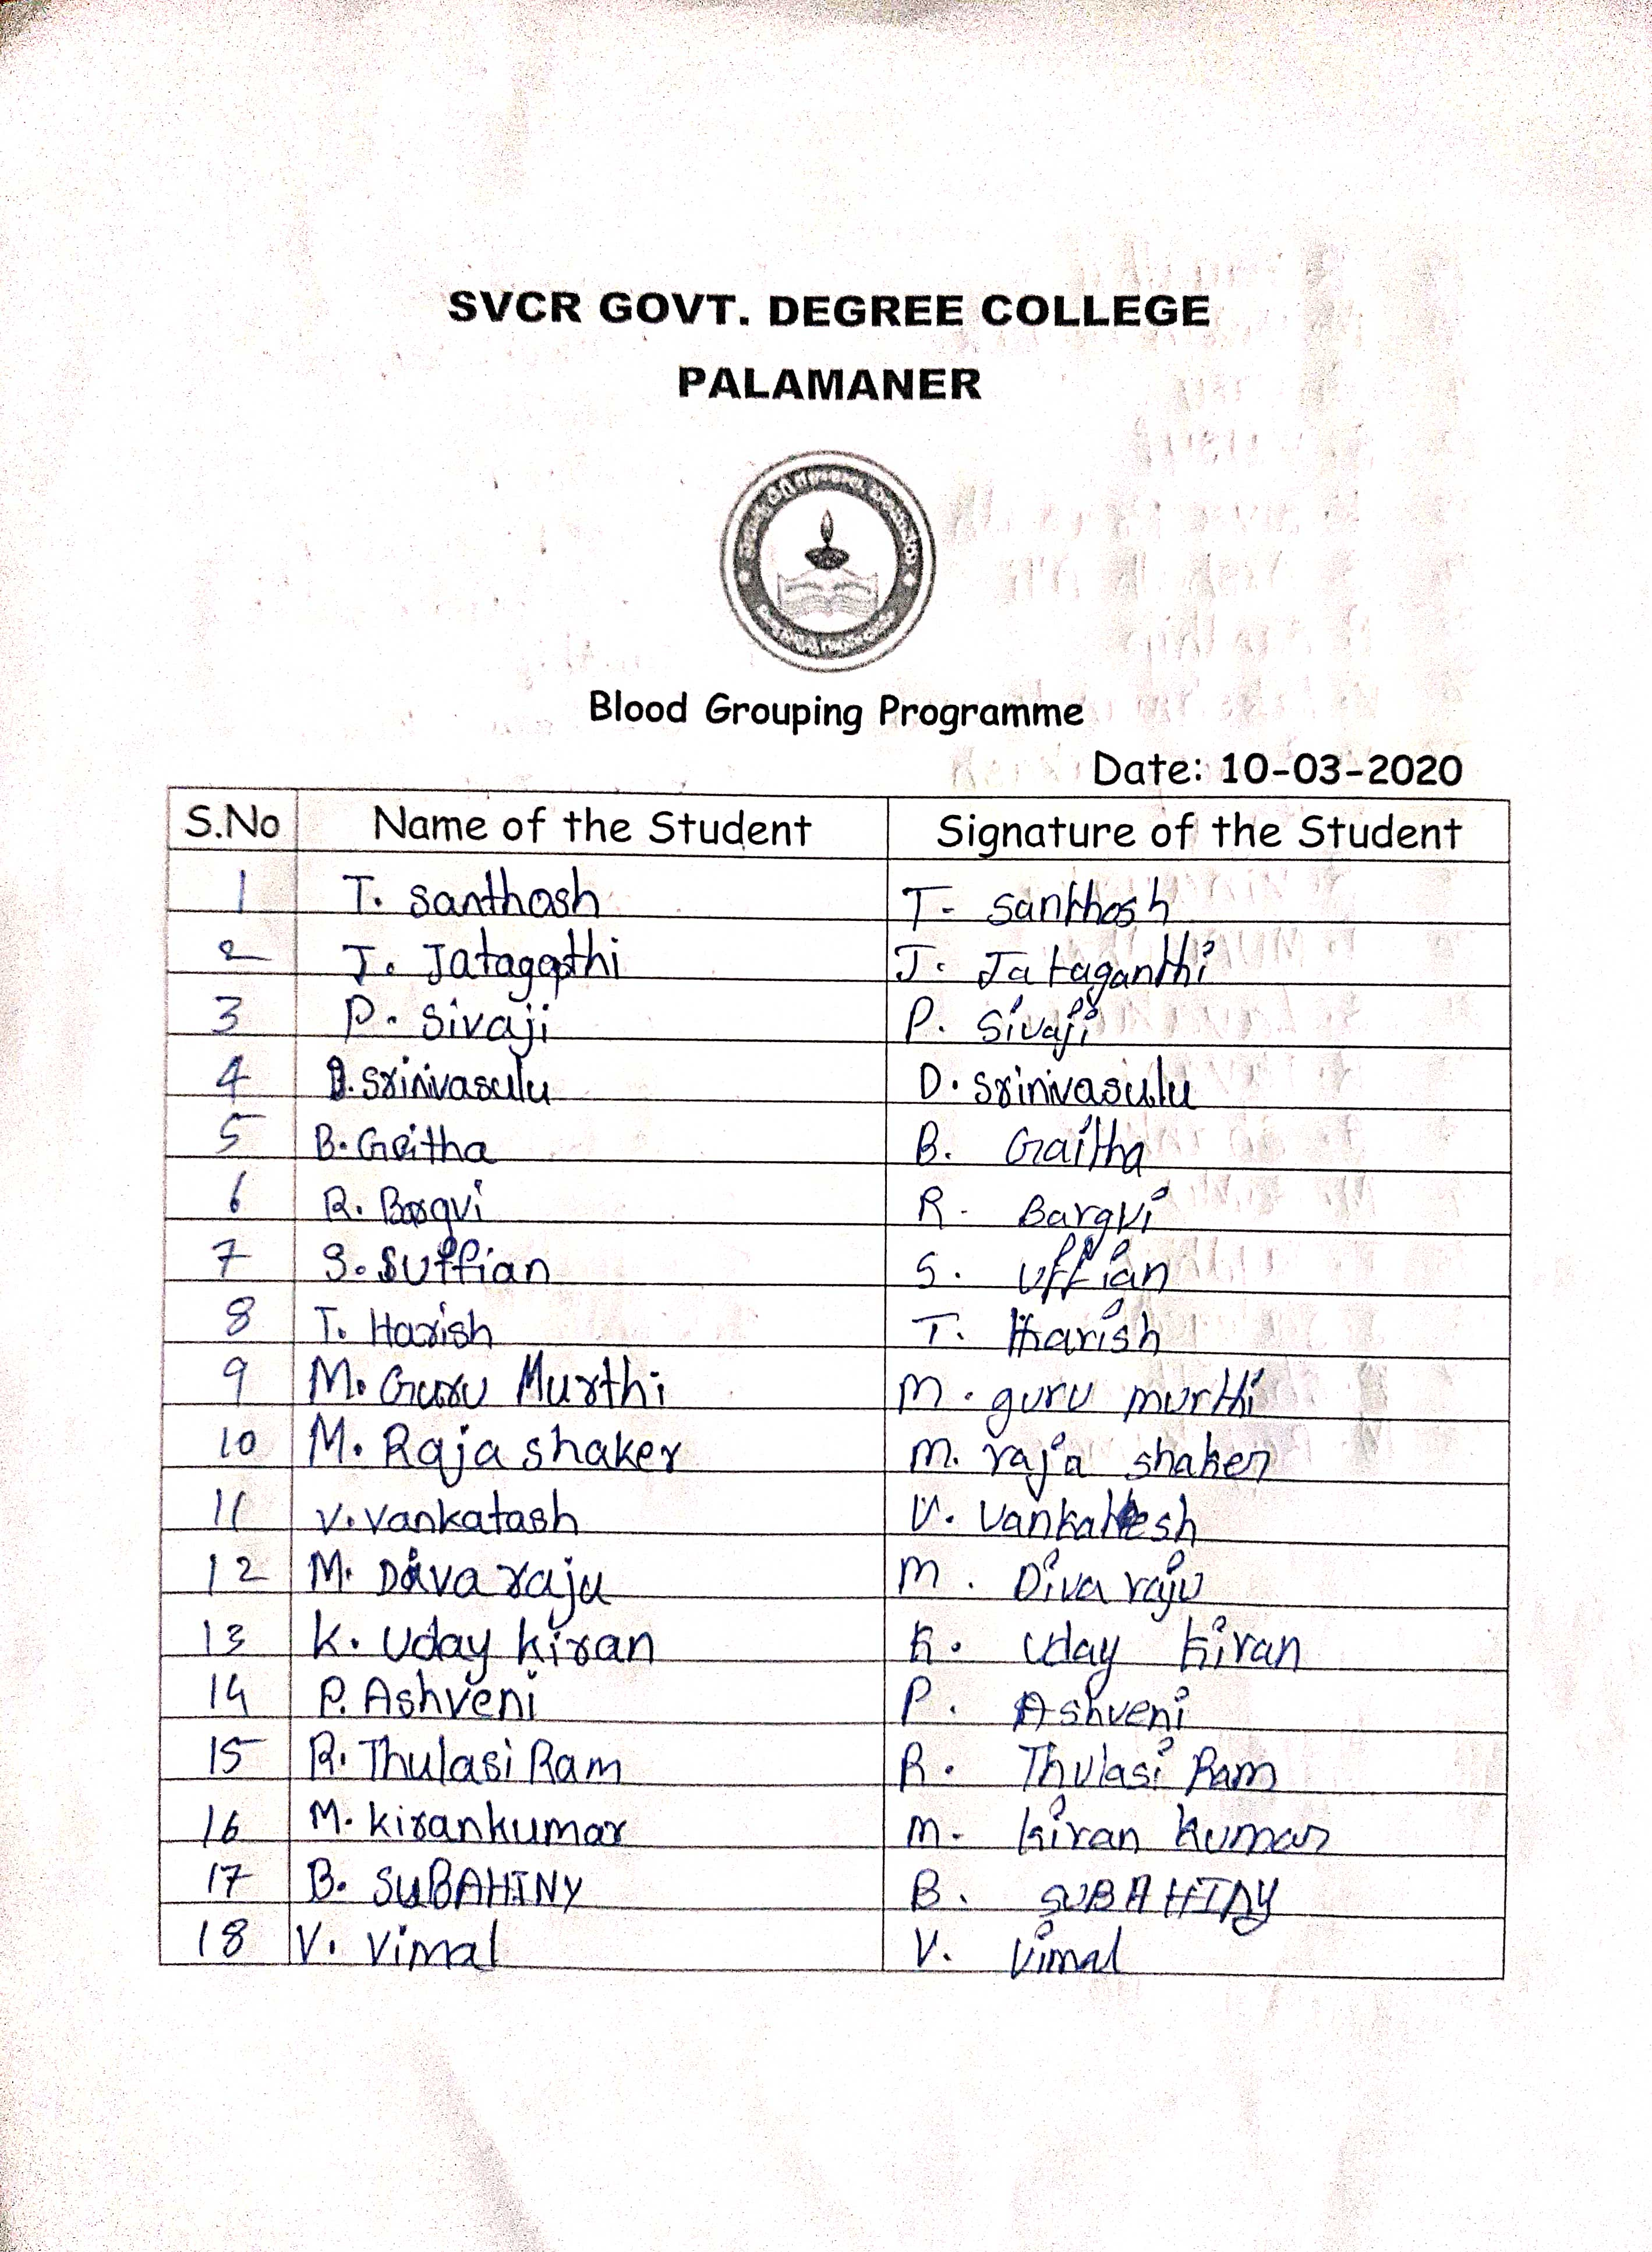
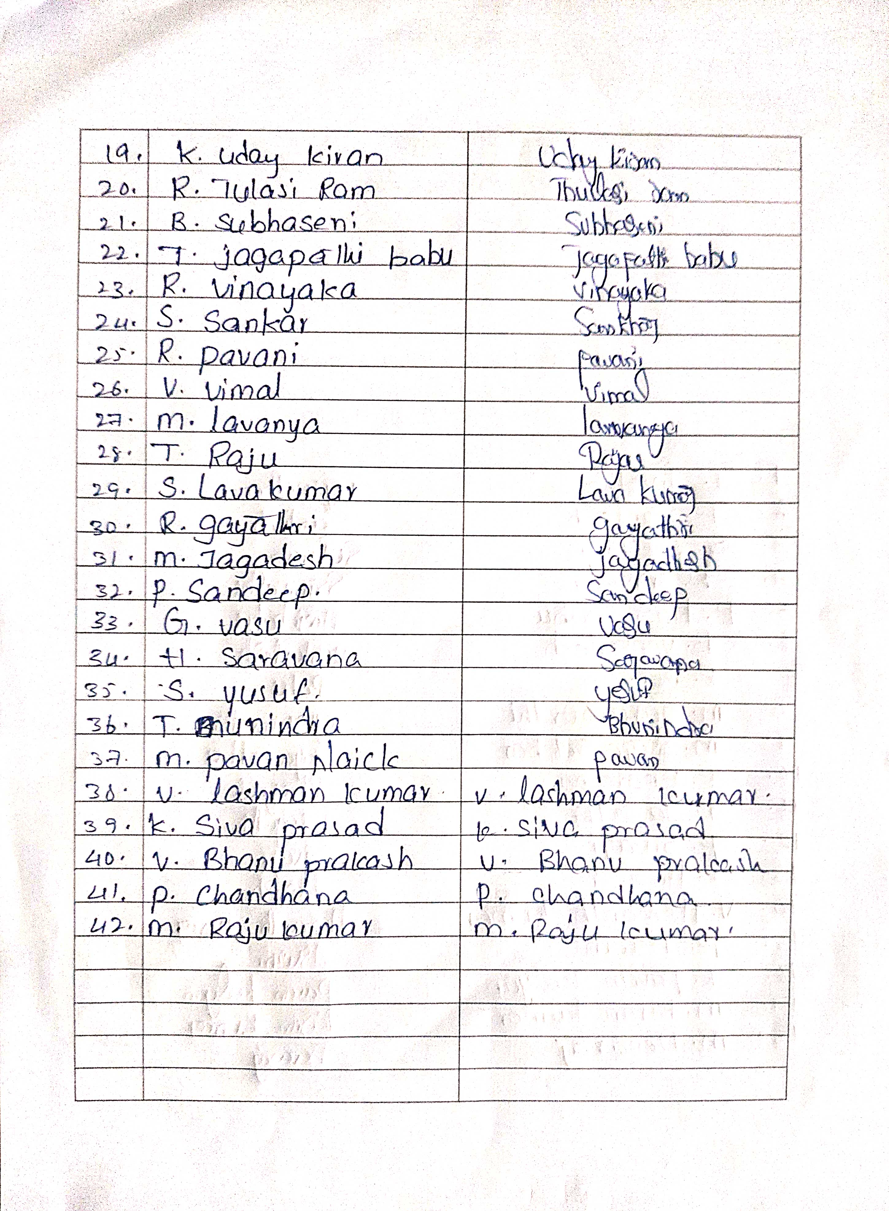

FEED BACK:
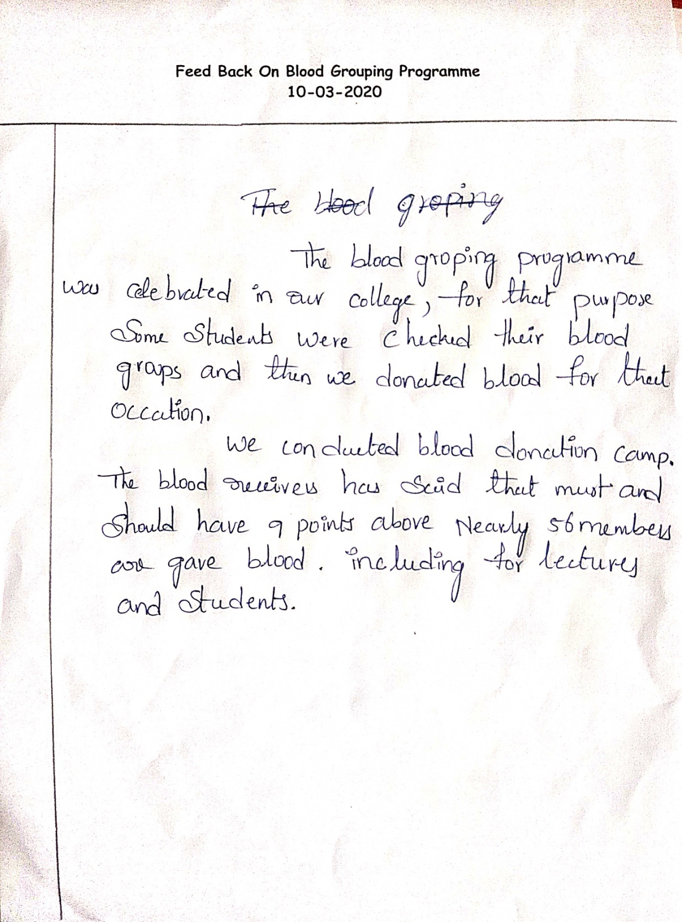

PHOTOS

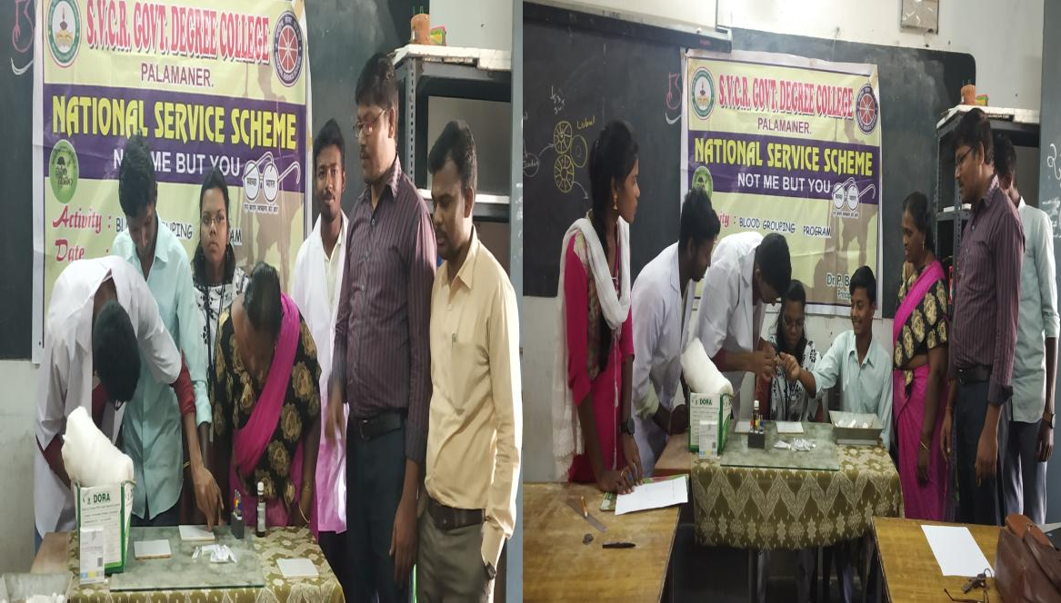

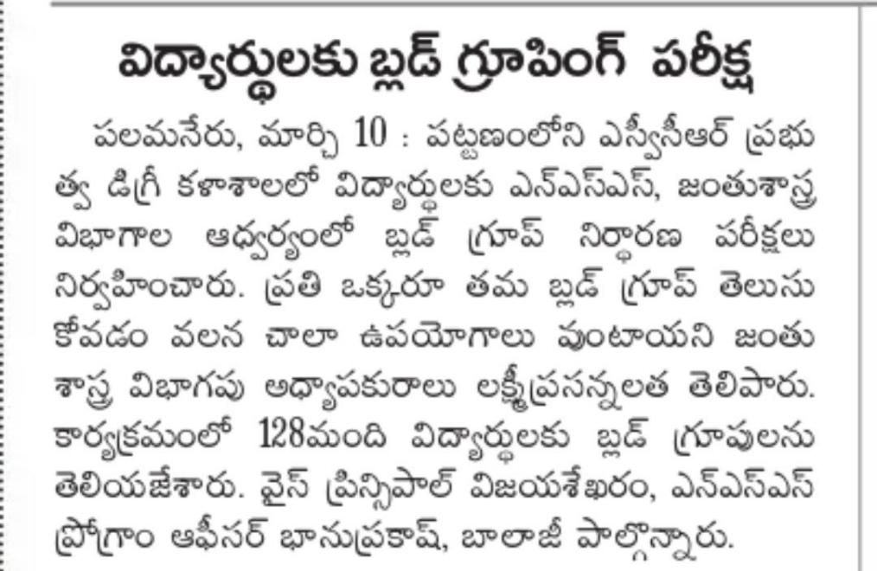
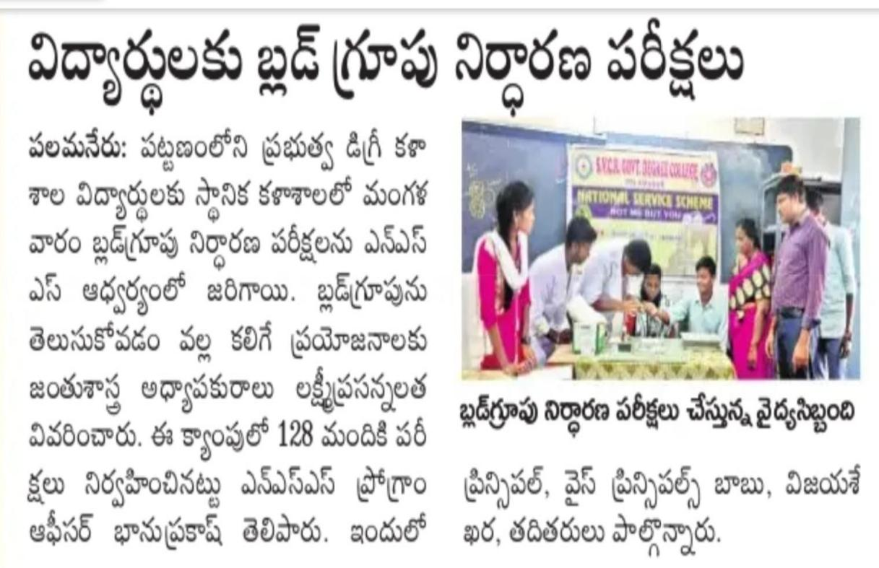

SVCR GOVT DEGREE COLLEGE PALAMANER
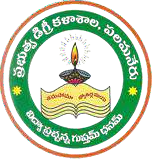

PROGRAM NAME: INDEPENDENCE DAY CELEBRATIONS
DATE: 15.08.2020
VENUE: OPEN GROUND IN THE COLLEGE RESOURCE PERSON: PRINCIPAL OF THE COLLEGE

Circular
This is to inform all the students and the staff of the college to attend Independence Day celebrations in the college premises on 15.08.2020 at 8.30 am.

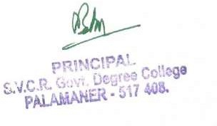

OBJECTIVE OF THE PROGRAM:
- To inculcate patriotism among the students.
- To motivate the students to work for the nation.
- To encourage the students to join NCC and serve for the nation. REPORT :
A spectacular event of Independence is celebrated in the campus. The staff and the NCC cadets attended the flag salutation event and with much honor the cadets of NCC did the event. The pandemic too could not suppress the enthusiasm of the students and the staff in attending the event.

OUTCOME:
- The students became aware of Indian Independence movement.
- The Students are well motivated after watching the NCC parade.
- The first year students of the college aspire to join NCC .
- The singing of the students is well appreciated by all.

STUDENTS AND STAFF ATTENDENCE LIST:

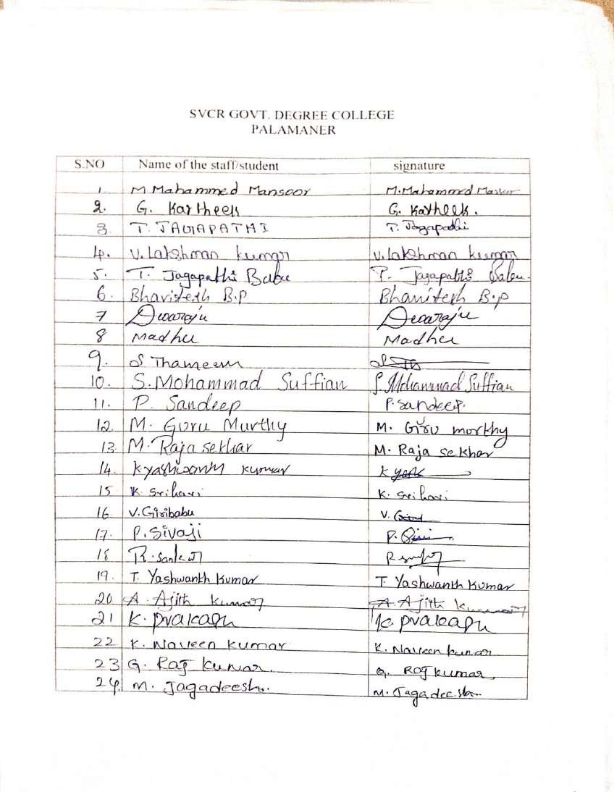

PHOTOS:

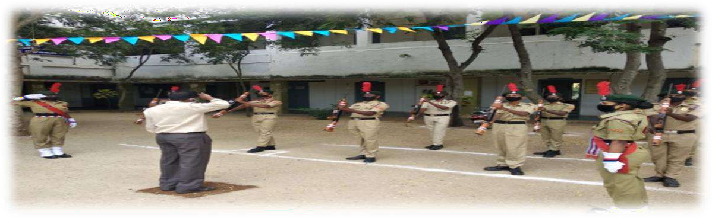

SVCR GOVT DEGREE COLLEGE PALAMANER

PROGRAM NAME: National Service Scheme Day Celebration PROGRAM DATE: 24-09-2020
TIME: 1.30 PM
VENUE: OPEN GROUND

Circular
All the students and staff have to attend the sapling plantation activity that is going to be conducted in the open yard of the college on the occasion of NSS day celebrations on 24.09.2020 at 1.30 PM. The staff and the students must follow the COVID – 19 rules.

OBJECTIVE:
- To learn about the importance of NSS in the college.
- To plant more saplings. REPORT:
The NSS Day is conducted in the college and the activities of cleaning have taken place. The garden in the college has been cleaned. Due to the pandemic less number of students attended the activity. Following the pandemic rules tree plantation too is done.
ATTENDANCE:
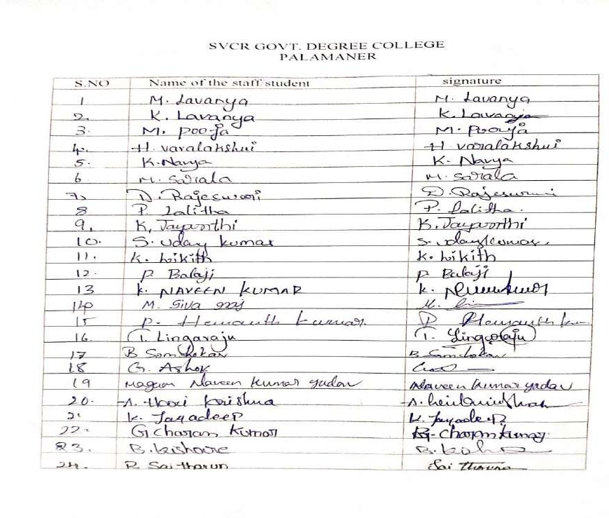

OUTCOME:
- The college campus is cleaned by the staff and the students.
- A good number of saplings have been planted.

PHOTOS:
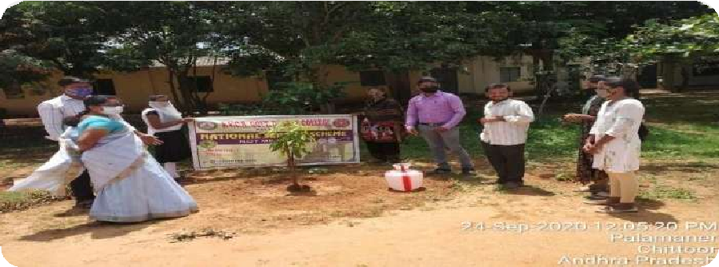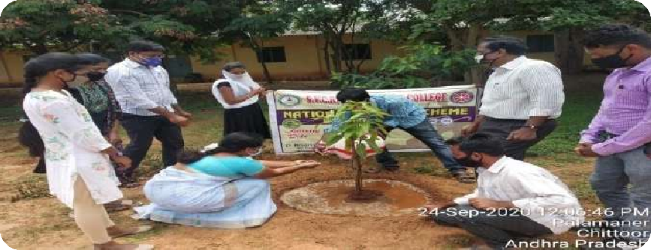

SVCR GOVT DEGREE COLLEGE PALAMANER

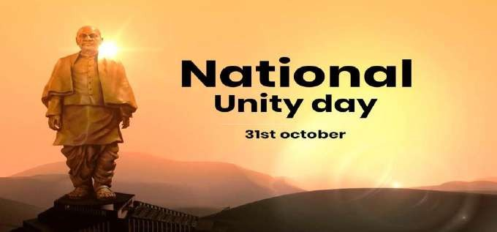

PROGRAM NAME: NATIONAL UNITY DAY
DATE: 31.10.2020
VENUE: VIRTUAL CLASS ROOM
RESOURCE PERSON: PRINCIPAL OF THE COLLEGE

OBJECTIVE OF THE PROGRAM:
- To make students to understand the importance of National Unity Day.
- To promote patriotism among the students.
- To inculcate the habit of promoting culture. REPORT :
During the National Unity Day the oath is taken by the Principal and the staff along with the NCC cadets. The importance of the National Unity Day is well explained and following the COVID – 19 rules a simple rally is carried out by the NCC cadets.

OUTCOME:
- The staff and the Principal actively participated in oath taking.
- Though there are less number of students they developed a feel for the country.

STUDENTS ATTENDENCE LIST

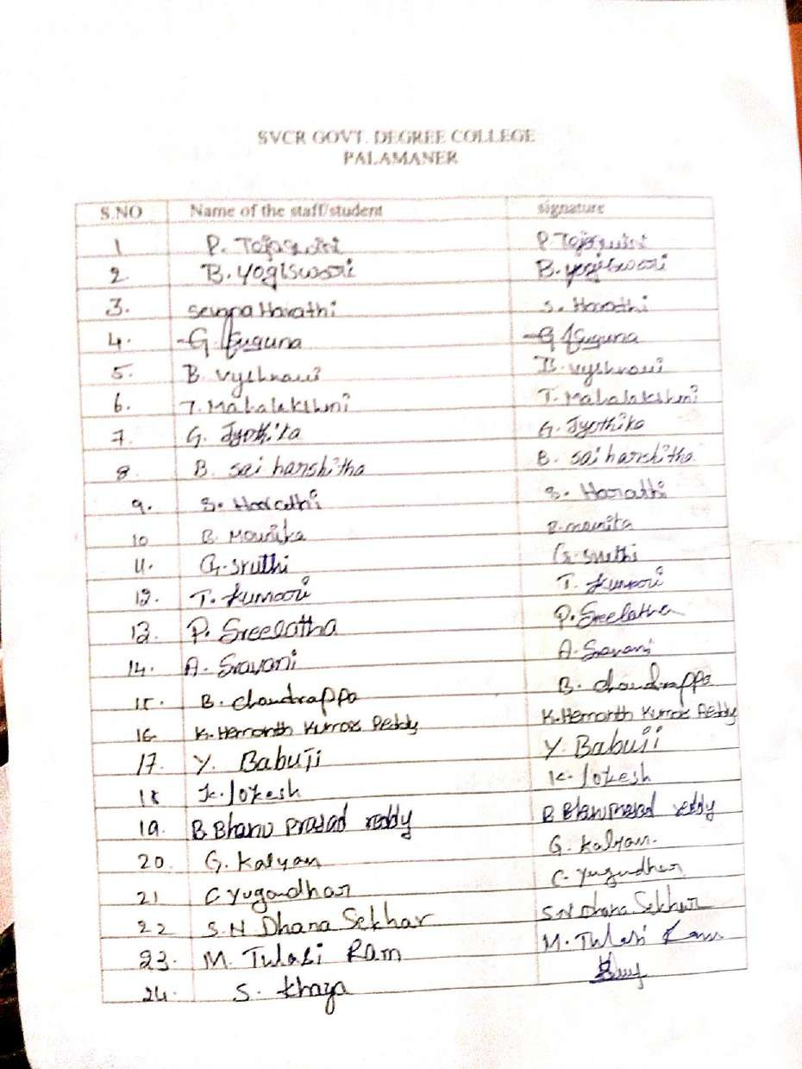

PHOTOS:

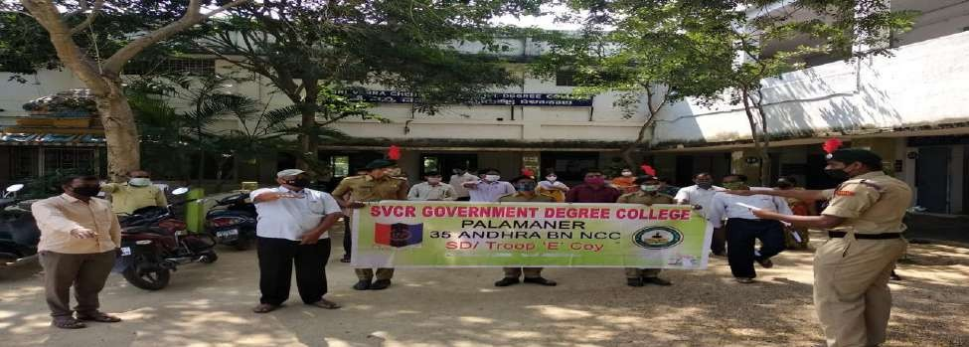

SVCR GOVT DEGREE COLLEGE PALAMANER
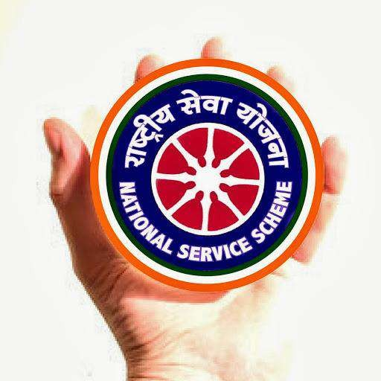

PROGRAM NAME: NSS SPECIAL CAMP UNIT-I PROGRAM DATE: 01.03.2021 TO 07.03.2021 TIME: 9:AM TO 6:PM
VENUE: Mandal Praja Parishad School,Berupalli Village,T. Odduru, Palamaner. RESOURCE PERSON: NSS

NSS SPECIAL CAMP REPORT
NSS Unit I & II of S.V.C.R Govt Degree College, Palamaner conducted Special Camping Programme from 01st March 2021 to 07th March, 2021 at Mandal Praja Parishad School, Berupalli Village, T. Odduru Panchayat, Palamaner. The camping area includes Berupalli Village and T. Odduru Village. Apart from the local youth, 45 student-volunteers have been participated in the camp. This camp was headed by Dr. P. Babu, Principal, SVCR Govt Degree College, Palamaner and Sri. P. Bhanuprakash, NSS Programme Officer, Unit-II, SVCR Govt Degree College, Palamaner. The camp was organized with the main theme “Health, Public Sanitation and Personal Hygiene”.
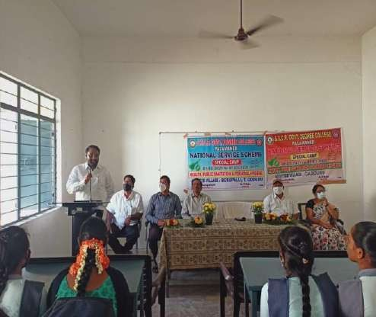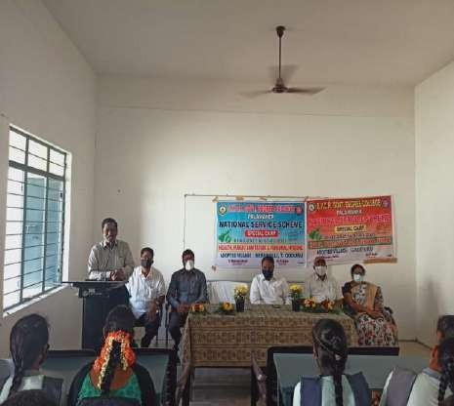
DAY-1 INAUGURAL SESSION (01-03-2021)

The NSS Special Camping Programme began with an inaugural function held at SVCR Govt Degree College, Palamaner. Dr. P. Babu, Principal of the college presided over the function. Sri. Rahul Ambedkar, Junior Civil Judge, Palamaner attended the programme as Chief Guest. Dr. G. Sridevi, IQAC Coordinator and M. Vijayasekharam, Vice-principal,
SVCR Govt. Degree College, Palamaner

are the guests of honour for the function. Dr. E. Chandra Naidu, NSS Programme Officer Unit-I, Sri. P. Bhanuprakash, NSS Programme Officer Unit-II; Teaching and Non-teaching staff of SVCR GDC, and NSS volunteers attended the function. The inaugural function was started with a serene prayer followed by NSS song “We Shall Overcome” by the volunteers.
The Principal, who presided over the function addressed the gathering, and reminded the aims and objectives of NSS. He asked the student volunteers to utilize this opportunity to serve villagers, and bring laurels to the college. Sri. Rahul

Ambedkar emphasized that the Homo-sapien race survived in the evolution process as they used to live in groups and help each other. He insisted the students to voluntarily render service to up-lift the weaker sections of the society He also asked them to gain knowledge and develop personality through active participation in all the NSS activities. Sri. M. Vijayasekharam, Vice-principal, SVCR Govt. Degree College, Palamaner suggested the volunteers and villagers make use of the camp in the best way. Dr. G. Sridevi suggested NSS volunteers to create awareness among the villagers about the preventive measures of COVID-19. After that, the NSS programme officer had given brief insight about seven days programme. Other speakers of the function extended their wishes to make the Special Camping Programme a grand success. After the Inaugural function, Camp officers and NSS Volunteers were involved in cleaning the degree college campus by removing the weeds and bushes of the grass.
Village authorities welcomed the NSS team into their village and assured them all sorts of co-operation needed in making the special camp a grand success. In the afternoon session of the first day, the NSS team planned to clean the premises of MPPS, Berupalli. Four groups of NSS volunteers cleaned the playground and vacant areas in the school compound whereas the other groups focussed on cleaning the inside the classrooms. The volunteers cleaned the garbage which was strewn around the school campus. Later, the volunteers started a Procession in the streets of the villages to create awareness among the villagers about the ensuing special camp programme in the village for a period of one week. Lastly, volunteers discussed about the activities to be undertaken for the next day in the camp with NSS programme officer. Volunteers sang the NSS song and concluded the first day by NSS clapping.

DAY-2 STUDENTS WORKING AT VILLAGE (02-03-2021)

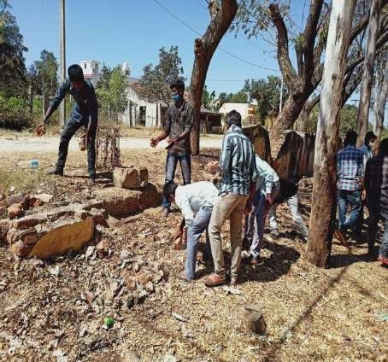
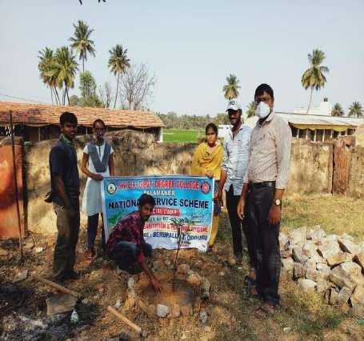

The morning session of the second day has been started with Swacchata Hi Seva and Shramadanam in the Berupalli village. As a part of Shramadanam Programme, the Camp officer along with the Volunteers as a sub groups organized a cleanliness drive. The total village is divided into five parts and cleaning work is assigned to five groups of NSS Volunteers. They were actively involved in the cleaning of the roads and sewage canals in the village. The roads and canals were cleaned by removing the weeds, grass and plastic waste.
Volunteers collected different saplings from the nearby nursery and brought them to the village for plantation. The saplings include medicinal valued and fruit bearing varieties like mango, black plum, neem, jackfruit etc. NSS volunteers in groups planted saplings in the school campus and along two sides of the road in the village. Later, they watered the saplings and also safe guarded them with plant guards prepared with the sticks and wire mesh. Finally, the volunteers discussed about the activities to be undertaken for the next day with the camp officer. Volunteers sang the NSS song and concluded the day by NSS clapping.

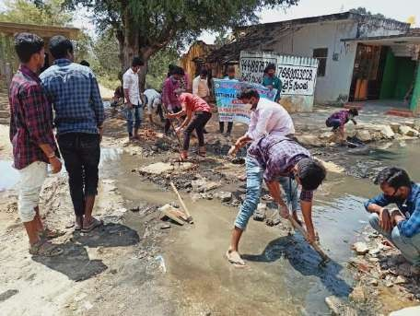
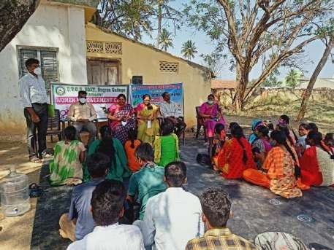
DAY-3 VOLUNTEERS CLEANING SEWAGE (03-03-2021)

In the first session of the day, an awareness rally on “Preventive measures of COVID- 19” was organized in the Berupalli and T. Odduru villages by the NSS volunteers along with the children of the village. They went through the streets of the village and explained through placards and slogans that maintaining social distance, wearing mask and using soap or sanitizer for hands protects the individual from novel corona virus infections. The rally also emphasized on keeping hands clean through proper methods of hand washing before eating and after defecation which keeps one free from disease causing bacteria and viruses. Later, the NSS volunteers involved in the Shramadanam Programme in the T.Odduru village. They cleaned the village roads, removed the dust

heaps and cleared the stagnant drainage flows and attempted to create awareness on Cleanliness and hygiene in the village.
In the post lunch session, motivating and inspiring talks are organized for the benefit of volunteers and the villagers.
- Dr. P. Babu, Principal, SVCR Govt. Degree College, Palamaner has delivered a Lecture on “Renewable sources of energy and alternative fuels”. He explained the need to focus on the alternative fuels like biogas, biodiesel, bioethanol,etc. He emphasized that wide usage of renewable sources of energy like solar energy, wind energy, tidal energy, biomass energy, etc is the need of the hour as it is not associated with air pollution emissions.
- Dr. G. Sridevi, IQAC Coordinator, SVCR Govt. Degree College, Palamaner has delivered a Lecture on “Personality Development through NSS”. She quoted that “Besides rendering service to the society through NSS, the volunteers may get chance to develop their personality and get benefited through this camp. She hasgiven certain tips for the personality development to the volunteers. Her presentation had shown positive motivation on the young minds.
- Smt. Lakshmi Prasanna Latha, Lecturer in Zoology, SVCR GDC, Palamaner addressed the NSS volunteers on the “Health and Personal hygiene”. She explained that a busy lifestyle makes one fall into the habit of choosing unhealthy snacks or spending free time in front of the television or computer. Thesechoices can be dangerous for the health in the long-run. Hence, it is very necessary to follow a healthy lifestyle. She suggested a few ways to lead a healthy lifestyle such as regular physical activity, preferably eating more fruit and vegetables, switching off the TV and Computer screen and getting active through playing real games.
- Smt. M. Sandhyarani, Coordinator, Women Empowerment Cell, SVCR GDC, Palamaner has delivered an invited talk on “Save girl child, Save future”. She expressed that gender equality prevents violence against women and girls. It's essential for economic prosperity. Societies that value women and men as equal are safer and healthier.
- In order to develop personality among NSS volunteers, an invited talk on “Time Management” has been arranged in the last session of the camp. The resource person is Lt. T. Balaji, ANO- NCC, SVCR GDC, Palamaner. He explained about goal setting, planning and stress management. They actively participated and thoroughly enjoyed the interactive session.

Lastly, the volunteers discussed about the activities to be undertaken for the next day with the camp officer. Volunteers sang the NSS song and concluded the day by NSS clapping.
DAY-4 (04-03-2021)

“Three Days COVID-19 Awareness and Prevention Campaign”
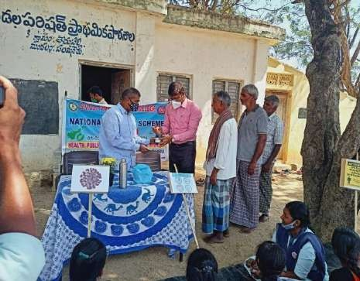
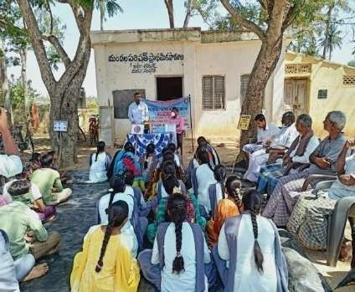

The morning session of the fourth day has been started with a “Three Days COVID-19 Awareness and Prevention Campaign” in the Berupalli village. As a part of it, awareness programme on “COVID-19 and Preventive Measures” was organized under the supervision of Dr. Mohana Krishna, Govt. Homeopathic Hospital, Palamaner. He explained about the mode of infection and control measures for COVID-19. He explained that COVID-19 is an infectious disease caused by novel Corona virus. It can also be transmitted from person to person. This virus spreads through droplets of saliva or discharge from the nose when an infected person coughs or sneezes. The disease is contagious and dangerous leading to deaths among human beings. The symptoms of COVID-19 H1N1 are fever, dry cough, headache, cold, sore throat, diarrhoea, loss of small or taste etc. It is recommended to visit the doctor as soon as a person suffers any of these symptoms. He suggested the following steps to keep COVID-19 away:
  - The best way to prevent COVID-19 is maintaining social distance.
  - Highly recommended to wear masks on mouth and nose so that they do not intakethe virus from the environment.
  - Wash your hands properly using soap or sanitizer. This prevents the virus to getinto the body and infect us.
  - Avoid contact with people infected with corona virus.
Later, Dr. Mohana Krishna prepared the Homeopathy Medicine, Arsenicum album as a preventive drug against COVID-19. He explained the dosage of medicine and precautions to be taken after taking medicines to the volunteers. They in turn gave the

first dose of the Swine Flu preventive medicine directly to more than 600 members of the Berpalli and T. Odduru Villages. They also explained the precautions and control measures to be taken to keep COVID-19 away. Volunteers have covered the households by campaigning door to door in the village.
Dr. G. Chinna Reddy, Lecturer in Chemistry, SVCR GDC, Palamaner has delivered a lecture on “Reduce, Reuse and Recycle concept of plastics”. He said that RRR formula must be followed by every individual to minimize the harmful effects of plastic pollution on human beings, plants and animals. He suggested not buy things that come in wasteful plastic packaging or that cannot be recycled. He also suggested to use stainless steel or copper water bottles instead of bottles that were made from plastic.
Sri. P. Bhanuprakash, NSS Program Officer addressed the NSS volunteers and discussed with them the method to boost body’s immunity power. He suggested using immunity boosting foods like drumsticks, coconut water, lemon, garlic, onion, turmeric, etc. He also suggested the volunteers to always use cooked food, eat fruits in an empty stomach and drink plenty of water. Lastly, NSS volunteers watered the saplings in the Berupalli village and discussed about the activities to be undertaken for the next day in the camp with camp officer and concluded the fourth day by NSS clapping.
DAY-5 (05-03-2021)
In continuation to the previous day programme on “Three Days COVID-19 Awareness and Prevention Campaign”, the NSS Volunteers given the second dose of Homeopathy medicine directly to the persons to prevent COVID-19 and covered all the households by campaigning door to door in the Berupalli and T. Odduru villages.
In the afternoon session of the day, NSS volunteers were involved in the Shramadanam Programme in the Berupalli village. They cleaned the village roads, and cleared the stagnant drainage flows. They covered the road pits with mud. They also sprayed bleaching powder on the sewage canals and attempted to create awareness on cleanliness and hygiene among the villagers.
In the last session of the day, NSS volunteers were actively involved in the cleaning program of tank bund in Berupalli village. They removed weeds, dust heaps, garbage, plastic remains, and bushes. They also watered the plants near the tank bund. Finally, volunteers discussed about the activities to be undertaken for the next day in the camp with camp officer and concluded the day by NSS clapping.

DAY-6 (06-03-2021)
The dairy sector plays an important role as a subsidiary source of income in addition to agriculture for the livelihood in Palamaner, which is well known as Milk City of South. To

improve the health condition of cattle, Animal Health Camp (Veterinary Camp) was organized in the Berupalli village of T. Odduru panchayath. Mr. M. Mogileeswar, Veterinary Health Assistant, Palamaner extended his helping hand in the smooth conduct of the animal health camp. A public announcement was made and also door to door communication was given to the village people by the volunteers to utilize the Animal Health Camp. The NSS volunteers played a vital role in making this camp successful with their commitment in gathering the cows, calves, goats to the camp. In this camp around 80 cows, 24 calves and 10 goats were sprayed Butox for the prevention and the treatment of ectoparasitic infestations in cattle caused by the parasites like mange mites, lice, ticks and flies. The Veterinary Health Assistant explained the animal health conditions to their owners and the following free medicine was distributed with the help of volunteers.
- Albendazole Oral suspension : Deworming syrup.
- Multivitamin and Calcium Tablets
- Furazolidone and FenbendazoleTablets
- Stomavet-Digestive tonic powder
- Termin Plus cream

The afternoon session of the sixth day of the camp has been started with the “Three Days COVID-19 Awareness and Prevention Campaign”, through which the NSS volunteers given the third dose of Homeopathy medicine directly to the persons to prevent COVID-19 and covered all the households by campaigning door to door in the Berupalli and T. Odduru villages. Later, volunteers cleaned MPP school campus in Berupalli village. Finally, volunteers discussed about the activities to be undertaken for the last day in the camp with the camp officer and concluded the day by NSS clapping.
CARE FOR ANIMALS :
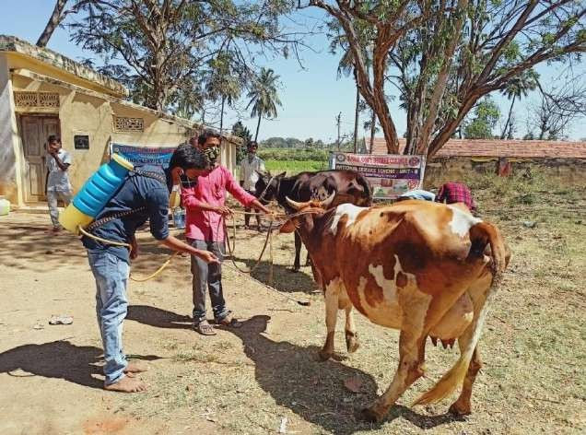

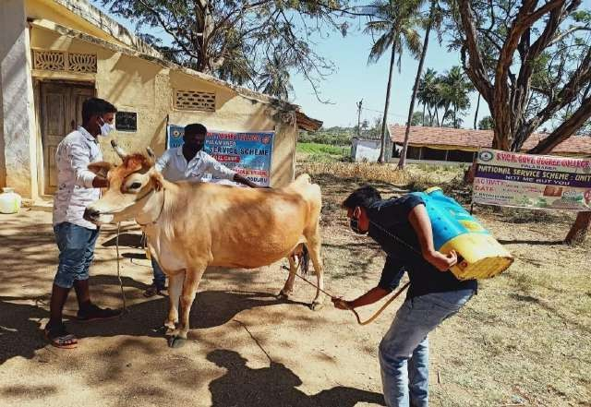

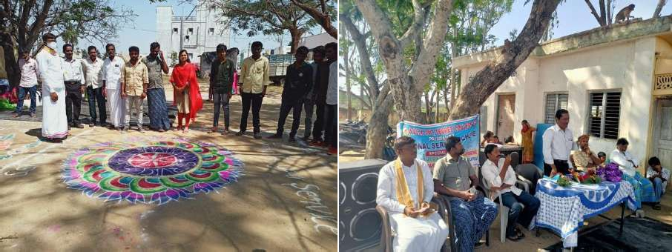
DAY-7 (07-03-2021)

RANGOLI COMPETITIONS Fig: VALEDICTORY FUNCTION

On the last day of the camp, Rangoli competitions were conducted for the women in the village and also for the NSS volunteers. Later, a cultural programme was organized for the volunteers and the village children in the school premises. They enjoyed in singing and dancing for folk songs. NSS volunteers made all the necessary arrangements for the valedictory function of seven days Special Camping Programme at Berupalli.

Valedictory Ceremony:
The last session of the day was allotted to the valedictory function. The Principal of our College Dr. P. Babu presided over the function. Sri. B. Munaswamy, Sarpanch, T.Odduru Panchayat, Palamaner was the chief guest for the function. Sri. O. Sai Bangaram, Panchayat Secretary, T. Odduru Panchayath and Sri. Madhava Reddy Village Representative, Berupalli were the Guests of Honour. Representatives from the village, teaching and non-teaching staff of the college, and volunteers have attended the function.

Camp Officer Sri P. Bhanuprakash addressed the gathering and submitted a report on various service activities undertaken during their 7 days of Special Camping Programme in the village. Principal appreciated the volunteers for their work and thanked the village authorities for their support. He motivated the students to do better and continuous services to society. Sri. B. Munaswamy, profusely thanked the volunteers and camp officer for their various service activities undertaken in the village. Sri. O. Sai Bangaram in his address emphasized that the Camping Programme of its kind will definitely help the volunteers in their personality development. He expressed that the purpose of the camp was served in inculcating social, cultural, moral, educational and ethical values among volunteers.
The volunteers in groups have shared their experiences about the camp. Prizes were given to all those who have been participated in Rangoli competitions. M. Ganesh, NSS volunteer proposed a vote of thanks to the villagers of Berupalli and T. Odduru for their support and encouragement. He also thanked all the dignitaries, guests, teaching and non-teaching staff for their esteemed presence. The camp has been concluded with National Anthem.

Concluding remarks:

All these seven days, the camp followed a good discipline and managed the time systematically. Volunteers learned how to live in society and communicate with their fellow members. The camp also helped the NSS volunteers to enrich the creative aspect of their personality with high morale and self–confidence. The experience they had in the camp will last long and will guide them for the rest of their future.

Acknowledments:

We acknowledge Prof. Padmanabham, NSS coordinator, S.V. University for sanctioning of the special camping programme. The NSS unit is highly thankful to the Principal, teaching and non-teaching staff members, who had visited and helped to conduct the Camp smoothly and successfully. Special thanks to resource persons and guests for enlightening and guiding volunteers.
Ultimately, we would like to convey gratitude and regards to the print media for covering all our camp activities.

SVCR GOVT DEGREE COLLEGE PALAMANER
PROGRAM NAME: NSS SPECIAL CAMP UNIT-II PROGRAM DATE: 03.03.2021 TO 07.03.2021 TIME: 9:AM TO 6:PM
VENUE: Gaddur (vi) ,Palamaner. RESOURCE PERSON: NSS

01.03.2021

DAY 1

The NSS special camp inauguration is done at the college. The units have celebrated the event together. The Unit – I decided to conduct special camp at Gadduru village. After the inauguration the students cleaned the campus.

2.03.2021

DAY-2

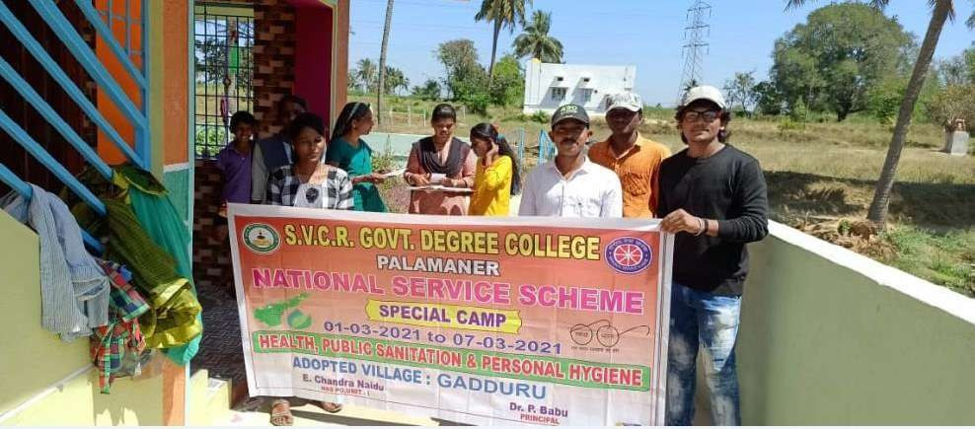
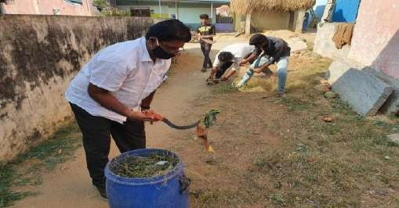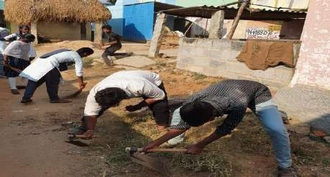

The students cleaned the premises of the school and the temple in Gadduru. There was a pool was in the middle of the main street with drain water. The students cleaned the pool and made renovations to the pipe, which is leaking. The road was cleaned and no more pool in the midst of the road.

In the afternoon, the members of Women Empowerment Cell visited the centre and took the students in a procession to sensitize on the matters ofsave the girl child to the villagers and to the students groups too.

3.03.2021

DAY-3

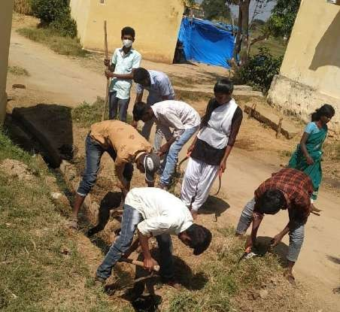
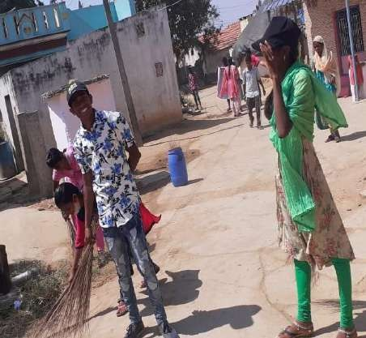

The entire village was cleaned on the 4th day of the camp. The students cleaned the sewage canals and the cow dung heaps in the midst of the village. Then a meeting was arranged for the villagers and awareness on utilizing the cow dung for different purposes is explained.
The students moved around the villages from door to door and sensitizedon the matters of COVID
– 19 and the precautions to take to avoid the same.

4.03.2021

DAY-4

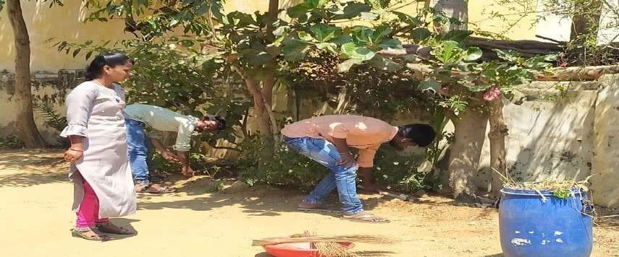
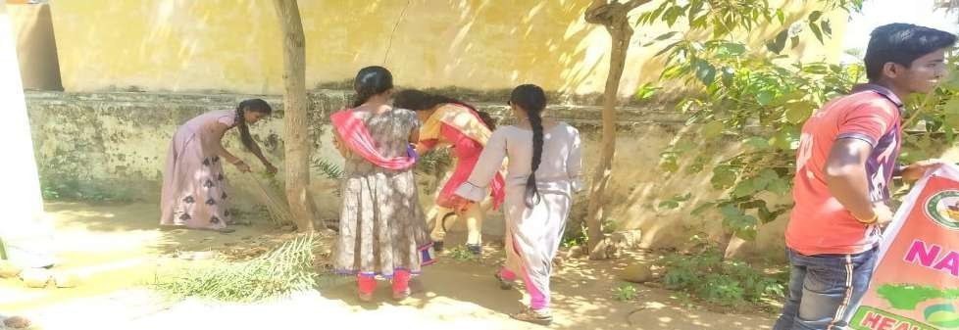

The NSS Volunteers cleaned the village all over. The shrubs on theeither side of the road were removed and the road was made tidy.

5.03.2021

DAY-5

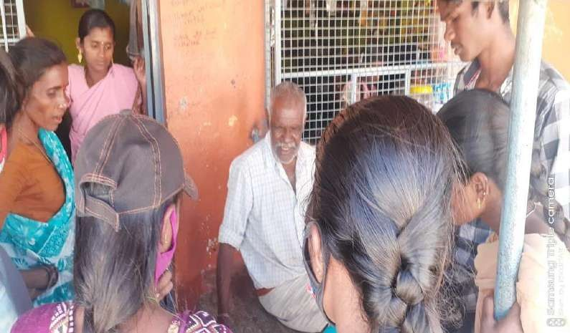

On the 5th day survey from home to home is done. As a part of this survey the issues relating to their health and hygiene are collected. The importance of being clean is explained. The cadets later noticed that some of the streets are still with some dirt and so the same is cleaned.
In the afternoon the students have been explained on the qualities of a leader. Self employment schemes too have been explained to the

6.03.2021

DAY-6

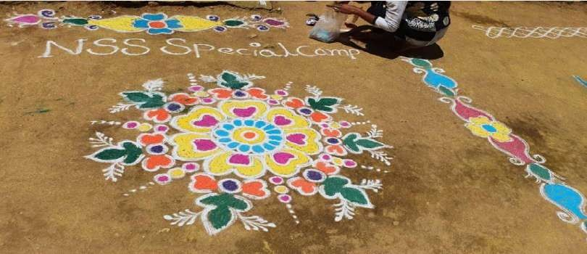
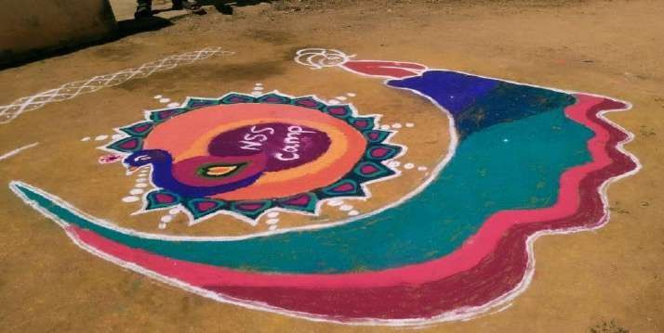

On the 6th day of the camp the valedictory function was arranged.
A competition on rangoli was conducted. The winners are given applause.

7.03.2021

DAY-7

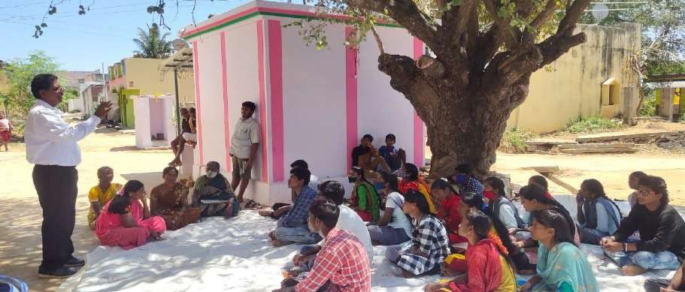
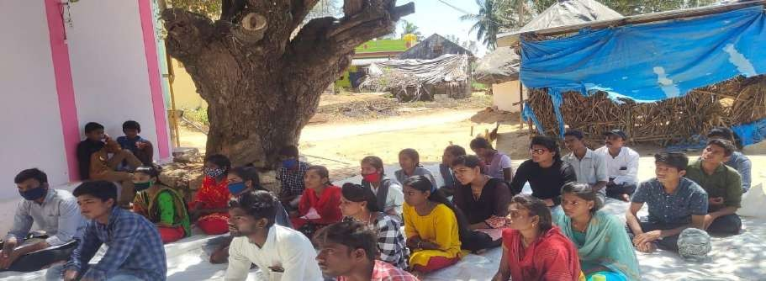

A valedictory meeting was conducted. The students gave feedback on the activities conducted by them. The Principal gave a message on service and it’s fruits. Some prominent people in the village too participated in the function, and praised the efforts of the volunteers.

SVCR GOVT DEGREE COLLEGE PALAMANER

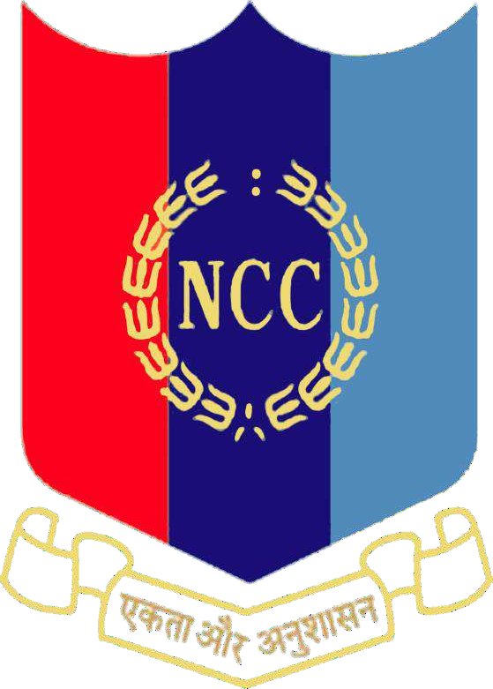
PROGRAM NAME: NCC CADRE CAMP PROGRAM DATE: 01.03.2021
TIME: 9:AM TO 9:AM TO 5:PM VENUE: SVCR GOVT.DEGREE COLLEGE
RESOURCE PERSON: T. BALAJI LECTURER IN CHEMISTRY

REPORT:

A cadre camp of NCC was conducted in the college. The NCC cadets have been trained during the days of camp. The trainers trained them in the matters of drill and weapon usage and mapping etc. The students previously used to visit other colleges for this kind of training, Due to the efforts of ANO Lt. T. Balaji the camp is being conducted in the campus and thus the students are well benefitted.
PHOTOS

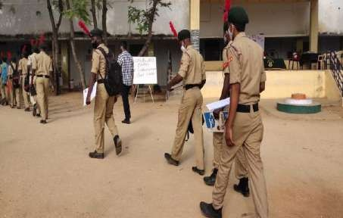
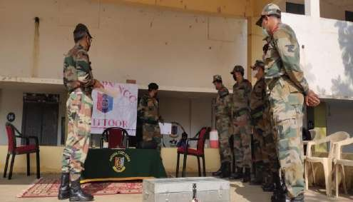

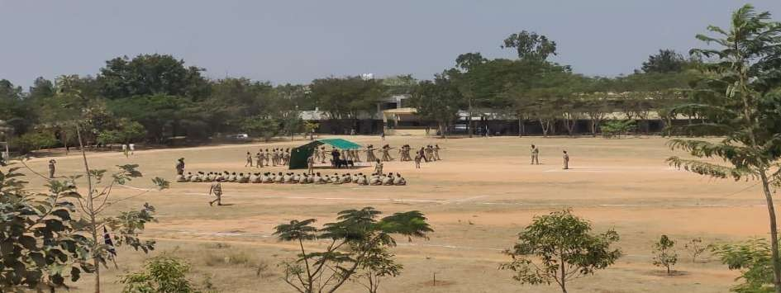

SVCR GOVT DEGREE COLLEGE PALAMANER

PROGRAM NAME: SPIT FREE INDIA MOVEMENT PROGRAM DATE: 17.03.2021
TIME: 10.00AM
VENUE: PRINCIPAL CHAMBER RESOURCE PERSON: COLLEGE STAFF

REPORT:
The team NSS has worked on Spit free India during the COVID – 19. For the herculean task the institute has received two gold medals for the students and one gold medal for the coordinator, Sri P. Bhanu Prakash.

PHOTOS:
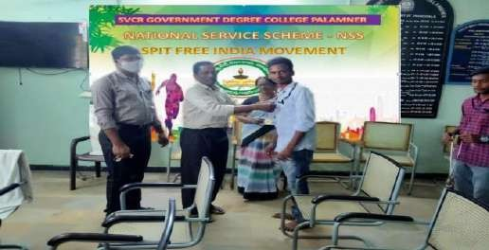
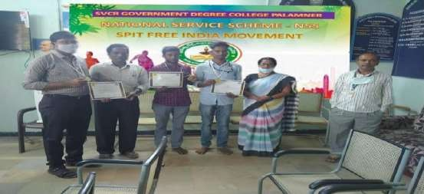

SVCR GOVT DEGREE COLLEGE PALAMANER

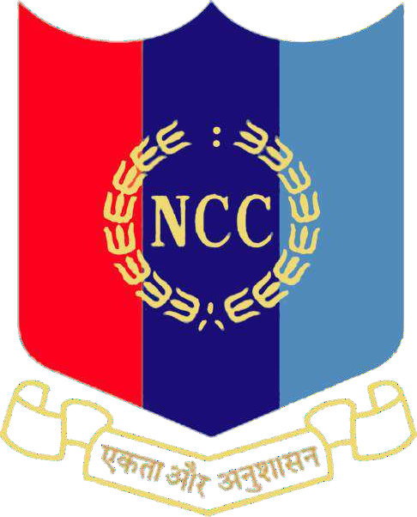

PROGRAM NAME: NCC “B CERTIFICATE” EXAMNATION
PROGRAM DATE: 19.03.2021 TIME: 9:00AM
VENUE: SVCR GOVT. DEGREE COLLEGE, PALAMANER
RESOURCE PERSON: The examiners are 15 in number:
- 5 (A) Girls BN NCC Tirupati, Commanding Officers, 02 PI Staff
- 35 (A) BN NCC, Chittoor, SM, PI staff, Civilian Staff

REPORT:
SVCR Government Degree College, Palamaner has conducted the reputed B certificate examination for the cadets of NCC from 07 colleges. The colleges are
- SVCR Government Degree College, Palamaner.
- B.T. College, Madanapalle
- MITS College, Madanapalle
- Dravidian University, Kuppam
- PVKN Government College, Chittoor
- PCR Government Junior College, Chittoor
- SR Government Degree College, Punganur

Totally 336 students from the above colleges have undergone the examination in Practicals, drill test, FC & DC, Map reading and theory examination. All these examinations are conducted for 02 days.

PHOTOS:
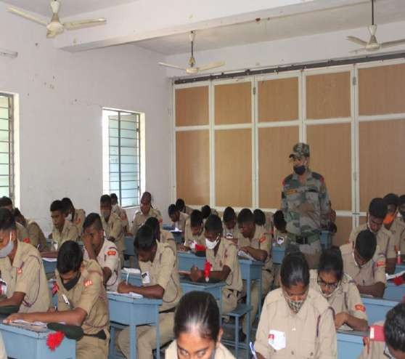
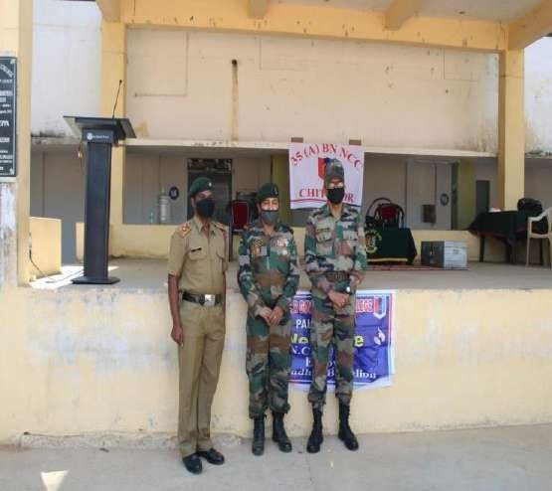

SVCR GOVERNMENT DEGREE COLLEGE, PALAMANER

BLOOD DONATION CAMP

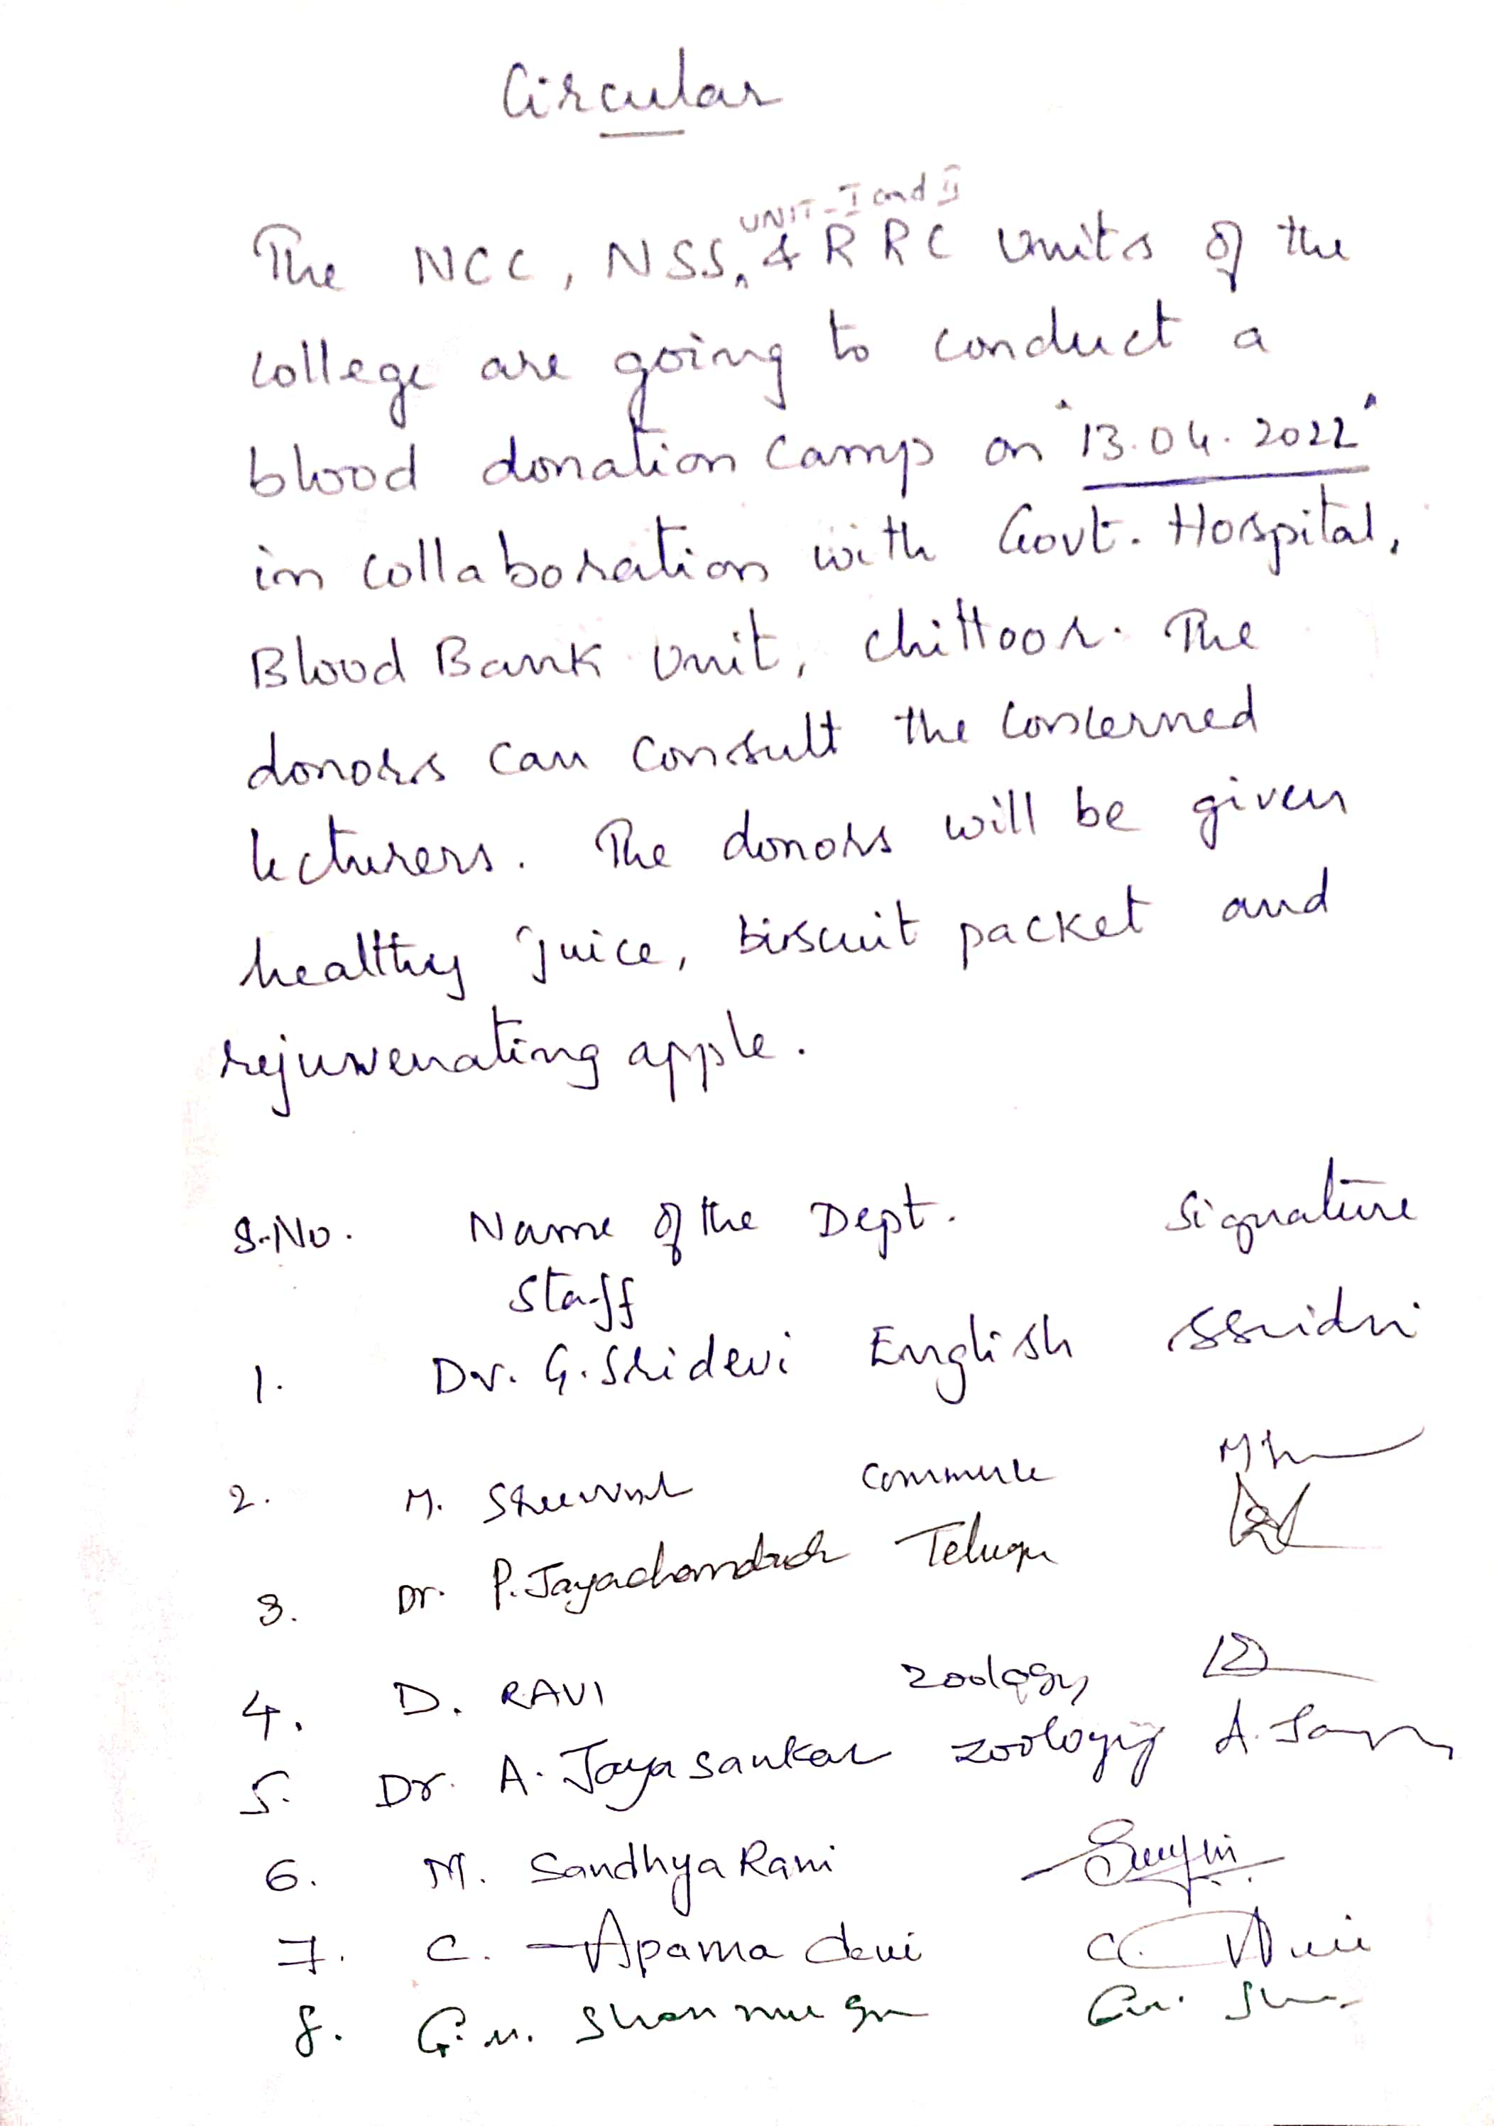

OBJECTIVE OF THE PROGRAMME:

- To motivate the students and the staff on the need for blood donation.
- To promote social responsibility among the students and the staff.

REPORT OF THE PROGRAMME:

The students and the staff are intimated beforehand about the blood donation camp. They are explained by the RRC coordinator that nothing will happen if they donate blood. By doing this they can help the society. As a matter of motivation the staff donated blood at first and later the students are checked by the doctor and those who are fit from them the blood is taken. Thus 88 units of blood has been collected. The program is conducted in collaboration with the Government Hospital, Chittoor. The students and the staff have been praised for their service based activity.

OUT COME:
- 88 units of blood have been collected.
- The students and the staff are well motivated to serve the society.

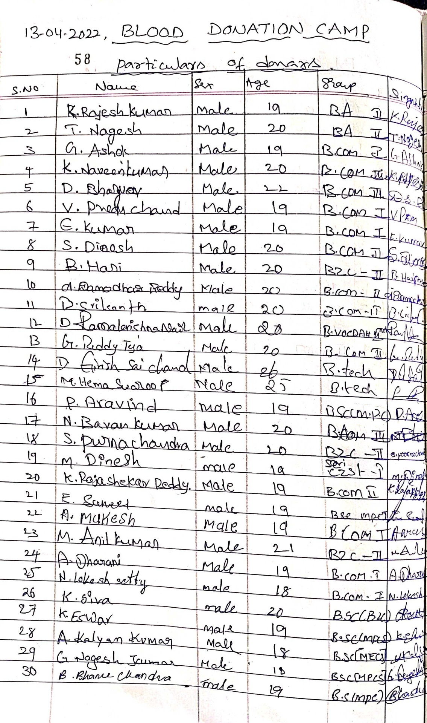

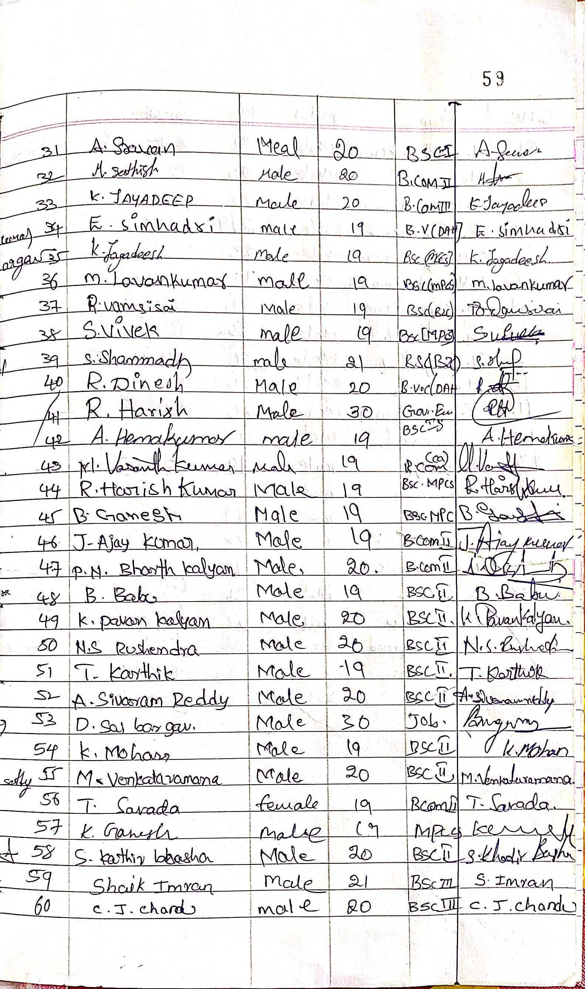

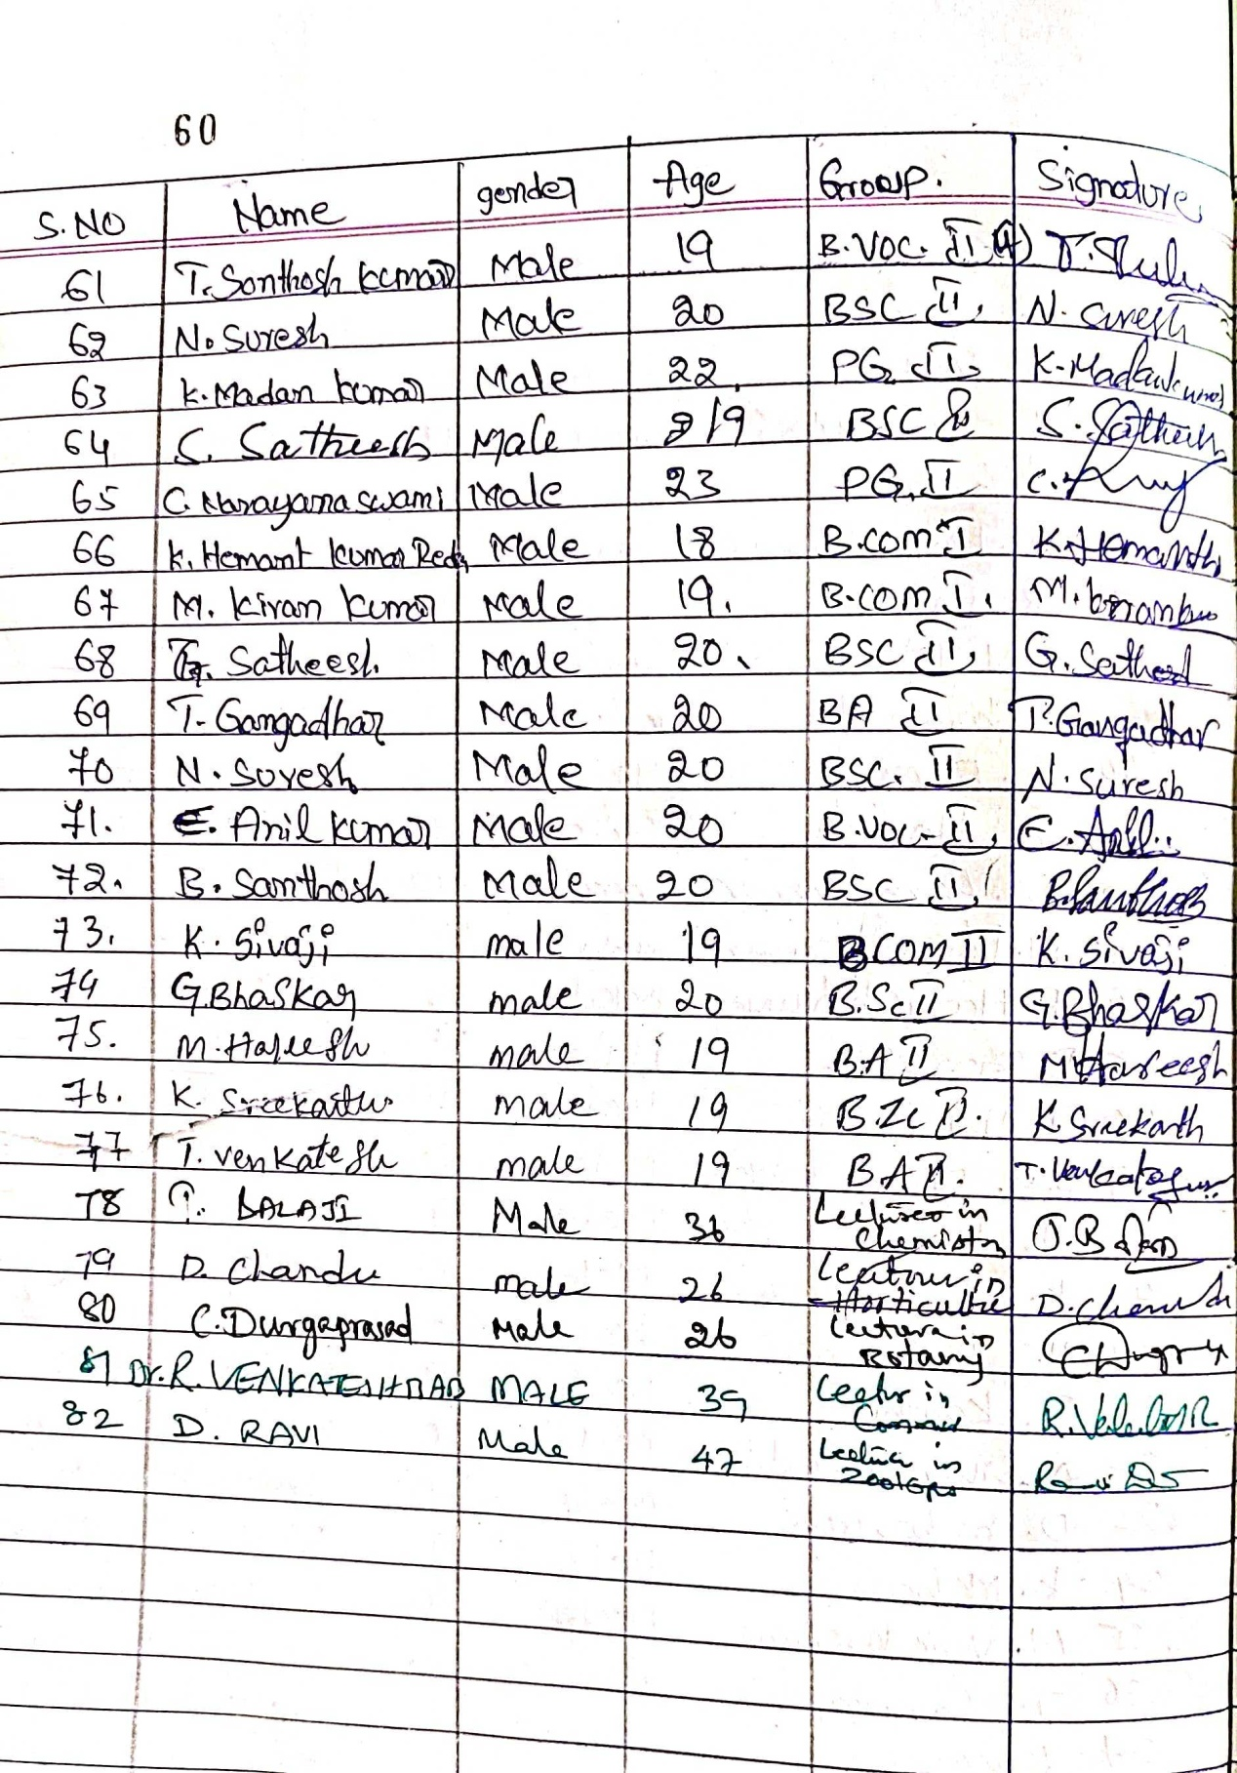

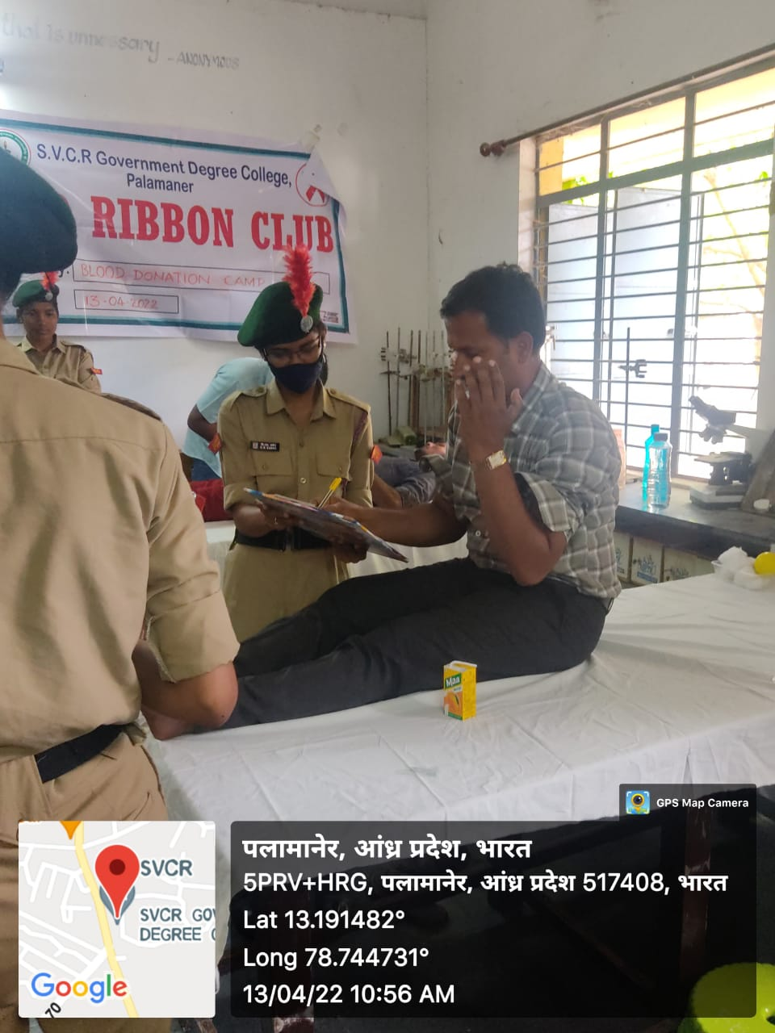

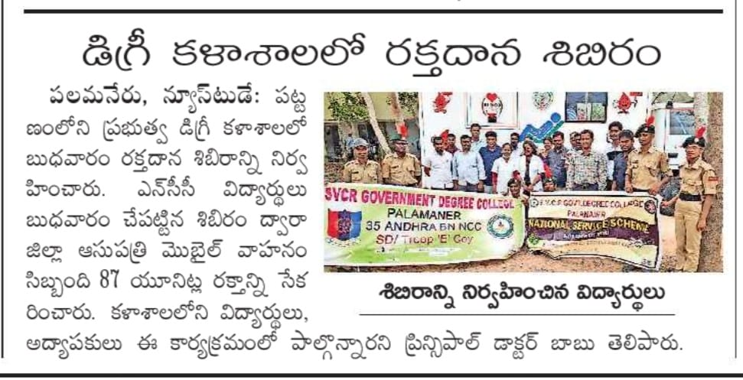
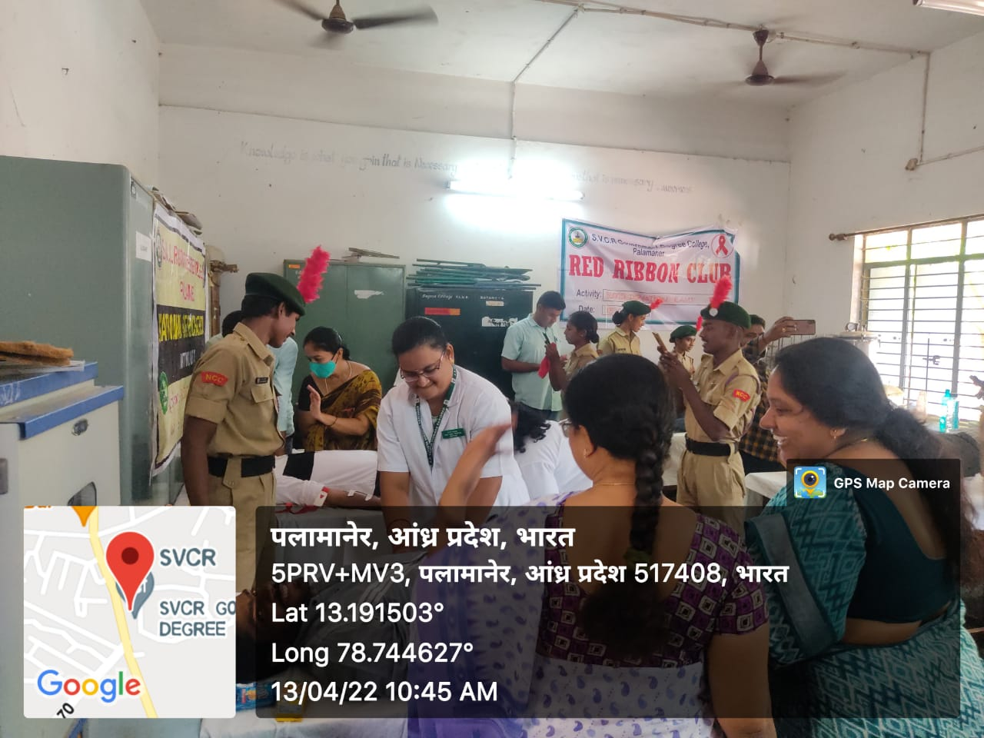

HEALTH CHECKUP CAMP AT ARYA VYSYA KALYANA MANDAPAM PALAMANER
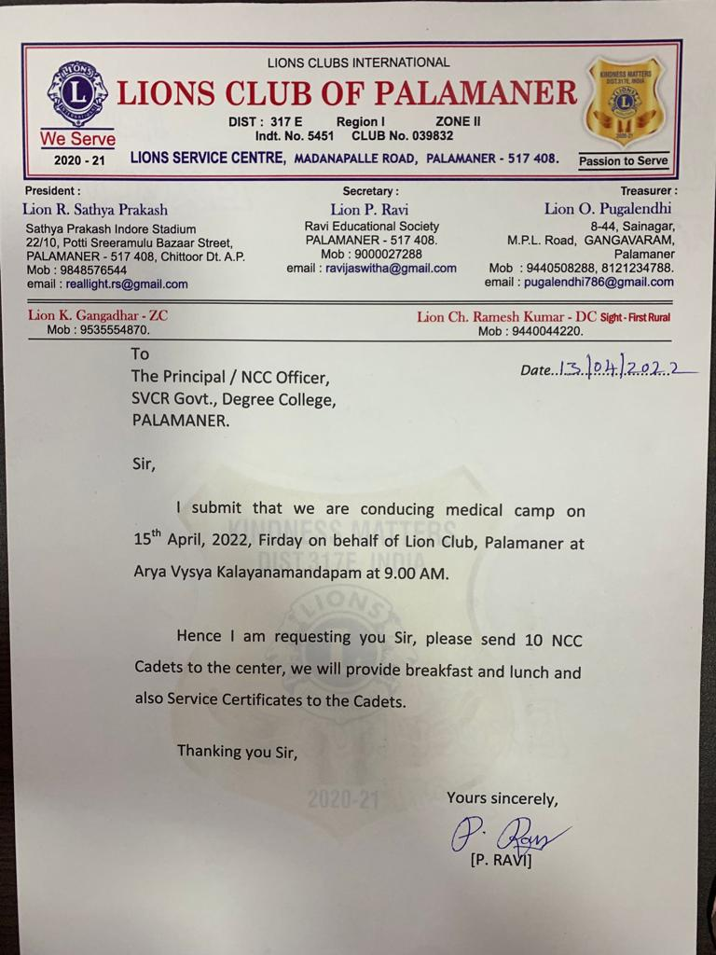

OBJECTIVE OF THE PROGRAMME:
- To make the students as the responsible citizens.
- To serve the needy.

REPORT OF THE PROGRAMME:
As per the request made by the Lions Club of Palamaner the NCC cadets went as volunteers to regulate the queues and to help the needy. 12 cadets with uniform attended the Health camp and served the needy old and the ailed persons. They helped the organizers. It is done purely on service motto. The organizers praised the services of the cadets at the end of the day for the making the camp a perfect one.

OUT COME:
- The students learnt how to help the needy.
- The students developed a feel to serve the society.

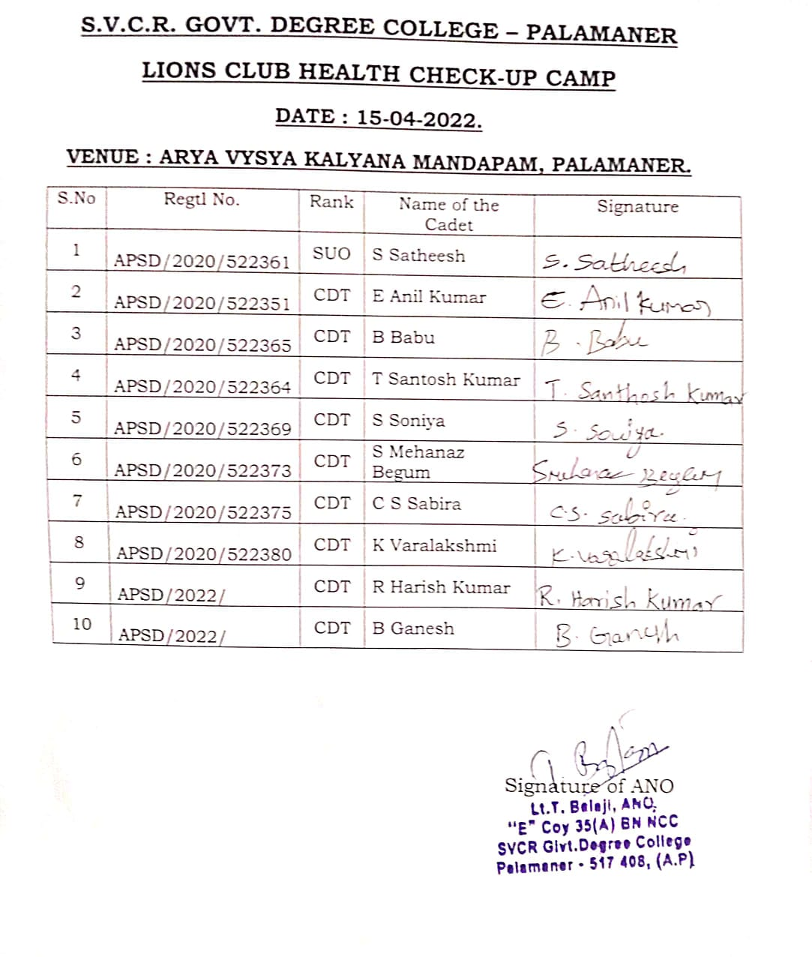

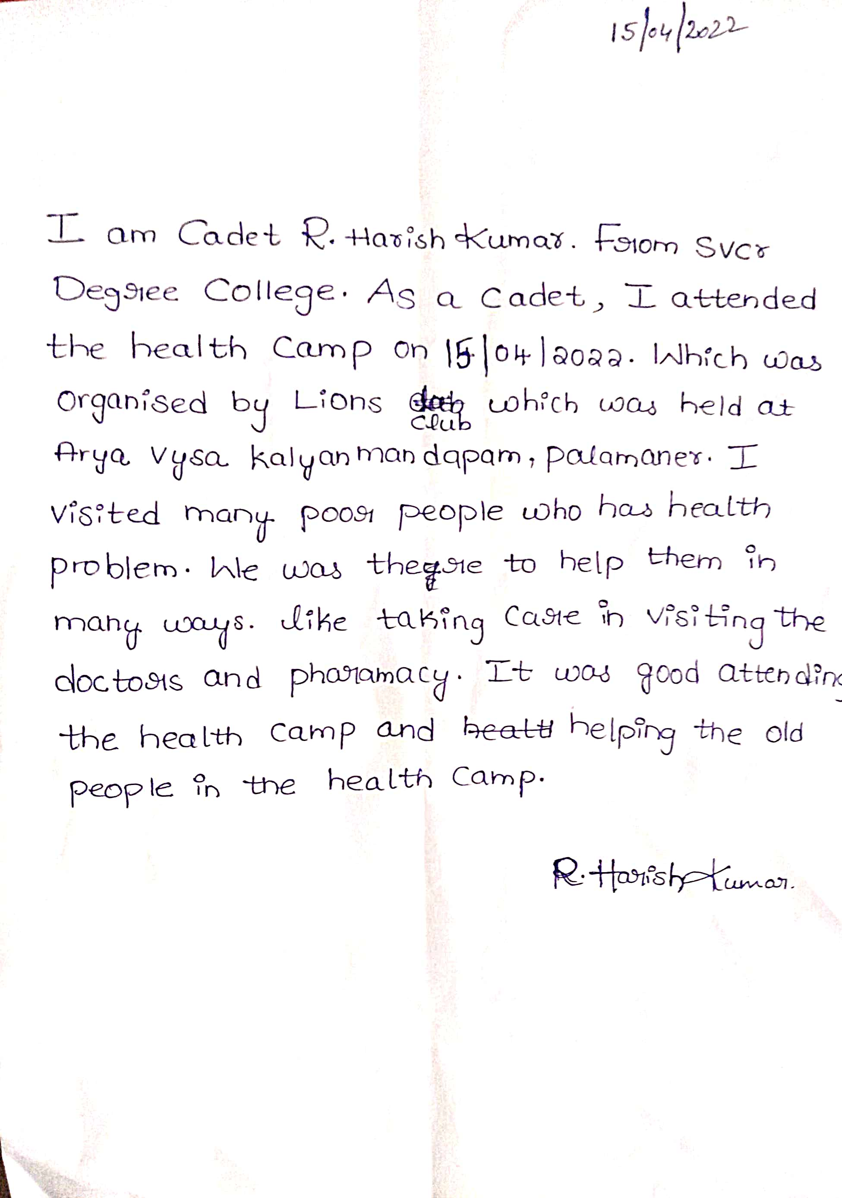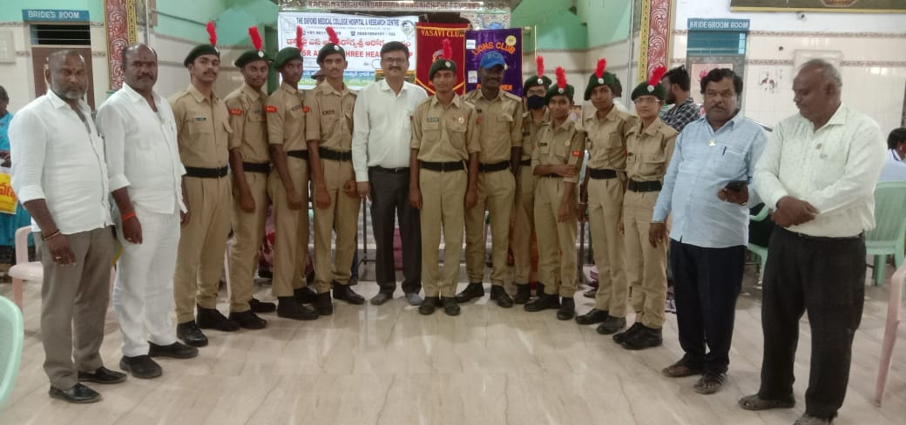

Circular
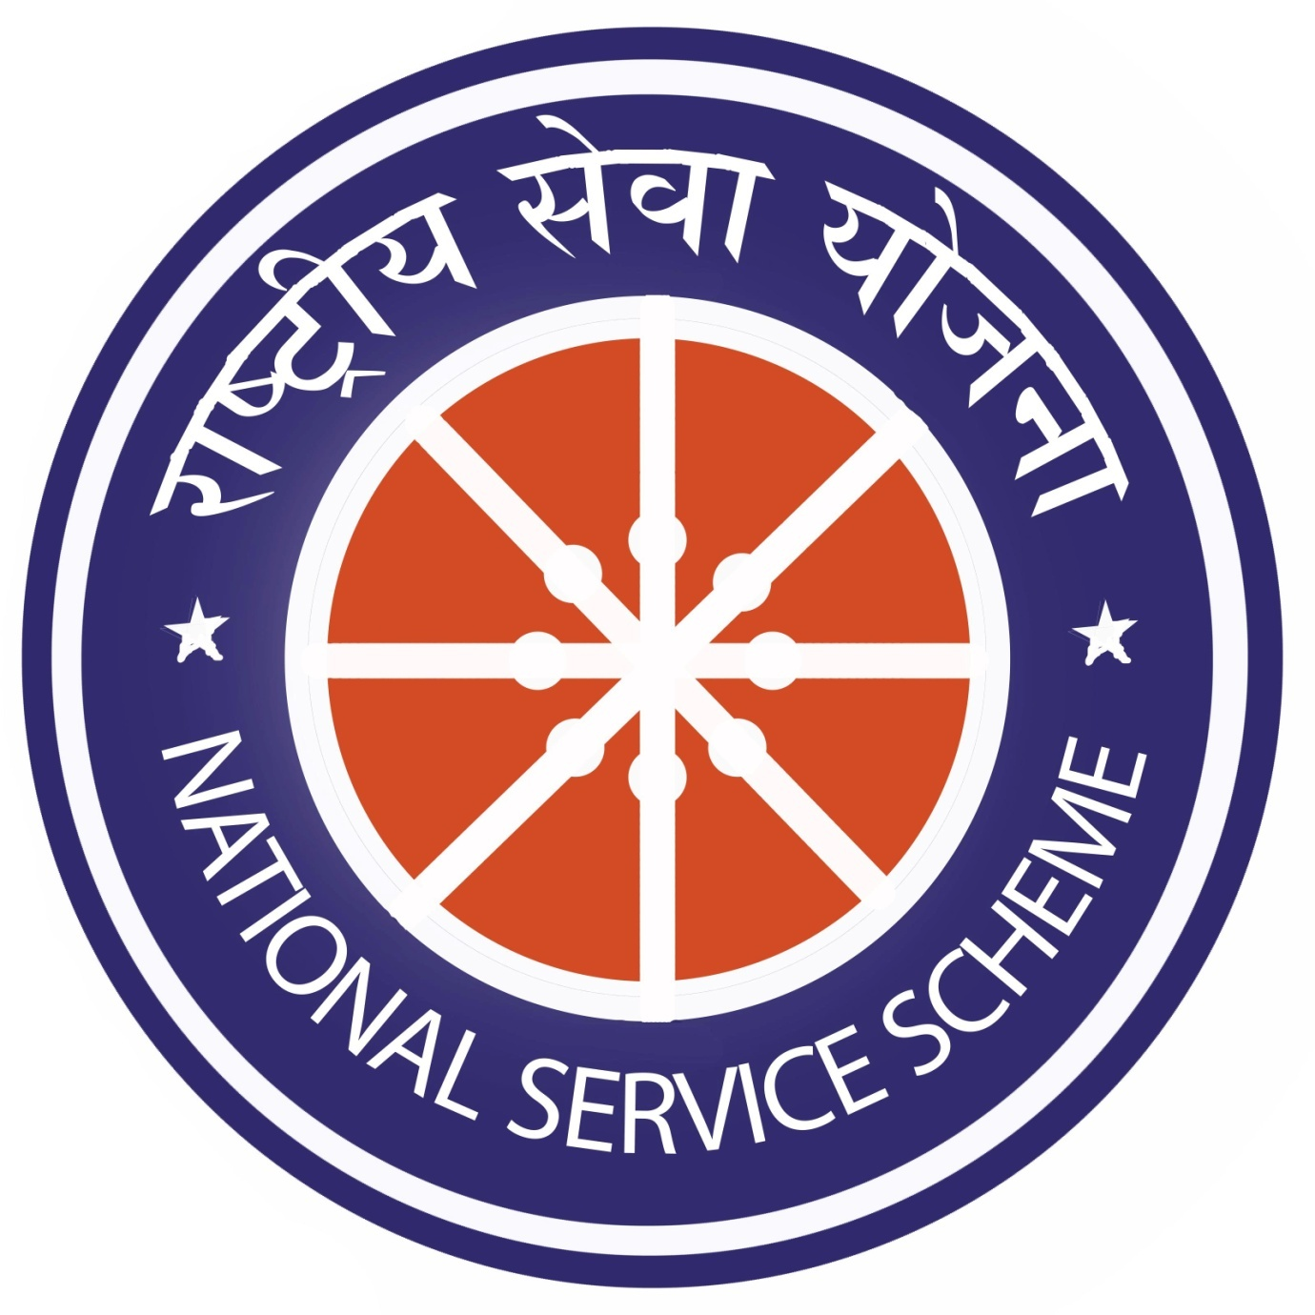
The NSS Unit – 2 of the college is going to a seven day special camp at Sri Lanka Colony, Gangavaram from 15.03.2022 onwards. Hence, the selected candidates of NSS Unit – 2 and the staff are informed to attend the inauguration function at Mathematics room in RUSA building at 12 PM on 15.03.2022.

OBJECTIVES OF THE PROGRAM:
- To motivate the students towards the social responsibility.
- To encourage the students to get a firsthand knowledge on team work.
- To equip the students with the motto “Not Me, but You”.
- To make the students to understand the importance of working for others.
- To prepare the students to build a selfless society.

DAY WISE REPORT OF THE PROGRAM
DAY 1
Tuesday, 15. 03. 2022
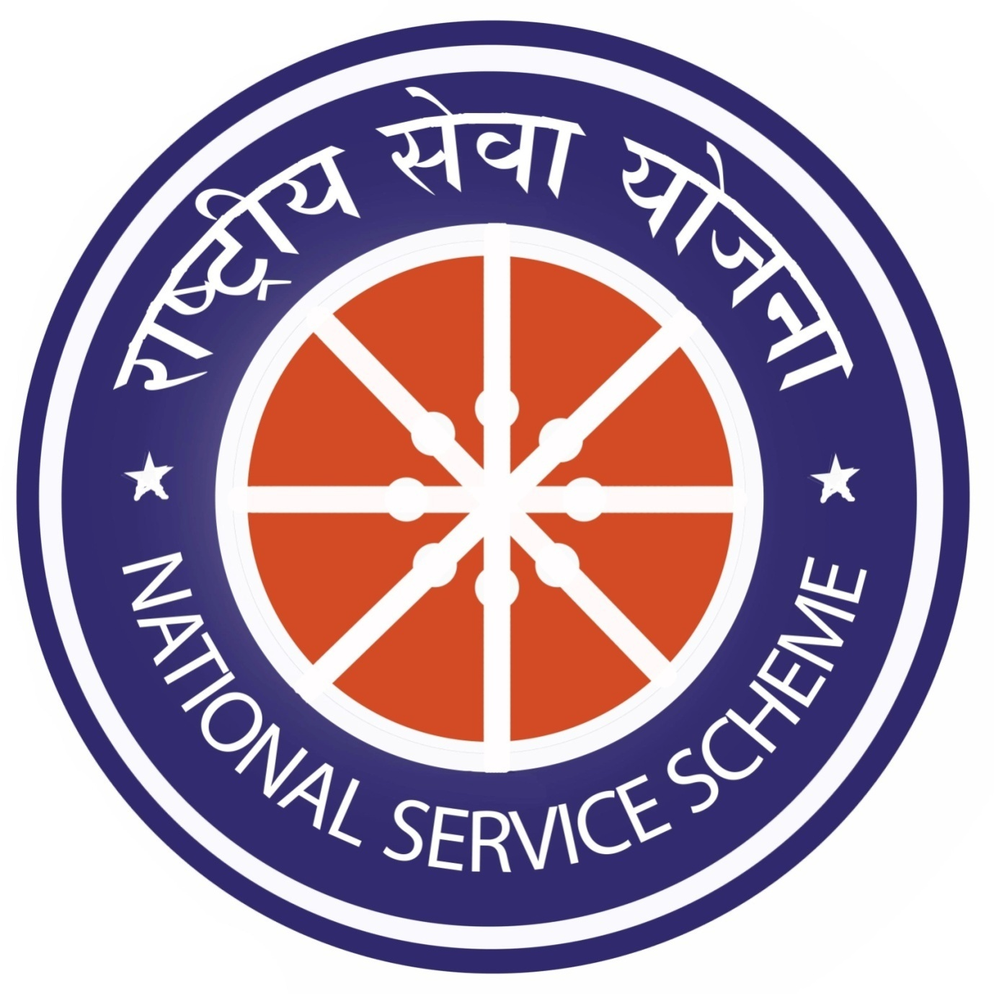
The Coordinator of NSS Unit – 2 has selected 45 students who have a bent of mind to learn about society. The self motivated students and the Coordinator Mr. K.CH.V. Subbaiah Naidu, Lecturer in Mathematics selected Srilanka Colony in Gangavaram as their place of habitation and decided to work for the people there.
A formal inauguration is conducted in the college campus with the Principal, IQAC Coordinator and the Vice Principal. The speakers motivated the students to participate in all the activities with a great spirit and asked them to do their best in the camp. The students too promised the same to the dignitaries of the event.
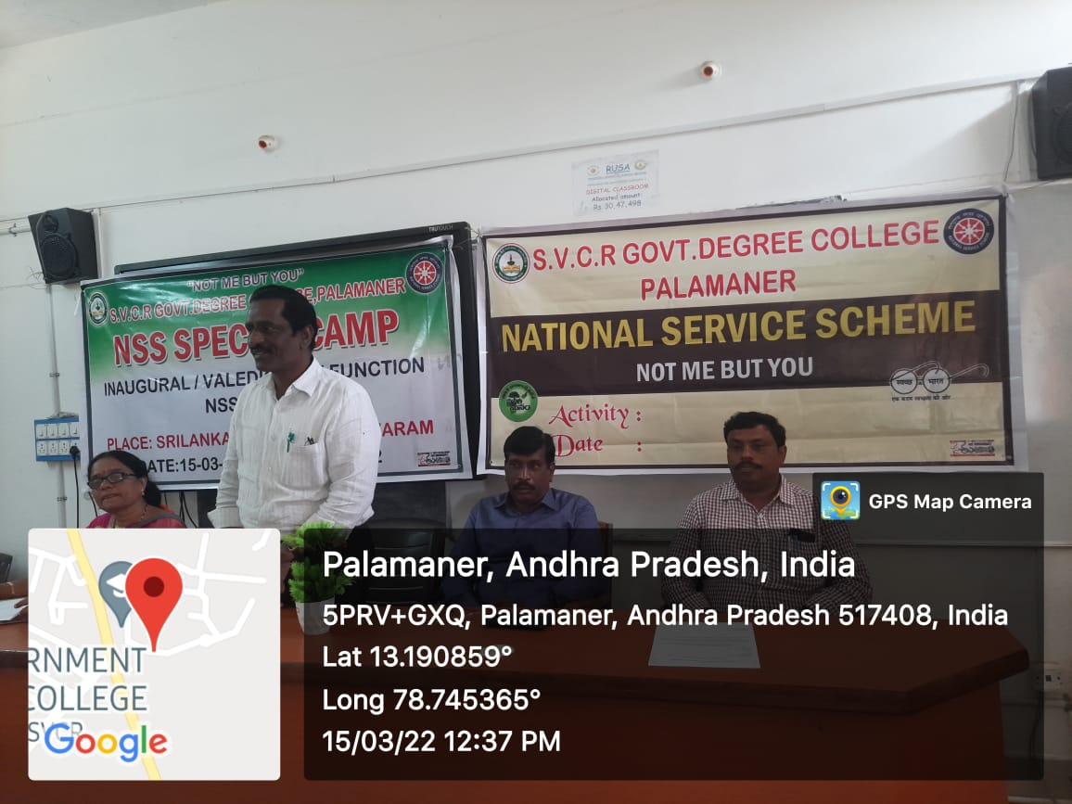
In the afternoon of the same day the volunteers cleaned the campus and made the soil good for planting.

DAY 2
Wednesday, 16.03.2022
On 16.03.2022 the unit conducted its cleaning activities in the colony. As a part of the program the volunteers cleaned the Mandal Parishad Development Office premises. The office conducted the Jayanthi of Potti Sree Ramulu, a great departed leader of Andhra Pradesh. The volunteers too participated in the activity and paid their homage to him. The Mandal Development Officer narrated the martyrdom of Potti Sree Ramulu for Andhra Pradesh. The Coordinator Sri K.CH.V. Subbaiah Naidu took care of the entire activity.

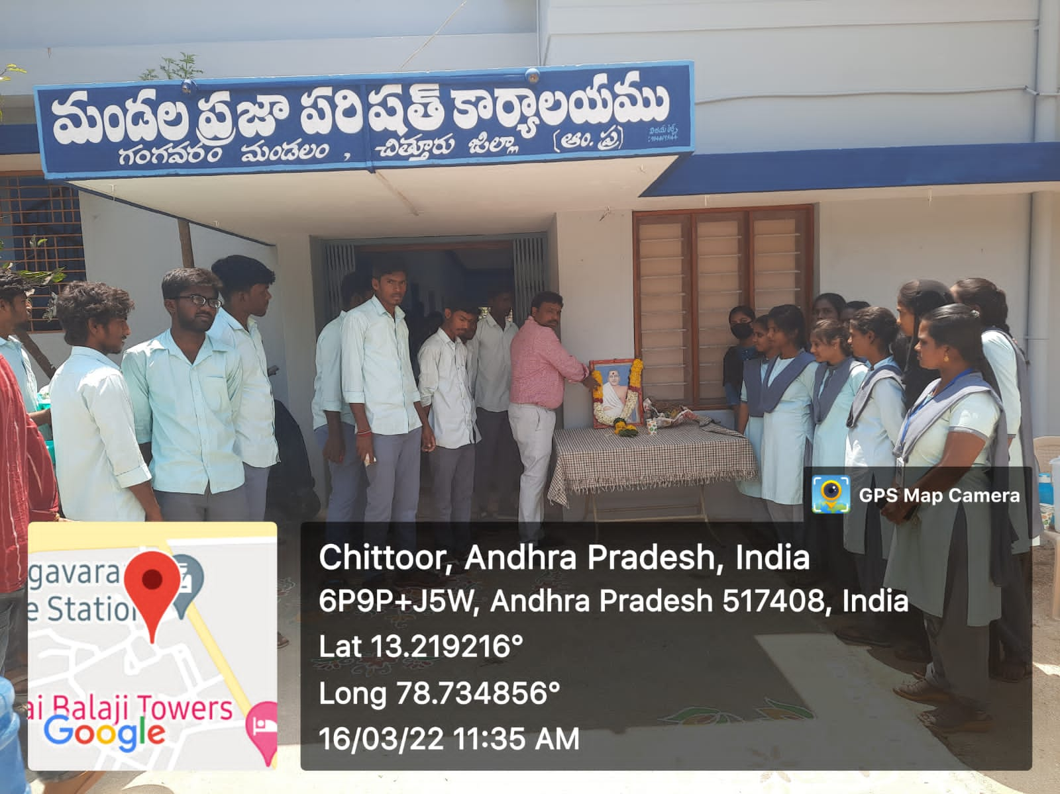
DAY 3
Thursday, 17.03.2022
The International Women’s Day Celebrations motivated the volunteers. They participated in the awareness program by the Department of Police. The Circle Inspector of Police of Gangavaram Mandal visited the camp and explained the self defensive methods to the volunteers. A lady cop demonstrated the entire session. The event was organized by the Coordinator. In the afternoon the students went to the streets of the village and gave awareness to the villagers on the need for the girl child and they demonstrated the self defensive methods to the young girls of the village. This gave a kind of recreation to the volunteers of the camp.
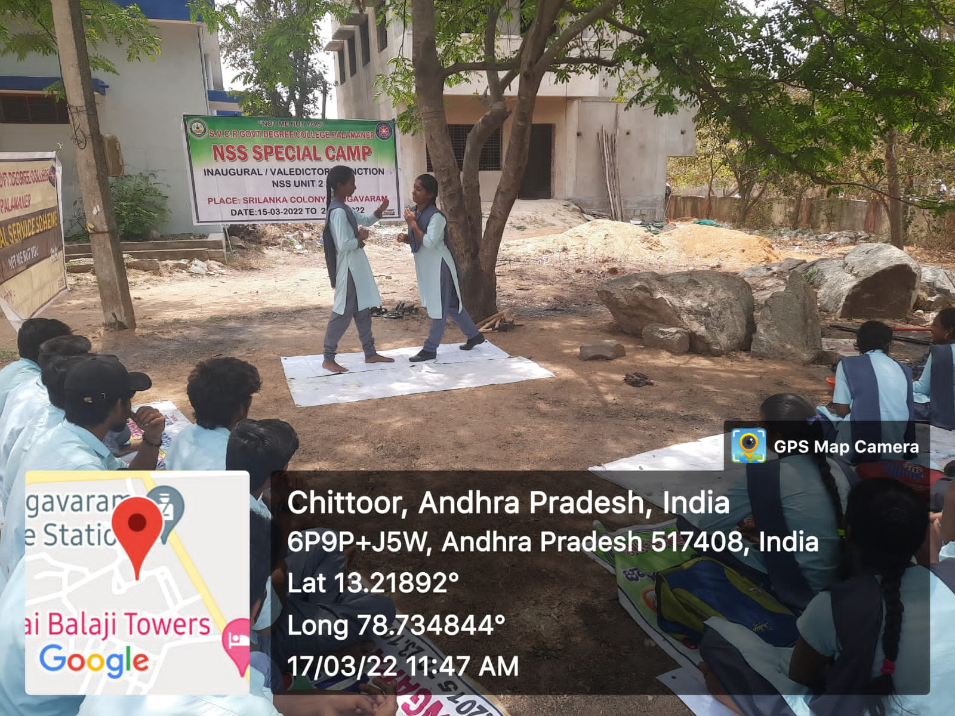
DAY 4
Friday, 18.03.2021
The day was really fruitful day in the camp. The Palamaner Prakruthi Parirakshana Samithi Convenor, Dr M. Devendra (A school teacher also) visited the volunteers. On this day the camp was organized in the campus. He brought medicinal and shady saplings to the campus. IQAC coordinator Dr G. Sridevi and Unit – 2 Coordinator Sri K.CH.V. Subbaiah Naidu motivated the students on the importance of greenery. The students planted the saplings and promised to take care of them. The activity went on up to evening. The volunteers accepted the request made by Dr. M. Devendra garu, Who planned to do avenue plantation in the month of May after their semester end examinations. The volunteers are highly motivated by the speeches and they actively participated in the plantation activity.

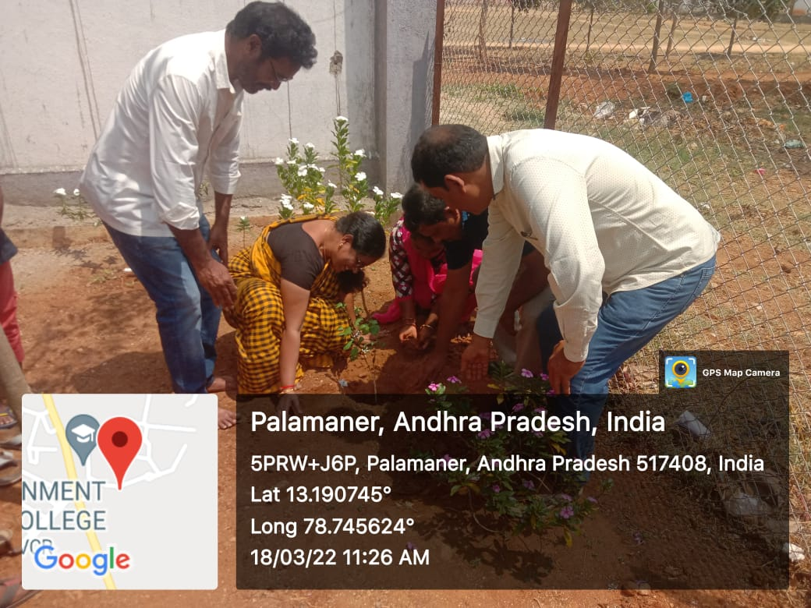

DAY 5
Saturday, 19.03.2022
An awareness rally on the preventive methods to be taken for eradication of AIDS from society has been taken by the volunteers. The rally was conducted from the MPDO office, where in the Mandal Development Officer, Sri Bhaskar also participated. The volunteers distributed pamphlets and educated the illiterate villagers on the deadly disease.
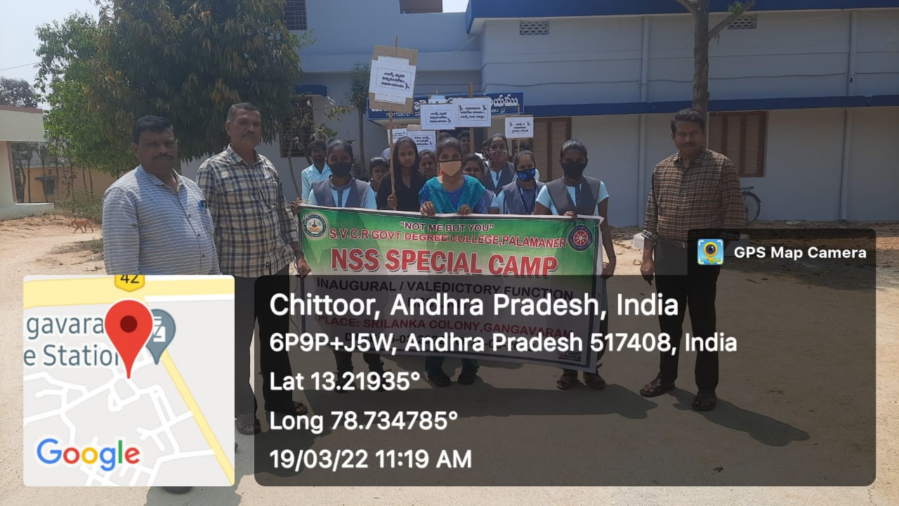

DAY 6
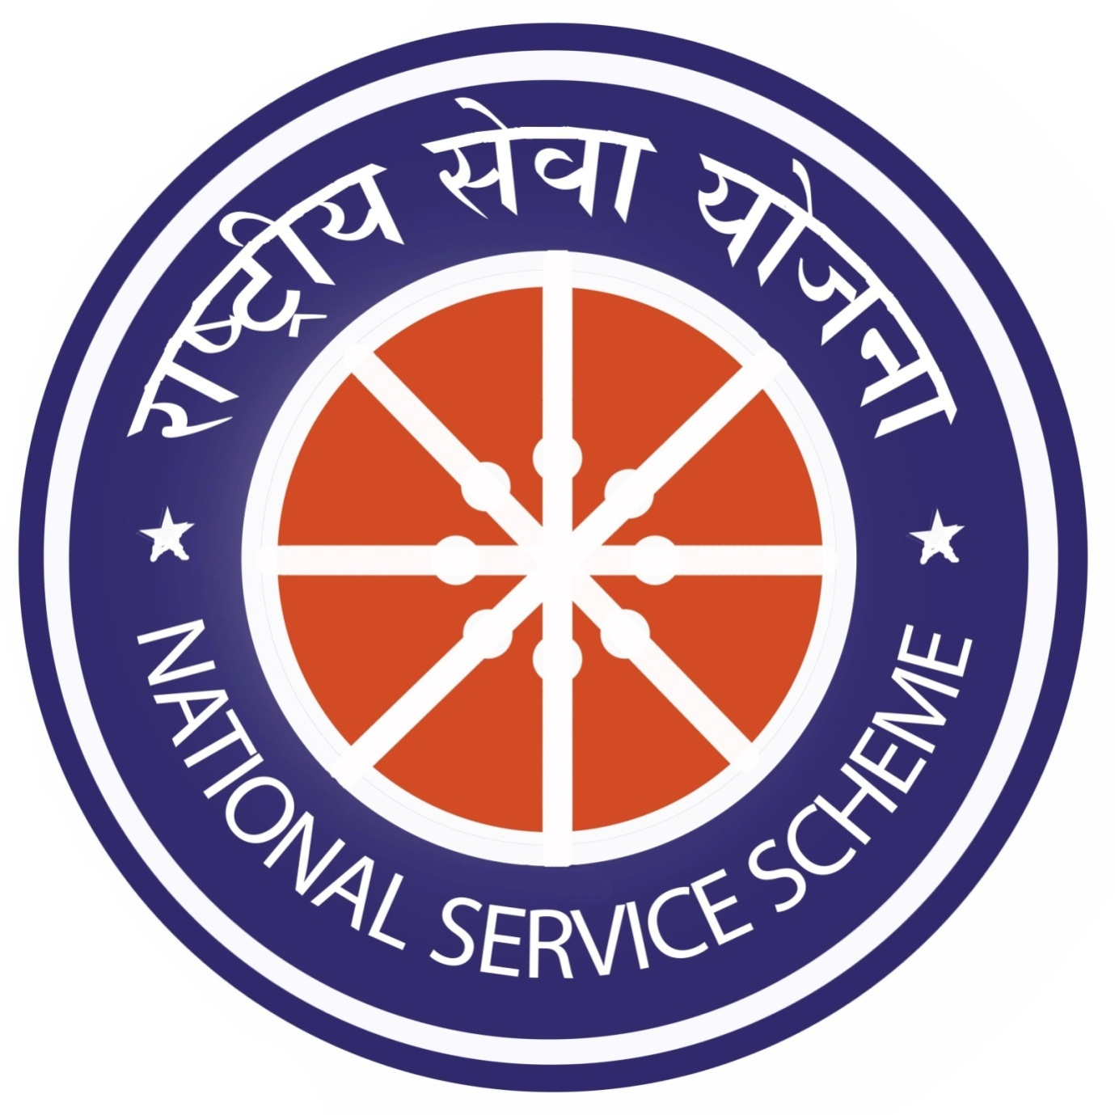
Sunday, 20.03.2022
As it is Sunday the students are very enthusiastic to teach the villagers. Most of the volunteers are from Science groups. So they are given a task to educate the villagers on the pandemic, COVID – 19. The volunteers are self learned on the pandemic. So it became easy for them to explain about the hazards created by corona virus. They explained about the precautions to be taken to stop spreading of the disease. A rally too was conducted on the day by the IQAC coordinator Dr.G. Sridevi and NSS Unit – 2 Coordinator Sri K.CH.V. Subbaiah Naidu garu.
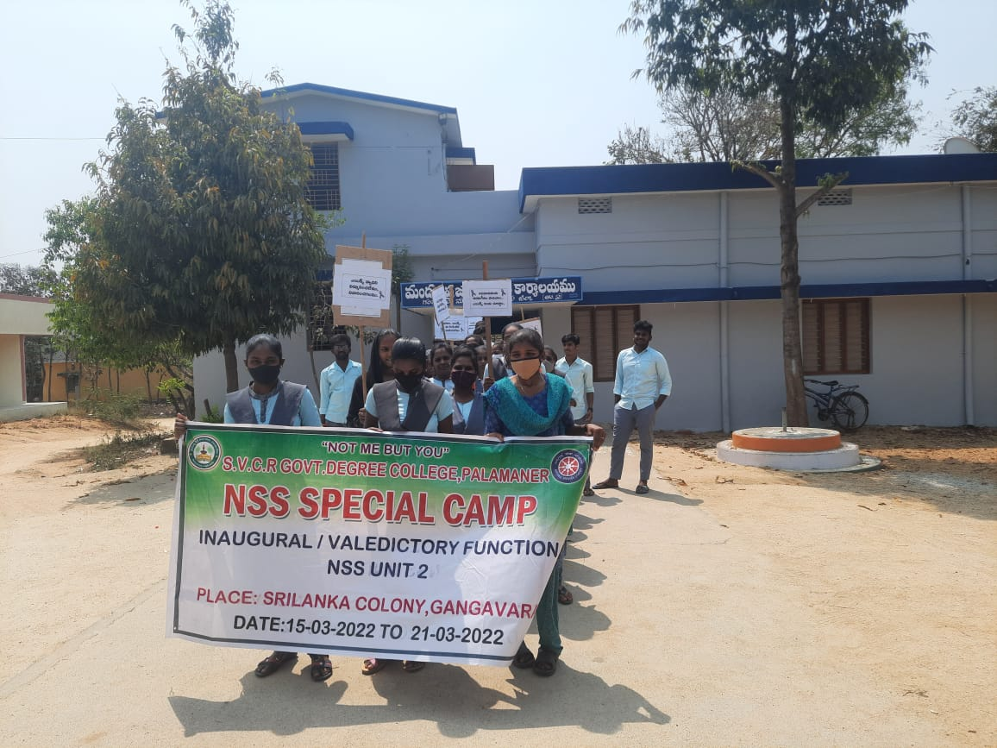

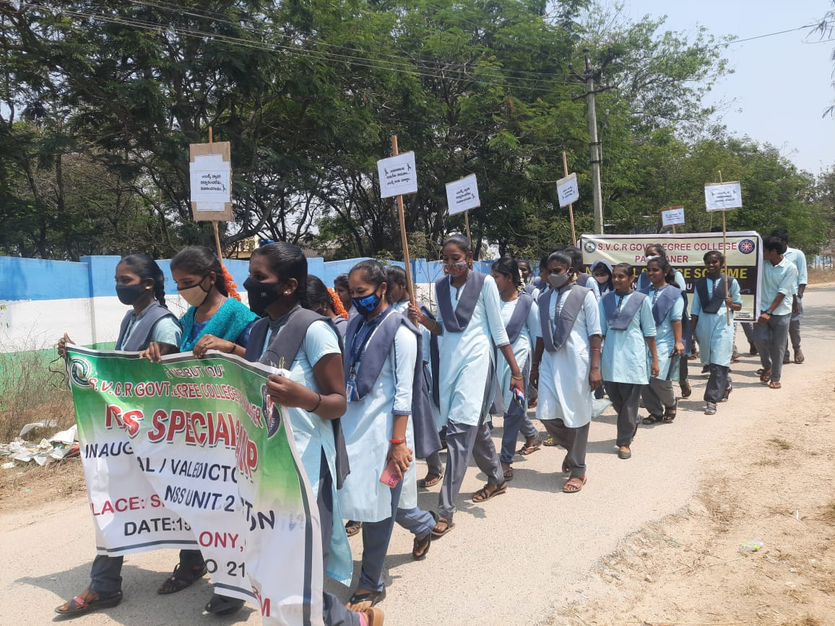
DAY 7
Monday, 21.03.2022
The valedictory function was conducted. The Mandal Development Officer, Sri Bhaskar garu presided over the function. He praised the services done by the students to the village. He thanked the coordinator Sri Subbaiah Naidu garu for conducting such an inspirational camp in their mandal. The volunteers shared their experience throughout the camp. A thankful day came to an end with a vote of thanks uttered by Sri Kiran Babu, Lecturer in Mathematics.
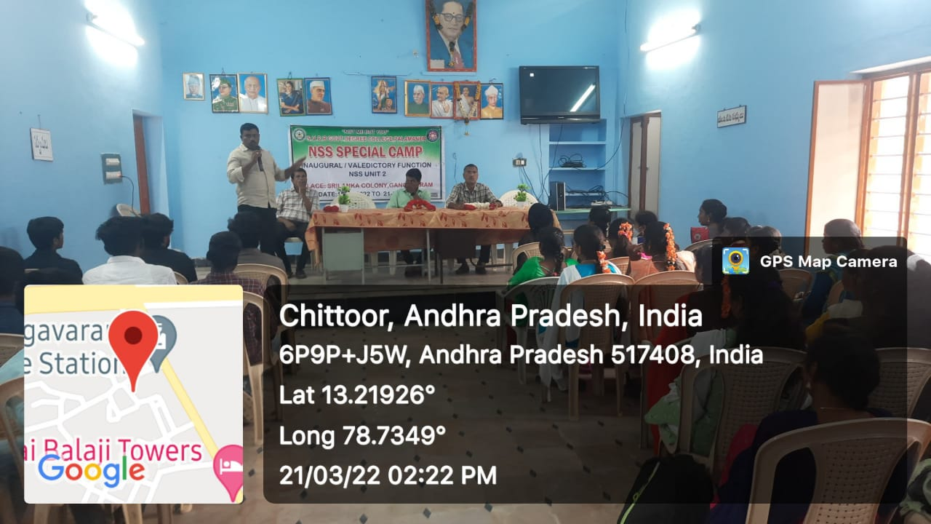
OUTCOME OF THE PROGRAM:
- The volunteers learnt the motto.
- The volunteers learnt to serve for their land.
- The volunteers perceived the importance of the team work.
- The volunteers became teachers and explained the need for health and hygiene and they promised to follow the same.
- The volunteers learnt the importance of greenery.

